July 2012
Aegis Media

Paul Yates

mESSAGING – eXCHANGE 2010 test environment – Detailed design

Purpose of Document

This document is intended to be used when reviewing or creating IT Architecture Designs.

This document will detail all the components that make up the Exchange 2010 Test Environment.

Intended Audience

Project Manager, Global Chief Technology Officer (CTO), Global Enterprise Architect, Global Messaging Specialists, Regional Chief Information Officers (CIO), Tata Consultancy Services
Author | Version | Date
Paul Yates | 0.10 | 19th June 2012

Document History

Status | Owner | Version | Date | Reason for Change
Draft | Paul Yates | 0.10 | 19th June 2012 | Document Created
Draft | Paul Yates | 0.11 | 17th June 2012 | Draft Completed

Review

Name | Role | Date
Richard Jones | Project Manager
Colin Towers | Global CTO
James Morris | Global Enterprise Architect
Matt Dixon | Regional CIO
Stephen Wigney | Regional CIO
Bill Kohler | Regional CIO
 | Tata Consultancy Services

* Enterprise Architecture will review the High Level Design to ensure that it aligns with the overall vision. If the detailed design fundamentally changes then the High Level Design must be updated and reviewed with the appropriate people within the Enterprise Architecture Team.
Table of Contents
Purpose of Document 2
Intended Audience 2
Document History 2
Review 2
Testing Environment 5
Testing Environment Components 6
Exchange 2010 6
Topology 6
Server List 6
Specifications 7
Client Access 8
Topology 8
Server List 9
Specifications 10
Client List 10
Namespace 11
Symantec.Cloud / Backup /RBAC 13
Topology 13
MX Record 13
Server List 14
Specifications 15
Riverbed Stingray Load Balancers 16
Topology – Server Farm (SSF1) 16
Servers 16
Specification 17
Topology – Extranet Silo 17
Servers 17
Specifications 18
Configuration – Server Farm (SSF1) 19
Configuration – Extranet Silo 20
Threat Management Gateway 21
Topology 21
Servers 21
Specifications 22
Configuration 23
Blackberry 24
Topology 24
Servers 24
Specification 25
Implementation 25
Storage Performance Testing 26
Backup Performance Testing 27
Coexistence / Migration & End to End Testing 28
Topology 28
Servers 29
Client 30
Specification 30
Mail Routing 31
Network 32
VLANS 32
Firewall Policies 32
Hardware Inventory 33
Software Inventory 34

Testing Environment

The testing environment is a replica of the final agreed production design, with the exception of some of the technologies used, for example NetApp storage. The environment is split over 2 datacentres within the EMEA region with high availability using multiple DAGs with 2 active copies and 1 passive copy.
The datacentres are located in the following locations:
Datacentre A (UKLAB1) – Level 3, Goswell Road, London
Datacentre B (UKLAB2) – Global Switch 2, London
The entire environment is based on VMware with local storage and is as follows:
Datacentre A (UKLAB1) – Dell PowerEdge R710
Datacentre B (UKLAB2) – CISCO UCS
This environment will be used initially as a proof of concept to test all of the individual components involved in the Exchange 2003 and Exchange 2010 transition. A test script will be run against each component to which success criteria has been defined.
Once Exchange 2010 is in full production this environment will be used only for testing. This will include Windows Updates, hotfixes, service packs, feature enhancements and requests.

Testing Environment Components

Exchange 2010
The purpose of this testing environment is the build, configure, document and test the core Exchange 2010 components.

Forest / Domain Name: LAB.loc (Secure Server Farm 1 & 2)
External Namespace: aemedia-data.com

There is the following dependency for the Exchange 2010 component testing:

- Virtual Machines (VM)
- Active Directory
- Certificate Services
- Exchange 2003
- Exchange 2010

The following items will not be tested during the Exchange 2010 component test phase, but will be tested subsequently as part of the production installation and signed off before the pilot phase.

- Performance Testing
- Jetstress

Topology

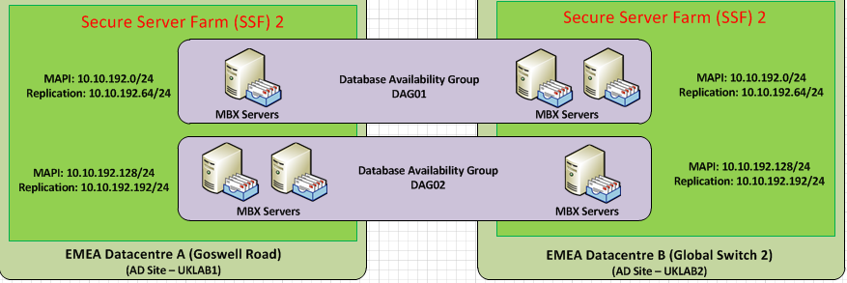

Server List

Hostname | IP Address | Role | Site | OS
UKLAB1DCM01 | 10.10.139.50 | DC / GC / DNS | EMEA Datacentre A | Windows 2008 R2 SP1 SE
UKLAB1DCM02 | 10.10.139.51 | DC / GC / DNS | EMEA Datacentre A | Windows 2008 R2 SP1 SE
UKLAB1DCM03 | 10.10.139.52 | DC / GC / DNS | EMEA Datacentre A | Windows 2003 R2 SE
UKLAB2DCM01 | 10.10.193.200 | DC / GC / DNS | EMEA Datacentre B | Windows 2008 R2 SP1 SE
UKLAB2DCM02 | 10.10.193.201 | DC / GC / DNS | EMEA Datacentre B | Windows 2008 R2 SP1 SE
UKLAB1MBX01 | 10.10.193.10 – MAPI  10.10.193.70 - Replication | Mailbox – DAG A | EMEA Datacentre A | Windows 2008 R2 SP1 EE
UKLAB1MBX02 | 10.10.193.11 – MAPI  10.10.193.71 - Replication | Mailbox – DAG A | EMEA Datacentre A | Windows 2008 R2 SP1 EE
UKLAB2MBX03 | 10.10.192.142 – MAPI  10.10.192.202 - Replication | Mailbox – DAG A | EMEA Datacentre A | Windows 2008 R2 SP1 EE
DAG01 | 10.10.192.13 | DAG
UKLAB2MBX01 | 10.10.192.140 – MAPI  10.10.192.200 - Replication | Mailbox – DAG B | EMEA Datacentre B | Windows 2008 R2 SP1 EE
UKLAB2MBX02 | 10.10.192.141 – MAPI  10.10.192.201 - Replication | Mailbox – DAG B | EMEA Datacentre B | Windows 2008 R2 SP1 EE
UKLAB1MBX03 | 10.10.192.12 – MAPI  10.10.192.73 – Replication | Mailbox – DAG B | EMEA Datacentre B | Windows 2008 R2 SP1 EE
DAG02 | 10.10.192.143 | DAG
UKLAB1BHM01 | 10.10.139.53 | Exchange 2003 Bridgehead | EMEA Datacentre A | Windows 2003 R2 SE
UKLAB1EXM01 | 10.10.139.54 | Exchange 2003 Mailbox | EMEA Datacentre A | Windows 2003 R2 SE
UKLAB2CAM01 | 10.10.139.35 | Certificate Services | EMEA Datacentre B | Windows 2008 R2 SP1 EE

Specifications

Hostname | CPU / Core | RAM | NIC | Additional Storage
UKLAB1DCM01 | 1 vCPU | 2048 MB | 1 vNIC | 1 x 50GB VMDK  2 x 15GB VMDK
UKLAB1DCM02 | 1 vCPU | 2048 MB | 1 vNIC | 1 x 50GB VMDK  2 x 15GB VMDK
UKLAB1DCM03 | 1 vCPU | 2048 MB | 1 vNIC | 1 x 50GB VMDK  2 x 15GB VMDK
UKLAB2DCM01 | 1 vCPU | 2048 MB | 1 vNIC | 1 x 50GB VMDK  2 x 15GB VMDK
UKLAB2DCM02 | 1 vCPU | 2048 MB | 1 vNIC | 1 x 50GB VMDK  2 x 15GB VMDK
UKLAB1MBX01 | 2 vCPU | 4096 MB | 2 vNIC | 3 x 40GB VMDK
UKLAB1MBX02 | 2 vCPU | 4096 MB | 2 vNIC | 3 x 40GB VMDK
UKLAB2MBX03 | 2 vCPU | 4096 MB | 2 vNIC | 3 x 40GB VMDK
DAG01
UKLAB2MBX01 | 2 vCPU | 4096 MB | 2 vNIC | 3 x 40GB VMDK
UKLAB2MBX02 | 2 vCPU | 4096 MB | 2 vNIC | 3 x 40GB VMDK
UKLAB1MBX03 | 2 vCPU | 4096 MB | 2 vNIC | 3 x 40GB VMDK
DAG02
UKLAB1BHM01 | 2 vCPU | 4096 MB | 1 vNIC | 1 x 20GB VMDK  1 x 100GB VMDK
UKLAB1EXM01 | 1 vCPU | 2048 MB | 1 vNIC | 1 x 24GB VMDK  2 X 50GB VMDK  1 x 10GB VMDK  1 x 100GB VMDK
UKLAB2CAM01 | 2 vCPU | 4096 MB | 1 vNIC | 1 x 40GB VMDK

Client Access
The purpose of this testing environment is the build, configure, document and test of the client access components.
Forest / Domain Name: LAB.loc (Secure Server Farm 1 & 2) & DMZ (Extranet Silo)
External Namespace: aemedia-data.com

There is the following dependency for the Exchange 2010 component testing:
- Virtual Machines (VM)
- Active Directory (2008 R2 Only)
- Certificate Services (2008 R2 Only)
- Exchange 2010
- TMG 2010 SP2
- Riverbed Stingray Version 8.1R1Load Balancers
- XP Client with Office 2007, IE9, Firefox, Safari, Chrome
- XP Client with Office 2010, IE9, Firefox, Safari, Chrome
- Windows 7 Client with Office 2007, IE9, Firefox, Safari, Chrome
- Windows 7 Client with Office 2010, IE9, Firefox, Safari, Chrome
- MAC with Office 2011, Safari, Firefox, Chrome
- MAC with Entourage 2008, Safari, Firefox, Chrome
- Firewall

Topology
The diagram below represents the test lab architecture required for TMG and Client Access Testing. The Client Access Servers will be configured in a hardware load balanced array.

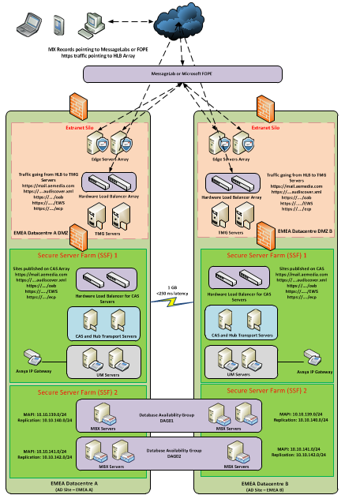

Server List

Hostname | IP Address | Role | Site | OS
UKLAB1DCM01 | 10.10.139.50 | DC / GC / DNS | EMEA Datacentre A | Windows 2008 R2 SP1 SE
UKLAB1DCM02 | 10.10.139.51 | DC / GC / DNS | EMEA Datacentre A | Windows 2008 R2 SP1 SE
UKLAB2DCM01 | 10.10.193.200 | DC / GC / DNS | EMEA Datacentre B | Windows 2008 R2 SP1 SE
UKLAB2DCM02 | 10.10.193.201 | DC / GC / DNS | EMEA Datacentre B | Windows 2008 R2 SP1 SE
UKLAB1MBX01 | 10.10.193.10 – MAPI  10.10.193.70 - Replication | Mailbox – DAG A | EMEA Datacentre A | Windows 2008 R2 SP1 EE
UKLAB1MBX02 | 10.10.193.11 – MAPI  10.10.193.71 - Replication | Mailbox – DAG A | EMEA Datacentre A | Windows 2008 R2 SP1 EE
UKLAB2MBX03 | 10.10.192.142 – MAPI  10.10.192.202 - Replication | Mailbox – DAG A | EMEA Datacentre A | Windows 2008 R2 SP1 EE
UKLAB2MBX01 | 10.10.192.140 – MAPI  10.10.192.200 - Replication | Mailbox – DAG B | EMEA Datacentre B | Windows 2008 R2 SP1 EE
UKLAB2MBX02 | 10.10.192.141 – MAPI  10.10.192.201 - Replication | Mailbox – DAG B | EMEA Datacentre B | Windows 2008 R2 SP1 EE
UKLAB1MBX03 | 10.10.192.12 – MAPI  10.10.192.73 – Replication | Mailbox – DAG B | EMEA Datacentre B | Windows 2008 R2 SP1 EE
UKLAB2CAM01 | 10.10.139.35 | Certificate Services | EMEA Datacentre B | Windows 2008 R2 SP1 EE
UKLAB1CAS01 | 10.10.139.56 | CAS and Hub Role | EMEA Datacentre A | Windows 2008 R2 SP1 SE
UKLAB1CAS02 | 10.10.139.57 | CAS and Hub Role | EMEA Datacentre A | Windows 2008 R2 SP1 SE
UKLAB2CAS01 | 10.10.193.202 | CAS and Hub Role | EMEA Datacentre B | Windows 2008 R2 SP1 SE
UKLAB2CAS02 | 10.10.192.203 | CAS and Hub Role | EMEA Datacentre B | Windows 2008 R2 SP1 SE
UKLAB1EDG01 | 10.10.193.15 | Edge Transport | EMEA Datacentre A | Windows 2008 R2 SP1 SE
UKLAB1EDG02 | 10.10.193.16 | Edge Transport | EMEA Datacentre A | Windows 2008 R2 SP1 SE
UKLAB2EDG01 | 10.10.193.10 | Edge Transport | EMEA Datacentre B | Windows 2008 R2 SP1 SE
UKLAB2EDG02 | 10.10.193.11 | Edge Transport | EMEA Datacentre B | Windows 2008 R2 SP1 SE
UKLAB2TMG00 | 10.10.193.22 | Threat Management Gateway Management Node | EMEA Datacentre B | N/A
UKLAB1TMG01 | 10.10.193.17 – Internal  10.10.193.73 – External  10.10.193.142 – Heartbeat  10.10.193.23 | Threat Management Gateway | EMEA Datacentre A | Windows 2008 R2 SP1 EE
UKLAB1TMG02 | 10.10.193.18 – Internal  10.10.193.74 – External  10.10.193.143 – Heartbeat  10.10.193.23 | Threat Management Gateway | EMEA Datacentre A | Windows 2008 R2 SP1 EE
UKLAB2TMG01 | 10.10.193.12 – Internal  10.10.193.70 – External  10.10.193.140 – Heartbeat | Threat Management Gateway | EMEA Datacentre B | Windows 2008 R2 SP1 EE
UKLAB2TMG02 | 10.10.193.13 – Internal  10.10.193.71 – External  10.10.193.141 - Heartbeat | Threat Management Gateway | EMEA Datacentre B | Windows 2008 R2 SP1 EE
UKLAB1NLB01 | 10.10.193.19 | Load Balancer | EMEA Datacentre A | RiOS 6
UKLAB1NLB02 | 10.10.193.75 | Load Balancer | EMEA Datacentre A | RiOS 6
UKLAB2NLB01 | 10.10.193.14 | Load Balancer | EMEA Datacentre B | RiOS 6
UKLAB2NLB02 | 10.10.193.72 | Load Balancer | EMEA Datacentre B | RiOS 6
UKLAB1DCM01.dmzlab.loc | 10.10.193.22 | DC / GC / DNS | EMEA Datacentre B | Windows 2008 R2 SP1 SE
UKLAB2DCM01.dmzlab.loc | 10.10.193.20 | DC / GC / DNS | EMEA Datacentre B | Windows 2008 R2 SP1 SE

Specifications

Hostname | CPU / Core | RAM | NIC | Additional Storage
UKLAB1DCM01 | 1 vCPU | 2048 MB | 1 vNIC | 1 x 50GB VMDK  2 x 15GB VMDK
UKLAB1DCM02 | 1 vCPU | 2048 MB | 1 vNIC | 1 x 50GB VMDK  2 x 15GB VMDK
UKLAB2DCM01 | 1 vCPU | 2048 MB | 1 vNIC | 1 x 50GB VMDK  2 x 15GB VMDK
UKLAB2DCM02 | 1 vCPU | 2048 MB | 1 vNIC | 1 x 50GB VMDK  2 x 15GB VMDK
UKLAB1MBX01 | 2 vCPU | 4096 MB | 2 vNIC | 3 x 40GB VMDK
UKLAB1MBX02 | 2 vCPU | 4096 MB | 2 vNIC | 3 x 40GB VMDK
UKLAB2MBX03 | 2 vCPU | 4096 MB | 2 vNIC | 3 x 40GB VMDK
UKLAB2MBX01 | 2 vCPU | 4096 MB | 2 vNIC | 3 x 40GB VMDK
UKLAB2MBX02 | 2 vCPU | 4096 MB | 2 vNIC | 3 x 40GB VMDK
UKLAB1MBX03 | 2 vCPU | 4096 MB | 2 vNIC | 3 x 40GB VMDK
UKLAB2CAM01 | 2 vCPU | 4096 MB | 1 vNIC | 1 x 40GB VMDK
UKLAB1CAS01 | 2 vCPU | 4096 MB | 1 vNIC | 3 x 40GB VMDK
UKLAB1CAS02 | 2 vCPU | 4096 MB | 1 vNIC | 3 x 40GB VMDK
UKLAB2CAS01 | 2 vCPU | 4096 MB | 1 vNIC | 3 x 40GB VMDK
UKLAB2CAS02 | 2 vCPU | 4096 MB | 1 vNIC | 3 x 40GB VMDK
UKLAB1EDG01 | 2 vCPU | 4096 MB | 1 vNIC | 3 x 40GB VMDK
UKLAB1EDG02 | 2 vCPU | 4096 MB | 1 vNIC | 3 x 40GB VMDK
UKLAB2EDG01 | 2 vCPU | 4096 MB | 1 vNIC | 3 x 40GB VMDK
UKLAB2EDG02 | 2 vCPU | 4096 MB | 1 vNIC | 3 x 40GB VMDK
UKLAB1TMG01 | 2 vCPU | 4096 MB | 3 vNIC | 3 x 40GB VMDK
UKLAB1TMG02 | 2 vCPU | 4096 MB | 3 vNIC | 3 x 40GB VMDK
UKLAB2TMG00 | 2 vCPU | 4096 MB | 1 vNIC | 1 X 100GB VMDK
UKLAB2TMG01 | 2 vCPU | 4096 MB | 3 vNIC | 3 x 40GB VMDK
UKLAB2TMG02 | 2 vCPU | 4096 MB | 3 vNIC | 3 x 40GB VMDK
UKLAB1NLB01 | 1 vCPU | 2048 MB | 1 vNIC | 1 x 8GB VMDK
UKLAB1NLB02 | 1 vCPU | 2048 MB | 1 vNIC | 1 x 8GB VMDK
UKLAB2NLB01 | 1 vCPU | 2048 MB | 1 vNIC | 1 x 8GB VMDK
UKLAB2NLB02 | 1 vCPU | 2048 MB | 1 vNIC | 1 x 8GB VMDK
UKLAB1DCM01.dmzlab.loc | 1 vCPU | 2048 MB | 1 vNIC | 1 x 50GB VMDK  2 x 15GB VMDK
UKLAB2dcm01.dmzlab.loc | 1 vCPU | 2048 MB | 1 vNIC | 1 x 50GB VMDK  2 x 15GB VMDK

Client List

Name | OS | Client Components
UKLAB1WS001 | Windows 7 | Outlook 2007 | IE9 | Firefox 13.x | Safari 5.x | Chrome 19.x
UKLAB1WS002 | Windows XP | Outlook 2007 | IE9 | Firefox 13.x | Safari 5.x | Chrome 19.x
UKLAB1WS003 | MAC (Lion) | Entourage 2008 |  | Firefox 13.x | Safari 5.x | Chrome 19.x
UKLAB1WS004 | MAC (Snow Leopard) | Entourage 2008 |  | Firefox 13.x | Safari 5.x | Chrome 19.x
UKLAB1WS005 | Windows 7 | Outlook 2010 | IE9 | Firefox 13.x | Safari 5.x | Chrome 19.x
UKLAB1WS006 | Windows XP | Outlook 2010 | IE9 | Firefox 13.x | Safari 5.x | Chrome 19.x
UKLAB1WS007 | MAC (Snow Leopard) | Outlook 2011 |  | Firefox 13.x | Safari 5.x | Chrome 19.x
UKLAB1WS008 | MAC( Lion) | Outlook 2011 |  | Firefox 13.x | Safari 5.x | Chrome 19.x

Namespace

Client Type | Internal URL | External URL
Outlook Web App | EMEA Datacentre A  https://labmail01.aemedia-data.com/owa  EMEA Datacentre B  https://labmail02.aemedia-data.com/owa | EMEA Datacentre A  https://labmail01.aemedia-data.com/owa  EMEA Datacentre B  https://labmail02.aemedia-data.com/owa
Exchange Control Panel | EMEA Datacentre A  https://labmail01.aemedia-data.com/ecp  EMEA Datacentre B  https://labmail02.aemedia-data.com/ecp | EMEA Datacentre A  https://labmail01.aemedia-data.com/ecp  EMEA Datacentre B  https://labmail02.aemedia-data.com/ecp
Exchange Web Services | EMEA Datacentre A  https://labmail01.aemedia-data.com/ews/exchange.asmx  EMEA Datacentre B  https://labmail02.aemedia-data.com/ews/exchange.asmx | EMEA Datacentre A  https://labmail01.aemedia-data.com/ews/exchange.asmx  EMEA Datacentre B  https://labmail02.aemedia-data.com/ews/exchange.asmx
RPC Client Access Service | EMEA Site A  https://outlook-siteA.aemedia-data.com  EMEA Site B  https://outlook-siteB.aemedia-data.com | N/A – The RPC Client Access Array is configured globally, not internal/external.  All CAS servers in the AD site will be a member of respective AD site CAS array. All mailbox databases in the AD site will have the RPCClientAccessServer attribute configured to the FQDN of the CAS array.
Outlook Anywhere | EMEA Datacentre A  https://labmail01.aemedia-data.com  EMEA Datacentre B  https://labmail02.aemedia-data.com | EMEA Datacentre A  https://labmail01.aemedia-data.com  EMEA Datacentre B  https://labmail02.aemedia-data.com
ActiveSync | EMEA Datacentre A  https://labmail01.aemedia-data.com/Microsoft-Server-ActiveSync  EMEA Datacentre B  https://labmail02.aemedia-data.com/Microsoft-Server-ActiveSync | EMEA Datacentre A  https://labmail01.aemedia-data.com/Microsoft-Server-ActiveSync  EMEA Datacentre B  https://labmail02.aemedia-data.com/Microsoft-Server-ActiveSync
Offline Address Book | EMEA Datacentre A  https://labmail01.aemedia-data.com/oab  EMEA Datacentre B  https://labmail02.aemedia-data.com/oab | EMEA Datacentre A  https://labmail01.aemedia-data.com/oab  EMEA Datacentre B  https://labmail02.aemedia-data.com/oab
AutoDiscover | https://autodiscover.aemedia-data.com/Autodiscover/Autodiscover.xml  Aegis Media will be configuring numerous Autodiscover URLs for their departments/business who will be using different primary SMTP address. Aegis will provide the details. This is unlikely to be confirmed at this stage exactly which domains as we need to collate this information  Site scopes will be configured to ensure that clients will request AutoDiscover information from a Client Access Server closes to their Active Directory site.
Exchange 2003 | https://legacy.aemedia-data.com  Note – the existing Exchange Server 2003 infrastructure must be reconfigured to support this new namespace for coexistence between Exchange Server 2010 and Exchange Server 2003 to operate correctly.

Symantec.Cloud / Backup /RBAC
The purpose of this testing environment is the build, configure, document and test the Symantec.Cloud, Data protection management backup and RBAC administration model components.

Forest / Domain Name: LAB.loc (Secure Server Farm 1 & 2) & DMZ (Extranet Silo)
External Namespace: aemedia-data.com

There is the following dependency for the Exchange 2010 component testing:

- Virtual Machines (VM)
- Active Directory
- Exchange 2010
- Symantec.Cloud
- Backup Environment
- System Centre Operations Manager
- System Centre Configuration Manager
- Windows XP / Client

The following items will not be tested during the Exchange 2010 component test phase, but will be tested subsequently as part of the production installation and signed off before the pilot phase.

- Performance Testing
- Windows Updates using System Centre Configuration Manager
- Backup of Exchange 2010
- System Centre Operations Manager Management Pack for Exchange 2010

Topology

The diagram below represents the test lab architecture required for Inbound and Outbound mail routing from the Edge of the Aegis network to Symantec.Cloud and vice versa. The Edge Servers are configured in a hardware load balanced array.

Please Note: The CAS/ HUB, Mailbox and Load Balancers are also part of this topology and can be viewed in Client Access Topology architecture diagram above.

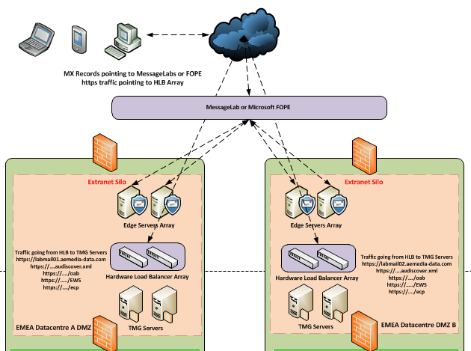

MX Record

MX Record | Cost | TTL
Cluster8.eu.messagelabs.com | 10 | 360
Cluster8a.eu.messagelabs.com | 20 | 360

Server List

Hostname | IP Address | Role | Site | OS
UKLAB1DCM01 | 10.10.139.50 | DC / GC / DNS | EMEA Datacentre A | Windows 2008 R2 SP1 SE
UKLAB1DCM02 | 10.10.139.51 | DC / GC / DNS | EMEA Datacentre A | Windows 2008 R2 SP1 SE
UKLAB2DCM01 | 10.10.193.200 | DC / GC / DNS | EMEA Datacentre B | Windows 2008 R2 SP1 SE
UKLAB2DCM02 | 10.10.193.201 | DC / GC / DNS | EMEA Datacentre B | Windows 2008 R2 SP1 SE
UKLAB1MBX01 | 10.10.193.10 – MAPI  10.10.193.70 - Replication | Mailbox – DAG A | EMEA Datacentre A | Windows 2008 R2 SP1 EE
UKLAB1MBX02 | 10.10.193.11 – MAPI  10.10.193.71 - Replication | Mailbox – DAG A | EMEA Datacentre A | Windows 2008 R2 SP1 EE
UKLAB2MBX03 | 10.10.192.142 – MAPI  10.10.192.202 - Replication | Mailbox – DAG A | EMEA Datacentre A | Windows 2008 R2 SP1 EE
UKLAB2MBX01 | 10.10.192.140 – MAPI  10.10.192.200 - Replication | Mailbox – DAG B | EMEA Datacentre B | Windows 2008 R2 SP1 EE
UKLAB2MBX02 | 10.10.192.141 – MAPI  10.10.192.201 - Replication | Mailbox – DAG B | EMEA Datacentre B | Windows 2008 R2 SP1 EE
UKLAB1MBX03 | 10.10.192.12 – MAPI  10.10.192.73 – Replication | Mailbox – DAG B | EMEA Datacentre B | Windows 2008 R2 SP1 EE
UKLAB2CAM01 | 10.10.139.35 | Certificate Services | EMEA Datacentre B | Windows 2008 R2 SP1 EE
UKLAB1CAS01 | 10.10.139.56 | CAS and Hub Role | EMEA Datacentre A | Windows 2008 R2 SP1 SE
UKLAB1CAS02 | 10.10.139.57 | CAS and Hub Role | EMEA Datacentre A | Windows 2008 R2 SP1 SE
UKLAB2CAS01 | 10.10.193.202 | CAS and Hub Role | EMEA Datacentre B | Windows 2008 R2 SP1 SE
UKLAB2CAS02 | 10.10.192.203 | CAS and Hub Role | EMEA Datacentre B | Windows 2008 R2 SP1 SE
UKLAB1EDG01 | 10.10.193.15 | Edge Transport | EMEA Datacentre A | Windows 2008 R2 SP1 SE
UKLAB1EDG02 | 10.10.193.16 | Edge Transport | EMEA Datacentre A | Windows 2008 R2 SP1 SE
UKLAB2EDG01 | 10.10.193.10 | Edge Transport | EMEA Datacentre B | Windows 2008 R2 SP1 SE
UKLAB2EDG02 | 10.10.193.11 | Edge Transport | EMEA Datacentre B | Windows 2008 R2 SP1 SE
UKLAB2TMG00 | 10.10.193.22 | Threat Management Gateway Management Node | EMEA Datacentre B | N/A
UKLAB1TMG01 | 10.10.193.17 – Internal  10.10.193.73 – External  10.10.193.142 – Heartbeat  10.10.193.23 | Threat Management Gateway | EMEA Datacentre A | Windows 2008 R2 SP1 EE
UKLAB1TMG02 | 10.10.193.18 – Internal  10.10.193.74 – External  10.10.193.143 – Heartbeat  10.10.193.23 | Threat Management Gateway | EMEA Datacentre A | Windows 2008 R2 SP1 EE
UKLAB2TMG01 | 10.10.193.12 – Internal  10.10.193.70 – External  10.10.193.140 – Heartbeat | Threat Management Gateway | EMEA Datacentre B | Windows 2008 R2 SP1 EE
UKLAB2TMG02 | 10.10.193.13 – Internal  10.10.193.71 – External  10.10.193.141 - Heartbeat | Threat Management Gateway | EMEA Datacentre B | Windows 2008 R2 SP1 EE
UKLAB1NLB01 | 10.10.193.19 | Load Balancer | EMEA Datacentre A | RiOS 6
UKLAB1NLB02 | 10.10.193.75 | Load Balancer | EMEA Datacentre A | RiOS 6
UKLAB2NLB01 | 10.10.193.14 | Load Balancer | EMEA Datacentre B | RiOS 6
UKLAB2NLB02 | 10.10.193.72 | Load Balancer | EMEA Datacentre B | RiOS 6
UKLAB1WS001 | 10.10.139.55 | Client Machine | EMEA Datacentre B | Windows 7
UKLAB1DCM01.dmzlab.loc | 10.10.193.22 | DC / GC / DNS | EMEA Datacentre B | Windows 2008 R2 SP1 SE
UKLAB2DCM01.dmzlab.loc | 10.10.193.20 | DC / GC / DNS | EMEA Datacentre B | Windows 2008 R2 SP1 SE

Specifications

Hostname | CPU / Core | RAM | NIC | Additional Storage
UKLAB1DCM01 | 1 vCPU | 2048 MB | 1 vNIC | 1 x 50GB VMDK  2 x 15GB VMDK
UKLAB1DCM02 | 1 vCPU | 2048 MB | 1 vNIC | 1 x 50GB VMDK  2 x 15GB VMDK
UKLAB2DCM01 | 1 vCPU | 2048 MB | 1 vNIC | 1 x 50GB VMDK  2 x 15GB VMDK
UKLAB2DCM02 | 1 vCPU | 2048 MB | 1 vNIC | 1 x 50GB VMDK  2 x 15GB VMDK
UKLAB1MBX01 | 2 vCPU | 4096 MB | 2 vNIC | 3 x 40GB VMDK
UKLAB1MBX02 | 2 vCPU | 4096 MB | 2 vNIC | 3 x 40GB VMDK
UKLAB2MBX03 | 2 vCPU | 4096 MB | 2 vNIC | 3 x 40GB VMDK
UKLAB2MBX01 | 2 vCPU | 4096 MB | 2 vNIC | 3 x 40GB VMDK
UKLAB2MBX02 | 2 vCPU | 4096 MB | 2 vNIC | 3 x 40GB VMDK
UKLAB1MBX03 | 2 vCPU | 4096 MB | 2 vNIC | 3 x 40GB VMDK
UKLAB2CAM01 | 2 vCPU | 4096 MB | 1 vNIC | 1 x 40GB VMDK
UKLAB1CAS01 | 2 vCPU | 4096 MB | 1 vNIC | 3 x 40GB VMDK
UKLAB1CAS02 | 2 vCPU | 4096 MB | 1 vNIC | 3 x 40GB VMDK
UKLAB2CAS01 | 2 vCPU | 4096 MB | 1 vNIC | 3 x 40GB VMDK
UKLAB2CAS02 | 2 vCPU | 4096 MB | 1 vNIC | 3 x 40GB VMDK
UKLAB1EDG01 | 2 vCPU | 4096 MB | 1 vNIC | 3 x 40GB VMDK
UKLAB1EDG02 | 2 vCPU | 4096 MB | 1 vNIC | 3 x 40GB VMDK
UKLAB2EDG01 | 2 vCPU | 4096 MB | 1 vNIC | 3 x 40GB VMDK
UKLAB2EDG02 | 2 vCPU | 4096 MB | 1 vNIC | 3 x 40GB VMDK
UKLAB1TMG01 | 2 vCPU | 4096 MB | 3 vNIC | 3 x 40GB VMDK
UKLAB1TMG02 | 2 vCPU | 4096 MB | 3 vNIC | 3 x 40GB VMDK
UKLAB2TMG00 | 2 vCPU | 4096 MB | 1 vNIC | 1 X 100GB VMDK
UKLAB2TMG01 | 2 vCPU | 4096 MB | 3 vNIC | 3 x 40GB VMDK
UKLAB2TMG02 | 2 vCPU | 4096 MB | 3 vNIC | 3 x 40GB VMDK
UKLAB1NLB01 | 1 vCPU | 2048 MB | 1 vNIC | 1 x 8GB VMDK
UKLAB1NLB02 | 1 vCPU | 2048 MB | 1 vNIC | 1 x 8GB VMDK
UKLAB2NLB01 | 1 vCPU | 2048 MB | 1 vNIC | 1 x 8GB VMDK
UKLAB2NLB02 | 1 vCPU | 2048 MB | 1 vNIC | 1 x 8GB VMDK
UKLAB1WS001 | 1 vCPU | 2048 MB | 1 vNIC | 1 x 40GB VMDK
UKLAB1DCM01.dmzlab.loc | 1 vCPU | 2048 MB | 1 vNIC | 1 x 50GB VMDK  2 x 15GB VMDK
UKLAB2dcm01.dmzlab.loc | 1 vCPU | 2048 MB | 1 vNIC | 1 x 50GB VMDK  2 x 15GB VMDK

Riverbed Stingray Load Balancers
The purpose of this testing environment is the build, configure, document and test of the Riverbed Stingray Load Balancers.

Forest / Domain Name: LAB.loc (Secure Server Farm 1 & 2) & DMZ (Extranet Silo)
External Namespace: aemedia-data.com

There is the following dependency for the Riverbed Stingray Load Balancer component testing:

- Virtual Machines (VM)
- Active Directory
- Exchange 2010
- Riverbed Stingray Load Balancers
- TMG 2010 SP2
- Windows XP / Client

Topology – Server Farm (SSF1)

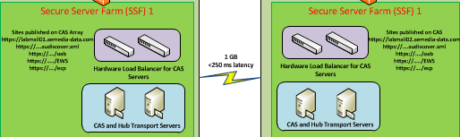

Servers

Hostname | IP Address | Role | Site | OS
UKLAB1DCM01 | 10.10.139.50 | DC / GC / DNS | EMEA Datacentre A | Windows 2008 R2 SP1 SE
UKLAB1DCM02 | 10.10.139.51 | DC / GC / DNS | EMEA Datacentre A | Windows 2008 R2 SP1 SE
UKLAB1DCM03 | 10.10.139.52 | DC / GC / DNS | EMEA Datacentre A | Windows 2003 R2 SE
UKLAB2DCM01 | 10.10.193.200 | DC / GC / DNS | EMEA Datacentre B | Windows 2008 R2 SP1 SE
UKLAB2DCM02 | 10.10.193.201 | DC / GC / DNS | EMEA Datacentre B | Windows 2008 R2 SP1 SE
UKLAB1MBX01 | 10.10.193.10 – MAPI  10.10.193.70 - Replication | Mailbox – DAG A | EMEA Datacentre A | Windows 2008 R2 SP1 EE
UKLAB1MBX02 | 10.10.193.11 – MAPI  10.10.193.71 - Replication | Mailbox – DAG A | EMEA Datacentre A | Windows 2008 R2 SP1 EE
UKLAB2MBX03 | 10.10.192.142 – MAPI  10.10.192.202 - Replication | Mailbox – DAG A | EMEA Datacentre A | Windows 2008 R2 SP1 EE
UKLAB2MBX01 | 10.10.192.140 – MAPI  10.10.192.200 - Replication | Mailbox – DAG B | EMEA Datacentre B | Windows 2008 R2 SP1 EE
UKLAB2MBX02 | 10.10.192.141 – MAPI  10.10.192.201 - Replication | Mailbox – DAG B | EMEA Datacentre B | Windows 2008 R2 SP1 EE
UKLAB1MBX03 | 10.10.192.12 – MAPI  10.10.192.73 – Replication | Mailbox – DAG B | EMEA Datacentre B | Windows 2008 R2 SP1 EE
UKLAB1CAS01 | 10.10.139.56 | CAS and Hub Role | EMEA Datacentre A | Windows 2008 R2 SP1 SE
UKLAB1CAS02 | 10.10.139.57 | CAS and Hub Role | EMEA Datacentre A | Windows 2008 R2 SP1 SE
UKLAB2CAS01 | 10.10.193.202 | CAS and Hub Role | EMEA Datacentre B | Windows 2008 R2 SP1 SE
UKLAB2CAS02 | 10.10.192.203 | CAS and Hub Role | EMEA Datacentre B | Windows 2008 R2 SP1 SE
UKLAB1NLB01 | 10.10.193.19 | Load Balancer | EMEA Datacentre A | RiOS 6
UKLAB2NLB01 | 10.10.193.14 | Load Balancer | EMEA Datacentre B | RiOS 6
UKLAB1WS001 | 10.10.139.55 | Client Machine | EMEA Datacentre B | Windows 7

Specification

Hostname | CPU / Core | RAM | NIC | Additional Storage
UKLAB1DCM01 | 1 vCPU | 2048 MB | 1 vNIC | 1 x 50GB VMDK  2 x 15GB VMDK
UKLAB1DCM02 | 1 vCPU | 2048 MB | 1 vNIC | 1 x 50GB VMDK  2 x 15GB VMDK
UKLAB1DCM03 | 1 vCPU | 2048 MB | 1 vNIC | 1 x 50GB VMDK  2 x 15GB VMDK
UKLAB2DCM01 | 1 vCPU | 2048 MB | 1 vNIC | 1 x 50GB VMDK  2 x 15GB VMDK
UKLAB2DCM02 | 1 vCPU | 2048 MB | 1 vNIC | 1 x 50GB VMDK  2 x 15GB VMDK
UKLAB1MBX01 | 2 vCPU | 4096 MB | 2 vNIC | 3 x 40GB VMDK
UKLAB1MBX02 | 2 vCPU | 4096 MB | 2 vNIC | 3 x 40GB VMDK
UKLAB2MBX03 | 2 vCPU | 4096 MB | 2 vNIC | 3 x 40GB VMDK
UKLAB2MBX01 | 2 vCPU | 4096 MB | 2 vNIC | 3 x 40GB VMDK
UKLAB2MBX02 | 2 vCPU | 4096 MB | 2 vNIC | 3 x 40GB VMDK
UKLAB1MBX03 | 2 vCPU | 4096 MB | 2 vNIC | 3 x 40GB VMDK
UKLAB1CAS01 | 2 vCPU | 4096 MB | 1 vNIC | 3 x 40GB VMDK
UKLAB1CAS02 | 2 vCPU | 4096 MB | 1 vNIC | 3 x 40GB VMDK
UKLAB2CAS01 | 2 vCPU | 4096 MB | 1 vNIC | 3 x 40GB VMDK
UKLAB2CAS02 | 2 vCPU | 4096 MB | 1 vNIC | 3 x 40GB VMDK
UKLAB1NLB01 | 1 vCPU | 2048 MB | 1 vNIC | 1 x 8GB VMDK
UKLAB2NLB01 | 1 vCPU | 2048 MB | 1 vNIC | 1 x 8GB VMDK
UKLAB1WS001 | 1 vCPU | 2048 MB | 1 vNIC | 1 x 40GB VMDK

Topology – Extranet Silo

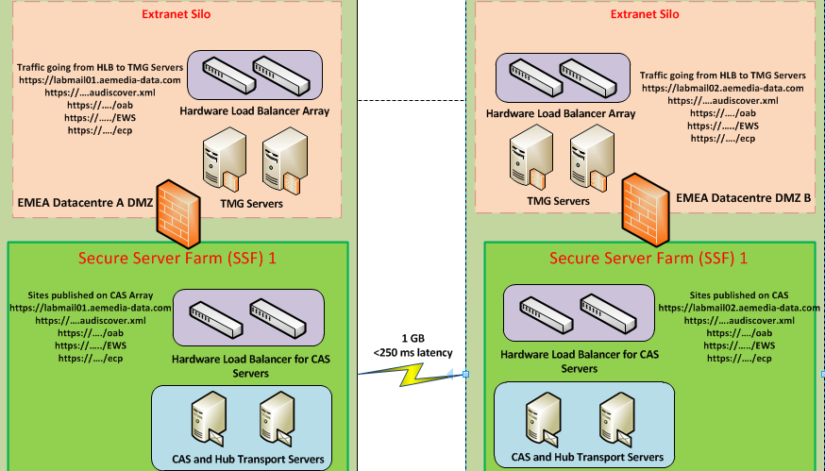

Servers

Hostname | IP Address | Role | Site | OS
UKLAB1DCM01 | 10.10.139.50 | DC / GC / DNS | EMEA Datacentre A | Windows 2008 R2 SP1 SE
UKLAB1DCM02 | 10.10.139.51 | DC / GC / DNS | EMEA Datacentre A | Windows 2008 R2 SP1 SE
UKLAB1DCM03 | 10.10.139.52 | DC / GC / DNS | EMEA Datacentre A | Windows 2008 R2 SP1 SE
UKLAB2DCM01 | 10.10.193.200 | DC / GC / DNS | EMEA Datacentre B | Windows 2008 R2 SP1 SE
UKLAB2DCM02 | 10.10.193.201 | DC / GC / DNS | EMEA Datacentre B | Windows 2008 R2 SP1 SE
UKLAB1MBX01 | 10.10.193.10 – MAPI  10.10.193.70 - Replication | Mailbox – DAG A | EMEA Datacentre A | Windows 2008 R2 SP1 EE
UKLAB1MBX02 | 10.10.193.11 – MAPI  10.10.193.71 - Replication | Mailbox – DAG A | EMEA Datacentre A | Windows 2008 R2 SP1 EE
UKLAB2MBX03 | 10.10.192.142 – MAPI  10.10.192.202 - Replication | Mailbox – DAG A | EMEA Datacentre A | Windows 2008 R2 SP1 EE
UKLAB2MBX01 | 10.10.192.140 – MAPI  10.10.192.200 - Replication | Mailbox – DAG B | EMEA Datacentre B | Windows 2008 R2 SP1 EE
UKLAB2MBX02 | 10.10.192.141 – MAPI  10.10.192.201 - Replication | Mailbox – DAG B | EMEA Datacentre B | Windows 2008 R2 SP1 EE
UKLAB1MBX03 | 10.10.192.12 – MAPI  10.10.192.73 – Replication | Mailbox – DAG B | EMEA Datacentre B | Windows 2008 R2 SP1 EE
UKLAB1CAS01 | 10.10.139.56 | CAS and Hub Role | EMEA Datacentre A | Windows 2008 R2 SP1 SE
UKLAB1CAS02 | 10.10.139.57 | CAS and Hub Role | EMEA Datacentre A | Windows 2008 R2 SP1 SE
UKLAB2CAS01 | 10.10.193.202 | CAS and Hub Role | EMEA Datacentre B | Windows 2008 R2 SP1 SE
UKLAB2CAS02 | 10.10.192.203 | CAS and Hub Role | EMEA Datacentre B | Windows 2008 R2 SP1 SE
UKLAB2TMG00 | 10.10.193.22 | Threat Management Gateway Management Node | EMEA Datacentre B | N/A
UKLAB1TMG01 | 10.10.193.17 – Internal  10.10.193.73 – External  10.10.193.142 – Heartbeat  10.10.193.23 | Threat Management Gateway | EMEA Datacentre A | Windows 2008 R2 SP1 EE
UKLAB1TMG02 | 10.10.193.18 – Internal  10.10.193.74 – External  10.10.193.143 – Heartbeat  10.10.193.23 | Threat Management Gateway | EMEA Datacentre A | Windows 2008 R2 SP1 EE
UKLAB2TMG01 | 10.10.193.12 – Internal  10.10.193.70 – External  10.10.193.140 – Heartbeat | Threat Management Gateway | EMEA Datacentre B | Windows 2008 R2 SP1 EE
UKLAB2TMG02 | 10.10.193.13 – Internal  10.10.193.71 – External  10.10.193.141 - Heartbeat | Threat Management Gateway | EMEA Datacentre B | Windows 2008 R2 SP1 EE
UKLAB1NLB02 | 10.10.193.75 | Load Balancer | EMEA Datacentre A | RiOS 6
UKLAB2NLB02 | 10.10.193.72 | Load Balancer | EMEA Datacentre B | RiOS 6
UKLAB1WS001 | 10.10.139.55 | Client Machine | EMEA Datacentre B | Windows 7
UKLAB1DCM01.dmzlab.loc | 10.10.193.22 | DC / GC / DNS | EMEA Datacentre B | Windows 2008 R2 SP1 SE
UKLAB2DCM01.dmzlab.loc | 10.10.193.20 | DC / GC / DNS | EMEA Datacentre B | Windows 2008 R2 SP1 SE

Specifications
Hostname | CPU / Core | RAM | NIC | Additional Storage
UKLAB1DCM01 | 1 vCPU | 2048 MB | 1 vNIC | 1 x 50GB VMDK  2 x 15GB VMDK
UKLAB1DCM02 | 1 vCPU | 2048 MB | 1 vNIC | 1 x 50GB VMDK  2 x 15GB VMDK
UKLAB1DCM03 | 1 vCPU | 2048 MB | 1 vNIC | 1 x 50GB VMDK  2 x 15GB VMDK
UKLAB2DCM01 | 1 vCPU | 2048 MB | 1 vNIC | 1 x 50GB VMDK  2 x 15GB VMDK
UKLAB2DCM02 | 1 vCPU | 2048 MB | 1 vNIC | 1 x 50GB VMDK  2 x 15GB VMDK
UKLAB1MBX01 | 2 vCPU | 4096 MB | 2 vNIC | 3 x 40GB VMDK
UKLAB1MBX02 | 2 vCPU | 4096 MB | 2 vNIC | 3 x 40GB VMDK
UKLAB2MBX03 | 2 vCPU | 4096 MB | 2 vNIC | 3 x 40GB VMDK
UKLAB2MBX01 | 2 vCPU | 4096 MB | 2 vNIC | 3 x 40GB VMDK
UKLAB2MBX02 | 2 vCPU | 4096 MB | 2 vNIC | 3 x 40GB VMDK
UKLAB1MBX03 | 2 vCPU | 4096 MB | 2 vNIC | 3 x 40GB VMDK
UKLAB1CAS01 | 2 vCPU | 4096 MB | 1 vNIC | 3 x 40GB VMDK
UKLAB1CAS02 | 2 vCPU | 4096 MB | 1 vNIC | 3 x 40GB VMDK
UKLAB2CAS01 | 2 vCPU | 4096 MB | 1 vNIC | 3 x 40GB VMDK
UKLAB2CAS02 | 2 vCPU | 4096 MB | 1 vNIC | 3 x 40GB VMDK
UKLAB1TMG01 | 2 vCPU | 4096 MB | 3 vNIC | 3 x 40GB VMDK
UKLAB1TMG02 | 2 vCPU | 4096 MB | 3 vNIC | 3 x 40GB VMDK
UKLAB2TMG00 | 2 vCPU | 4096 MB | 1 vNIC | 1 X 100GB VMDK
UKLAB2TMG01 | 2 vCPU | 4096 MB | 3 vNIC | 3 x 40GB VMDK
UKLAB2TMG02 | 2 vCPU | 4096 MB | 3 vNIC | 3 x 40GB VMDK
UKLAB1NLB02 | 1 vCPU | 2048 MB | 1 vNIC | 1 x 8GB VMDK
UKLAB2NLB02 | 1 vCPU | 2048 MB | 1 vNIC | 1 x 8GB VMDK
UKLAB1WS001 | 1 vCPU | 2048 MB | 1 vNIC | 1 x 40GB VMDK
UKLAB1DCM01.dmzlab.loc | 1 vCPU | 2048 MB | 1 vNIC | 1 x 50GB VMDK  2 x 15GB VMDK
UKLAB2dcm01.dmzlab.loc | 1 vCPU | 2048 MB | 1 vNIC | 1 x 50GB VMDK  2 x 15GB VMDK

Configuration – Server Farm (SSF1)

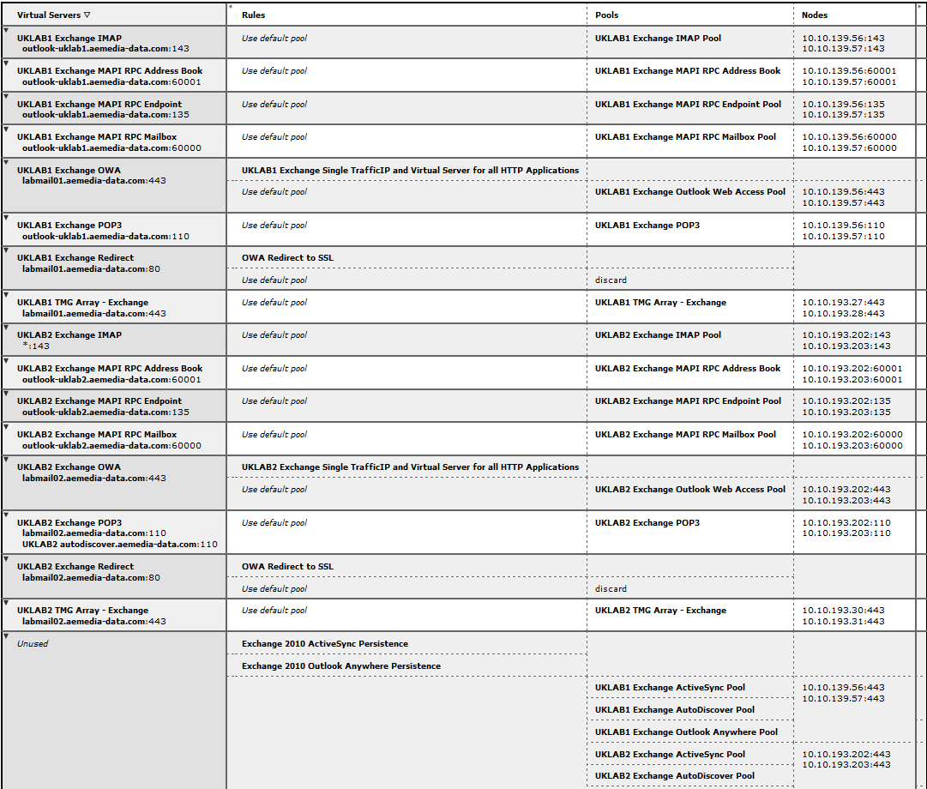

Although under the Unused Virtual Servers - Pools policy it shows UKLAB1 / UKLAB2 Exchange 2010 ActiveSync, AutoDiscover and Outlook Anywhere these are actually confirmed as part of the following 2 policies:
UKLAB1 Exchange OWA
UKLAB2 Exchange OWA

Configuration – Extranet Silo
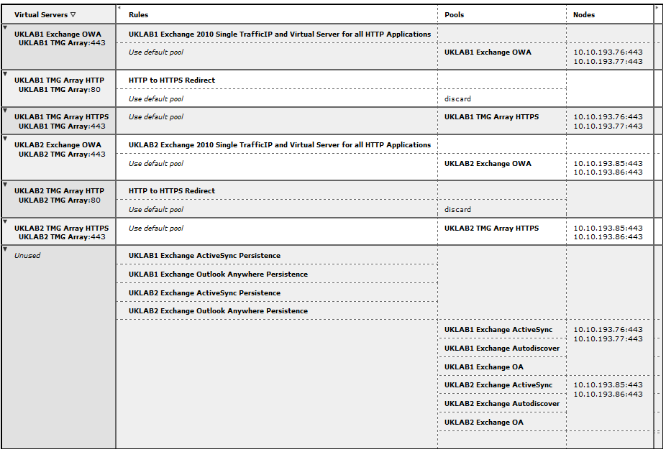
The load balancers in the Extranet Silo are responsible for load balancing the TMG servers.

Threat Management Gateway
The purpose of this testing environment is the build, configure, document and test of the Threat Management Gateway Servers.

Forest / Domain Name: LAB.loc (Secure Server Farm 1 & 2) & DMZ (Extranet Silo)
External Namespace: aemedia-data.com

There is the following dependency for the Threat Management Gateway component testing:

- Virtual Machines (VM)
- Active Directory
- Exchange 2010
- Riverbed Stingray Load Balancers
- TMG 2010 SP2
- Windows XP / Client

Topology

The diagram below represents the test lab architecture required for Threat Management Gateway Servers. These are load balanced by the Riverbed Stingrays in the Extranet Silo.

Please Note: The CAS/ HUB, Mailbox and Internal Load Balancers are also part of this topology and can be viewed in Client Access Topology architecture diagram.

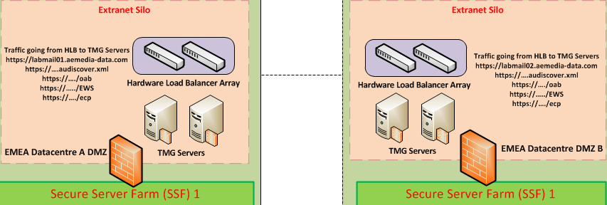

Servers

Hostname | IP Address | Role | Site | OS
UKLAB1DCM01 | 10.10.139.50 | DC / GC / DNS | EMEA Datacentre A | Windows 2008 R2 SP1 SE
UKLAB1DCM02 | 10.10.139.51 | DC / GC / DNS | EMEA Datacentre A | Windows 2008 R2 SP1 SE
UKLAB1DCM03 | 10.10.139.52 | DC / GC / DNS | EMEA Datacentre A | Windows 2008 R2 SP1 SE
UKLAB2DCM01 | 10.10.193.200 | DC / GC / DNS | EMEA Datacentre B | Windows 2008 R2 SP1 SE
UKLAB2DCM02 | 10.10.193.201 | DC / GC / DNS | EMEA Datacentre B | Windows 2008 R2 SP1 SE
UKLAB1MBX01 | 10.10.193.10 – MAPI  10.10.193.70 - Replication | Mailbox – DAG A | EMEA Datacentre A | Windows 2008 R2 SP1 EE
UKLAB1MBX02 | 10.10.193.11 – MAPI  10.10.193.71 - Replication | Mailbox – DAG A | EMEA Datacentre A | Windows 2008 R2 SP1 EE
UKLAB2MBX03 | 10.10.192.142 – MAPI  10.10.192.202 - Replication | Mailbox – DAG A | EMEA Datacentre A | Windows 2008 R2 SP1 EE
UKLAB2MBX01 | 10.10.192.140 – MAPI  10.10.192.200 - Replication | Mailbox – DAG B | EMEA Datacentre B | Windows 2008 R2 SP1 EE
UKLAB2MBX02 | 10.10.192.141 – MAPI  10.10.192.201 - Replication | Mailbox – DAG B | EMEA Datacentre B | Windows 2008 R2 SP1 EE
UKLAB1MBX03 | 10.10.192.12 – MAPI  10.10.192.73 – Replication | Mailbox – DAG B | EMEA Datacentre B | Windows 2008 R2 SP1 EE
UKLAB1CAS01 | 10.10.139.56 | CAS and Hub Role | EMEA Datacentre A | Windows 2008 R2 SP1 SE
UKLAB1CAS02 | 10.10.139.57 | CAS and Hub Role | EMEA Datacentre A | Windows 2008 R2 SP1 SE
UKLAB2CAS01 | 10.10.193.202 | CAS and Hub Role | EMEA Datacentre B | Windows 2008 R2 SP1 SE
UKLAB2CAS02 | 10.10.192.203 | CAS and Hub Role | EMEA Datacentre B | Windows 2008 R2 SP1 SE
UKLAB2TMG00 | 10.10.193.22 | Threat Management Gateway Management Node | EMEA Datacentre B | N/A
UKLAB1TMG01 | 10.10.193.17 – Internal  10.10.193.73 – External  10.10.193.142 – Heartbeat  10.10.193.23 | Threat Management Gateway | EMEA Datacentre A | Windows 2008 R2 SP1 EE
UKLAB1TMG02 | 10.10.193.18 – Internal  10.10.193.74 – External  10.10.193.143 – Heartbeat  10.10.193.23 | Threat Management Gateway | EMEA Datacentre A | Windows 2008 R2 SP1 EE
UKLAB2TMG01 | 10.10.193.12 – Internal  10.10.193.70 – External  10.10.193.140 – Heartbeat | Threat Management Gateway | EMEA Datacentre B | Windows 2008 R2 SP1 EE
UKLAB2TMG02 | 10.10.193.13 – Internal  10.10.193.71 – External  10.10.193.141 - Heartbeat | Threat Management Gateway | EMEA Datacentre B | Windows 2008 R2 SP1 EE
UKLAB1NLB02 | 10.10.193.75 | Load Balancer | EMEA Datacentre A | RiOS 6
UKLAB2NLB02 | 10.10.193.72 | Load Balancer | EMEA Datacentre B | RiOS 6
UKLAB1WS001 | 10.10.139.55 | Client Machine | EMEA Datacentre B | Windows 7
UKLAB1DCM01.dmzlab.loc | 10.10.193.22 | DC / GC / DNS | EMEA Datacentre B | Windows 2008 R2 SP1 SE
UKLAB2DCM01.dmzlab.loc | 10.10.193.20 | DC / GC / DNS | EMEA Datacentre B | Windows 2008 R2 SP1 SE

Specifications

Hostname | CPU / Core | RAM | NIC | Additional Storage
UKLAB1DCM01 | 1 vCPU | 2048 MB | 1 vNIC | 1 x 50GB VMDK  2 x 15GB VMDK
UKLAB1DCM02 | 1 vCPU | 2048 MB | 1 vNIC | 1 x 50GB VMDK  2 x 15GB VMDK
UKLAB1DCM03 | 1 vCPU | 2048 MB | 1 vNIC | 1 x 50GB VMDK  2 x 15GB VMDK
UKLAB2DCM01 | 1 vCPU | 2048 MB | 1 vNIC | 1 x 50GB VMDK  2 x 15GB VMDK
UKLAB2DCM02 | 1 vCPU | 2048 MB | 1 vNIC | 1 x 50GB VMDK  2 x 15GB VMDK
UKLAB1MBX01 | 2 vCPU | 4096 MB | 2 vNIC | 3 x 40GB VMDK
UKLAB1MBX02 | 2 vCPU | 4096 MB | 2 vNIC | 3 x 40GB VMDK
UKLAB2MBX03 | 2 vCPU | 4096 MB | 2 vNIC | 3 x 40GB VMDK
UKLAB2MBX01 | 2 vCPU | 4096 MB | 2 vNIC | 3 x 40GB VMDK
UKLAB2MBX02 | 2 vCPU | 4096 MB | 2 vNIC | 3 x 40GB VMDK
UKLAB1MBX03 | 2 vCPU | 4096 MB | 2 vNIC | 3 x 40GB VMDK
UKLAB1CAS01 | 2 vCPU | 4096 MB | 1 vNIC | 3 x 40GB VMDK
UKLAB1CAS02 | 2 vCPU | 4096 MB | 1 vNIC | 3 x 40GB VMDK
UKLAB2CAS01 | 2 vCPU | 4096 MB | 1 vNIC | 3 x 40GB VMDK
UKLAB2CAS02 | 2 vCPU | 4096 MB | 1 vNIC | 3 x 40GB VMDK
UKLAB1TMG01 | 2 vCPU | 4096 MB | 3 vNIC | 3 x 40GB VMDK
UKLAB1TMG02 | 2 vCPU | 4096 MB | 3 vNIC | 3 x 40GB VMDK
UKLAB2TMG00 | 2 vCPU | 4096 MB | 1 vNIC | 1 X 100GB VMDK
UKLAB2TMG01 | 2 vCPU | 4096 MB | 3 vNIC | 3 x 40GB VMDK
UKLAB2TMG02 | 2 vCPU | 4096 MB | 3 vNIC | 3 x 40GB VMDK
UKLAB1NLB02 | 1 vCPU | 2048 MB | 1 vNIC | 1 x 8GB VMDK
UKLAB2NLB02 | 1 vCPU | 2048 MB | 1 vNIC | 1 x 8GB VMDK
UKLAB1WS001 | 1 vCPU | 2048 MB | 1 vNIC | 1 x 40GB VMDK
UKLAB1DCM01.dmzlab.loc | 1 vCPU | 2048 MB | 1 vNIC | 1 x 50GB VMDK  2 x 15GB VMDK
UKLAB2dcm01.dmzlab.loc | 1 vCPU | 2048 MB | 1 vNIC | 1 x 50GB VMDK  2 x 15GB VMDK

Configuration

UKLAB1

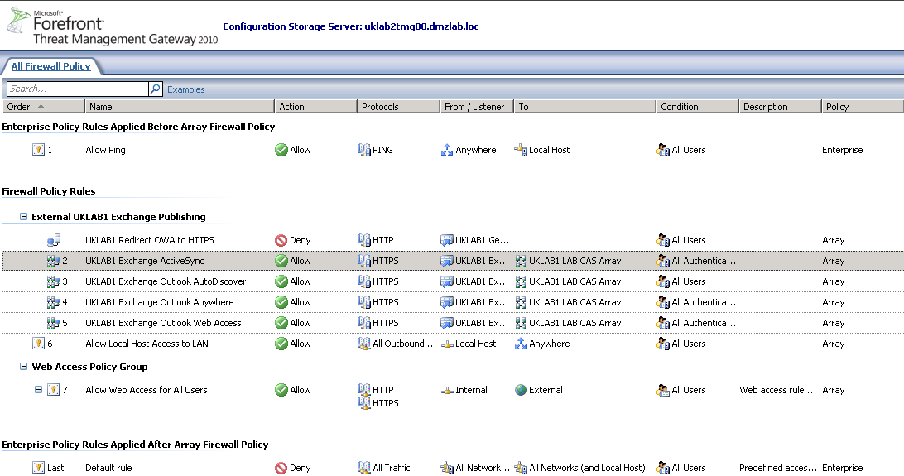

UKLAB2

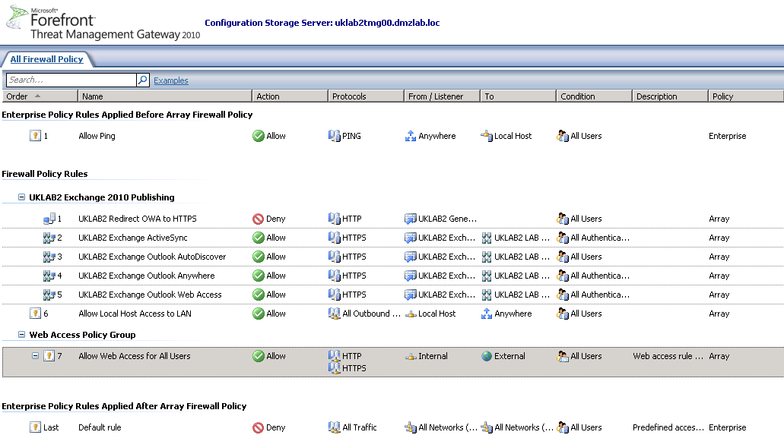

Blackberry
The purpose of this testing environment is the build, configure, document and test of Blackberry.

Forest / Domain Name: LAB.loc (Secure Server Farm 1 & 2)
External Namespace: aemedia-data.com

There is the following dependency for the Blackberry component testing:

- Virtual Machines (VM)
- Active Directory
- Exchange 2010
- Exchange 2003
- Blackberry Express Server
- Blackberry

Topology

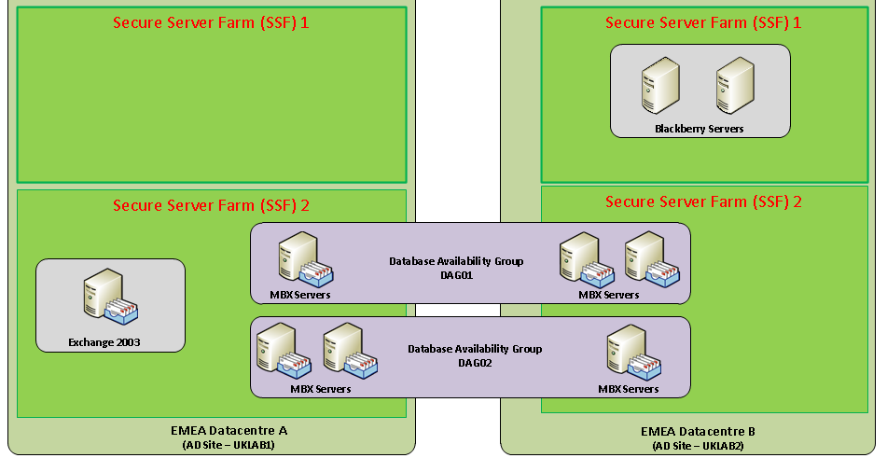

Servers

Hostname | IP Address | Role | Site | OS
UKLAB1DCM01 | 10.10.139.50 | DC / GC / DNS | EMEA Datacentre A | Windows 2008 R2 SP1 SE
UKLAB1DCM02 | 10.10.139.51 | DC / GC / DNS | EMEA Datacentre A | Windows 2008 R2 SP1 SE
UKLAB1DCM03 | 10.10.139.52 | DC / GC / DNS | EMEA Datacentre A | Windows 2008 R2 SP1 SE
UKLAB2DCM01 | 10.10.193.200 | DC / GC / DNS | EMEA Datacentre B | Windows 2008 R2 SP1 SE
UKLAB2DCM02 | 10.10.193.201 | DC / GC / DNS | EMEA Datacentre B | Windows 2008 R2 SP1 SE
UKLAB1MBX01 | 10.10.193.10 – MAPI  10.10.193.70 - Replication | Mailbox – DAG A | EMEA Datacentre A | Windows 2008 R2 SP1 EE
UKLAB1MBX02 | 10.10.193.11 – MAPI  10.10.193.71 - Replication | Mailbox – DAG A | EMEA Datacentre A | Windows 2008 R2 SP1 EE
UKLAB2MBX03 | 10.10.192.142 – MAPI  10.10.192.202 - Replication | Mailbox – DAG A | EMEA Datacentre A | Windows 2008 R2 SP1 EE
UKLAB2MBX01 | 10.10.192.140 – MAPI  10.10.192.200 - Replication | Mailbox – DAG B | EMEA Datacentre B | Windows 2008 R2 SP1 EE
UKLAB2MBX02 | 10.10.192.141 – MAPI  10.10.192.201 - Replication | Mailbox – DAG B | EMEA Datacentre B | Windows 2008 R2 SP1 EE
UKLAB1MBX03 | 10.10.192.12 – MAPI  10.10.192.73 – Replication | Mailbox – DAG B | EMEA Datacentre B | Windows 2008 R2 SP1 EE
UKLAB1EXM01 | 10.10.139.54 | Exchange 2003 Mailbox | EMEA Datacentre A | Windows 2003 R2 SE
UKLAB2BEM01 | Internal - 10.10.193.205 | Blackberry Enterprise Server | EMEA Datacentre B | Windows 2008 R2 SP1 SE
UKLAB2BEM02 | Internal - 10.10.193.206 | Blackberry Enterprise Server | EMEA Datacentre B | Windows 2008 R2 SP1 SE

Specification

Hostname | CPU / Core | RAM | NIC | Additional Storage
UKLAB1DCM01 | 1 vCPU | 2048 MB | 1 vNIC | 1 x 50GB VMDK  2 x 15GB VMDK
UKLAB1DCM02 | 1 vCPU | 2048 MB | 1 vNIC | 1 x 50GB VMDK  2 x 15GB VMDK
UKLAB1DCM03 | 1 vCPU | 2048 MB | 1 vNIC | 1 x 50GB VMDK  2 x 15GB VMDK
UKLAB2DCM01 | 1 vCPU | 2048 MB | 1 vNIC | 1 x 50GB VMDK  2 x 15GB VMDK
UKLAB2DCM02 | 1 vCPU | 2048 MB | 1 vNIC | 1 x 50GB VMDK  2 x 15GB VMDK
UKLAB1MBX01 | 2 vCPU | 4096 MB | 2 vNIC | 3 x 40GB VMDK
UKLAB1MBX02 | 2 vCPU | 4096 MB | 2 vNIC | 3 x 40GB VMDK
UKLAB2MBX03 | 2 vCPU | 4096 MB | 2 vNIC | 3 x 40GB VMDK
UKLAB2MBX01 | 2 vCPU | 4096 MB | 2 vNIC | 3 x 40GB VMDK
UKLAB2MBX02 | 2 vCPU | 4096 MB | 2 vNIC | 3 x 40GB VMDK
UKLAB1MBX03 | 2 vCPU | 4096 MB | 2 vNIC | 3 x 40GB VMDK
UKLAB1EXM01 | 1 vCPU | 2048 MB | 1 vNIC | 1 x 24GB VMDK  2 X 50GB VMDK  1 x 10GB VMDK  1 x 100GB VMDK
UKLAB2BEM01 | 1 vCPU | 2048 MB | 1 vNIC | 1 x 100GB VMDK
UKLAB2BEM02 | 1 vCPU | 2048 MB | 1 vNIC | 1 x 100GB VMDK

Implementation

http://docs.blackberry.com/en/admin/deliverables/25746/BlackBerry_Enterprise_Server_for_Microsoft_Exchange-Installation_and_Configuration_Guide--1301066-0310115318-001-5.0.3-US.pdf

Storage Performance Testing
The purpose of this testing environment is the build, configure, document and test the storage performance.

Forest / Domain Name: LAB.loc (Secure Server Farm 1 & 2)
External Namespace: aemedia-data.com
There is the following dependence for the storage test environment:
- Cisco UCS Servers
- NetApp SAN Storage
- Jetstress 2010

The following items will not be tested during the Storage Performance test phase as we don’t have the necessary infrastructure, but will be tested subsequently as part of the production installation and signed off before the pilot phase.

- Storage Performance
- Jetstress 2010

Backup Performance Testing
The purpose of this testing environment is the build, configure, document and test the backup performance.

Forest / Domain Name: LAB.loc (Secure Server Farm 1 & 2)
External Namespace: aemedia-data.com
There is the following dependence for the storage test environment:
- Cisco UCS Servers
- NetApp SAN Storage
- Backup Server
- Netbackup
- Tape Library

The following items will not be tested during the Backup Performance test phase as we don’t have the necessary infrastructure and this is being managed by Tata Consultancy Services (TCS). This will be tested subsequently as part of the production installation and signed off before the pilot phase.

- Tape Backup Performance
- NetApp Snap Vault Performance
- Restoration from Tape Performance
- Restoration from NetApp Vault Mirror Performance

Coexistence / Migration & End to End Testing
The purpose of this testing environment is the build, configure, document and test co-existence and migration process processes and procedures.

Forest / Domain Name: LAB.loc (Secure Server Farm 1 & 2) & DMZ (Extranet Silo)
External Namespace: aemedia-data.com

There is the following dependency for this component testing:
- Virtual Machines (VM)
- Active Directory
- Certificate Services (2008 R2 Only)
- Exchange 2010
- Exchange 2003
- TMG 2010 SP2
- Riverbed Stingray Version 8.1R1Load Balancers
- XP Client with Office 2007, IE9, Firefox, Safari, Chrome
- XP Client with Office 2010, IE9, Firefox, Safari, Chrome
- Windows 7 Client with Office 2007, IE9, Firefox, Safari, Chrome
- Windows 7 Client with Office 2010, IE9, Firefox, Safari, Chrome
- MAC with Office 2011, Safari, Firefox, Chrome
- MAC with Entourage 2008, Safari, Firefox, Chrome
- Firewall
- E2E Messaging Migration Tool
- Blackberry
- ActiveSync Devices - iPhone / iPad / Android / Symbian / Windows

Topology

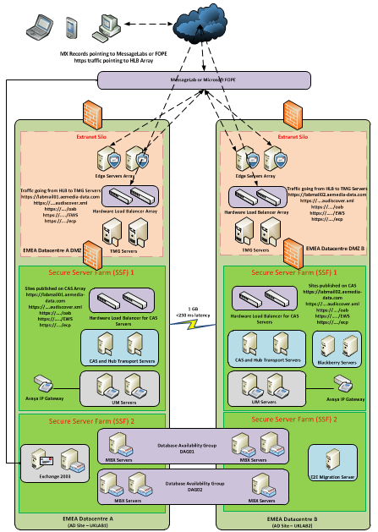

Servers

Hostname | IP Address | Role | Site | OS
UKLAB1DCM01 | 10.10.139.50 | DC / GC / DNS | EMEA Datacentre A | Windows 2008 R2 SP1 SE
UKLAB1DCM02 | 10.10.139.51 | DC / GC / DNS | EMEA Datacentre A | Windows 2008 R2 SP1 SE
UKLAB2DCM01 | 10.10.193.200 | DC / GC / DNS | EMEA Datacentre B | Windows 2008 R2 SP1 SE
UKLAB2DCM02 | 10.10.193.201 | DC / GC / DNS | EMEA Datacentre B | Windows 2008 R2 SP1 SE
UKLAB1MBX01 | 10.10.192.10 – MAPI  10.10.192.70 - Replication | Mailbox – DAG A | EMEA Datacentre A | Windows 2008 R2 SP1 EE
UKLAB1MBX02 | 10.10.192.11 – MAPI  10.10.192.71 - Replication | Mailbox – DAG A | EMEA Datacentre A | Windows 2008 R2 SP1 EE
UKLAB2MBX03 | 10.10.192.142 – MAPI  10.10.192.202 - Replication | Mailbox – DAG A | EMEA Datacentre A | Windows 2008 R2 SP1 EE
DAG01 | 10.10.192.13 | DAG
UKLAB2MBX01 | 10.10.192.140 – MAPI  10.10.192.200 - Replication | Mailbox – DAG B | EMEA Datacentre B | Windows 2008 R2 SP1 EE
UKLAB2MBX02 | 10.10.192.141 – MAPI  10.10.192.201 - Replication | Mailbox – DAG B | EMEA Datacentre B | Windows 2008 R2 SP1 EE
UKLAB1MBX03 | 10.10.192.12 – MAPI  10.10.192.73 – Replication | Mailbox – DAG B | EMEA Datacentre B | Windows 2008 R2 SP1 EE
DAG02 | 10.10.192.143 | DAG
UKLAB2CAM01 | 10.10.139.35 | Certificate Services | EMEA Datacentre B | Windows 2008 R2 SP1 EE
UKLAB1CAS01 | 10.10.139.56 | CAS and Hub Role | EMEA Datacentre A | Windows 2008 R2 SP1 SE
UKLAB1CAS02 | 10.10.139.57 | CAS and Hub Role | EMEA Datacentre A | Windows 2008 R2 SP1 SE
UKLAB2CAS01 | 10.10.193.202 | CAS and Hub Role | EMEA Datacentre B | Windows 2008 R2 SP1 SE
UKLAB2CAS02 | 10.10.192.203 | CAS and Hub Role | EMEA Datacentre B | Windows 2008 R2 SP1 SE
UKLAB1EDG01 | 10.10.193.15 | Edge Transport | EMEA Datacentre A | Windows 2008 R2 SP1 SE
UKLAB1EDG02 | 10.10.193.16 | Edge Transport | EMEA Datacentre A | Windows 2008 R2 SP1 SE
UKLAB2EDG01 | 10.10.193.10 | Edge Transport | EMEA Datacentre B | Windows 2008 R2 SP1 SE
UKLAB2EDG02 | 10.10.193.11 | Edge Transport | EMEA Datacentre B | Windows 2008 R2 SP1 SE
UKLAB2TMG00 | 10.10.193.22 | Threat Management Gateway Management Node | EMEA Datacentre B | N/A
UKLAB1TMG01 | 10.10.193.17 – Internal  10.10.193.73 – External  10.10.193.142 – Heartbeat  10.10.193.23 | Threat Management Gateway | EMEA Datacentre A | Windows 2008 R2 SP1 EE
UKLAB1TMG02 | 10.10.193.18 – Internal  10.10.193.74 – External  10.10.193.143 – Heartbeat  10.10.193.23 | Threat Management Gateway | EMEA Datacentre A | Windows 2008 R2 SP1 EE
UKLAB2TMG01 | 10.10.193.12 – Internal  10.10.193.70 – External  10.10.193.140 – Heartbeat | Threat Management Gateway | EMEA Datacentre B | Windows 2008 R2 SP1 EE
UKLAB2TMG02 | 10.10.193.13 – Internal  10.10.193.71 – External  10.10.193.141 - Heartbeat | Threat Management Gateway | EMEA Datacentre B | Windows 2008 R2 SP1 EE
UKLAB1NLB01 | 10.10.193.19 | Load Balancer | EMEA Datacentre A | RiOS 6
UKLAB1NLB02 | 10.10.193.75 | Load Balancer | EMEA Datacentre A | RiOS 6
UKLAB2NLB01 | 10.10.193.14 | Load Balancer | EMEA Datacentre B | RiOS 6
UKLAB2NLB02 | 10.10.193.72 | Load Balancer | EMEA Datacentre B | RiOS 6
UKLAB1BHM01 | 10.10.139.53 | Exchange 2003 Bridgehead | EMEA Datacentre A | Windows 2003 R2 SE
UKLAB1EXM01 | 10.10.139.54 | Exchange 2003 Mailbox | EMEA Datacentre A | Windows 2003 R2 SE
UKLAB2BEM01 | 10.10.193.205 | Blackberry Enterprise Server | EMEA Datacentre B | Windows 2008 R2 SP1 SE
UKLAB2BEM02 | 10.10.193.206 | Blackberry Enterprise Server | EMEA Datacentre B | Windows 2008 R2 SP1 SE
UKLAB2MGM01 | 10.10.193.204 | E2E Migration Server | EMEA Datacentre B | Windows 2008 R2 SP1 SE
UKLAB1DCM01.dmzlab.loc | 10.10.193.22 | DC / GC / DNS | EMEA Datacentre B | Windows 2008 R2 SP1 SE
UKLAB2DCM01.dmzlab.loc | 10.10.193.20 | DC / GC / DNS | EMEA Datacentre B | Windows 2008 R2 SP1 SE

Client

Name | OS | Client Components
UKLAB1WS001 | Windows 7 | Outlook 2007 | IE9 | Firefox 13.x | Safari 5.x | Chrome 19.x
UKLAB1WS002 | Windows XP | Outlook 2007 | IE9 | Firefox 13.x | Safari 5.x | Chrome 19.x
UKLAB1WS003 | MAC (Lion) | Entourage 2008 |  | Firefox 13.x | Safari 5.x | Chrome 19.x
UKLAB1WS004 | MAC (Snow Leopard) | Entourage 2008 |  | Firefox 13.x | Safari 5.x | Chrome 19.x
UKLAB1WS005 | Windows 7 | Outlook 2010 | IE9 | Firefox 13.x | Safari 5.x | Chrome 19.x
UKLAB1WS006 | Windows XP | Outlook 2010 | IE9 | Firefox 13.x | Safari 5.x | Chrome 19.x
UKLAB1WS007 | MAC (Snow Leopard) | Outlook 2011 |  | Firefox 13.x | Safari 5.x | Chrome 19.x
UKLAB1WS008 | MAC( Lion) | Outlook 2011 |  | Firefox 13.x | Safari 5.x | Chrome 19.x

Specification

Hostname | CPU / Core | RAM | NIC | Additional Storage
UKLAB1DCM01 | 1 vCPU | 2048 MB | 1 vNIC | 1 x 50GB VMDK  2 x 15GB VMDK
UKLAB1DCM02 | 1 vCPU | 2048 MB | 1 vNIC | 1 x 50GB VMDK  2 x 15GB VMDK
UKLAB2DCM01 | 1 vCPU | 2048 MB | 1 vNIC | 1 x 50GB VMDK  2 x 15GB VMDK
UKLAB2DCM02 | 1 vCPU | 2048 MB | 1 vNIC | 1 x 50GB VMDK  2 x 15GB VMDK
UKLAB1MBX01 | 2 vCPU | 4096 MB | 2 vNIC | 3 x 40GB VMDK
UKLAB1MBX02 | 2 vCPU | 4096 MB | 2 vNIC | 3 x 40GB VMDK
UKLAB2MBX03 | 2 vCPU | 4096 MB | 2 vNIC | 3 x 40GB VMDK
UKLAB2MBX01 | 2 vCPU | 4096 MB | 2 vNIC | 3 x 40GB VMDK
UKLAB2MBX02 | 2 vCPU | 4096 MB | 2 vNIC | 3 x 40GB VMDK
UKLAB1MBX03 | 2 vCPU | 4096 MB | 2 vNIC | 3 x 40GB VMDK
UKLAB2CAM01 | 2 vCPU | 4096 MB | 1 vNIC | 1 x 40GB VMDK
UKLAB1CAS01 | 2 vCPU | 4096 MB | 1 vNIC | 3 x 40GB VMDK
UKLAB1CAS02 | 2 vCPU | 4096 MB | 1 vNIC | 3 x 40GB VMDK
UKLAB2CAS01 | 2 vCPU | 4096 MB | 1 vNIC | 3 x 40GB VMDK
UKLAB2CAS02 | 2 vCPU | 4096 MB | 1 vNIC | 3 x 40GB VMDK
UKLAB1EDG01 | 2 vCPU | 4096 MB | 1 vNIC | 3 x 40GB VMDK
UKLAB1EDG02 | 2 vCPU | 4096 MB | 1 vNIC | 3 x 40GB VMDK
UKLAB2EDG01 | 2 vCPU | 4096 MB | 1 vNIC | 3 x 40GB VMDK
UKLAB2EDG02 | 2 vCPU | 4096 MB | 1 vNIC | 3 x 40GB VMDK
UKLAB1TMG01 | 2 vCPU | 4096 MB | 3 vNIC | 3 x 40GB VMDK
UKLAB1TMG02 | 2 vCPU | 4096 MB | 3 vNIC | 3 x 40GB VMDK
UKLAB2TMG00 | 2 vCPU | 4096 MB | 1 vNIC | 1 X 100GB VMDK
UKLAB2TMG01 | 2 vCPU | 4096 MB | 3 vNIC | 3 x 40GB VMDK
UKLAB2TMG02 | 2 vCPU | 4096 MB | 3 vNIC | 3 x 40GB VMDK
UKLAB1NLB01 | 1 vCPU | 2048 MB | 1 vNIC | 1 x 8GB VMDK
UKLAB1NLB02 | 1 vCPU | 2048 MB | 1 vNIC | 1 x 8GB VMDK
UKLAB2NLB01 | 1 vCPU | 2048 MB | 1 vNIC | 1 x 8GB VMDK
UKLAB2NLB02 | 1 vCPU | 2048 MB | 1 vNIC | 1 x 8GB VMDK
UKLAB1EXM01 | 1 vCPU | 2048 MB | 1 vNIC | 1 x 20GB VMDK  1 x 100GB VMDK
UKLAB1BHM01 | 2 vCPU | 4096 MB | 1 vNIC | 1 x 24GB VMDK  2 X 50GB VMDK  1 x 10GB VMDK  1 x 100GB VMDK
UKLAB2BEM01 | 1 vCPU | 2048 MB | 1 vNIC | 1 x 100GB VMDK
UKLAB2BEM02 | 1 vCPU | 2048 MB | 1 vNIC | 1 x 100GB VMDK
UKLAB2MGM01 | 1 vCPU | 2048 MB | 1 vNIC | 1 x 100GB VMDK
UKLAB1DCM01.dmzlab.loc | 1 vCPU | 2048 MB | 1 vNIC | 1 x 50GB VMDK  2 x 15GB VMDK
UKLAB2dcm01.dmzlab.loc | 1 vCPU | 2048 MB | 1 vNIC | 1 x 50GB VMDK  2 x 15GB VMDK

Mail Routing

Internal E-Mail will route between the Exchange 2010 connectors within each respective Administrative Group.

E-Mail sent to an external user from a client using Exchange 2010 will route via the Exchange 2010 to the connector G-GLOBAL-H-LON then outbound to Symantec.Cloud.

E-Mail sent to an external user from a client using the Exchange 2003 will route directly out via the connector G-GLOBAL-H-LON to Symantec.Cloud.

Incoming E-Mail destined for a user on Exchange 2010 will route to G-GLOBAL-H-LON then through the Exchange 2010 connector to the user’s mailbox.

Incoming E-Mail destined for a user on Exchange 2003 will route through G-GLOBAL-H-LON then to the user’s mailbox.

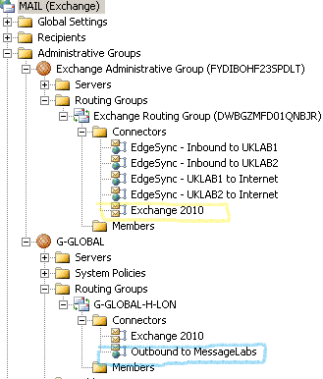

Network
This section highlights the VLANs that have been used for the different components on the testing environment.

VLANS
The VLANS are stretched between EMEA Datacentre A and B.
VLAN ID | IP Subnet | Default Gateway | Component
VLAN 2 | 10.10.128.0/20 | 10.10.128.60 | EMEA Datacentre A – DC / DNS / Exchange 2003 / Exchange 2010 CAS & HT / Clients
VLAN 240 | 10.10.192.0/26 | 10.10.192.1 | EMEA Datacentre A – Exchange 2010 Mailbox MAPI
VLAN 241 | 10.10.192.64/26 | 10.10.192.65 | EMEA Datacentre A – Exchange 2010 Mailbox Replication
VLAN 242 | 10.10.192.128/26 | 10.10.192.129 | EMEA Datacentre B – Exchange 2010 Mailbox MAPI
VLAN 243 | 10.10.192.192/26 | 10.10.192.193 | EMEA Datacentre B – Exchange 2010 Mailbox Replication
VLAN 244 | 10.10.193.0/26 | 10.10.193.1 | EMEA Datacentre A & B - Internal DMZ – Edge / Riverbed / TMG
VLAN 245 | 10.10.193.64/26 | 10.10.193.65 | EMEA Datacentre A & B - External DMZ – Edge / Riverbed / TMG
VLAN 246 | 10.10.193.128/26 | 10.10.193.129 | EMEA Datacentre A & B - TMG Heartbeat
VLAN 247 | 10.10.193.192/26 | 10.10.193.193 | EMEA Datacentre B - DC / DNS / Exchange 2010 CAS & HT / Certificate Authority / Clients

Firewall Policies
The below are policies used to present Exchange 2003 / Exchange 2010 externally. This includes components such as Mail Routing / ActiveSync / Outlook Anywhere and Blackberry.

Server | Internal IP Address | External IP Address | Destination | Ports Opened
UKLAB2EDG01 | 10.10.193.10 | 91.206.177.227 | 117.120.16.0/21  193.109.254.0/23  194.106.220.0/23  195.245.230.0/23  212.125.75.16/28  216.82.240.0/20  62.173.108.16/28  62.231.131.0/24  85.158.136.0/21 | 25
UKLAB2EDG02 | 10.10.193.11 | 91.206.177.228 | 117.120.16.0/21  193.109.254.0/23  194.106.220.0/23  195.245.230.0/23  212.125.75.16/28  216.82.240.0/20  62.173.108.16/28  62.231.131.0/24  85.158.136.0/21 | 25
UKLAB1EDG01 | 10.10.193.15 | 91.206.177.225 | 117.120.16.0/21  193.109.254.0/23  194.106.220.0/23  195.245.230.0/23  212.125.75.16/28  216.82.240.0/20  62.173.108.16/28  62.231.131.0/24  85.158.136.0/21 | 25
UKLAB1EDG02 | 10.10.193.16 | 91.206.177.226 | 117.120.16.0/21  193.109.254.0/23  194.106.220.0/23  195.245.230.0/23  212.125.75.16/28  216.82.240.0/20  62.173.108.16/28  62.231.131.0/24  85.158.136.0/21 | 25
UKLAB1BHM01 | 10.10.139.53 | 91.206.177.240 | 117.120.16.0/21  193.109.254.0/23  194.106.220.0/23  195.245.230.0/23  212.125.75.16/28  216.82.240.0/20  62.173.108.16/28  62.231.131.0/24  85.158.136.0/21 | 25
UKLAB2BEM01 | 10.10.193.205 | 91.206.177.88 | 193.109.81.33  91.186.25.33 | 3101
UKLAB2BEM01 | 10.10.193.206 | 91.206.177.89 | 193.109.81.33  91.186.25.33 | 3101
LABMAIL01.AEMEDIA-DATA.COM | 10.10.193.78 | 91.206.177.224 | ANY | 80 & 443
LABMAIL02.AEMEDIA-DATA.COM | 10.10.193.87 | 91.206.177.229 | ANY | 80 & 443

Hardware Inventory
The following hardware items are used within the Messaging Test Environment
Serial Number | Manufacturer | Item | Location
4ZQFK4J | Dell | R710 | Goswell Road C2/5
FOX1450GK9L | Cisco | N20-B6625-1 | Global Switch 2 C7/12

Software Inventory
The following software items are used within the Messaging Test Environment:

- VMware ESX
- Windows 2008 R2 SP1 Enterprise Edition (x64)
- Windows 2008 R2 SP1 Standard Edition (x64)
- Windows 2003 R2 Standard Edition (x86)
- Microsoft Windows Enterprise 7
- Microsoft Windows XP Professional
- MAC Lion
- MAC Snow Leopard
- Microsoft Office 2010
- Microsoft Office 2007
- Entourage 2008
- Microsoft Office 2011
- Microsoft Exchange Server 2010 Enterprise Edition
- Microsoft Exchange Server 2010 Standard Edition
- Microsoft Exchange Server 2003 Enterprise Edition
- Microsoft Exchange Server 2003 Standard Edition
- Microsoft Threat Management Gateway 2010 SP2
- RiOS 6
- Blackberry Express Server 5.0.3
- E2E Messaging Migration Tool
- Internet Explorer 9
- Google Chrome
- Mozilla Firefox
- Safari

