Architecture and Design for Microsoft Exchange Server 2010
Build Guide

Prepared for

Aegis Media
Monday, 18 June 2012
Version 0.1 Draft
Prepared by
Mohit Uppal

Contributors
Doug Gowans

Revision and Signoff Sheet
Change Record
Date | Author | Version | Change reference
14-May-2012 | Mohit Uppal | 0.1 | Initial draft document
Reviewers
Name | Version approved | Position | Date

Table of Contents
1 Introduction 10
1.1 Business Justification 10
1.2 Scope 10
1.3 Audience 10
1.4 Prerequisites 10
1.5 Assumptions 10
1.6 Virtualization 11
1.7 Deployment Sequence 12
2 Server and IP Address Information 13
2.1 Server Naming Convention 14
3 Environment Preparation 15
3.1 Permissions Requirements 15
3.2 Prepare Active Directory 15
3.2.1 Prepare Legacy Permissions 16
3.2.2 Prepare Schema 16
3.2.3 Prepare Active Directory 17
3.2.4 Prepare Additional Domains 18
4 Client Access and Hub Transport Server Configuration 19
4.1 Additional Software Verification 19
4.2 Prerequisites and Hotfixes 19
4.2.1 Hotfix Installs 19
4.2.2 Exchange 2010 SP2 Prerequisites 19
4.2.3 Automate Installation of Prerequisites 19
4.2.4 Exchange Features Prerequisites 20
4.3 Network Interfaces Configuration 20
4.4 Domain Membership Configuration 20
4.5 Drive Configuration 21
4.6 Drive Permissions 21
4.7 Windows Firewall 22
4.8 Local Administrators Verification 22
4.9 Page File Modifications 23
4.10 Client Access and Hub Transport Server Verification Steps 24
4.10.1 Organizational Unit Verification 24
4.10.2 Active Directory Site Verification 24
4.10.3 Domain Controller Diagnostics Verification 25
4.10.4 Exchange Pre-Deployment Analyzer Verification 26
4.11 Client Access and Hub Transport Role Installation Steps 27
4.11.1 Installation Order 27
4.11.2 Exchange 2010 Unattended Install Steps 27
4.11.3 Exchange 2010 Manual Installation Steps 28
4.11.4 Product Key Configuration 32
4.11.5 Exchange 2010 Update Rollup Installation 33
4.11.6 Check Processor Scheduling Configuration 33
4.12 Configure Certificate Services 34
4.12.1 PKI and Certificates 34
4.12.2 Certificate Namespace 34
4.12.3 Certificate Configuration 35
4.12.3.1 Create Certificate 35
4.12.3.2 Submit the Request to the Internal CA 35
4.12.3.3 Import Certificate to the First CAS Server 38
4.12.3.4 Export Certificate to apply to Other Servers 38
4.12.3.5 Import Certificate to All Other Servers 38
4.13 Create Kerberos Service Account and Assign SPNs 40
4.14 Client Access Server Role Configuration 41
4.14.1 Exchange 2010 Namespaces Design 41
4.14.2 DNS 42
4.14.3 RPC Client Access Array 42
4.14.4 RPC Client Access and Address Book Service Configuration 43
4.14.5 Exchange Autodiscover Configuration 44
4.14.6 Outlook Anywhere Configuration 45
4.14.7 Offline address book Configuration 46
4.14.8 Exchange Web Services Configurations 46
4.14.9 Exchange ActiveSync Configuration 47
4.14.10 Outlook Web Access Configuration 47
4.14.11 Exchange Control Panel Configuration 48
4.14.12 POP3 Configurations 48
4.15 Hub Transport Server Role Configuration 49
4.15.1 Configure Organization Transport Settings 49
4.15.2 Configure Transport Server Configuration 50
4.15.3 Configure Receive Connectors 51
4.15.3.1 Configuring Default & Client Receive Connectors 51
4.15.4 Configure Send Connectors 52
4.15.5 Change the Location of the Queue Database and Transport Logs 52
4.15.6 Configuring Accepted Domains 53
4.15.7 Configure Remote Domains 60
4.15.8 Configuring E-Mail Address Policy 61
5 Mailbox Server Role Configuration 62
5.1 Additional Software Verification 62
5.2 Prerequisites and Hotfixes 62
5.2.1 Hotfix Installs 62
5.2.2 Exchange 2010 SP2 Prerequisites 62
5.2.3 Automate Installation of Prerequisites 62
5.2.4 Exchange Features Prerequisites 63
5.3 Mailbox Servers Network Interfaces Configuration 63
5.3.1 MAPI NIC Networking Properties 63
5.3.2 MAPI NIC Configuration 64
5.3.3 Replication NIC Networking Properties 65
5.3.4 Replication NIC Configuration 65
5.3.5 Network Card Configuration Order 66
5.4 Domain Membership Configuration 67
5.5 Drive Configuration 67
5.6 Drive Permissions 68
5.7 Windows Firewall 69
5.8 Local Administrators Verification 70
5.9 Page File Modifications 70
5.10 Mailbox Server Verification Steps 71
5.10.1 Organizational Unit Verification 72
5.10.2 Active Directory Site Verification 72
5.10.3 Domain Controller Diagnostics Verification 72
5.10.4 Exchange Pre-Deployment Analyzer Verification 73
5.11 Mailbox Role Installation Steps 74
5.11.1 Installation Order 75
5.11.2 Exchange 2010 Unattended Install Steps 75
5.11.3 Exchange 2010 Manual Installation Steps 75
5.11.4 Product Key Configuration 78
5.11.5 Exchange 2010 Update Rollup Installation 78
5.11.6 Check Processor Scheduling Configuration 79
5.12 Exchange Mailbox Server Role Configuration 79
5.12.1 Database Naming Convention 79
5.12.2 Database Availability Group Creation 79
5.12.3 Database Availability Group Member Server Addition 81
5.12.4 Database Availability Group Network Configuration 81
5.12.5 Enable Datacenter Activation Coordination Mode 83
5.12.6 First Database Configuration 84
5.12.7 Public Folder Database Configuration 85
5.12.8 Mailbox Database Copy Addition 85
5.12.9 Mailbox Database Copy Activation Preference 86
5.12.10 Configure AutoDatabaseMountDial for BestAvailability 86
5.12.11 Add New Mailbox Databases 87
5.12.11.1 Database Configuration 87
5.12.11.2 One LUN per Database / LUN Layout 88
6 Edge Transport Server Configuration 89
6.1 Additional Software Verification 89
6.2 Prerequisites and Hotfixes 89
6.2.1 Hotfix Installs 89
6.2.2 Exchange 2010 SP2 Prerequisites 89
6.2.3 Automate Installation of Prerequisites 89
6.2.4 Exchange Features Prerequisites 90
6.3 Network Interfaces Configuration 90
6.4 Domain Membership Configuration 90
6.5 Drive Configuration 91
6.6 Drive Permissions 91
6.7 Windows Firewall 92
6.8 Local Administrators Verification 92
6.9 Page File Modifications 93
6.10 Exchange Pre-Deployment Analyzer Verification 94
6.11 Edge Transport Role Installation Steps 95
6.11.1 Installation Order 95
6.11.2 Exchange 2010 Unattended Install Steps 95
6.11.3 Exchange 2010 Manual Installation Steps 96
6.11.4 Product Key Configuration 99
6.11.5 Exchange 2010 Update Rollup Installation 99
6.11.6 Check Processor Scheduling Configuration 100
6.12 Exchange Edge Server Role Configuration 100
6.13 Routing Outbound E-Mail to a Smart Host 101
7 Deploying Unified Messaging 102
7.1 Deploy and Configure Telephony Components 102
7.2 Unified Messaging Server Configuration 103
7.3 Additional Software Verification 103
7.4 Prerequisites and Hotfixes 103
7.4.1 Hotfix Installs 103
7.4.2 Exchange Features Prerequisites 103
7.5 Network Interfaces Configuration 103
7.6 Domain Membership Configuration 104
7.7 Drive Configuration 104
7.8 Windows Firewall 105
7.9 Local Administrators Verification 105
7.10 Page File Modifications 106
7.11 Unified Messaging Server Verification Steps 107
7.11.1 Organizational Unit Verification 107
7.11.2 Active Directory Site Verification 107
7.11.3 Domain Controller Diagnostics Verification 108
7.11.4 Exchange Pre-Deployment Analyzer Verification 109
7.12 Unified Messaging Role Installation Steps 110
7.12.1 Installation Order 110
7.12.2 Exchange 2010 Unattended Install Steps 111
7.12.3 Exchange 2010 Manual Installation Steps 111
7.12.4 Product Key Configuration 112
7.12.5 Exchange 2010 Update Rollup Installation 112
7.12.6 Install the Unified Messaging Language Packs 113
7.12.7 Check Processor Scheduling Configuration 114
7.13 Create and Configure UM Components 115
7.13.1 Create and configure UM dial plans 115
7.13.2 Create and configure your UM IP gateways 118
7.13.3 Create and configure your UM hunt groups (optional) 119
7.13.4 Create and configure a UM mailbox policy 121
7.13.5 Add a Unified Messaging server to dial plans 122
7.13.6 Create and configure UM auto attendants (optional) 123
7.13.7 Post Deployment Tasks for Unified Messaging 125
7.13.7.1 Enabling Users for Unified Messaging 125
7.13.7.2 Secure Your UM Deployment 126
7.13.7.3 PIN Policies for UM-enabled Users 126
8 Handoff Tests 127
8.1 Create Test Mailboxes 127
8.2 Client Access Server Handoff Test 127
8.3 Hub Transport Handoff Test 128
APPENDIX A - Load Balancer Configuration 129
APPENDIX B - Verifying static ports are used between Outlook and Exchange 2010 129
APPENDIX C – Configure PowerShell Remoting for all Exchange Servers 129

- Introduction
  - Business Justification
This document describes how Aegis Media will install Exchange 2010 SP2 CAS, Hub, Mailbox, Unified Messaging and Edge servers and configurations of these roles.
If additional requirements are needed, they will either be referenced as web links or as appendices to this document.
By having the build guide, Aegis Media will be able to ensure standardization across the enterprise, reducing total cost of ownership (TCO), and easing troubleshooting steps.
  - Scope
The scope of this document is limited to installation of an Exchange 2010 CAS, Hub, Mailbox, Unified Messaging and Edge servers installs for the Aegis Media EMEA environment running on Windows Server 2008 R2 operating system. CAS and Hub transport roles will be co-located and all other role will be installed on its own hardware, this document describes each build.
  - Audience
This document provides the Aegis Media design, engineering, and testing teams with an overview of the deployment process of Exchange 2010 SP2.
The primary audience for this document is the technical resource personnel who need to know how the Exchange 2010 SP2 Servers will be deployed in the Aegis Media environment.
  - Prerequisites
The administrator should have working knowledge of Windows Server 2008 R2 concepts, Exchange 2010 SP2 concepts, the Exchange Management Console and Exchange Management Shell, the command line, and various system utilities. This document does not elaborate on the details of any system utility except as necessary to complete the tasks within.
In addition, before implementing the server role, the administrator should review the Understanding Client Access, Understanding Transport, Understanding Mailbox and Understanding Unified Messaging topics in the Exchange Library.
  - Assumptions
This document assumes that Windows Server 2008 R2 Standard or Enterprise Edition is installed on the intended servers per Aegis Media baseline regulations which include the latest approved service pack and hotfixes installed.
This document assumes that the account for the Exchange tasks have been delegated the Server Management role, as described in the Server Management topic in the Exchange Server 2010 Library. For installing Exchange 2010 SP2 in the production environment Aegis Media will require an account with schema, enterprise admin and domain admin rights in global.loc forest/domain and domain admin rights in all other domains.
Important:
The procedures within this document should be followed sequentially. If changes are made out of sequence, unexpected results may occur.
  - Virtualization
Microsoft supports Exchange Server 2010 SP2 in lab or production on hardware virtualization software only when all the following conditions are true:
- Microsoft Hyper-V Server, Microsoft Hyper-V Server R2, or any third-party hypervisor that has been validated under the Windows Server Virtualization Validation Program.
- Is deployed on the Windows Server 2008 R2 operating system.
- Meets all of the requirements set forth in the Exchange Server 2010 or newer System Requirements.
- The storage used by the Exchange Server guest machine can be virtual storage of a fixed size (for example, fixed virtual hard drives (VHDs) in a Hyper-V environment), SCSI pass-through storage, or Internet SCSI (iSCSI) storage. Pass-through storage is storage that is configured at the host level and dedicated to one guest machine. Pass-through volumes must be presented as block-level storage to the hardware virtualization software, because Exchange Server 2010 doesn't support using network attached storage (NAS) volumes.
- In a Hyper-V environment, each fixed VHD must be less than 2,040 gigabytes (GB).
- Virtual disks that dynamically expand are not supported by Exchange Server.
- Virtual disks that use differencing or delta mechanisms (such as Hyper-V's differencing VHDs or snapshots) are not supported.
- No other server-based applications, other than management software (for example, antivirus software, backup software, virtual machine management software, etc.) can be deployed on the physical host machine. The host machine should be dedicated to running guest virtual machines.
- Microsoft does not support combining Exchange Server high availability solutions (database availability groups (DAGs)) with hypervisor-based clustering, high availability or migration solutions. DAGs are supported in hardware virtualization environments provided that the virtualization environment doesn’t employ clustered root servers.
- Some hypervisors include features for taking snapshots of virtual machines. Virtual machine snapshots capture the state of a virtual machine while it is running. This feature enables you to take multiple snapshots of a virtual machine and then revert the virtual machine to any of the previous states by applying a snapshot to the virtual machine. However, virtual machine snapshots are not application-aware, and using them can have unintended and unexpected consequences for a server application that maintains state data, such as Exchange Server. As a result, making virtual machine snapshots of an Exchange Server guest virtual machine is not supported.
- Many hardware virtualization products allow you to specify the number of virtual processors that should be allocated to each guest virtual machine. The virtual processors located in the guest virtual machine share a fixed number of logical processors in the physical system. Exchange Server supports a virtual processor-to-logical processor ratio no greater than 2:1. For example, a dual processor system using quad core processors contains a total of 8 logical processors in the host system. On a system with this configuration, do not allocate more than a total of 16 virtual processors to all guest virtual machines combined.
- The operating system for an Exchange Server guest machine must use a fixed sized disk that has a minimum size equal to 15 GB plus the size of the virtual memory that's allocated to the guest machine. This requirement is necessary to account for the operating system and paging file disk requirements. For example, if the guest machine is allocated 16 GB of memory, the minimum disk space needed for the guest operating system disk is 31 GB.
For complete details about current virtualization recommendations see the Best Practices for Virtualizing Exchange Server 2010 with Windows Server 2008 R2 Hyper V.
  - Deployment Sequence
The following deployment sequence will be followed for the deployment of Exchange 2010 SP2 Solution:
Step Number | Description | Comments
1 | Prepare Active Directory | AD must be operating in a healthy state before deploying Exchange (Section 3.2)
2 | Configure Certificate Services | If an internal CA will be used the CA must be fully configured and operational before installing Exchange (These guides do not outline certificate services configuration)
3 | Deploy Hardware Load Balancer | HLB’s must be deployed at each site prior to CAS role deployment
4 | Deploy TMG Servers | TMG servers must be deployed at each site. (This guide do not outline TMG configurations)
5 | Deploy and Configure Exchange 2010 SP2 Servers | This document

Note:
Please note that this document has been written based on Aegis Media lab environment, Aegis Media lab environment is built as replica of production. Please be sure to use production names and IP address when using this guide to build the production environment.
- Server and IP Address Information
- Server Naming Table
- Server Naming Convention
Below is a list of CAS, Hub, Mailbox, UM and Edge servers that will be configured and deployed in the production environment of the Aegis Media.
Hostname | IP Address | Role | Site | OS
TBD | TBD | CAS and Hub Role | EMEA Datacentre A | Windows 2008 R2 SP1 SE
TBD | TBD | CAS and Hub Role | EMEA Datacentre A | Windows 2008 R2 SP1 SE
TBD | TBD | CAS and Hub Role | EMEA Datacentre B | Windows 2008 R2 SP1 SE
TBD | TBD | CAS and Hub Role | EMEA Datacentre B | Windows 2008 R2 SP1 SE
TBD | TBD | Mailbox – DAG A | EMEA Datacentre A | Windows 2008 R2 SP1 EE
TBD | TBD | Mailbox – DAG A | EMEA Datacentre A | Windows 2008 R2 SP1 EE
TBD | TBD | Mailbox – DAG A | EMEA Datacentre A | Windows 2008 R2 SP1 EE
TBD | TBD | Mailbox – DAG B | EMEA Datacentre B | Windows 2008 R2 SP1 EE
TBD | TBD | Mailbox – DAG B | EMEA Datacentre B | Windows 2008 R2 SP1 EE
TBD | TBD | Mailbox – DAG B | EMEA Datacentre B | Windows 2008 R2 SP1 EE
TBD | TBD | Unified Messaging Role | EMEA Datacentre A | Windows 2008 R2 SP1 SE
TBD | TBD | Unified Messaging Role | EMEA Datacentre A | Windows 2008 R2 SP1 SE
TBD | TBD | Unified Messaging Role | EMEA Datacentre B | Windows 2008 R2 SP1 SE
TBD | TBD | Unified Messaging Role | EMEA Datacentre B | Windows 2008 R2 SP1 SE
TBD | TBD | Edge Transport Role | EMEA Datacentre A | Windows 2008 R2 SP1 SE
TBD | TBD | Edge Transport Role | EMEA Datacentre A | Windows 2008 R2 SP1 SE
TBD | TBD | Edge Transport Role | EMEA Datacentre B | Windows 2008 R2 SP1 SE
TBD | TBD | Edge Transport Role | EMEA Datacentre B | Windows 2008 R2 SP1 SE

Below is a list of CAS, Hub, Mailbox, UM and Edge servers that will be configured and deployed in the lab environment of Aegis Media.
Hostname | IP Address | Role | Site | OS
UKLAB1CAS01 | TBD | CAS and Hub Role | EMEA Datacentre A | Windows 2008 R2 SP1 SE
UKLAB1CAS02 | TBD | CAS and Hub Role | EMEA Datacentre A | Windows 2008 R2 SP1 SE
UKLAB2CAS01 | TBD | CAS and Hub Role | EMEA Datacentre B | Windows 2008 R2 SP1 SE
UKLAB2CAS02 | TBD | CAS and Hub Role | EMEA Datacentre B | Windows 2008 R2 SP1 SE
UKLAB1MBX01 | TBD | Mailbox – DAG A | EMEA Datacentre A | Windows 2008 R2 SP1 EE
UKLAB1MBX02 | TBD | Mailbox – DAG A | EMEA Datacentre A | Windows 2008 R2 SP1 EE
UKLAB2MBX03 | TBD | Mailbox – DAG A | EMEA Datacentre A | Windows 2008 R2 SP1 EE
UKLAB2MBX01 | TBD | Mailbox – DAG B | EMEA Datacentre B | Windows 2008 R2 SP1 EE
UKLAB2MBX02 | TBD | Mailbox – DAG B | EMEA Datacentre B | Windows 2008 R2 SP1 EE
UKLAB1MBX03 | TBD | Mailbox – DAG B | EMEA Datacentre B | Windows 2008 R2 SP1 EE
UKLAB1UMM01 | TBD | Unified Messaging Role | EMEA Datacentre A | Windows 2008 R2 SP1 SE
UKLAB1EDG01 | TBD | Edge Transport Role | EMEA Datacentre A | Windows 2008 R2 SP1 SE
UKLAB1EDG02 | TBD | Edge Transport Role | EMEA Datacentre A | Windows 2008 R2 SP1 SE
UKLAB2EDG01 | TBD | Edge Transport Role | EMEA Datacentre B | Windows 2008 R2 SP1 SE
UKLAB2EDG02 | TBD | Edge Transport Role | EMEA Datacentre B | Windows 2008 R2 SP1 SE
  - Server Naming Convention
The server naming convention for messaging and communication servers will follow the below guidelines:
Datacentre | City Code | System Type
EMEA Datacentre A | TBD | Production
EMEA Datacentre B | TBD | Production
Global Switch 2 | UKLAB2 | Lab
Goswell Road | UKLAB1 | Lab

System Type | Naming Convention
Production | TBD
Lab | UKLAB

Server Role | Naming Convention
Exchange CAS and Hub | CAS
Exchange UM | UMM
Exchange Mailbox | MBX
Exchange Edge | EDG

- Environment Preparation
This section discusses environmental dependencies necessary for Exchange Server 2010 implementation.
- Permissions Requirements
- Prepare Active Directory
  - Permissions Requirements
Phase | Steps | Permissions
Install prerequisite software. | Manually install Windows Updates, and then automatically install prerequisite software. | Local Administrator for the server being worked on.
Prepare AD DS. | Prepare the schema, forest and domain for Exchange Server 2010 SP2 | Member of Schema Admins group and Administrator rights on the schema master  Member of Enterprise Admins group  Member of Enterprise Admins or Domain Admins group to Run /Preparedomain command
Prepare Windows for Setup. | Install required Windows Updates, configure Windows Firewall. | Local Administrator for the server being worked on.
Create and verify DNS records. | Configure DNS A and SRV records. | DNS Admins group
Install Exchange |  | Interactive installation account requires membership in:  First Install:  Local Administrators group  Domain Admins group  Subsequent Installs:  Local Administrators group and  Domain Admins group or Organization Management group or Delegated Setup group
Configure certificates for Exchange 2010 Servers | Request a mutual TLS (MTLS) certificate for Exchange server and then assign the certificate to each server using EMC. | Local Administrators group  Organization Management group or delegated as per Aegis Media Process
Create and enable user mailboxes |  | Recipient Management RBAC group
  - Prepare Active Directory
Before you install Microsoft Exchange Server 2010 on any servers in your organization, you must prepare Active Directory and domains. This topic explains how to prepare your Active Directory and domains for Exchange 2010. For additional details about preparing Active Directory for Exchange see the following TechNet: http://technet.microsoft.com/en-us/library/bb125224(EXCHG.140).aspx
Note: Be sure to have validated complete backups of the Active Directory environment before performing any major changes like Prepare Schema or Prepare Active Directory.
    - Prepare Legacy Permissions
Before installing Exchange 2010 into an environment with Exchange 2003 you must first run a command to prepare the forest. From an elevated command prompt (not PowerShell) run the following command once for the global.loc environment.
<Exchange 2010 SP2 installation media>\Setup.com PrepareLegacyExchangePermissions
    - Prepare Schema
From an elevated command prompt (not PowerShell) run the following command once for the global.loc environment.
<Exchange 2010 SP2 installation media>\Setup.com /PrepareSchema
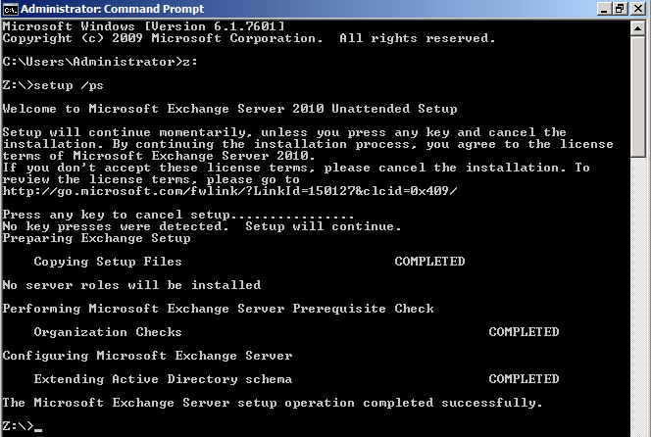
Note:
- To run this command, the administrator must be a member of the Schema Admins group and the Enterprise Admins group.
- The administrator must run this command on a 64-bit computer in the same domain and in the same Active Directory site as the schema master FSMO role holder domain controller.
- After the administrator runs this command, they should wait for the changes to replicate across entire Active Directory forest servicing Exchange organization before continuing to the next step. The amount of time this takes is dependent upon the Active Directory site topology.
Use ADSIEdit and verify the following values for Schema partition. For Exchange 2010 SP2 the value of rangeUpper attribute of ms-Exch-Schema-Version-Pt object in CN=Schema will equal 14732 when setup /PrepareSchema is run successfully. Verify this value before proceeding to the next steps in the production environment.
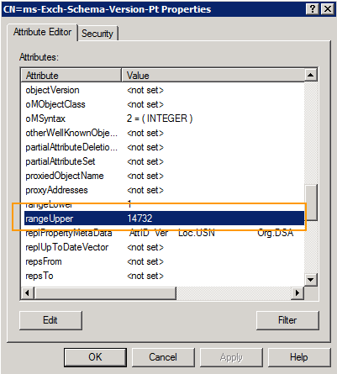
    - Prepare Active Directory
From an elevated command prompt (not PowerShell) run the following command once for the global.loc environment.
<Exchange 2010 SP2 installation media>\Setup.com /PrepareAD
Note:
This command prepares the local domain for the introduction of Exchange. This means that it is not necessary to run the Setup /PrepareDomain command in the specific domain where the /PrepareAD command was run, in this case global.loc.
    - Prepare Additional Domains
Aegis Media will be enabling Exchange users in all their other domains in their forest. Therefore it is required to run the /PrepareAllDomains in this environment.
<Exchange 2010 SP2 installation media>\Setup.exe /PrepareAllDomains
Or to prepared individual domain one at a time
<Exchange 2010 SP2 installation media>\Setup.exe /PrepareDomain:<FQDN of domain you want to prepare>
Note:
/PrepareAllDomains will prepare all remaining domains in the forest. /PrepareDomain can be used to specify a specific domain.
To verify the first domain is prepared successfully, make sure that there is a new OU in the root domain (global.loc) called Microsoft Exchange Security Groups. This OU should contain the following new Exchange USGs:
- Exchange Security Groups OU:
- Organization Management
- Recipient Management
- Server Management
- View-Only Organization Management
- Public Folder Management
- UM Management
- Hygiene Management
- Records Management
- Discovery Management
- Delegated Setup
- ExchangeLegacyInterop
To verify all other domains are prepared go to each domain controller in all domains in which you will install Exchange 2010, the Exchange Servers USG has permissions on the Domain Controller Security Policy\Local Policies\User Rights Assignment\Manage Auditing and Security Log policy

- Client Access and Hub Transport Server Configuration
The following media is required for this section.
- Windows Server 2008 R2 SP1 Standard Edition Installation Files
- Exchange 2010 SP2 Installation Files
- Microsoft Office 2010 Filter Packs
- Exchange 2010 SP2 Rollup Update 2 or latest version
  - Additional Software Verification
All of the steps listed below leverage remote desktop for configuration. Be sure to enable remote desktop on all servers.
As an optional process, install Microsoft Network Monitor 3.4. This software will help with network troubleshooting. (http://go.microsoft.com/fwlink/?LinkId=86611).
  - Prerequisites and Hotfixes
Contained is a list of prerequisites and hotfixes that are required to be installed on all Exchange 2010 SP2 servers. Be sure to perform all below steps on servers that will host Exchange 2010 roles.
    - Hotfix Installs
Aegis Media has decided to deploy Exchange 2010 server on Windows 2008 R2 SP1 operating system. Service Pack 1 includes all required hotfixes for Exchange server deployment, no additional hotfixes required for this version of Windows.
    - Exchange 2010 SP2 Prerequisites
On Exchange 2010 Transport and Mailbox server roles require the Office 2010 Filter Pack for Exchange Server 2010 SP2. Install and Configure the Office 2010 Filter Pack on all servers that will host either of these Exchange 2010 roles.
- Microsoft Office 2010 Filter Packs (Download FilterPack64bit.exe for Server 2008 R2 systems)
http://go.microsoft.com/fwlink/?linkid=191548
Note: Exchange 2010 SP2 will automatically register the IFilters during setup.
    - Automate Installation of Prerequisites
<path to >\FilterPack64bit.exe /quiet
Note: Add the /norestart to prevent an automatic reboot of the server. Server must be restarted after all prerequistes are installed.
    - Exchange Features Prerequisites
Exchange 2010 SP2 includes an option to “Automatically install Windows Server roles and features required for Exchange Server”. These steps can safely be skipped and performed during the Exchange install step.
  - Network Interfaces Configuration
The below network configurations are applicable to CAS/Hub servers.
- Log on to the server with an account that has been delegated at least local administrative access.
- Click Start > Control Panel, and then double-click Network and Sharing Center.
- Click Manage Network Connections.
- Locate the connection for the internal network and rename it according to your organization's naming standards.
- Right-click the connection and then select Properties.
- For Internet Protocol Version 4 (TCP/IPv4), add the following:
  - Static IP Address, Subnet Mask, and Gateway
  - DNS Server IP Addresses
  - Select the check box to Append parent suffixes of the primary DNS suffix.
  - WINS IP Addresses (if using WINS)
- If you are using Internet Protocol Version 6 (TCP/IPv6), configure the IPv6 settings according to your organization's network standards.
Note: IPv6 should not be disabled on Exchange servers. For current guidance around network adapter configuration see the following blog article: Time to revisit recommendations around Windows networking enhancements usually called Microsoft Scalable Networking Pack
  - Domain Membership Configuration
CAS/Hub servers will be part of global.loc domain.
- Connect to the server through Remote Desktop, and then log on with an account that has been delegated local administrative access.
- Click Start > right-click My Computer, and then select Properties.
- View the preview. If incorrect proceed to change settings.
- Under the Computer Name, domain, and workgroup settings, click Change Settings.
- Click Change.
- Choose the Domain option button, and then enter the appropriate domain name, global.loc.
- Enter the appropriate credentials.
- Click OK and OK.
- Click OK to close System Properties.
- Restart the server
  - Drive Configuration
- Connect to the server through Remote Desktop and then log on with an account that has been delegated local administrative access.
- Click Start > Administrative Tools, and then select Computer Management.
- Expand Storage and then click Disk Management.
- Using the Disk Management snap-in of the Microsoft Management Console (MMC), format, rename, and assign the appropriate Drive Letters so that the volumes and DVD drive match the appropriate server configuration.
LUN | Drive letter | Usage
1 | C | Operating system, Exchange binaries, and tracking logs
2 | D | mail.que database (Transport database)
3 | E | Tracking logs, Transaction logs (Transport database)
6 | Z | DVD drive
  - Drive Permissions
- Login to the server with an account that has been delegated local administrative access.
- Click Start, and then select Computer.
- Right-click D Drive and then select Properties.
- Click the Security tab.
- Click Edit.
- Click Add, and then select the local server from Locations.
- Grant the following rights as outlined in the following table.
Account | Permissions
Administrators | Full Control
SYSTEM | Full Control
Authenticated Users | Read and Execute, List, Read
CREATOR OWNER | Full Control
Network Services | Full Control
- Click the Advanced button.
- Select the CREATOR OWNER permission entry, and then click View/Edit.
- Select Subfolders and Files Only from the drop-down list.
- Click OK two times.
- Click OK to close the drive properties.
- Repeat steps 3-12 for each additional drive (other than the C drive).
  - Windows Firewall
Because the Windows Firewall service applies Windows service hardening rules to standard Windows Networking services, Microsoft does not support stopping the Windows Firewall service. Aegis Media do not want to use Windows Firewall, turn the firewall features off by using the Group Policy settings, without stopping the service, as described in http://technet.microsoft.com/en-us/library/cc771032(WS.10).aspx.
- Connect to the server through Remote Desktop and then log on with an account that has been delegated local administrative access.
- Click Start > Administrative Tools, and then select Computer Management > Configuration > Services. Ensure the Windows Firewall is Automatic and Started.
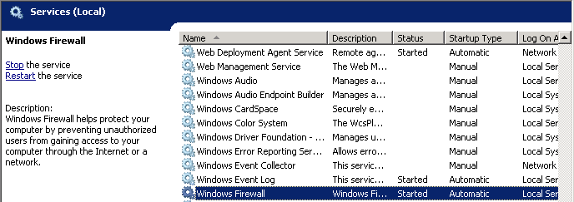
- Connect to the server through Remote Desktop and then log on with an account that has been delegated local administrative access.
- Click Start > Administrative Tools, and then select Windows Firewall and Advanced Security.
- Select Windows Firewall and Advanced Security > Ensure Windows Firewall is off for Domain, Private, and Public Profile.
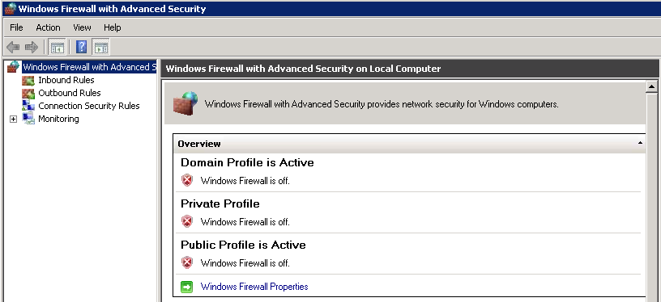
  - Local Administrators Verification
- Connect to the server through Remote Desktop and then log on with an account that has been delegated local administrative access.
- Click Start > Administrative Tools, and then select Computer Management.
- Select Configuration > Local Users and Groups > Groups > Administrators
- Verify (or add if not already there) that the Domain Admins account and the user account that will perform the Exchange installation are members of the local Administrators group on this server.
- Verify that the installation user account is a member of a group which is a member of the local Administrators group on the Windows Server 2008 server. If it is not, use an account that is a member of the local Administrators group before continuing.
    - Local Administrator Account Password Reset
- Connect to the server through Remote Desktop, and then log on with an account that has been delegated local administrative access.
- Click Start, right-click Computer, and then select Manage.
- Expand the nodes to find Configuration\Local Users and Groups\Users.
- Right-click Administrator and then select Set Password. Change the password so that it meets strong complexity requirements
  - Page File Modifications
- Connect to the server through Remote Desktop, and then log on with an account that has been delegated local administrative access.
- Click Start, right-click Computer, and then select Properties.
- Select the Advanced System Settings.
- Under Startup and Recovery, click Settings.
- Under Write Debugging Information, select Kernel Memory Dump from the memory dump drop-down list.
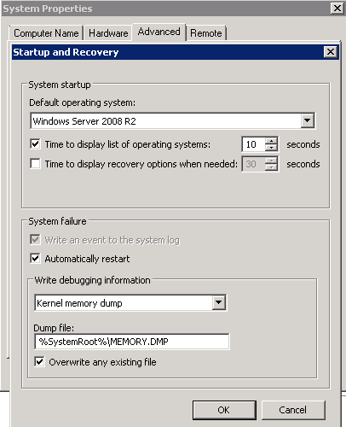
- Click OK.
- Under Performance, click Settings.
- Click the Advanced tab.
- Under Virtual Memory, click Change.
  - On all servers perform the following steps:
  - De-select Automatically Manage paging file size for all drives.
  - Set a Static page file on C:
  - In the Drive list, click C:, and then click Custom size.
  - Type 32778 in Initial Size (MB:) and Maximum Size (MB:)
  - The recommended size for a server with over 8 GB of memory is RAM + 10MB
    - 32 * 1024 = 32768 MB
    - 10 MB + 32768 MB = 32778 MB
    - Click Set
  - Click OK three times to close the System Properties dialog box.
- Clicks OK two times to close the System Properties dialog box.
- Click No if prompted to restart the system.
Note:
For more information about page file recommendations, see the following Microsoft Knowledge Base articles: How to determine the appropriate page file size for 64-bit versions of Windows Server 2003 or Windows XP and Overview of memory dump file options for Windows Vista, Windows Server 2008, Windows Server 2003, Windows XP, and Windows 2000
  - Client Access and Hub Transport Server Verification Steps
The following procedures are in this section:
- Organizational Unit Verification
- Active Directory Site Verification
- Domain Controller Diagnostics Verification
- Exchange Pre-Deployment Analyzer Verification
    - Organizational Unit Verification
Submit a change request to the appropriate operations group and have the computer object moved to the appropriate organizational unit (OU). Organizational Unit will be global.loc\Servers.
    - Active Directory Site Verification
- Connect to the server through Remote Desktop, and then log on with an account that has been delegated local administrative access.
- Open a Command Prompt window.
- Verify that the server is in the correct domain and Active Directory site. At the command line, type the following:
NLTEST /server:%COMPUTERNAME% /dsgetsite
- The name of the Active Directory site to which the server belongs will be displayed. If the server is not in the correct Active Directory site, submit a change request to the appropriate operations group and have the server moved to the appropriate Active Directory site.

Note:
It is required to have a Global Catalog server in every site that will host an Exchange 2010 Server. Ensure there are GC’s for all Exchange domains in the site verified in this step.
The proper site for all servers at Aegis Media is EMEA Datacentre A and EMEA Datacentre B
    - Domain Controller Diagnostics Verification
DCDIAG (Domain Controller Diagnostics) is a Windows support tool that tests network connectivity and DNS resolution for domain controllers.
- Connect to the server through Remote Desktop, and then log on with an account that has been delegated local administrative access.
- Open a Command Prompt window, and then change paths to the C drive.
- Run the following command:
dcdiag /s:<Domain Controller> /test:connectivity /f:c:\dcdiag.log

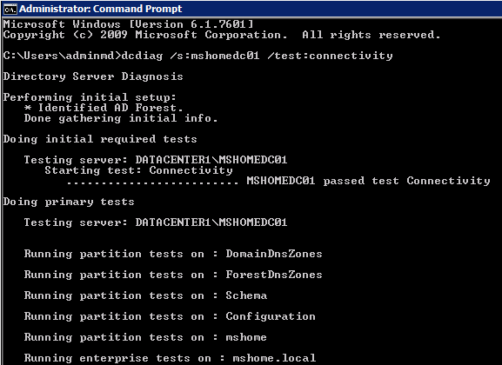
Note:
Rerun the command with each <domain Controller> within the same Domain and AD site that Exchange server is being deployed. Ensure that root forest domain controllers for the same AD Site are also tested.
- Review the output of C:\dcdiag.log file, and verify that there are no connectivity issues with the local domain controller.
- Repeat steps 3 and 4 for each domain controller in the local Active Directory site.
Note:
If the account being used does not have administrative privileges, several tests under the Doing primary tests heading may not pass. These tests can be ignored if the connectivity tests pass. In addition, the log file may report that some service validation tests did not pass. These messages can be ignored if the services do not exist on the domain controller.
    - Exchange Pre-Deployment Analyzer Verification
You can use the Exchange Pre-Deployment Analyzer (ExPDA) to perform an overall topology readiness scan of your environment. When you run ExPDA, it provides a detailed report that will alert you if there are any issues within your organization, which could prevent you from deploying Exchange 2010. For example, ExPDA will notify you if you haven't deployed the minimum required Exchange service pack on all your existing Exchange servers. You can download ExPDA from the Microsoft Download Center at http://go.microsoft.com/fwlink/?LinkId=184599.
- Connect via Remote Desktop to a server in the environment that has ExPDA installed, and then log on with an account that has been delegated local administrative access. Depending on the configuration, do the following:
- Click Start > All Programs > Exchange Readiness Tools and then select Pre-Deployment Analyzer Tool.
- Select Check for updates on startup (recommended), choose a Customer Experience Improvement Program option, select Check for updates now and apply any updates for ExPDA.
- On the Welcome page, choose Select options for a new scan.
- Provide the appropriate information to connect to Active Directory and click Connect to the Active Directory server.
- On the Start a new Best Practices Scan page, click Start Scanning.
- Review the report and take action on any errors or warnings that are reported by following the resolution articles that are provided within ExPDA.
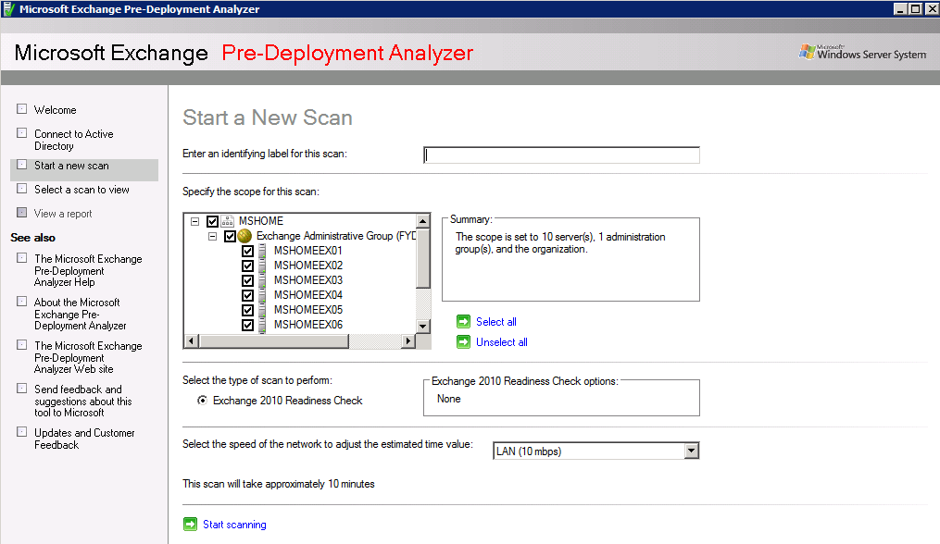
  - Client Access and Hub Transport Role Installation Steps
The following media is required for this section.
- Microsoft Exchange Server 2010 SP2 installation files
- Update Rollup 2 for Exchange Server 2010 Service Pack 2
The following procedures are in this section:
- Installation Order
- Exchange 2010 Unattended Install Steps
- Exchange 2010 Manual Installation Steps
- Product Key Configuration
- Exchange 2010 Update Rollup Installation
- System Performance Verification
Perform the following steps on each server to complete setup of all Exchange servers. Be sure to install all servers before continuing to Section 4.13.
This section includes both unattended and manual methods of performing Exchange role installations. Choose one and proceed to implement those steps.
    - Installation Order
Server Roles | Datacentre
CAS and Hub Server 1 | EMEA Datacentre A
CAS and Hub Server 2 | EMEA Datacentre A
CAS and Hub Server 1 | EMEA Datacentre B
CAS and Hub Server 2 | EMEA Datacentre B
    - Exchange 2010 Unattended Install Steps
You can now select the /InstallWindowsComponents parameter during an unattended install of Exchange 2010 SP1. If you select the option to install Windows roles and features, progress is shown and the appropriate roles and features are installed. If a reboot is required, you will have to reboot the server and launch Setup.com again with the /InstallWindowsComponents parameter. If the Windows roles and features were correctly installed Setup.com will continue installing Exchange.
Follow the procedure detailed in the Install Exchange 2010 in Unattended Mode topic in the Exchange Server 2010 Library.
Use the below commands to install all proper server role required
From an elevated command prompt (not PowerShell)
For CAS and Hub Role:

<Exchange 2010 SP2 installation media>\setup.com /m:install /role:C,H /InstallWindowsComponents /ExternalCASServerDomain:Mail.aemedia.com /LegacyRoutingServer:<Exchange 2003 bridgehead server>
Note:
Please note the legacy routing server can only be specified for the first Hub Transport server installation in an organization with legacy Exchange Servers.
    - Exchange 2010 Manual Installation Steps
If preferred you can manually install Exchange on each server by following the below steps.
On the Start page, make sure that you've completed Steps 1 through 3. If you haven't already installed the components discussed in those steps, Setup will link you to the appropriate sites where you can download the components. For more information about Windows PowerShell installation, see Install Windows Management Framework.
Important:
Installing Exchange 2010 on Windows Server 2008 R2, don't use the downloadable .NET Framework package. Instead, use Server Manager in Windows Server 2008 R2 or run ServerManagerCmd -i NET-Framework
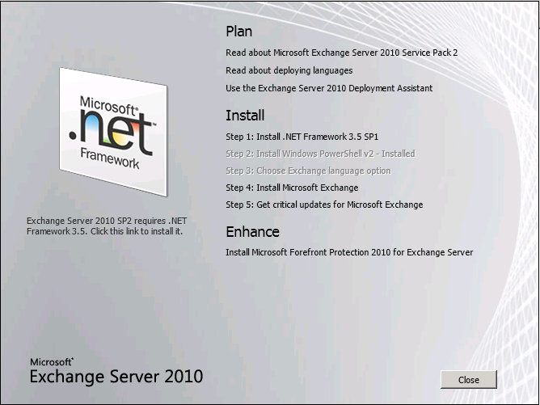
- On the welcome screen select “Next” to continue
- Accept license agreement and click Next
- Select No on the Error Reporting page
- Select Custom Exchange Server Installation and click Next. Be sure to select the “Automatically install Windows Server roles and features required for Exchange Server”.
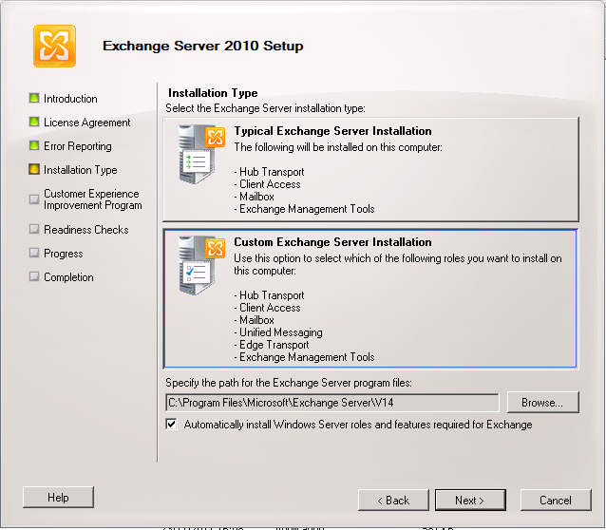
- From Server Role selection, select “Client Access Role” and “Hub Transport Role” and click Next. Be sure to select the “Automatically install Windows Server roles and features required for Exchange Server”
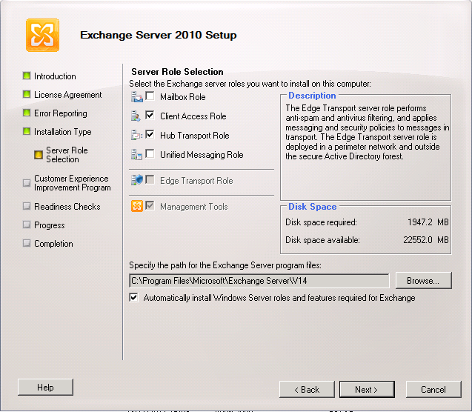
- Configure Client Access Server external domain enter mail.aemedia.com.
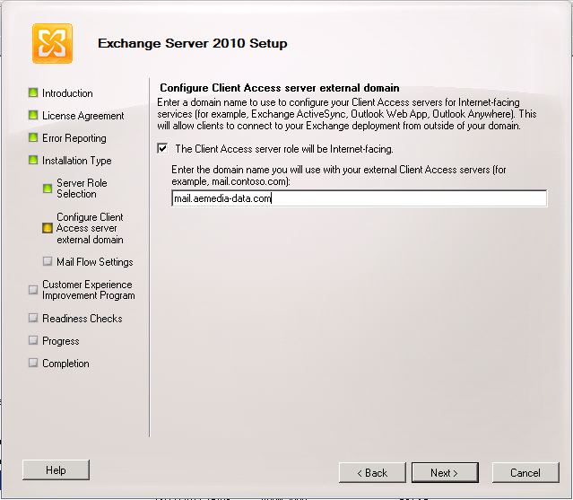
- On the “Mail Flow Settings” ” page, choose the Exchange 2003 bridgehead server that's located in the routing group to which you'll create the initial routing group connector. A routing group connector is required for mail flow between Exchange 2010 and Exchange 2003 when these Exchange server versions coexist in the same organization.
Note:
Please note the legacy routing server can only be specified for the first Hub Transport server installation in an organization with legacy Exchange Servers.
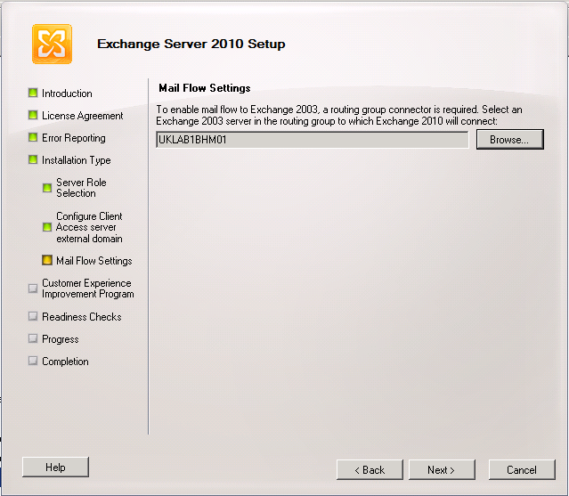
- On the “Customer Experience Improvement Program” page choose the appropriate option for the organization.
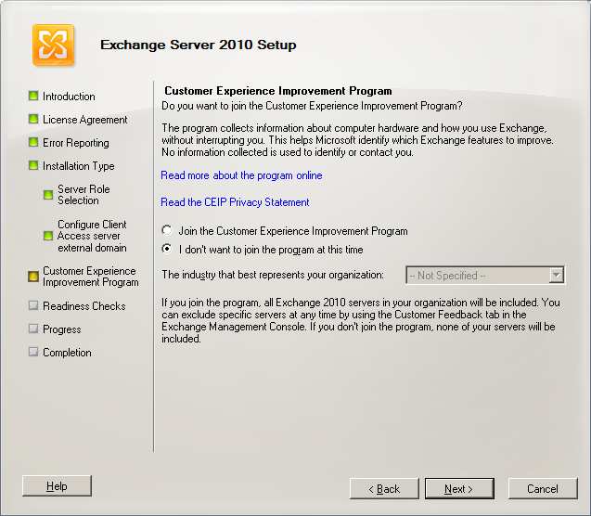
- On the Readiness Checks page, view the status to determine if the organization and server role prerequisite checks completed successfully. If they haven't completed successfully, you must resolve any reported errors before you can install Exchange 2010. You don't need to exit Setup when resolving some of the prerequisite errors. After resolving a reported error, click Retry to re-run the prerequisite check. Be sure to also review any warnings that are reported. If all readiness checks have completed successfully, click Install to install Exchange 2010.
Note:
If you select the option to install Windows roles and features, progress is shown and the appropriate roles and features are installed. If a reboot is required, you will have to reboot the server and launch Setup again. When Setup is launched again, Setup will resume where it left off.
- Verify that setup completes successfully without any errors before proceeding to next server
- Repeat steps for all servers following the order outlined in Section 4.11.1.
    - Product Key Configuration
- Launch the Exchange Management Shell with an account that has been delegated the Server Management role.
- Follow the procedure documented in the Enter Product Key topic in the Exchange Server 2010 Library (http://go.microsoft.com/fwlink/?LinkId=187234).
Set-ExchangeServer -Identity uklab1cas01 -ProductKey aaaaa-aaaaa-aaaaa-aaaaa-aaaaa
    - Exchange 2010 Update Rollup Installation
At the time of this writing Exchange 2010 Service Pack 2 is on UR2. New Exchange 2010 rollups get released roughly every 3 to 4 months. It is recommended that Aegis Media confirm there isn’t any new Update Rollup’s (UR) available at time of deployment into production. Follow the below steps to apply the most current Update Rollup.
- Connect to the server through Remote Desktop, and then log on with an account that has local administrative access.
- Obtain the latest company approved rollup, and then copy it to the server in the software directory.
- Go to software directory
- Double-click the MSP file, and then follow the GUI instructions.
Note:
The Rollup Update can take upwards of 20 minutes to complete per server.
- Restart the server once the Rollup has completed which is indicated by the Finish button’s appearance.
    - Check Processor Scheduling Configuration
By default, Exchange 2010 optimizes the server’s processor scheduling management for background services.
- Connect to the server through Remote Desktop, and then log on with an account that has local administrative access.
- Click Start, right-click Computer, and then select Properties.
- Select the Advanced System Settings.
- Under Performance, click Settings.
- Click the Advanced tab.
- Verify that Processor Scheduling is set to Background Services.
- Click OK.

  - Configure Certificate Services
- PKI and Certificates
- Certificate Namespace
- Certificate Configuration
- Create Kerberos Service Account and Assign SPNs
    - PKI and Certificates
At Aegis Media a commercial certificate is needed as Client Access server will service client requests from the Internet. Additional steps will be required for any reverse proxy or Riverbed device that performs SSL offloading.
For more information about using the certificate tasks, see the Understanding TLS Certificates topic in the Exchange Server 2010 Library.
Note:
If generating a certificate that will use Subject Alternative Names be sure that the certificate’s principal name will be the one that the clients will use to connect (for example, mail.aemedia.com). Do not list the Autodiscover, Legacy or IMAP namespace as the principal name in the certificate.
    - Certificate Namespace
Property | Value | Note
Friendly Name | mail.aemedia.com | Principle name
Domain Name | mail.aemedia.com  autodiscover.aemedia.com  autodiscover.<SMTP Address>  legacy.aemedia.com  <CAS servers FQDN> | The order of the names on the certificate is important – a Subject Alternate Name (SAN) certificate is a requirement here  Aegis Media will be configuring numerous Autodiscover URLs for their departments/business who will be using different primary SMTP address. Aegis will provide the details. This is unlikely to be confirmed at this stage exactly which domains as we need to collate this information
Deployment | Internal: Certificate store on all CAS servers  External: Certificate store on all TMG Servers used for publishing Exchange services | For internal client access into CAS  For external client access to Exchange services
Issuing CA | Internal CA  External: Public CA

    - Certificate Configuration
An certificate will be used for all deployment on all Exchange servers.
      - Create Certificate
- Launch the Exchange Management Shell with an account that has been delegated the Server Management role.
- Generate the certificate request by using the following Exchange Management Shell command. The DomainName parameter includes the principal URL and the Autodiscover FQDN; be sure to define other FQDNs that clients may utilize. The FriendlyName parameter matches the principal URL that is used by Microsoft Office Outlook Web App and Outlook Anywhere.
Aegis Media Public CA request:
This is an example
$Data = New-ExchangeCertificate -GenerateRequest -SubjectName [Full Subject Path] -DomainName mail.aemedia.com,autodiscover.aemedia.com,CAS01.aemedia.com
-FriendlyName mail.aemedia.com -PrivateKeyExportable $true -Keysize 2048

Set-Content -Path "D:\Aemedia-CertReq-2010.req" -Value $Data

An example of [Full Subject Path] is "c=UK, o=servers, cn=CAS01.global.loc".
Note:
The Windows RPC/HTTP client-side component in Windows Vista requires that the Subject Name (Common Name) on the certificate match the “Certificate Principal Name” configured for the Outlook Anywhere connection in the Outlook profile. This behaviour was changed in Windows Vista Service Pack 1 (SP1). Therefore, as a best practice, make sure that mail.aemedia.com is listed as the Subject Name in your certificate unless you plan to change the configuration. You can use the Set-OutlookProvider cmdlet to change the configuration. For more information about how to change the configuration, see the Exchange Team Blog article, When, if and how do you modify Outlook Providers?
      - Submit the Request to the Internal CA
Submit the request file to the Certificate Authority (CA) and have the CA generate the certificate.
- Go to the http://certservername/certsrv
- Open the Internal CA web site under Microsoft Active Directory Certificate Services Welcome Screen
- Select Request a certificate
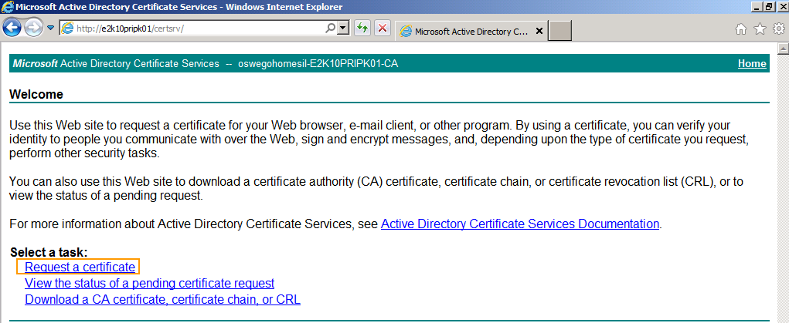
- Under Request a Certificate select advanced certificate request
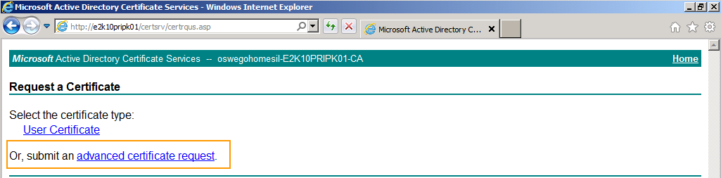
- Under Advanced Certificate Request select “Submit a certificate request by using a base-64-encoded CMC or PKCS #10 file, or submit a renewal request by using a base-64-encoded PKCS #7 file
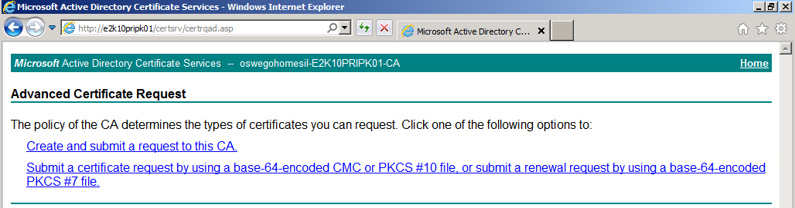
- Open the cert.req file that Aegis Media saved in the D:\Aegis Media-CertReq-2010.req
- Select from “-----BEGIN NEW CERTIFICATE REQUEST-----“ to “-----END NEW CERTIFICATE REQUEST-----“ and copy.
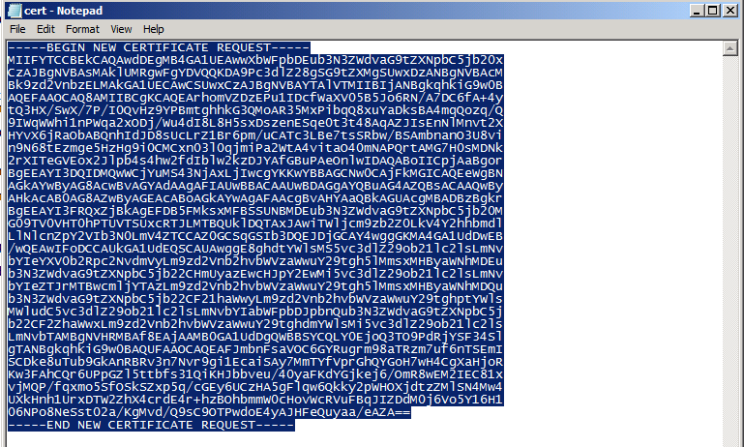
- Under Submit a Certificate Request or Renewal Request > Saved Request: > Base-64-encoded certificate request (CMC or PKCS #10 or PKCS #7): paste the cert request as seen below.
- Ensure you select the Web Template that has been configured for private key exportable and select submit.
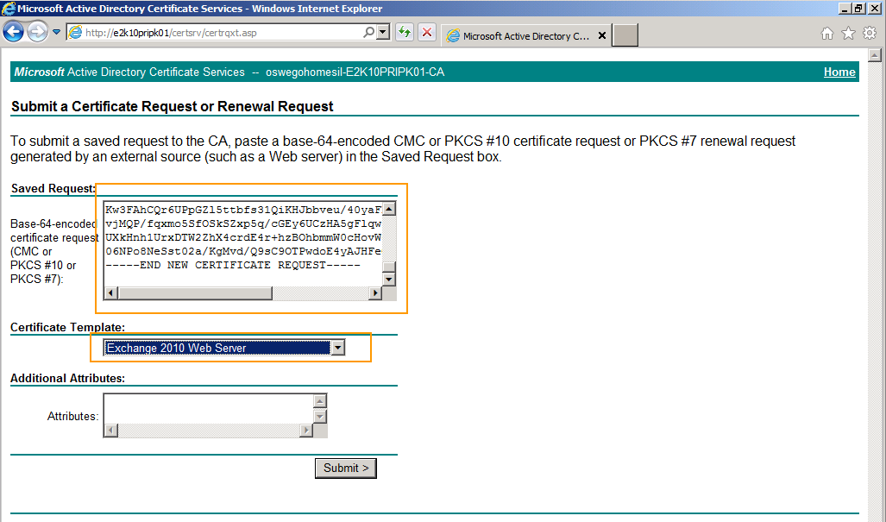
- Download the certificate from the Certificate page by selecting Base 64 encoded and Download Certificate
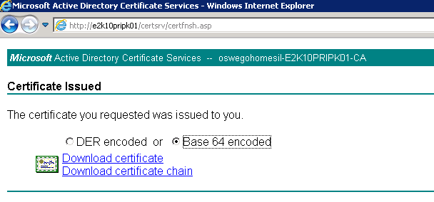
- Now Save the certificate as D:\AemediaExchange.cer
      - Import Certificate to the First CAS Server
- After receiving the certificate back from the CA, import and enable the certificate by running the following Exchange Management Shell command where [services] can be POP, IMAP, IIS, or a combination:
Import-ExchangeCertificate -FileData ([Byte[]]$(Get-Content –Path D:\AemediaExchange.cer -Encoding byte -ReadCount 0))

- Then enable the certificate for use on the first server:

Enable-ExchangeCertificate -Thumbprint <cert thumbprint> -services IIS
      - Export Certificate to apply to Other Servers
- On the existing CAS server from and elevated Exchange management shell run
$file = Export-ExchangeCertificate -Thumbprint <cert thumbprint> -BinaryEncoded:$true -Password (Get-Credential).password

Set-Content -Path "<path>\Export.pfx" -Value $file.FileData -Encoding Byte
- Copy the Export.pfx file to the other Exchange CAS servers that are going to use the certificate
      - Import Certificate to All Other Servers
Import-ExchangeCertificate -FileData ([Byte[]]$(Get-Content -Path <path>\export.pfx –privatekeyexportable:$true -Encoding byte -ReadCount 0)) -Password:(Get-Credential).password

Enable-ExchangeCertificate -Thumbprint <cert thumbprint> -services IIS

- Alternatively, Import Exchange Certificate to a multitude of servers at the same time by choosing Import Certificate from the Action Pane.
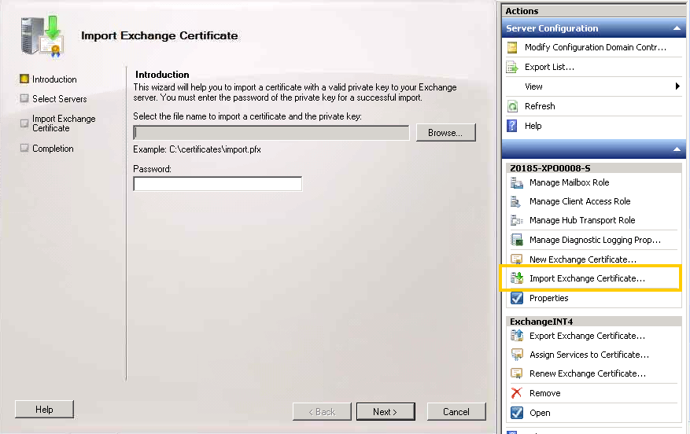
- Choose the .pfx file to import, and type the password of the pfx and click next.
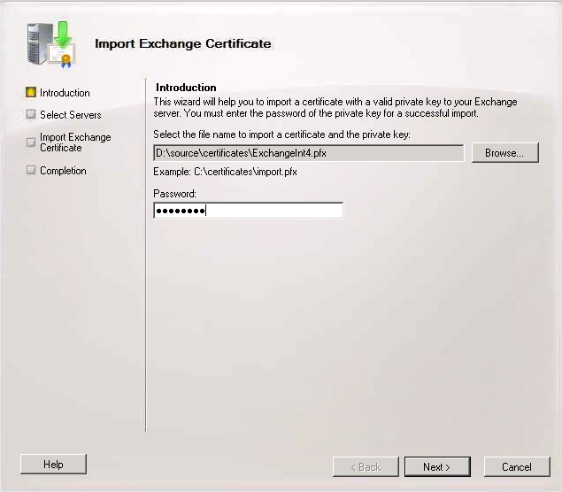
- Pick all the CAS servers to install it to and click ok.
- Now click Import and Finish.
- Now assign the certificate to multiple servers, Select "Assign Services to Certificate.
- Leave IMAP and POP selected, > check IIS > click next.
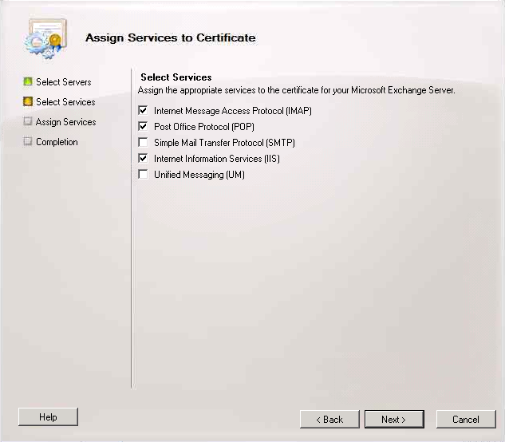
- Click Next > Assign > Finish
  - Create Kerberos Service Account and Assign SPNs
In order to prevent a known problem with NTLM authentication exhaustion, the issue is a specific number of threads that can handle NTLM authentication, controlled by MaxConcurrentAPI vale. With a sufficiently high volume a bottleneck effect will result in some transactions having a significant delay or even being dropped. Making matters worse is software like RIM’s Blackberry Enterprise Server which increases logon requests. For full details about the issue see the Configuring Kerberos Authentication for Load-Balanced Client Access Servers and Using Kerberos with a Client Access Server Array or a Load-Balancing Solution topic in the Exchange Server 2010 Library.
            - Logon to Active Directory Users and Computers and create a service account.
Example Account: svcacc_CASKerbe$
Note:
There are no particular requirements for the name of the ASA credential. Aegis Media can use any name that conforms to their naming scheme. A computer account must be 15 characters or less.
            - On a computer with Support Tools and proper AD rights run the following commands to create the SPNs for the newly created service account.
Setspn -S exchangeMDB/outlook-siteA.aemedia.com Svc_CASKerberos
Setspn -S exchangeAB/outlooksiteA.aemedia.com Svc_CASKerberos
Setspn -S exchangeRFR/outlooksiteA.aemedia.com Svc_CASKerberos
Setspn -S exchangeMDB/outlook-siteB.aemedia.com Svc_CASKerberos
Setspn -S exchangeAB/outlooksiteB.aemedia.com Svc_CASKerberos
Setspn -S exchangeRFR/outlooksiteB.aemedia.com Svc_CASKerberos
Setspn -S http/mail.aemedia.com Svc_CASKerberos
Setspn -S http/autodiscover.aemedia.com Svc_CASKerberos
            - Run the following command to finish setting the alternate account for all CAS Array systems to the following Kerberos service account. For additional details about this step see the TechNet article entitled Using the RollAlternateServieAccountPassword.ps1 Script in the Shell:
RollAlternateserviceAccountPassword.ps1 -ToEntireForest -GenerateNewPasswordFor “AD\svcacc_CASKerbe$" –Verbose
Note:
Aegis Media can create a computer account or a user based service account for the alternate service account. Because a computer account doesn’t allow interactive logon, it may have simpler security policies than a user account and therefore be preferable as an ASA credential. If you create a computer account, the password doesn't actually expire, but Microsoft still recommends updating the password periodically. Local group policy can specify a maximum account age for computer accounts and there might be scripts scheduled to periodically delete computer accounts that do not meet current policies. Periodically updating the password for computer accounts will ensure that your computer accounts aren't deleted for not meeting local policy. Your local security policy will determine when the password needs to be changed. When creating this account use the Aegis Media corporate standards.
  - Client Access Server Role Configuration
    - Exchange 2010 Namespaces Design
Client Type | Internal URL | External URL
Outlook Web App | https://mail.aemedia.com/owa | https://mail.aemedia.com/owa
Exchange Control Panel | https://mail.aemedia.com/ecp | https://mail.aemedia.com/ecp
Exchange Web Services | https://mail.aemedia.com/ews/exchange.asmx | https://mail.aemedia.com/ews/exchange.asmx
RPC Client Access Service | EMEA Site A  https://outlook-siteA.aemedia.com  EMEA Site B  https://outlook-siteB.aemedia.com | N/A – The RPC Client Access Array is configured globally, not internal/external.  All CAS servers in the AD site will be a member of this array. All mailbox databases in the AD site will have the RPCClientAccessServer attribute configured to the FQDN of the CAS array.
Outlook Anywhere | https://mail.aemedia.com | https://mail.aemedia.com
ActiveSync | https://mail.aemedia.com/Microsoft-Server-ActiveSync | https://mail.aemedia.com/Microsoft-Server-ActiveSync
Offline Address Book | https://mail.aemedia.com/oab | https://mail.aemedia.com/oab
AutoDiscover | https://autodiscover.aemedia.com/Autodiscover/Autodiscover.xml  Aegis Media will be configuring numerous Autodiscover URLs for their departments/business who will be using different primary SMTP address. Aegis will provide the details. This is unlikely to be confirmed at this stage exactly which domains as we need to collate this information  Site scopes will be configured to ensure that clients will request AutoDiscover information from a Client Access Server closes to their Active Directory site.
Exchange 2003 | https://legacy.aemedia.com  Note – the existing Exchange Server 2003 infrastructure must be reconfigured to support this new namespace for coexistence between Exchange Server 2010 and Exchange Server 2003 to operate correctly.
    - DNS
Create Following DNS entries:
Port | Location | DNS FQDN | IP address | Members | Notes
TCP 443 | Internal and External | mail.aemedia.com | Riverbed GTM (Global Traffic Manager)
TCP 443 | Internal and External | autodiscover.aemedia.com | GTM |  | Additional DNS entries would be needed for the additional SMTP used by Aegis Media.
TCP 135 and  60000 | Internal | Outlook-SiteA.aemedia.com  Outlook-SiteB.aemedia.com | Site A VIP  Site B VIP | Site A CAS Servers  Site B CAS Servers | An CAS array per AD site
    - RPC Client Access Array
If this is the first Client Access server being installed in the Active Directory site, and the Client Access server infrastructure will participate in a load-balanced array, then you also need to create the RPC Client Access array object. The fully-qualified domain name (FQDN) you specify for the RPC Client Access array should map to the FQDN or virtual IP address that is used for the load-balanced array that was previously created.
Launch the Exchange Management Shell with an account that has been delegated the Server Management role and then run the following command:
First you create the new CAS array using the following commands:
New-ClientAccessArray -Fqdn <FQDN of CAS load balanced array> -Site <Active Directory Site>
Note:
The client access array names should NOT be resolvable on the Internet.
    - RPC Client Access and Address Book Service Configuration
If the Client Access server is configured to participate in a load-balanced array, follow these steps to configure the RPC Client Access and Address Book services to use a specific TCP port for client connections. The procedure uses TCP 60000 and TCP 60001, but you can utilize any TCP high ports that are available within the environment between ports 59531 and 60554 (adjust load-balanced array rules accordingly).
Important:
Incorrectly editing the registry can cause serious problems that may require Aegis Media to reinstall the operating system. Problems resulting from editing the registry incorrectly may not be able to be resolved. Before editing the registry, back up any valuable data.
- Start Registry Editor.
  - Navigate to HKEY_LOCAL_MACHINE\System\CurrentControlSet\Services\MSExchangeRPC
  - Right-click MSExchangeRPC, point to New, and then click Key.
  - Type ParametersSystem to name the new key.
  - Right-click Parameters, point to New, and then click REG_DWORD (x32).
  - Type TCP/IP Port to name the new value.
  - Double-click TCP/IP Port.
  - In the Value data box change to decimal, type 60000, and then click OK.
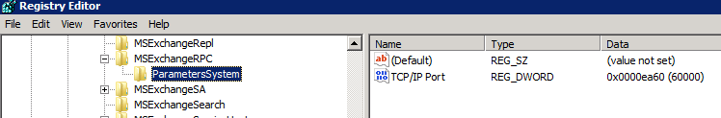
  - Next navigate to HKEY_LOCAL_MACHINE\System\CurrentControlSet\Services\MSExchangeAB
  - Right-click MSExchangeAB, point to New, and then click Key.
  - Type Parameters to name the new key.
  - Right-click Parameters, point to New, and then click String Value.
  - Type RpcTcpPort to name the new value.
  - Double-click RpcTcpPort.
  - In the Value data box, type 60001, and then click OK.
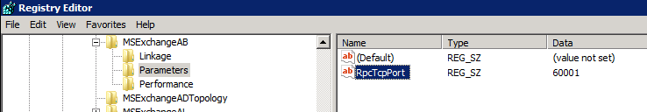
- Close Registry Editor and then restart the Microsoft Exchange Address Book service.
Note:
Refer to the following articles for further details about RPC static ports. http://technet.microsoft.com/en-us/library/ff625248.aspx and http://social.technet.microsoft.com/wiki/contents/articles/configuring-static-rpc-ports-on-an-exchange-2010-client-access-server.aspx
    - Exchange Autodiscover Configuration
Exchange 2010 includes a service named the Autodiscover service. The Autodiscover service makes it easier to configure Outlook 2007 or Outlook 2010 and some mobile phones. For more information, see the Understanding the Autodiscover Service topic in the Exchange Server 2010 Library.
Be sure to follow the namespaces outlined in section 4.14.1
- Launch the Exchange Management Shell with an account that has been delegated the Server Management role.
- Configure the internal Autodiscover URL by running the following command within the Exchange Management Shell.
Be sure to follow the namespaces outlined in section 4.14.1
In the following example, UKLAB1CAS01 is the name of the Client Access server and internal.domain.fqdn is the internal namespace used for Autodiscover:
Set-ClientAccessServer -Identity UKLAB1CAS01 -AutoDiscoverServiceInternalUri https://autodiscover.aemedia.com/Autodiscover/Autodiscover.xml
    - Outlook Anywhere Configuration
- Launch the Exchange Management Shell with an account that has been delegated the Server Management role.
- Use the Shell to configure the Outlook Anywhere external host name for the Autodiscover service
Be sure to follow the namespaces outlined in section 4.14.1
This example sets the external host name for Outlook Anywhere on the Client Access server UKLAB1CAS01.
Enable-OutlookAnywhere -Server UKLAB1CAS01 -ExternalHostname "mail.aemedia.com" -DefaultAuthenticationMethod "Basic" -SSLOffloading:$False
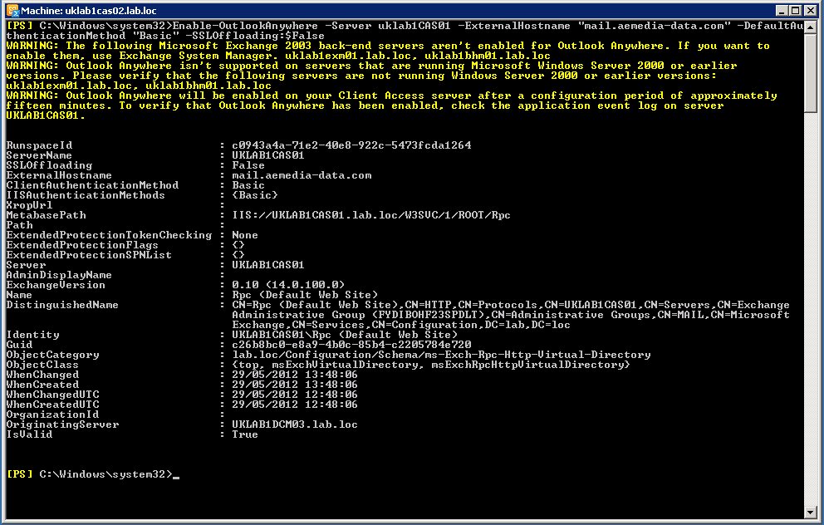
    - Offline address book Configuration
- Launch the Exchange Management Shell with an account that has been delegated the Server Management role.
- Use the Shell to configure the offline address book external and internal URL for the Autodiscover service
Be sure to follow the namespaces outlined in section 4.14.1
This example sets the external URL for the offline address book virtual directory on the Client Access server UKLAB1CAS01.
Set-OABVirtualDirectory -identity "UKLAB1CAS01\OAB (Default Web Site)" -externalurl https://mail.aemedia.com/OAB -Internalurl https://mail.aemedia.com/OAB -RequireSSL:$true
    - Exchange Web Services Configurations
- Launch the Exchange Management Shell with an account that has been delegated the Server Management role.
- Use the Shell to configure the Exchange Web Services external and internal URL for the Autodiscover service
Be sure to follow the namespaces outlined in section 4.14.1
This example sets the external URL for the Exchange Web services virtual directory on the Client Access server UKLAB1CAS01.
Set-WebServicesVirtualDirectory -identity "UKLAB1CAS01\EWS (Default Web Site)" -externalurl https://mail.aemedia.com/EWS/Exchange.asmx -Internalurl https://mail.aemedia.com/EWS/Exchange.asmx -BasicAuthentication:$True
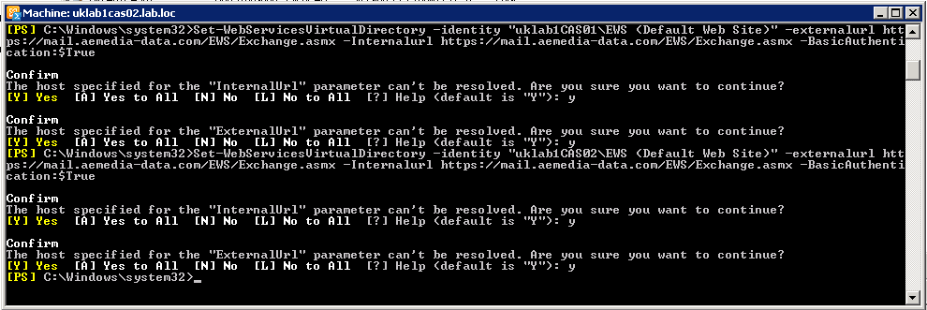
    - Exchange ActiveSync Configuration
- Launch the Exchange Management Shell with an account that has been delegated the Server Management role.
- Use the Shell to configure the Autodiscover service in Exchange ActiveSync
Be sure to follow the namespaces outlined in section 4.14.1
This example configures the Autodiscover service and sets the ExternalURL and InternalURL property.
Set-ActiveSyncVirtualDirectory -Identity "UKLAB1CAS01\Microsoft-Server-ActiveSync (Default Web Site)" -ExternalURL https://mail.aemedia.com/Microsoft-Server-ActiveSync -Internalurl https://mail.aemedia.com/Microsoft-Server-ActiveSync
    - Outlook Web Access Configuration
Aegis Media has decided to implement single URL with multiple sites using TMG pre-authentication and groups. To configure these settings follow the below step.
Be sure to follow the namespaces outlined in section 4.14.1
- Launch the Exchange Management Shell with an account that has been delegated the Organization Management role.
- Configure the OWA external and internal URL by running the following commands within the Exchange Management Shell.
Be sure to follow the namespaces outlined in section 4.14.1:
Set-OwaVirtualDirectory -Identity "UKLAB1CAS01\OWA (Default Web Site)" -ExternalURL https://mail.aemedia.com/OWA -InternalURL https://mail.aemedia.com/OWA -FormsAuthentication $True -BasicAuthentication $True
    - Exchange Control Panel Configuration
- Launch the Exchange Management Shell with an account that has been delegated the Organization Management role.
- Configure the ECP external URL by running the following commands within the Exchange Management Shell.
Be sure to follow the namespaces outlined in section 4.14.1:
Set-EcpVirtualDirectory –Identity “UKLAB1CAS01\ecp (Default Web Site)” ExternalURL https://mail.aemedia.com/ecp –InternalUrl https://mail.aemedia.com/ecp -FormsAuthentication $True -BasicAuthentication $True
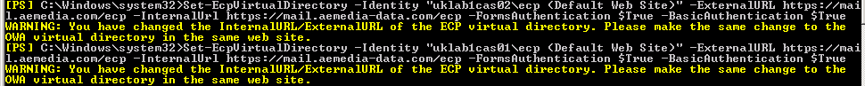
    - POP3 Configurations
Client Access server will allow POP3 connections internally in Aegis Media.
- Launch the Exchange Management Shell with an account that has been delegated the Server Management role.
- To configure the POP3 bindings, run the following command. In the following example, CAS01 is the Client Access server and 0.0.0.0 implies any IP address.
Set-PopSettings -server UKLAB1CAS01 -UnencryptedOrTLSBindings "0.0.0.0:110" -SSLBindings "0.0.0.0:995"
- To disable plain text authentication and enable custom calendar item retrieval option for POP3, run the following command. In the following example, mail.contoso.com is the certificate name and external URL.
Set-PopSettings -server UKLAB1CAS01 -X509CertificateName "mail.aemedia.com" -LoginType SecureLogin -CalendarItemRetrievalOption Custom -OwaServerUrl https://mail.aemedia.com/owa
- To enable the Exchange POP3 service for automatic startup, run the following command:
Set-Service MSExchangePOP3 -ComputerName UKLAB1CAS01 -StartupType automatic
  - Hub Transport Server Role Configuration
The Hub Transport server role is a required role in a Microsoft Exchange Server 2010 organization that provides routing within a single organizational network by using the Active Directory service site. Deployed inside the Active Directory forest, computers that have the Hub Transport server role installed handle all mail flow inside the organization, apply transport rules, apply journal rules, and deliver messages to recipients' mailboxes. Messages that are sent to the Internet are relayed by the Hub Transport server to the Edge Transport server role that is deployed in the perimeter network. Messages that are received from the Internet are processed by the Edge Transport server before they are relayed to the Hub Transport server. The Hub Transport server role stores all its configuration information in Active Directory. This information includes transport rules settings, journal rule settings, and connector configurations.
    - Configure Organization Transport Settings
Transport settings define how all Hub Transport servers running Microsoft Exchange Server 2010 function in your organization. The options configured are used by all Hub Transport servers. The below settings have been defined for the Aegis Media Environment.
- Launch the Exchange Management Shell with an account that has been delegated the Server Management role.
- Modify various settings on the default Receive connector by running the following command:
Set-TransportConfig –MaxReceiveSize 100MB
Set-TransportConfig –MaxSendSize 100MB
Set-TransportConfig –MaxDumpsterSizePerDatabase 150MB
Set-TransportConfig –MaxDumpsterTime 7
Set-TransportConfig –ExternalPostmasterAddress postmaster@aemedia.com
Set-TransportConfig –ExternalDsnREportingAuthority smtp.aemedia.com
Set-TransportConfig -ShadowRedundancyEnabled $true

Note:
For additional details about Configuring Transport Settings Properties article in TechNet, for additional details about sizing see the TechNet article entitled Understanding Mailbox Database and Log Capacity Factors.
    - Configure Transport Server Configuration
Use the Set-TransportServer cmdlet to set the transport configuration options for computers running Microsoft Exchange Server 2010 that have the Hub Transport server role or Edge Transport server role installed. All Exchange 2010 Hub Transports servers at Aegis Media should be configured identically in both data centers for all of these settings.
- Launch the Exchange Management Shell with an account that has been delegated the Server Management role.
- Modify various settings on the default Receive connector by running the following command (See table below for settings):

Set-TransportServer –Identity UKLAB1CAS01 -ActiveUserStatisticsLogMaxDirectorySize 1GB –MessageTrackingLogMaxDirectorySize 5GB –MessageTrackingLogSubjectLoggingEnabled $True –MaxPerDomainOutboundConnections 20 –ReceiveProtocolLogMaxDirectorySize 5GB –SendProtocolLogMaxDirectorySize 5GB –ServerStatisticsLogMaxDirectorySize 1GB

You can use the following table for information you need for the command.
Parameter values for Hub Transport server configuration
Parameter | Default value | AEGIS MEDIA Value
ActiveUserStatisticsLogMaxDirectorySize | 250 MB | 1 GB
ActiveUserStatisticsLogMaxAge | 30 Days | <Default>
ActiveUserStatisticsLogMaxFileSize | 10 MB | <Default>
ConnectivityLogMaxDirectorySize | 250 MB | 1 GB
ConnectivityLogMaxAge | 30 Days | <Default>
ConnectivityLogMaxFileSize | 10 MB | <Default>
MessageTrackingLogMaxDirectorySize | 1 GB | 5 GB
MessageTrackingLogMaxAge | 30 Days | <Default>
MessageTrackingLogMaxFileSize | 10 MB | <Default>
ReceiveProtocolLogMaxDirectorySize | 250 MB | 5 GB
ReceiveProtocolLogMaxAge | 30 Days | <Default>
ReceiveProtocolLogMaxFileSize | 10 MB | <Default>
RoutingTableLogMaxDirectorySize | 50 MB | <Default>
RoutingTableLogMaxAge | 7 Days | <Default>
SendProtocolLogMaxDirectorySize | 250 MB | 5 GB
SendProtocolLogMaxAge | 30 Days | <Default>
SendProtocolLogMaxFileSize | 10 MB | <Default>
ServerStatisticsLogMaxDirectorySize | 250 MB | 1 GB
ServerStatisticsLogMaxAge | 14 Days | <Default>
ServerStatisticsLogMaxFileSize | 10 MB | <Default>
    - Configure Receive Connectors
There are several receive connectors that need to be configured for the Aegis Media environment. The below table describes the required connectors for the Aegis Media environment.
Connector Name | Description/Configuration
Default | Default receive connector to accept SMTP connections from other Exchange Hub Transport or Edge servers in the organization  See section 4.15.3.1 below.
Client | Default receive connector to accept connections from non-MAPI clients such as POP and IMAP clients. Since POP / IMAP will be supported at Aegis Media, the default client receive connector should be enabled.
Ex2003 to Ex2010 | To enable mail flow between the Exchange 2010 deployment and your existing Exchange 2003 organization, you need to create a routing group connector. This routing group connector is created during the setup of your first Exchange 2010 Hub Transport server.

Note:
After installation Exchange 2003 connectors should be configured to work. Validate their settings and confirm proper routing. This step should be performed immediately after install to confirm nothing was modified or broken during the install of Exchange 2010 into the environment.
      - Configuring Default & Client Receive Connectors
By default, the default Receive connector will accept various authentication mechanisms and allow users as well as Exchange servers to connect. The following steps modify this behavior by restricting the type of authentication that can occur and ensuring only Exchange servers can connect and transmit messages to this Receive connector. Also, in addition to the default Receive connector, each Hub Transport server has a client Receive connector that listens on TCP 587.
Modify the default Receive connector’s permissions and authentication mechanisms using the following command. This command should be run for all Exchange 2010 Hub Transport servers.
Set-ReceiveConnector "<ServerName>\Default <ServerName>" -PermissionGroups "ExchangeServers, ExchangeLegacyServers" -AuthMechanism ExchangeServer
Aegis Media has decided to enable POP protocols on the Exchange 2010 environment. To complete this step run the below command for each Hub Transport server installed in the environment
Get-ReceiveConnector “<ServerName>\Default <ServerName>" | Set-ReceiveConnector –Enabled $True
    - Configure Send Connectors
Aegis Media will configure Edge Subscriptions between Hub and Edge servers which will automatically create send connector. The following send connectors are created by default.
- An implicit Send connector from the Hub Transport servers that are in the same forest to the Edge Transport server.
- A Send connector from the Edge Transport server to the Hub Transport servers in the Active Directory site to which the Edge Transport server is subscribed.
- A Send connector from the Edge Transport server to the Internet
Please refer to section 6.12 for EdgeSync configurations.
    - Change the Location of the Queue Database and Transport Logs
The following section outlines the steps to change the location of the queue database, queue database transaction logs and additional Transport Server specific logging. Perform the following steps on all Hub Transport servers.
- Connect to an Exchange 2010 server via Remote Desktop, and then log on with an account that has local administrative access and that has been delegated the Server Management role (or higher).
- Verify that the “Microsoft Exchange Transport” service is stopped. If it is not stopped, stop the service.
Net stop MSExchangeTransport
- Create the folder D:\Exchange\QueueLogs.
- Create the subfolder D:\Exchange\QueueLogs\Temp
- Copy the files Trn.log, Trntmp.log, Trnnnnnn.log, Trnres00001.jrs, Trnres00002.jrs, Temp.edb, Mail.que and Trn.chk from the original location (C:\Program Files\Microsoft\Exchange Server\V14\TransportRoles\data\Queue) to the QueueLogs folder.
- Navigate to <Exchange Install Path>\bin.
- Open the EdgeTransport.exe.config file in Notepad and edit the following entry:
<add key="QueueDatabasePath" value="D:\Exchange\QueueLogs" />
<add key="QueueDatabaseLoggingPath" value="D:\Exchange\QueueLogs" />
<add key="TemporaryStoragePath" value="D:\Exchange\QueueLogs\Temp" />
Save the file
- Create the E:\Exchange\Logs folder.
- Move the folders that reside in <Exchange Install Path>\TransportRoles\Logs to the E:\Exchange\Logs folder.
- Launch the Exchange Management Shell with an account that has been delegated the Organization Management role and then run the following command:
Set-TransportServer <ServerName> -ConnectivityLogPath "E:\Exchange\Logs\Connectivity" -MessageTrackingLogPath "E:\Exchange\Logs\MessageTracking" -ReceiveProtocolLogPath "E:\Exchange\Logs\ProtocolLog\SmtpReceive" -SendProtocolLogPath "E:\Exchange\Logs\ProtocolLog\SmtpSend" -ActiveUserStatisticsLogPath "E:\Exchange\Logs\ActiveUserStats" -ServerStatisticsLogPath "E:\Exchange\Logs\ServerStats" -RoutingTableLogPath "E:\Exchange\Logs\Routing"
- Open a command prompt with elevated administrator permissions and start the Transport service by running the following command:
Net start MSExchangeTransport
- Verify that the new Trn.log, Trntmp.log, Trnres00001.jrs, Trnres00002.jrs, and Temp.edb files are created at the new location (E:\Exchange\QueueLogs).
Remove the unused Trn.log, Trntmp.log, Trnnnnnn.log, Trnres00001.jrs, Trnres00002.jrs, and Temp.edb files from the original location.
Note:
For additional details about moving the location of the queue database see the following TechNet article: http://technet.microsoft.com/en-us/library/bb125177.aspx
    - Configuring Accepted Domains
An accepted domain is any SMTP namespace for which a Microsoft Exchange organization sends or receives e-mail. Accepted domains include those domains for which the Exchange organization is authoritative. An Exchange organization is authoritative when it handles mail delivery for recipients in the accepted domain.
Aegis Media has multiple domains that need be configured for the Exchange 2010 system. For more information about configuring accepted domains see Understanding Accepted Domains topic in the Exchange Server 2010 Library
Note:
Because Aegis Media will be migrating from Exchange 2007 the Accepted Domains should all be configured correctly. Use the table below to validate the configuration. The command below shows how to configure any domains that aren’t already configured correctly.
- Launch the Exchange Management Shell with an account that has been delegated the Organization Management role.
- Configure the accepted domains by running the following commands:

New-AcceptedDomain –Name “aemedia.com” –DomainName “aemedia.com” –DomainType “Authoritative”

SMTP Domain | Type
 | Authoritative
  21twentyone.com
  aaamedia.com.tw
  aca-demy.co.uk
  acteurope.eu.com
  aegisignition.com
  aegis-kinder-jugendhilfe.de
  aegismedia.com.au
  aegisplc.co.uk
  aegisplc.com
  aemedia.asia
  aemedia.com
  aemedia.de
  aemedia.dk
  aemedia.fi
  aemedia.ie
  aemedia-resolutions.com
  aemedia-resolutions.de
  aemedia-resolutions-tr.com
  aemediatrade.com
  aevolve.asia
  aevolve.com.my
  alban.co.uk
  amdeepblue.com
  ammomarketing.com
  amnetgroup.com
  anepiccompany.com
  apollomarketing.com
  apollo-marketing.com.au
  bebrandx.com
  bemarvellous.com
  blue-am.com
  bluestreak.com
  bookmark.nl
  bornlondon.com
  brandscope.co.in
  brandscope.in
  brandxlab.com
  carat.co.th
  carat.co.uk
  carat.com
  carat.com.cn
  carat.com.tr
  carat.dk
  carat.fi
  carat.ie
  carat.it
  carat.no
  carat.se
  carat21.de
  carat-berlin.de
  caratcanada.com
  caratculture.com
  carat-ddorf.de
  caratdeepblue.dk
  carat-direct.de
  caratdisneyteam.com
  carat-expert.de
  caratfresh.com
  carat-hamburg.de
  caratinteractive.com
  carat-jobs.de
  carat-kinder-jugendhilfe.de
  caratmedia.com
  carat-muenchen.de
  carat-na.com
  carat-sponsorship.de
  caratsponsorship.dk
  carat-trade.com
  carat-wiesbaden.de
  checkit.nl
  chewing-com.com
  clownfish.co.uk
  clownfishmarketing.co.uk
  clownfishmarketing.com
  concord.co.uk
  connectfactory.com
  copernicusmarketing.com
  creasy.fr
  creo.biz
  creooslo.no
  cursor-media.com
  de-construct.com
  deconstruct.nl
  de-construct.nl
  deepblue-belgium.com
  deepbluedenmark.dk
  deepbluesa.com
  diffiniti.com
  diffiniti.ie
  digitalmadesimple.tv
  directhome.dk
  directly.dk
  directly.fi
  dist.se
  distcreative.com
  distcreative.dk
  domingopr.se
  doosra.in
  driven-llc.com
  dr-pichutta.de
  eccla.fr
  electric-avenue.com.sg
  elink-ad.com
  e-medianet.com
  extenseo.be
  fcm.co.za
  featherbrooksbank.co.uk
  freestyleinteractive.com
  freshactivation.com
  genesismedia.com
  genesisvizeum.com
  glueisobar.com
  gluelondon.com
  haystac.co.nz
  haystac.com.sg
  healthcaremedia.eu.com
  healthcaremediaeurope.com
  heartland-cn.com
  hme.eu.com
  hms-carat.de
  hms-groupvizeum.de
  hms-wiesbaden.de
  hyperspace.com.sg
  hyperspacedigital.com
  if.net.my
  igk.co.kr
  implicom.com
  ingeniointeractiva.es
  ingeniomedia.es
  insightresearch.dk
  iprospect.be
  iprospect.ca
  iprospect.co.kr
  iprospect.co.nz
  iprospect.co.uk
  iprospect.com
  iprospect.com.au
  iprospect.com.cn
  iprospect.com.hk
  iprospect.com.my
  iprospect.com.sg
  iprospect.com.tr
  iprospect.com.tw
  iprospect.dk
  iprospect.es
  iprospect.fi
  iprospect.in
  iprospect.no
  iprospect.pt
  iprospect.se
  iprospectmanchester.co.uk
  iprospectmanchester.com
  iprospect-wiesbaden.de
  isobar.com
  isobar.dk
  isobar.ie
  isobar.net
  isobar.nl
  isobar.no
  isobaraustralia.com
  isobaraustralia.com.au
  isobarcommunications.com
  isobarcommunications.dk
  jjpartners.se
  jjpexperience.com
  jnjmediacare.com
  jplusmediacare.com
  jumptank.com
  justinternational.com
  justmedia.co.uk
  kobalt.nl
  kobaltmedia.nl
  magictouch.im
  magictouch.net
  marvellous.fr
  marvellous.no
  marvellousmobile.dk
  marvellousmobile.fi
  marvellousmobile.fr
  marvellousmobile.no
  marvellousmobile.se
  mecsa.co.za
  mediabureauet.dk
  medialand.nl
  mediamnt.com
  mediapool.ee
  mediasal.es
  mediekompetens.dk
  mencompany.it
  mindblossom.com
  minigetawaystockholm.com
  molecular.com
  morgagni33.it
  msm-wiesbaden.de
  mvmediagroup.co.uk
  mv-online.co.uk
  mwoffice.de
  netthink.es
  netthinkisobar.es
  onedigital.com.au
  open-outdoor.com
  outdoorvision.com
  planete-interactive.com
  planint.com
  posterscope.co.uk
  posterscope.com
  posterscope.com.cn
  posterscope.de
  posterscope.fi
  posterscope.hu
  ppma.com.cn
  promotions-online.com
  promovator.dk
  promovator.se
  psiad.com
  psiad-cn.com
  publistory.fr
  qamedia.com
  rangeonlinemedia.com
  rapidsa.co.za
  ribersports.com
  rmsarcar.ch
  rmsarcar.com
  safecom.com.au
  smartdata.be
  sourceooh.com
  stb.com.ph
  suddenly.dk
  suddenly.fi
  suddenly.se
  suddenlyoslo.no
  synergybe.co.nz
  taconi.co.uk
  teamsri.com
  teamta.com.au
  teamvelocity.com
  thisispr.se
  tillwembley.se
  tkzo.net
  view.pt
  viewisobar.com
  viewisobar.pt
  vividsport.com
  vizeum.com
  vizeum.com.au
  vizeum.com.cn
  vizeum.dk
  vizeum.fi
  vizeum.ie
  vizeum.nl
  vizeum.no
  vizeum.se
  wearesuperglue.com
  whitesheep.fi
  wwwins.com
  wwwins.com.hk
  xenion.de
  xenionisobar.de
  yourfreshworld.com
  zoomnews.dk
    - Configure Remote Domains
Remote Domains are used by Exchange to validate mail flow to remote domains is handled appropriately. Remote domains will be configured as follows. This section only needs to be done once.
Use EMC (Organization Configuration > Hub Transport > Remote Domains) to validate and configure any of the below settings.
Name | Domain | Option | Setting
Default | * | Specify out-of-office message types delivered to this remote domain | Allow external out-of-office messages only
Default | * | Allow automatic replies | Unchecked
Default | * | Allow automatic forward | Unchecked
Default | * | Allow delivery reports | Checked
Default | * | Allow non-delivery reports | Checked
Default | * | Display sender’s name on messages | Unchecked
    - Configuring E-Mail Address Policy
An accepted domain is any SMTP namespace for which a Microsoft Exchange organization sends or receives e-mail. Accepted domains include those domains for which the Exchange organization is authoritative. An Exchange organization is authoritative when it handles mail delivery for recipients in the accepted domain.
For more information about configuring E-Mail Address Policies see Managing E-Mail Address Policies topic in the Exchange Server 2010 Library
Aegis Media has multiple Recipient policies in the Exchange 2003 environment which are applied to users based on the company or department using “Custom Attribute 14 equals value”. Aegis Media will have multiple Email Address polices in Exchange 2010 as well to meet business requirements.
- Launch the Exchange Management Shell with an account that has been delegated the Organiztion Management role.
- Configure the accepted domains by running the following commands:

new-EmailAddressPolicy -Name 'aemedia.com' -IncludedRecipients 'AllRecipients' -ConditionalCustomAttribute14 'aemedia.com' -Priority 'Lowest' -EnabledEmailAddressTemplates 'SMTP:%g.%s@aemedia.com'

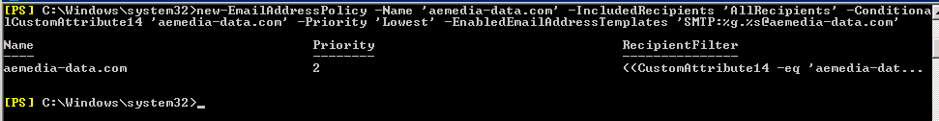
Please refer to this link for details of Email Address policies Managing E-Mail Address Policies

- Mailbox Server Role Configuration
The following media is required for this section.
- Windows Server 2008 R2 SP1 Enterprise Edition Installation Files
- Exchange 2010 SP2 Installation Files
- Microsoft Office 2010 Filter Packs
- Exchange 2010 SP2 Rollup Update 2 or latest version
  - Additional Software Verification
All of the steps listed below leverage remote desktop for configuration. Be sure to enable remote desktop on all servers.
As an optional process, install Microsoft Network Monitor 3.4. This software will help with network troubleshooting. (http://go.microsoft.com/fwlink/?LinkId=86611).
  - Prerequisites and Hotfixes
Contained is a list of prerequisites and hotfixes that are required to be installed on all Exchange 2010 SP2 servers. Be sure to perform all below steps on servers that will host Exchange 2010 roles.
    - Hotfix Installs
Aegis Media has decided to deploy Exchange 2010 server on Windows 2008 R2 SP1 operating system. Service Pack 1 includes all required hotfixes for Exchange server deployment, no additional hotfixes required for this version of Windows.
    - Exchange 2010 SP2 Prerequisites
On Exchange 2010 Hub Transport and Mailbox server roles require the Office 2010 Filter Pack for Exchange Server 2010 SP2. Install and Configure the Office 2010 Filter Pack on all servers that will host either of these Exchange 2010 roles. The Aegis Media deployment will require the Office 2010 Filter Packs on all servers.
- Microsoft Office 2010 Filter Packs (Download FilterPack64bit.exe for Server 2008 R2 systems)
http://go.microsoft.com/fwlink/?linkid=191548
Note: Exchange 2010 SP2 will automatically register the IFilters during setup.
    - Automate Installation of Prerequisites
<path to >\FilterPack64bit.exe /quiet
Note: Add the /norestart to prevent an automatic reboot of the server. Server must be restarted after all prerequistes are installed.
    - Exchange Features Prerequisites
Exchange 2010 SP2 includes an option to “Automatically install Windows Server roles and features required for Exchange Server”. These steps can safely be skipped and performed during the Exchange install step.
  - Mailbox Servers Network Interfaces Configuration
Aegis Media has chosen to leverage a single MAPI network where two adapters will be connected and teamed in fault tolerant mode. For the Replication network Aegis Media has decided to leverage a single network adapter. This means there will be two logical networks for every Mailbox server.
Each network in each DAG member server must be on its own network subnet. Each server in the DAG can be on a different subnet, but the MAPI and Replication networks must be routable and provide connectivity, such that there is no direct routing that allows heartbeat traffic from the Replication network on one DAG member server to the MAPI network on another DAG member server, or vice versa, or between multiple Replication networks in the DAG.*
Knowing these design requirements careful consideration must be taken when configuring the networks. Teaming should be enabled on the MAPI network in redundancy mode only. Microsoft doesn’t support teaming in load balancing mode. In addition, if problems or issues occur that are related to teaming, Microsoft Customer Support Services may require teaming be disabled in order to complete troubleshooting. If this resolves the issue, you must seek assistance from the hardware manufacturer. Finally the routing that is configured on the replication networks must be planned so that we don’t create cross replication or MAPI network communications.
Note: *See the TechNet article entitled Planning for High Availability and Site Resilience for further details.
    - MAPI NIC Networking Properties
Networking Feature | Setting
Client for Microsoft Networks | Enabled
Microsoft Network Monitor Driver | Enabled
QoS Packet Scheduler | Disabled (Optional)
File and Printer Sharing for Microsoft Networks | Enabled
IP Version 6 | Disabled (Optional)
IP Version 4 | Enabled
Link-Layer Topology Discovery Mapper I/O Driver | Enabled
Link-Layer Topology Discovery Responder | Enabled
    - MAPI NIC Configuration
- Log on to the server with an account that has been delegated at least local administrative access.
- Click Start > Control Panel, and then double-click Network and Sharing Center.
- Click Manage Network Connections.
- Locate the connection for the internal network and rename it to MAPI.
- Right-click the connection and then select Properties.
- For Internet Protocol Version 4 (TCP/IPv4), add the following:
  - Static IP Address, Subnet Mask, and Gateway
  - DNS Server IP Addresses
  - Click Advanced > DNS >
  - Select the check box to Append parent suffixes of the primary DNS suffix and add appropriate domains to the list.
  - Ensure that DNS suffix and search orders are configured according to the organizations standards.
  - Ensure Register this connection's addresses in DNS is checked.
  - Click the WINS tab, enter the IP Addresses (if using WINS). Under NetBIOS setting select Default. Ensure “Disable NetBIOS over TCP/IP” is not checked.
  - Uncheck "Enable LMHOSTS lookup"
- If you are using Internet Protocol Version 6 (TCP/IPv6), configure the IPv6 settings according to your organization's network standards.
Note: It is assumed that teaming is already configured according to requirements for the MAPI network.
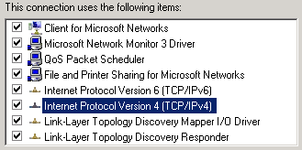
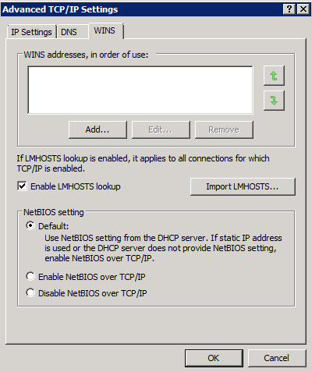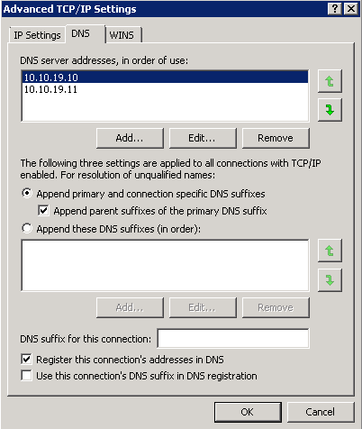
    - Replication NIC Networking Properties
Replication NIC Properties are only for servers running the mailbox role.
Networking Feature | Setting
Client for Microsoft Networks | Disabled
QoS Packet Scheduler | Disabled (Optional)
File and Printer Sharing for Microsoft Networks | Disabled
IP Version 6 | Disabled
IP Version 4 | Enabled
Link-Layer Topology Discovery Mapper I/O Driver | Enabled
Link-Layer Topology Discovery Responder | Enabled

    - Replication NIC Configuration
            - Log on to the server with an account that has been delegated at least local administrative access.
            - Click Start > Control Panel, and then double-click Network and Sharing Center.
            - Click Manage Network Connections.
            - Locate the connection for the internal network and rename it to Replication.
            - Right-click the connection and then select Properties.
            - For Internet Protocol Version 4 (TCP/IPv4), add the following:
              - Static IP Address, Subnet Mask
              - For the Gateway leave it blank as it will be configured via a static routing entry.
              - DNS Server IP Addresses should also be left blank.
              - Click Advanced > DNS >
              - Ensure "Register this Connection's addresses in DNS" is not checked.
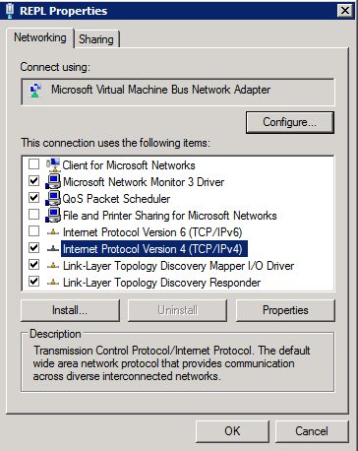
            - Click the WINS TAB, Disable the LMHosts Lookup. Ensure "Enable NetBIOS over TCP/IP" is unchecked for the Replication Network.
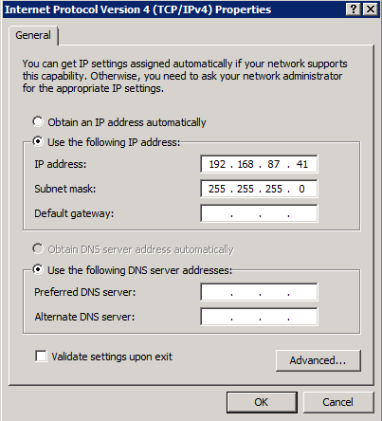
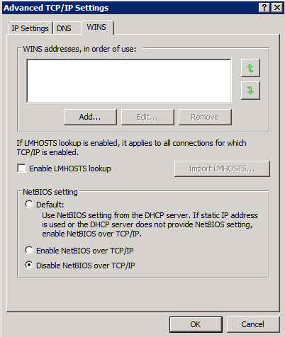
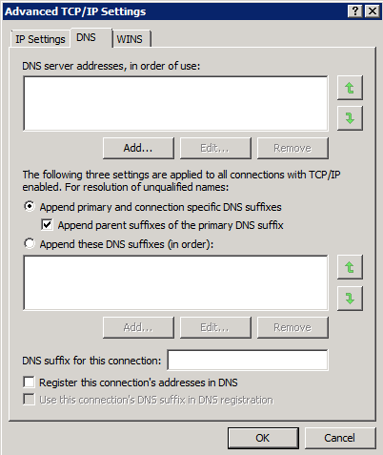

    - Network Card Configuration Order
Each network adapter must be configured properly based on its intended use. A network adapter that's used for a MAPI network is configured differently from a network adapter that's used for a Replication network. In addition to configuring each network adapter correctly, you must also configure the network connection order in Windows so that the MAPI network is at the top of the connection order.
In order to place MAPI above the Replication Network perform the following to see the Advanced Menu under Network and Sharing Center.
- Start Menu > Control Panel > Change View by: Category to Large Icons > Network and Sharing Center > Change Adapter Settings> Organize > Layout > Menu bar
- Now Select Advanced from the Menu > Advanced Setting
- Use the green arrow keys to the right to move the MAPI connection to the top of the list.
- In addition ensure that IPv4 is configured with a priority than IPv6 on all adapters.
- Go to Provider Order, Network Providers; use the green arrow to move Microsoft Windows Network to the top. Move Microsoft Remote Desktop Session Host Services to the middle.
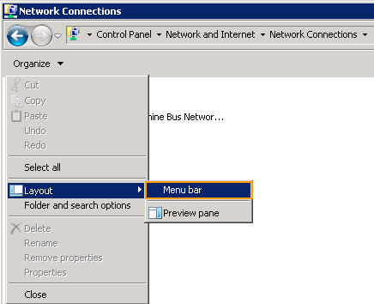
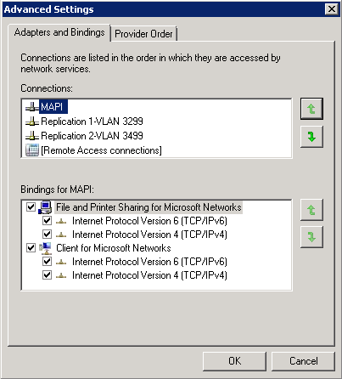

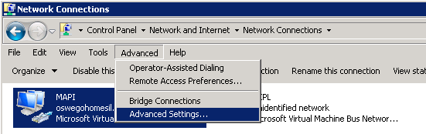
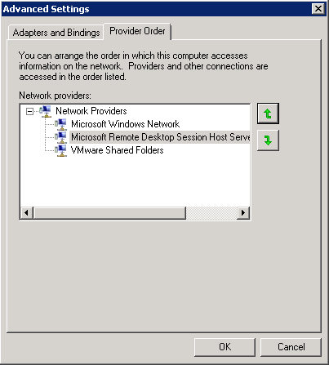
  - Domain Membership Configuration
Mailbox servers will be part of global.loc domain.
- Connect to the server through Remote Desktop, and then log on with an account that has been delegated local administrative access.
- Click Start > right-click My Computer, and then select Properties.
- View the preview. If incorrect proceed to change settings.
- Under the Computer Name, domain, and workgroup settings, click Change Settings.
- Click Change.
- Choose the Domain option button, and then enter the appropriate domain name, global.loc.
- Enter the appropriate credentials.
- Click OK and OK.
- Click OK to close System Properties.
- Restart the server
  - Drive Configuration
- Connect to the server through Remote Desktop and then log on with an account that has been delegated local administrative access.
- Click Start > Administrative Tools, and then select Computer Management.
- Expand Storage and then click Disk Management.
- Using the Disk Management snap-in of the Microsoft Management Console (MMC), format, rename, and assign the appropriate Drive Letters so that the volumes and DVD drive match the appropriate server configuration.

LUN | Drive letter | Usage
1 | C | Operating system, Exchange binaries, and tracking logs
2 | F | Exchange database and Log files. Mount points for each all databases under this location.
3 | Z | DVD drive

DAG Name | Number of Users | Storage Per Server | Number of User Databases
DAG01 | 11500 | 81 x 3 TB Drives | 240
DAG02 | 11500 | 81 x 3 TB Drives | 240

Name | Location | OU
DAG01 | On-Premise DAG | Global.loc\Computers\
DAG02 | On-Premise DAG | Global.loc\Computers\

LUN design approach: One LUN per database
DB | Database name | Database location | Database file name
Anchor LUN | -- | F:\ | --
DBx | <DAGName> MBX Store X | MP:\  \MDBx  \LOGx | PrivX.edb
DBy | <DAGName> MBX Store Y | MP:\  \MDBy  \LOGy | PrivY.edb
… | … | … | …

Note:
In the above table, the reference to MP stands for Mount Point. X and Y refer to unique databases.
  - Drive Permissions
- Login to the server with an account that has been delegated local administrative access.
- Click Start, and then select Computer.
- Right-click D Drive and then select Properties.
- Click the Security tab.
- Click Edit.
- Click Add, and then select the local server from Locations.
- Grant the following rights as outlined in the following table.
Account | Permissions
Administrators | Full Control
SYSTEM | Full Control
Authenticated Users | Read and Execute, List, Read
CREATOR OWNER | Full Control
Network Service | Full Control
- Click the Advanced button.
- Select the CREATOR OWNER permission entry, and then click View/Edit.
- Select Subfolders and Files Only from the drop-down list.
- Click OK two times.
- Click OK to close the drive properties.
- Repeat steps 3-12 for each additional drive (other than the C drive).
  - Windows Firewall
Because the Windows Firewall service applies Windows service hardening rules to standard Windows Networking services, Microsoft does not support stopping the Windows Firewall service. Aegis Media do not want to use Windows Firewall, turn the firewall features off by using the Group Policy settings, without stopping the service, as described in http://technet.microsoft.com/en-us/library/cc771032(WS.10).aspx.
- Connect to the server through Remote Desktop and then log on with an account that has been delegated local administrative access.
- Click Start > Administrative Tools, and then select Computer Management > Configuration > Services. Ensure the Windows Firewall is Automatic and Started.
- Connect to the server through Remote Desktop and then log on with an account that has been delegated local administrative access.
- Click Start > Administrative Tools, and then select Windows Firewall and Advanced Security.
- Select Windows Firewall and Advanced Security > Ensure Windows Firewall is off for Domain, Private, and Public Profile.
  - Local Administrators Verification
- Connect to the server through Remote Desktop and then log on with an account that has been delegated local administrative access.
- Click Start > Administrative Tools, and then select Computer Management.
- Select Configuration > Local Users and Groups > Groups > Administrators
- Verify (or add if not already there) that the Domain Admins account and the user account that will perform the Exchange installation are members of the local Administrators group on this server.
- Verify that the installation user account is a member of a group which is a member of the local Administrators group on the Windows Server 2008 server. If it is not, use an account that is a member of the local Administrators group before continuing.
    - Local Administrator Account Password Reset
- Connect to the server through Remote Desktop, and then log on with an account that has been delegated local administrative access.
- Click Start, right-click Computer, and then select Manage.
- Expand the nodes to find Configuration\Local Users and Groups\Users.
- Right-click Administrator and then select Set Password. Change the password so that it meets strong complexity requirements
  - Page File Modifications
- Connect to the server through Remote Desktop, and then log on with an account that has been delegated local administrative access.
- Click Start, right-click Computer, and then select Properties.
- Select the Advanced System Settings.
- Under Startup and Recovery, click Settings.
- Under Write Debugging Information, select Kernel Memory Dump from the memory dump drop-down list.
- Click OK.
- Under Performance, click Settings.
- Click the Advanced tab.
- Under Virtual Memory, click Change.
  - On all servers perform the following steps:
  - De-select Automatically Manage paging file size for all drives.
  - Set a Static page file on C:
  - In the Drive list, click C:, and then click Custom size.
  - Type 98314 in Initial Size (MB:) and Maximum Size (MB:)
  - The recommended size for a server with over 8 GB of memory is RAM + 10MB
    - 96 * 1024 = 98304 MB
    - 10 MB + 98304 MB = 98314 MB
    - Click Set
  - Click OK three times to close the System Properties dialog box.
- Clicks OK two times to close the System Properties dialog box.
- Click No if prompted to restart the system.
Note:
For more information about page file recommendations, see the following Microsoft Knowledge Base articles: How to determine the appropriate page file size for 64-bit versions of Windows Server 2003 or Windows XP and Overview of memory dump file options for Windows Vista, Windows Server 2008, Windows Server 2003, Windows XP, and Windows 2000
  - Mailbox Server Verification Steps
The following procedures are in this section:
- Organizational Unit Verification
- Active Directory Site Verification
- Domain Controller Diagnostics Verification
- Exchange Pre-Deployment Analyzer Verification
    - Organizational Unit Verification
Submit a change request to the appropriate operations group and have the computer object moved to the appropriate organizational unit (OU). Organizational Unit will be global.loc\Servers.
    - Active Directory Site Verification
- Connect to the server through Remote Desktop, and then log on with an account that has been delegated local administrative access.
- Open a Command Prompt window.
- Verify that the server is in the correct domain and Active Directory site. At the command line, type the following:
NLTEST /server:%COMPUTERNAME% /dsgetsite
- The name of the Active Directory site to which the server belongs will be displayed. If the server is not in the correct Active Directory site, submit a change request to the appropriate operations group and have the server moved to the appropriate Active Directory site.

Note:
It is required to have a Global Catalog server in every site that will host an Exchange 2010 Server. Ensure there are GC’s for all Exchange domains in the site verified in this step.
The proper site for all servers at Aegis Media is EMEA Datacentre A and EMEA Datacentre B
    - Domain Controller Diagnostics Verification
DCDIAG (Domain Controller Diagnostics) is a Windows support tool that tests network connectivity and DNS resolution for domain controllers.
- Connect to the server through Remote Desktop, and then log on with an account that has been delegated local administrative access.
- Open a Command Prompt window, and then change paths to the C drive.
- Run the following command:
dcdiag /s:<Domain Controller> /test:connectivity /f:c:\dcdiag.log

Note:
Rerun the command with each <domain Controller> within the same Domain and AD site that Exchange server is being deployed. Ensure that root forest domain controllers for the same AD Site are also tested.
- Review the output of C:\dcdiag.log file, and verify that there are no connectivity issues with the local domain controller.
- Repeat steps 3 and 4 for each domain controller in the local Active Directory site.
Note:
If the account being used does not have administrative privileges, several tests under the Doing primary tests heading may not pass. These tests can be ignored if the connectivity tests pass. In addition, the log file may report that some service validation tests did not pass. These messages can be ignored if the services do not exist on the domain controller.
    - Exchange Pre-Deployment Analyzer Verification
You can use the Exchange Pre-Deployment Analyzer (ExPDA) to perform an overall topology readiness scan of your environment. When you run ExPDA, it provides a detailed report that will alert you if there are any issues within your organization, which could prevent you from deploying Exchange 2010. For example, ExPDA will notify you if you haven't deployed the minimum required Exchange service pack on all your existing Exchange servers. You can download ExPDA from the Microsoft Download Center at http://go.microsoft.com/fwlink/?LinkId=184599.
- Connect via Remote Desktop to a server in the environment that has ExPDA installed, and then log on with an account that has been delegated local administrative access. Depending on the configuration, do the following:
- Click Start > All Programs > Exchange Readiness Tools and then select Pre-Deployment Analyzer Tool.
- Select Check for updates on startup (recommended), choose a Customer Experience Improvement Program option, select Check for updates now and apply any updates for ExPDA.
- On the Welcome page, choose Select options for a new scan.
- Provide the appropriate information to connect to Active Directory and click Connect to the Active Directory server.
- On the Start a new Best Practices Scan page, click Start Scanning.
- Review the report and take action on any errors or warnings that are reported by following the resolution articles that are provided within ExPDA.

  - Mailbox Role Installation Steps
The following media is required for this section.
- Microsoft Exchange Server 2010 SP2 installation files
- Update Rollup 2 for Exchange Server 2010 Service Pack 2
The following procedures are in this section:
- Installation Order
- Exchange 2010 Unattended Install Steps
- Exchange 2010 Manual Installation Steps
- Product Key Configuration
- Exchange 2010 Update Rollup Installation
- System Performance Verification
This section includes both unattended and manual methods of performing Exchange role installations. Choose one and proceed to implement those steps.
    - Installation Order
Server Roles | Datacentre
Mailbox Server 1 | EMEA Datacentre A
Mailbox Server 2 | EMEA Datacentre A
Mailbox Server 3 | EMEA Datacentre A
Mailbox Server 1 | EMEA Datacentre B
Mailbox Server 2 | EMEA Datacentre B
Mailbox Server 3 | EMEA Datacentre B
    - Exchange 2010 Unattended Install Steps
You can now select the /InstallWindowsComponents parameter during an unattended install of Exchange 2010 SP1. If you select the option to install Windows roles and features, progress is shown and the appropriate roles and features are installed. If a reboot is required, you will have to reboot the server and launch Setup.com again with the /InstallWindowsComponents parameter. If the Windows roles and features were correctly installed Setup.com will continue installing Exchange.
Follow the procedure detailed in the Install Exchange 2010 in Unattended Mode topic in the Exchange Server 2010 Library.
Use the below commands to install all proper server role required
From an elevated command prompt (not PowerShell)
For Mailbox Role:

<Exchange 2010 SP2 installation media>\setup.com /m:install /role:M /InstallWindowsComponents
    - Exchange 2010 Manual Installation Steps
If preferred you can manually install Exchange on each server by following the below steps.
On the Start page, make sure that you've completed Steps 1 through 3. If you haven't already installed the components discussed in those steps, Setup will link you to the appropriate sites where you can download the components. For more information about Windows PowerShell installation, see Install Windows Management Framework.
Important:
Installing Exchange 2010 on Windows Server 2008 R2, don't use the downloadable .NET Framework package. Instead, use Server Manager in Windows Server 2008 R2 or run ServerManagerCmd -i NET-Framework
- On the welcome screen select “Next” to continue
- Accept license agreement and click Next
- Select No on the Error Reporting page
- Select Custom Exchange Server Installation and specify the path for Exchange Server Program files.
- From Server Role selection, select “Mailbox Role” and click Next. Be sure to select the “Automatically install Windows Server roles and features required for Exchange Server”
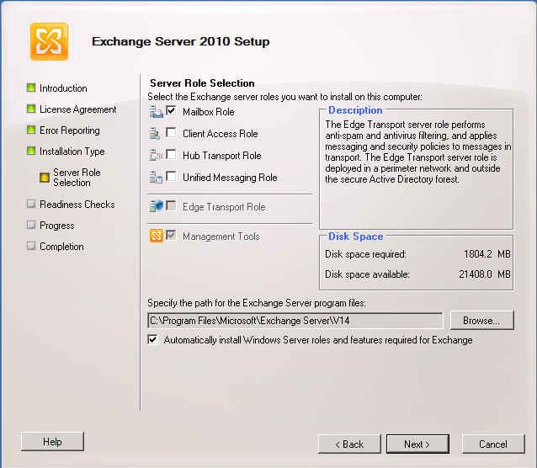
- On the “Customer Experience Improvement Program” page choose the appropriate option for the organization.
- On the Readiness Checks page, view the status to determine if the organization and mailbox server role prerequisite checks completed successfully. If they haven't completed successfully, you must resolve any reported errors before you can install Exchange 2010. You don't need to exit Setup when resolving some of the prerequisite errors. After resolving a reported error, click Retry to re-run the prerequisite check. Be sure to also review any warnings that are reported. If all readiness checks have completed successfully, click Install to install Exchange 2010.
Note:
If you select the option to install Windows roles and features, progress is shown and the appropriate roles and features are installed. If a reboot is required, you will have to reboot the server and launch Setup again. When Setup is launched again, Setup will resume where it left off.
- Verify that setup completes successfully without any errors before proceeding to next server
- Repeat steps for all servers following the order outlined in Section 5.11.1.
    - Product Key Configuration
- Launch the Exchange Management Shell with an account that has been delegated the Server Management role.
- Follow the procedure documented in the Enter Product Key topic in the Exchange Server 2010 Library (http://go.microsoft.com/fwlink/?LinkId=187234).
Set-ExchangeServer -Identity UKLAB1MBX01 -ProductKey aaaaa-aaaaa-aaaaa-aaaaa-aaaaa
    - Exchange 2010 Update Rollup Installation
At the time of this writing Exchange 2010 Service Pack 2 is on UR2. New Exchange 2010 rollups get released roughly every 3 to 4 months. It is recommended that Aegis Media confirm there isn’t any new Update Rollup’s (UR) available at time of deployment into production. Follow the below steps to apply the most current Update Rollup.
- Connect to the server through Remote Desktop, and then log on with an account that has local administrative access.
- Obtain the latest company approved rollup, and then copy it to the server in the software directory.
- Go to D:\source\<rollup directory>
- Double-click the MSP file, and then follow the GUI instructions.
Note:
The Rollup Update can take upwards of 20 minutes to complete per server.
- Restart the server once the Rollup has completed which is indicated by the Finish button’s appearance.
    - Check Processor Scheduling Configuration
By default, Exchange 2010 optimizes the server’s processor scheduling management for background services.
- Connect to the server through Remote Desktop, and then log on with an account that has local administrative access.
- Click Start, right-click Computer, and then select Properties.
- Select the Advanced System Settings.
- Under Performance, click Settings.
- Click the Advanced tab.
- Verify that Processor Scheduling is set to Background Services.
- Click OK.
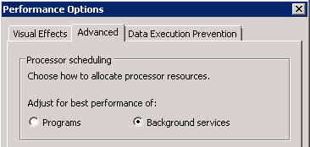
  - Exchange Mailbox Server Role Configuration
    - Database Naming Convention
Aegis Media will use the DAG name and a unique databases identifier to name each database. Two DAGs with three Mailbox servers each will be created each DAG will have 240 Databases, 80 per server.
DAG Name | Database Numbers | Number of Users | Storage Per Server | Number of User Databases
DAG01 | 80 | 11500 | 81 x 3 TB Drives | 144
DAG02 | 80 | 11500 | 81 x 3 TB Drives | 144

    - Database Availability Group Creation
- Launch the Exchange Management Shell with an account that has been delegated the Organization Management role.
- In environments where computer account creation is restricted or where computer accounts are created in a container other than the default computers container, you must pre-stage the cluster network object (CNO) and then provision the CNO by assigning permissions to it. Follow the procedures documented in the Pre-stage the Cluster Network Object for a Database Availability Group topic in the Exchange Server 2010 Library.
Note:
Aegis Media will need to pre-stage all two DAG cluster accounts. Below is the list of the DAG computer accounts and the location of the AD objects.
Name | Location | OU
DAG01 | EMEA Datacentre A & B | Global.loc\Computers\
DAG02 | EMEA Datacentre A & B | Global.loc\Computers\

- Create a database availability group by following the procedures documented in the Create a Database Availability Group topic in the Exchange Server 2010 Library.
New-DatabaseAvailabilityGroup -Name DAG01 -WitnessServer <Hub Servers> -WitnessDirectory 'D:\FSW\DAG01' -DatabaseAvailabilityGroupIPAddresses X.X.X.X,Y.X.X.Y

Set-DatabaseAvailabilityGroup DAG01 -AlternateWitnessServer <Hub Server Secondery Datacentre> -AlternateWitnessDirectory 'D:\FSW\DAG01

Note:
Use the below table to determine the settings for the above dialog. Use the FQDN for the server names.
DAG Name | Witness Server | Alternate Witness Server | Witness Directory
DAG01 | Hub Transport Server in Primary Datacentre | Hub Transport Server in Secondary Datacentre | D:\FSW\DAG01
DAG02 | Hub Transport Server in Primary Datacentre | Hub Transport Server in Secondary Datacentre | D:\FSW\DAG02

Note:
Be sure to grant the DAG computer account object access rights to each of the File Share Witness (FSW) locations on the CAS servers.
- Configure the database availability group properties such as the witness settings, replication port, compression, and encryption by following the procedures documented in the Configure Database Availability Group Properties topic in the Exchange Server 2010 Library.
    - Database Availability Group Member Server Addition
- Launch the Exchange Management Shell with an account that has been delegated the Organization Management role.
- Add the mailbox server to the database availability group by following the procedures documented in the Manage Database Availability Group Membership topic in the Exchange Server 2010 Library
Add-DatabaseAvailabilityGroupServer -Identity DAG01 -MailboxServer <Mailbox Servers>
Note:
Use the table in section 2 in order to determine server membership for each DAG.
- While adding mailbox servers to DAG you will get subnet warnings because servers are in different subnets.
    - Database Availability Group Network Configuration
- Launch the Exchange Management Shell with an account that has been delegated the Organization Management role.
- When the Windows Failover Cluster is formed it will create a cluster-managed network for each subnet detected within the failover cluster. When the DAG is formed, the initial DAG network configuration is based on the enumeration of the cluster networks. If the DAG will span subnets, the recommendation is to collapse the DAG networks into a single MAPI network and a single replication network. You can do this by adding the additional subnets to the appropriate DAG networks and deleting unused networks.
The below commands are for example only. Aegis Media will need to update each of these steps as it pertains to their environment:
Sites
    - Two Active Directory sites: UKLAB1 and UKLAB2
DAG Members
    - DAG01 members UKLAB1MBX01 and UKLAB1MBX02 located in UKLAB1 and UKLAB2MBX03 located in UKLAB2
    - DAG02 members UKLAB2MBX01 and UKLAB2MBX02 located in UKLAB2 and UKLAB1MBX03 located in UKLAB1
MAPI Networks
    - UKLAB1MBX01 and UKLAB1MBX02 have MAPI networks on 10.10.139.0/24 and UKLAB2MBX03 have MAPI network on 10.10.140.0/24
    - UKLAB2MBX01 and UKLAB2MBX02 have MAPI networks on 10.10.141.0/24 and UKLAB1MBX03 have MAPI network on 10.10.142.0/24
Replication Networks
    - UKLAB1MBX01 and UKLAB1MBX02 have replication networks on 10.10.143.0/24 and UKLAB2MBX03 have replication network on 10.10.144.0/24
    - UKLAB2MBX01 and UKLAB2MBX02 have replication networks on 10.10.145.0/24 and UKLAB1MBX03 have replication network on 10.10.146.0/24

The database availability group networks are configured as follows:
DAG Name | Network | Subnets
DAG01 | DAGNetwork01 | 10.10.139.0/24
DAG01 | DAGNetwork02 | 10.10.140.0/24
DAG02 | DAGNetwork03 | 10.10.141.0/24
DAG02 | DAGNetwork04 | 10.10.142.0/24
DAG01 | DAGNetwork05 | 10.10.143.0/24
DAG01 | DAGNetwork06 | 10.10.144.0/24
DAG02 | DAGNetwork07 | 10.10.145.0/24
DAG02 | DAGNetwork08 | 10.10.146.0/24

- To collapse these networks, run the following commands:
Set-DatabaseAvailabilityGroupNetwork <DAGName>\DAGNetwork01 -Subnets 10.10.139.0/24, 10.10.140.0/24
Set-DatabaseAvailabilityGroupNetwork <DAGName>\DAGNetwork02 -Subnets 10.10.141.0/24, 10.10.142.0/24

Set-DatabaseAvailabilityGroupNetwork <DAGName>\DAGNetwork03 -Subnets 10.10.143.0/24, 10.10.144.0/24

Set-DatabaseAvailabilityGroupNetwork <DAGName>\DAGNetwork04 -Subnets 10.10.145.0/24, 10.10.146.0/24

Remove-DatabaseAvailabilityGroupNetwork <DAGName>\DAGNetwork05
Remove-DatabaseAvailabilityGroupNetwork <DAGName>\DAGNetwork06

Remove-DatabaseAvailabilityGroupNetwork <DAGName>\DAGNetwork07

Remove-DatabaseAvailabilityGroupNetwork <DAGName>\DAGNetwork08

- To rename the networks according to their behavior, run the following commands,
Set-DatabaseAvailabilityGroupNetwork <DAGName>\DAGNetwork01 -Name MAPINetwork

Set-DatabaseAvailabilityGroupNetwork <DAGName>\DAGNetwork02 -Name MAPINetwork

Set-DatabaseAvailabilityGroupNetwork <DAGName>\DAGNetwork03 -Name ReplicationNetwork

Set-DatabaseAvailabilityGroupNetwork <DAGName>\DAGNetwork04 -Name ReplicationNetwork

- If both MAPI and replication networks are deployed, run the following command to enable replication and seeding traffic on the replication network (unless it is unavailable).
Set-DatabaseAvailabilityGroupNetwork <DAGName\MAPINetworkName> -ReplicationEnabled $false

- Configure Replication network route. This command must be run on each server in the DAG network with the corresponding network route statements. Open command prompt in Administrator mode.
Refer: http://blogs.technet.com/b/timmcmic/archive/2009/04/26/windows-2008-multi-subnet-clusters-and-using-static-routes.aspx
Run following command on Mailbox servers to configure routing on the replication network:
UKLAB1:
netsh interface ipv4 add route 10.10.143.0/24 “Repl1” 10.10.143.1

netsh interface ipv4 add route 10.10.144.0/24 “Repl2” 10.10.144.1

UKLAB2:
netsh interface ipv4 add route 10.10.145.0/24 “Repl1” 10.10.145.1

netsh interface ipv4 add route 10.10.146.0/24 “Repl2” 10.10.146.1

Note:
“Replication” is the name of the network the default gateway is on.
    - Enable Datacenter Activation Coordination Mode
Split brain syndrome is a concern with having DAG copies in remote data centers. To prevent this we leverage a strategy called Datacenter Activation Coordination (DAC) Mode. For details about DAC see the topic Understanding Datacenter Activation Coordination Mode in the Exchange Server 2010 Library. Follow the below procedures to enable DAC mode on all DAG’s
- Launch the Exchange Management Shell with an account that has been delegated the Server Management role.
- Run the following command:
Set-DatabaseAvailabilityGroup -Identity <DAG Name> -DatacenterActivationMode DagOnly

    - First Database Configuration
If database and logs are not created in the right location (i.e. if GUI was used for install), follow this procedure to relocate the files.
- Launch the Exchange Management Shell with an account that has been delegated the Server Management role.
Note: The values in the following table are example values, not recommended values. Revise these values to reflect the actual values for your organization.
First database configuration at Aegis Media
Database parameter | Old | New example
Name | Mailbox Database <GUID> | <ServerName> MBX DB 1
Log Path | %ProgramFiles%\Microsoft\Exchange Server\v14\Mailbox\Mailbox Database <GUID> | F:\MP\LOG01
Database Filename and Path | %ProgramFiles%\Microsoft\Exchange Server\v14\Mailbox\Mailbox Database <GUID>\Mailbox database <GUID>.edb | F:\MP\MBXDB1\Priv01.edb

- To list the name and id of the default mailbox database, run the following command in the Exchange Management Shell on the Mailbox Server:
Get-MailboxDatabase | ft Name,RunspaceId
- To dismount the database, run the following command,
Dismount-Database "Mailbox Database <GUID>”
- To change the mailbox database name, run the following command,
Set-MailboxDatabase "<Old DB Name>" -Name "<New Database Name>”
- To change the location of the database's transaction logs and the location of the database file, run the following command,
Move-DatabasePath "<Database Name>" -LogFolderPath "<New Log Location>" -EdbFilePath "<New DB Path and FileName>”
- To mount the database, run the following command,
Mount-Database "<New Database Name >”

    - Public Folder Database Configuration
Aegis Media will be required to configure Public Folders in order to support Entourage clients on Exchange 2010.
If a public folder database was created during the installation of the Mailbox server role, the public folder database will be placed in the default location.
- Launch the Exchange Management Shell with an account that has been delegated the Server Management role.
- Public folder database configuration at Turner
Database parameter | Old | New Location Example
Name | Public Folder Database <GUID> | <DAGName> PUB Store 2
Log Path | %Program Files%\Microsoft\Exchange Server\Mailbox\Public Folder Database <GUID> | E:\LOG02
Path and Filename | %Program Files%\Microsoft\Exchange Server\Mailbox\Public Folder Database <GUID>\ Public Folder database <GUID>.edb | E:\MDB02\Pub02.edb
- To dismount the database, run the following command:
Dismount-Database "Public Folder Database <GUID>"
- To change the mailbox database name from “Mailbox Database <GUID>” to “<ServerName> MBX Store 1”, run the following command:
Set-PublicFolderDatabase "<Old DB Name>" -Name "<New DB Name>"
- To change the location of the database's transaction logs and the location of the database file, run the following command:
Move-DatabasePath "<Database Name>" -LogFolderPath:<New Log Location> -EdbFilePath:<New DB Path and FileName>
- To mount the database, run the following command:
Mount-Database "<New DB Name>"
    - Mailbox Database Copy Addition
If mailbox databases already exist within the DAG, follow these steps to add mailbox database copies to the mailbox server.
- Launch the Exchange Management Shell with an account that has been delegated the Server Management role.
- Make sure that the directory and path structure exists on the target server for the database in question. Then, to add a database copy for a specific mailbox database, follow the Exchange Management Shell procedures outlined in the Add a Mailbox Database Copy topic in the Exchange Server 2010 Library.
Add-MailboxDatabaseCopy -Identity <Database Name> -MailboxServer <Server Name> -ActivationPreference 2
Note:
In order to setup and configure database copies correctly on all servers use the storage calculators provided.
    - Mailbox Database Copy Activation Preference
When configuring a mailbox copy, each copy should have an activation preference. This preference will help determine which server a database will failover to in case of a system failure. Follow these steps to configure the activation preference settings for each database.
- Launch the Exchange Management Shell with an account that has been delegated the Server Management role.
- Run the Set-MailboxDatabaseCopy command as outlined in the Configure Mailbox Database Copy Preferences topic in the Exchange Server 2010 Library.

Set-MailboxDatabaseCopy -Identity DAG01\<Database name> -ActivationPreference 1
Note:
The Exchange Mailbox Storage Calculator now has a distribution tab that will help layout the database Activation Preference for all databases on all servers.
    - Configure AutoDatabaseMountDial for BestAvailability
Aegis Media requires that all copies of each database have the AutoDatabaseMountDial set to GoodAvailability. The AutoDatabaseMountDial property specifies the automatic database mount behavior of a Mailbox server after a failover. Each behavior is based on the copy queue length, or the number of logs that are recognized by the passive copy that need to be replicated.
Value | Behaviour
BestAvailability | The database automatically mounts immediately after a failover if the queue length is less than or equal to 12.
GoodAvailability | The database automatically mounts immediately after a failover if the queue length is less than or equal to 6.
Lossless | The database does not automatically mount until all logs generated on the active device are copied to the passive device.

- Launch the Exchange Management Shell with an account that has been delegated the Server Management role.
- Run the following command:
Get-MailboxServer | Set-MailboxServer –AutoDatabaseMountDial GoodAvailability
    - Add New Mailbox Databases
To create the databases, run the following cmdlet by replacing <servername> with the name of our first Exchange 2010 Mailbox server:
- Launch the Exchange Management Shell with an account that has been delegated the Server Management role.
- Use the appropriate tables in Database / Log LUN and Database Configuration in the next section of this document for information that you need for the commands.
- To create the database, run the following command:
New-MailboxDatabase -Name "<DB Name>" -LogFolderPath <Transaction Log Location> -EdbFilePath <Database Path and FileName>
- To mount the database, run the following command:
Mount-Database "<Database Name>"
- Repeat steps 3 and 4 for each database that needs to be created.
      - Database Configuration
The following table is an example configuration that can be applied to each database that is created or customized for each database on the server, depending on requirements.
Database configuration for Aegis Media
Parameter | Default value | Aegis Media Value
Database Name |  | Database Name
Offline Address Book | [None] | <Set to Exchange 2010 OAB>
Warning Quota | 1991680 KB | 2.5GB
Send Quota | 2097152 KB | 3GB
Send Receive Quota | 2411520 KB | 3GB
Maintenance Schedule | Sun.1:00 AM-Sun.5:00 AM, Mon.1:00 AM-Mon.5:00 AM, Tue.1:00 AM-Tue.5:00 AM, Wed.1:00 AM-Wed.5:00 AM, Thu.1:00 AM-Thu.5:00 AM, Fri.1:00 AM-Fri.5:00 AM, Sat.1:00 AM-Sat.5:00 AM
Quota Notification Schedule | Sun.1:00 AM-Sun.1:15 AM, Mon.1:00 AM-Mon.1:15 AM, Tue.1:00 AM-Tue.1:15 AM, Wed.1:00 AM-Wed.1:15 AM, Thu.1:00 AM-Thu.1:15 AM, Fri.1:00 AM-Fri.1:15 AM, Sat.1:00 AM-Sat.1:15 AM
Mailbox Retention | 30.00:00:00
Deleted Item Retention | 3.00:00:00 | 14.00:00:0
Keep Deleted Items Until Backup | False
Set-MailboxDatabase -OfflineAddressBook "Default Offline Address Book"
-IssueWarningQuota 2.5GB -ProhibitSendQuota 3GB -ProhibitSendReceiveQuota 3GB -MailboxRetention 30.00:00:00 -DeletedItemRetention 14.00:00:00
      - One LUN per Database / LUN Layout
Single LUN per database architecture means that both the database and its corresponding log files are placed on the same LUN. To deploy this architecture, you must have two or more copies, and you must not be using a hardware-based VSS solution.
Some of the benefits of this strategy include:
- Simplifies storage administration with fewer LUNs to manage.
- Allows for a simple design in order to support JBOD on DAS.
- Provides flexibility to isolate the performance between databases when not sharing spindles between LUNs.
A concern with this strategy is that it limits the ability to perform hardware-based VSS backup and restore procedures (for example, clone snapshots). For VSS details, review the Understanding Backup, Restore and Disaster Recovery.
LUN design approach: One LUN per database
DB | Database name | Database location | Database file name
Anchor LUN | -- | F:\ | --
DBx | <DAGName> MBX Store X | MP:\  \MDBx  \LOGx | PrivX.edb
DBy | <DAGName> MBX Store Y | MP:\  \MDBy  \LOGy | PrivY.edb
… | … | … | …

- Edge Transport Server Configuration
The following media is required for this section.
- Windows Server 2008 R2 SP1 Standard Edition Installation Files
- Exchange 2010 SP2 Installation Files
- Microsoft Office 2010 Filter Packs
- Exchange 2010 SP2 Rollup Update 2 or latest version
  - Additional Software Verification
All of the steps listed below leverage remote desktop for configuration. Be sure to enable remote desktop on all servers.
As an optional process, install Microsoft Network Monitor 3.4. This software will help with network troubleshooting. (http://go.microsoft.com/fwlink/?LinkId=86611).
  - Prerequisites and Hotfixes
Contained is a list of prerequisites and hotfixes that are required to be installed on all Exchange 2010 SP2 servers. Be sure to perform all below steps on servers that will host Exchange 2010 roles.
    - Hotfix Installs
Aegis Media has decided to deploy Exchange 2010 server on Windows 2008 R2 SP1 operating system. Service Pack 1 includes all required hotfixes for Exchange server deployment, no additional hotfixes required for this version of Windows.
    - Exchange 2010 SP2 Prerequisites
On Exchange 2010 Hub Transport and Mailbox server roles require the Office 2010 Filter Pack for Exchange Server 2010 SP2. Install and Configure the Office 2010 Filter Pack on all servers that will host either of these Exchange 2010 roles. The Aegis Media deployment will require the Office 2010 Filter Packs on all servers.
- Microsoft Office 2010 Filter Packs (Download FilterPack64bit.exe for Server 2008 R2 systems)
http://go.microsoft.com/fwlink/?linkid=191548
Note: Exchange 2010 SP2 will automatically register the IFilters during setup.
    - Automate Installation of Prerequisites
<path to >\FilterPack64bit.exe /quiet
Note: Add the /norestart to prevent an automatic reboot of the server. Server must be restarted after all prerequistes are installed.
    - Exchange Features Prerequisites
Exchange 2010 SP2 includes an option to “Automatically install Windows Server roles and features required for Exchange Server”. These steps can safely be skipped and performed during the Exchange install step.
  - Network Interfaces Configuration
The below network configurations are applicable to CAS/Hub, Edge and UM servers.
- Log on to the server with an account that has been delegated at least local administrative access.
- Click Start > Control Panel, and then double-click Network and Sharing Center.
- Click Manage Network Connections.
- Locate the connection for the internal network and rename it according to your organization's naming standards.
- Right-click the connection and then select Properties.
- For Internet Protocol Version 4 (TCP/IPv4), add the following:
  - Static IP Address, Subnet Mask, and Gateway
  - DNS Server IP Addresses
  - Select the check box to Append parent suffixes of the primary DNS suffix.
  - WINS IP Addresses (if using WINS)
- If you are using Internet Protocol Version 6 (TCP/IPv6), configure the IPv6 settings according to your organization's network standards.
Note: IPv6 should not be disabled on Exchange servers. For current guidance around network adapter configuration see the following blog article: Time to revisit recommendations around Windows networking enhancements usually called Microsoft Scalable Networking Pack
  - Domain Membership Configuration
Edge servers will be part of DMZ.local domain.
- Connect to the server through Remote Desktop, and then log on with an account that has been delegated local administrative access.
- Click Start > right-click My Computer, and then select Properties.
- View the preview. If incorrect proceed to change settings.
- Under the Computer Name, domain, and workgroup settings, click Change Settings.
- Click Change.
- Choose the Domain option button, and then enter the appropriate domain name, dmz.local.
- Enter the appropriate credentials.
- Click OK and OK.
- Click OK to close System Properties.
- Restart the server
  - Drive Configuration
- Connect to the server through Remote Desktop and then log on with an account that has been delegated local administrative access.
- Click Start > Administrative Tools, and then select Computer Management.
- Expand Storage and then click Disk Management.
- Using the Disk Management snap-in of the Microsoft Management Console (MMC), format, rename, and assign the appropriate Drive Letters so that the volumes and DVD drive match the appropriate server configuration.
LUN | Drive letter | Usage
1 | C | Operating system, Exchange binaries, and tracking logs
2 | D | mail.que database (Transport database)
3 | E | Tracking logs, Transaction logs (Transport database)
6 | Z | DVD drive
  - Drive Permissions
- Login to the server with an account that has been delegated local administrative access.
- Click Start, and then select Computer.
- Right-click D Drive and then select Properties.
- Click the Security tab.
- Click Edit.
- Click Add, and then select the local server from Locations.
- Grant the following rights as outlined in the following table.
Account | Permissions
Administrators | Full Control
SYSTEM | Full Control
Authenticated Users | Read and Execute, List, Read
CREATOR OWNER | Full Control
Network Service | Full Control
- Click the Advanced button.
- Select the CREATOR OWNER permission entry, and then click View/Edit.
- Select Subfolders and Files Only from the drop-down list.
- Click OK two times.
- Click OK to close the drive properties.
- Repeat steps 3-12 for each additional drive (other than the C drive).
  - Windows Firewall
Because the Windows Firewall service applies Windows service hardening rules to standard Windows Networking services, Microsoft does not support stopping the Windows Firewall service. Aegis Media do not want to use Windows Firewall, turn the firewall features off by using the Group Policy settings, without stopping the service, as described in http://technet.microsoft.com/en-us/library/cc771032(WS.10).aspx.
- Connect to the server through Remote Desktop and then log on with an account that has been delegated local administrative access.
- Click Start > Administrative Tools, and then select Computer Management > Configuration > Services. Ensure the Windows Firewall is Automatic and Started.
- Connect to the server through Remote Desktop and then log on with an account that has been delegated local administrative access.
- Click Start > Administrative Tools, and then select Windows Firewall and Advanced Security.
- Select Windows Firewall and Advanced Security > Ensure Windows Firewall is off for Domain, Private, and Public Profile.
  - Local Administrators Verification
- Connect to the server through Remote Desktop and then log on with an account that has been delegated local administrative access.
- Click Start > Administrative Tools, and then select Computer Management.
- Select Configuration > Local Users and Groups > Groups > Administrators
- Verify (or add if not already there) that the Domain Admins account and the user account that will perform the Exchange installation are members of the local Administrators group on this server.
- Verify that the installation user account is a member of a group which is a member of the local Administrators group on the Windows Server 2008 server. If it is not, use an account that is a member of the local Administrators group before continuing.
    - Local Administrator Account Password Reset
- Connect to the server through Remote Desktop, and then log on with an account that has been delegated local administrative access.
- Click Start, right-click Computer, and then select Manage.
- Expand the nodes to find Configuration\Local Users and Groups\Users.
- Right-click Administrator and then select Set Password. Change the password so that it meets strong complexity requirements
  - Page File Modifications
- Connect to the server through Remote Desktop, and then log on with an account that has been delegated local administrative access.
- Click Start, right-click Computer, and then select Properties.
- Select the Advanced System Settings.
- Under Startup and Recovery, click Settings.
- Under Write Debugging Information, select Kernel Memory Dump from the memory dump drop-down list.
- Click OK.
- Under Performance, click Settings.
- Click the Advanced tab.
- Under Virtual Memory, click Change.
  - On all servers perform the following steps:
  - De-select Automatically Manage paging file size for all drives.
  - Set a Static page file on C:
  - In the Drive list, click C:, and then click Custom size.
  - Type 16394 in Initial Size (MB:) and Maximum Size (MB:)
  - The recommended size for a server with over 8 GB of memory is RAM + 10MB
    - 16 * 1024 = 16384 MB
    - 10 MB + 16384 MB = 16394 MB
    - Click Set
  - Click OK three times to close the System Properties dialog box.
- Clicks OK two times to close the System Properties dialog box.
- Click No if prompted to restart the system.
Note:
For more information about page file recommendations, see the following Microsoft Knowledge Base articles: How to determine the appropriate page file size for 64-bit versions of Windows Server 2003 or Windows XP and Overview of memory dump file options for Windows Vista, Windows Server 2008, Windows Server 2003, Windows XP, and Windows 2000
  - Exchange Pre-Deployment Analyzer Verification
You can use the Exchange Pre-Deployment Analyzer (ExPDA) to perform an overall topology readiness scan of your environment. When you run ExPDA, it provides a detailed report that will alert you if there are any issues within your organization, which could prevent you from deploying Exchange 2010. For example, ExPDA will notify you if you haven't deployed the minimum required Exchange service pack on all your existing Exchange servers. You can download ExPDA from the Microsoft Download Center at http://go.microsoft.com/fwlink/?LinkId=184599.
- Connect via Remote Desktop to a server in the environment that has ExPDA installed, and then log on with an account that has been delegated local administrative access. Depending on the configuration, do the following:
- Click Start > All Programs > Exchange Readiness Tools and then select Pre-Deployment Analyzer Tool.
- Select Check for updates on startup (recommended), choose a Customer Experience Improvement Program option, select Check for updates now and apply any updates for ExPDA.
- On the Welcome page, choose Select options for a new scan.
- Provide the appropriate information to connect to Active Directory and click Connect to the Active Directory server.
- On the Start a new Best Practices Scan page, click Start Scanning.
- Review the report and take action on any errors or warnings that are reported by following the resolution articles that are provided within ExPDA.

  - Edge Transport Role Installation Steps
The following media is required for this section.
- Microsoft Exchange Server 2010 SP2 installation files
- Update Rollup 2 for Exchange Server 2010 Service Pack 2
The following procedures are in this section:
- Installation Order
- Exchange 2010 Unattended Install Steps
- Exchange 2010 Manual Installation Steps
- Product Key Configuration
- Exchange 2010 Update Rollup Installation
- System Performance Verification
This section includes both unattended and manual methods of performing Exchange role installations. Choose one and proceed to implement those steps.
    - Installation Order
Server Roles | Datacentre
Edge Transport Server 1 | EMEA Datacentre A
Edge Transport Server 2 | EMEA Datacentre A
Edge Transport Server 1 | EMEA Datacentre B
Edge Transport Server 2 | EMEA Datacentre B
    - Exchange 2010 Unattended Install Steps
You can now select the /InstallWindowsComponents parameter during an unattended install of Exchange 2010 SP1. If you select the option to install Windows roles and features, progress is shown and the appropriate roles and features are installed. If a reboot is required, you will have to reboot the server and launch Setup.com again with the /InstallWindowsComponents parameter. If the Windows roles and features were correctly installed Setup.com will continue installing Exchange.
Follow the procedure detailed in the Install Exchange 2010 in Unattended Mode topic in the Exchange Server 2010 Library.
Use the below commands to install all proper server role required
From an elevated command prompt (not PowerShell)
For Edge Transport Role:

<Exchange 2010 SP2 installation media>\setup.com /m:install /role:E /InstallWindowsComponents

    - Exchange 2010 Manual Installation Steps
If preferred you can manually install Exchange on each server by following the below steps.
On the Start page, make sure that you've completed Steps 1 through 3. If you haven't already installed the components discussed in those steps, Setup will link you to the appropriate sites where you can download the components. For more information about Windows PowerShell installation, see Install Windows Management Framework.
Important:
Installing Exchange 2010 on Windows Server 2008 R2, don't use the downloadable .NET Framework package. Instead, use Server Manager in Windows Server 2008 R2 or run ServerManagerCmd -i NET-Framework
- On the welcome screen select “Next” to continue
- Accept license agreement and click Next
- Select No on the Error Reporting page
- Select Custom Exchange Server Installation and specify the path for Exchange Server Program files.
- From Server Role selection, “Edge Transport” and click Next. Be sure to select the “Automatically install Windows Server roles and features required for Exchange Server”
Note:
If a reboot is required reboot the computer and start the setup process again. Select the proper role based on the server being installed.
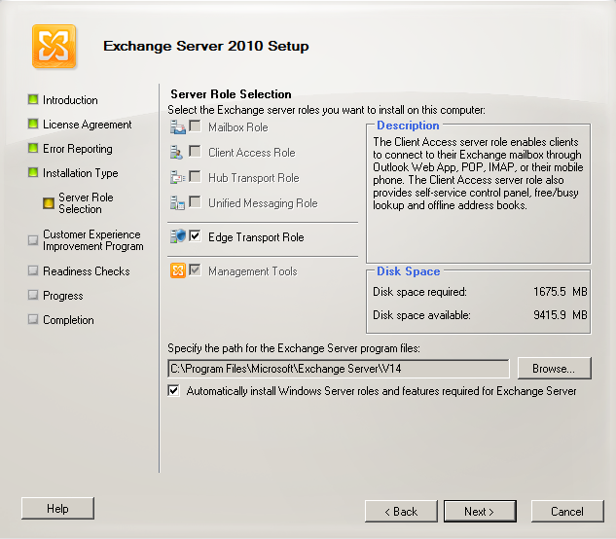
- On the “Customer Experience Improvement Program” page choose the appropriate option for the organization.
- On the Readiness Checks page, view the status to determine if the organization and server role prerequisite checks completed successfully. If they haven't completed successfully, you must resolve any reported errors before you can install Exchange 2010. You don't need to exit Setup when resolving some of the prerequisite errors. After resolving a reported error, click Retry to re-run the prerequisite check. Be sure to also review any warnings that are reported. If all readiness checks have completed successfully, click Install to install Exchange 2010.
Note:
If you select the option to install Windows roles and features, progress is shown and the appropriate roles and features are installed. If a reboot is required, you will have to reboot the server and launch Setup again. When Setup is launched again, Setup will resume where it left off.
- Verify that setup completes successfully without any errors before proceeding to next server
- Repeat steps for all servers following the order outlined in Section 6.11.1.
    - Product Key Configuration
- Launch the Exchange Management Shell with an account that has been delegated the Server Management role.
- Follow the procedure documented in the Enter Product Key topic in the Exchange Server 2010 Library (http://go.microsoft.com/fwlink/?LinkId=187234).
Set-ExchangeServer -Identity ExServer01 -ProductKey aaaaa-aaaaa-aaaaa-aaaaa-aaaaa
    - Exchange 2010 Update Rollup Installation
At the time of this writing Exchange 2010 Service Pack 2 is on UR2. New Exchange 2010 rollups get released roughly every 3 to 4 months. It is recommended that Aegis Media confirm there isn’t any new Update Rollup’s (UR) available at time of deployment into production. Follow the below steps to apply the most current Update Rollup.
- Connect to the server through Remote Desktop, and then log on with an account that has local administrative access.
- Obtain the latest company approved rollup, and then copy it to the server in the software directory.
- Go to D:\source\<rollup directory>
- Double-click the MSP file, and then follow the GUI instructions.
Note:
The Rollup Update can take upwards of 20 minutes to complete per server.
- Restart the server once the Rollup has completed which is indicated by the Finish button’s appearance.
    - Check Processor Scheduling Configuration
By default, Exchange 2010 optimizes the server’s processor scheduling management for background services.
- Connect to the server through Remote Desktop, and then log on with an account that has local administrative access.
- Click Start, right-click Computer, and then select Properties.
- Select the Advanced System Settings.
- Under Performance, click Settings.
- Click the Advanced tab.
- Verify that Processor Scheduling is set to Background Services.
- Click OK.
  - Exchange Edge Server Role Configuration
In order to facilitate automatic email routing and configuration from the Microsoft Exchange 2010 Edge servers to the Hub transport servers the following commands must be run.
In Aegis Media Exchange organization routes all outbound e-mail through a smart host, the default automatically created Send Connector to the Internet won't have the correct configuration.
In this scenario, Aegis Media run the following command in the Shell on the Hub Transport server to suppress automatic creation of the Send connector to the Internet.
- Open an Exchange 2010 Management shell window on Edge Transport Server.
- Run the following command on each Edge server to create the subscription file
New-EdgeSubscription -FileName "C:\EdgeSubEdgeserver1.xml"

Note:
This step will require Local Administrator on the Edge Server.
- Copy the subscription file to a hub transport server from Edge Transport Server.
- Open an Exchange 2010 management shell window on the Hub transport server
- Run the following command to import the edge subscription on each Hub Transport server in the matching AD site (aka EMEA Datacentre A Edge Server for EMEA Datacentre A-Site & EMEA Datacentre B Edge servers for EMEA Datacentre B-Site)
New-EdgeSubscription -FileData ([byte[]]$(Get-Content -Path "C:\EdgeSubEdgeserver1.xml" -Encoding Byte -ReadCount 0)) -CreateInternetSendConnector $false -CreateInboundSendConnector $true -Site " EMEA Datacentre A-Site"
Note:
This step will require Organization Management for the Hub Servers you’re running the command.
  - Routing Outbound E-Mail to a Smart Host
After the Edge Subscription process is complete, manually create a Send connector to the Internet. Create the Send connector inside the Exchange organization and select the Edge Subscription as the source server for the connector. Select the Custom usage and configure one or more smart hosts. The Send connector will be replicated to the AD LDS instance on the Edge Transport server the next time that EdgeSync synchronizes configuration data. You can also force EdgeSync synchronization to immediately start by running the Start-EdgeSynchronization cmdlet in the Shell on a Hub Transport server.
The following code provides an example of how to use the Shell to configure a Send connector for a subscribed Edge Transport server to route messages for all Internet address spaces through a smart host. This task is run inside the Exchange organization, not on the Edge Transport server.
New-SendConnector -Name "EdgeSync - Site-A to Internet" -Usage Custom -AddressSpaces SMTP:*;100 -DNSRoutingEnabled $false -SmartHosts 192.168.10.1 -SmartHostAuthMechanism None -SourceTransportServers EdgeSubscriptionName
Important:
This example doesn't specify any smart host authentication mechanism. Make sure that you configure the correct authentication mechanism and provide all necessary credentials when you create a smart host connector in your own Exchange organization.

- Deploying Unified Messaging
These steps are required to create a scalable and highly available system to support large numbers of Unified Messaging users. These steps are as follows:
- Deploy and configure your telephony components for Unified Messaging.
- Install the Unified Messaging server role.
- Create and configure the required Unified Messaging Active Directory components.
- Perform post deployment tasks for Unified Messaging.
  - Deploy and Configure Telephony Components
To successfully deploy an Exchange 2010 Unified Messaging server in an Exchange organization, the Exchange administrator must become knowledgeable about data networking concepts and telephony terminology and concepts and be able to correctly configure the telephony components that are required by Unified Messaging. Performing a new deployment or upgrading a legacy voice mail system requires significant knowledge about PBXs and Exchange 2010 Unified Messaging. For more information, see the Microsoft Exchange Server 2007 Unified Messaging (UM) Specialists Web site.
Generally, there are three tasks that must be completed to successfully configure the telephony components that are required by Unified Messaging:
- Provision PBX lines: The first step in deploying a scalable UM solution is to provision PBX lines.
- Organize channels: After you provision PBX-based voice channels, you can organize the channels as hunt groups.
- Deploy IP gateways: After you organize your voice channels as hunt groups, you must end these channels at IP gateways. IP gateways are used with a legacy PBX to convert the circuit-switched protocols found on a telephony network to IP-based packet-switched protocols.
When you integrate your organization's telephony and data networks during the deployment of Exchange 2010 Unified Messaging, you must configure the telephony and data networking components correctly. You must also configure the following components or interfaces to successfully deploy Unified Messaging:
- Configure the connection from the PBXs in your organization to communicate with your IP gateways. For details, see Configure an IP Gateway to Communicate with a PBX.
- Configure the connection from the IP gateway interface to the PBX. For more information about how to configure your PBX interface to communicate with your supported IP gateway, see the product documentation that's specific to your PBX. For details, see Configure an IP Gateway to Communicate with a PBX.
- Configure the connection from the IP gateway interface to the Exchange Server 2010 Unified Messaging server. For details, see Configure an IP Gateway or IP PBX for Use with a Unified Messaging Server.
- Configure the connection from the Unified Messaging server to the IP gateway interface. For details, see Connect a Unified Messaging Server to a Supported IP Gateway.
For more information about telephony components, see Understanding Telephony Concepts and Components.
  - Unified Messaging Server Configuration
The following media is required for this section.
- Windows Server 2008 R2 SP1 Standard Edition Installation Files
- Exchange 2010 SP2 Installation Files
- Exchange 2010 SP2 Rollup Update 2 or latest version
  - Additional Software Verification
All of the steps listed below leverage remote desktop for configuration. Be sure to enable remote desktop on all servers.
As an optional process, install Microsoft Network Monitor 3.4. This software will help with network troubleshooting. (http://go.microsoft.com/fwlink/?LinkId=86611).
  - Prerequisites and Hotfixes
Contained is a list of prerequisites and hotfixes that are required to be installed on all Exchange 2010 SP2 servers. Be sure to perform all below steps on servers that will host Exchange 2010 roles.
    - Hotfix Installs
Aegis Media has decided to deploy Exchange 2010 server on Windows 2008 R2 SP1 operating system. Service Pack 1 includes all required hotfixes for Exchange server deployment, no additional hotfixes required for this version of Windows.
    - Exchange Features Prerequisites
Exchange 2010 SP2 includes an option to “Automatically install Windows Server roles and features required for Exchange Server”. These steps can safely be skipped and performed during the Exchange install step.
  - Network Interfaces Configuration
The below network configurations are applicable to UM servers.
- Log on to the server with an account that has been delegated at least local administrative access.
- Click Start > Control Panel, and then double-click Network and Sharing Center.
- Click Manage Network Connections.
- Locate the connection for the internal network and rename it according to your organization's naming standards.
- Right-click the connection and then select Properties.
- For Internet Protocol Version 4 (TCP/IPv4), add the following:
  - Static IP Address, Subnet Mask, and Gateway
  - DNS Server IP Addresses
  - Select the check box to Append parent suffixes of the primary DNS suffix.
  - WINS IP Addresses (if using WINS)
- If you are using Internet Protocol Version 6 (TCP/IPv6), configure the IPv6 settings according to your organization's network standards.
Note: IPv6 should not be disabled on Exchange servers. For current guidance around network adapter configuration see the following blog article: Time to revisit recommendations around Windows networking enhancements usually called Microsoft Scalable Networking Pack
  - Domain Membership Configuration
UM servers will be part of global.loc domain.
- Connect to the server through Remote Desktop, and then log on with an account that has been delegated local administrative access.
- Click Start > right-click My Computer, and then select Properties.
- View the preview. If incorrect proceed to change settings.
- Under the Computer Name, domain, and workgroup settings, click Change Settings.
- Click Change.
- Choose the Domain option button, and then enter the appropriate domain name, global.loc.
- Enter the appropriate credentials.
- Click OK and OK.
- Click OK to close System Properties.
- Restart the server
  - Drive Configuration
- Connect to the server through Remote Desktop and then log on with an account that has been delegated local administrative access.
- Click Start > Administrative Tools, and then select Computer Management.
- Expand Storage and then click Disk Management.
- Using the Disk Management snap-in of the Microsoft Management Console (MMC), format, rename, and assign the appropriate Drive Letters so that the volumes and DVD drive match the appropriate server configuration.
LUN | Drive letter | Usage
1 | C | Operating system, Exchange binaries, and tracking logs
2 | Z | DVD drive
  - Windows Firewall
Because the Windows Firewall service applies Windows service hardening rules to standard Windows Networking services, Microsoft does not support stopping the Windows Firewall service. Aegis Media do not want to use Windows Firewall, turn the firewall features off by using the Group Policy settings, without stopping the service, as described in http://technet.microsoft.com/en-us/library/cc771032(WS.10).aspx.
- Connect to the server through Remote Desktop and then log on with an account that has been delegated local administrative access.
- Click Start > Administrative Tools, and then select Computer Management > Configuration > Services. Ensure the Windows Firewall is Automatic and Started.
- Connect to the server through Remote Desktop and then log on with an account that has been delegated local administrative access.
- Click Start > Administrative Tools, and then select Windows Firewall and Advanced Security.
- Select Windows Firewall and Advanced Security > Ensure Windows Firewall is off for Domain, Private, and Public Profile.
  - Local Administrators Verification
- Connect to the server through Remote Desktop and then log on with an account that has been delegated local administrative access.
- Click Start > Administrative Tools, and then select Computer Management.
- Select Configuration > Local Users and Groups > Groups > Administrators
- Verify (or add if not already there) that the Domain Admins account and the user account that will perform the Exchange installation are members of the local Administrators group on this server.
- Verify that the installation user account is a member of a group which is a member of the local Administrators group on the Windows Server 2008 server. If it is not, use an account that is a member of the local Administrators group before continuing.
    - Local Administrator Account Password Reset
- Connect to the server through Remote Desktop, and then log on with an account that has been delegated local administrative access.
- Click Start, right-click Computer, and then select Manage.
- Expand the nodes to find Configuration\Local Users and Groups\Users.
- Right-click Administrator and then select Set Password. Change the password so that it meets strong complexity requirements
  - Page File Modifications
- Connect to the server through Remote Desktop, and then log on with an account that has been delegated local administrative access.
- Click Start, right-click Computer, and then select Properties.
- Select the Advanced System Settings.
- Under Startup and Recovery, click Settings.
- Under Write Debugging Information, select Kernel Memory Dump from the memory dump drop-down list.
- Click OK.
- Under Performance, click Settings.
- Click the Advanced tab.
- Under Virtual Memory, click Change.
  - On all servers perform the following steps:
  - De-select Automatically Manage paging file size for all drives.
  - Set a Static page file on C:
  - In the Drive list, click C:, and then click Custom size.
  - Type 24586 in Initial Size (MB:) and Maximum Size (MB:)
  - The recommended size for a server with over 8 GB of memory is RAM + 10MB
    - 24 * 1024 = 24576 MB
    - 10 MB + 24576 MB = 24586 MB
    - Click Set
  - Click OK three times to close the System Properties dialog box.
- Clicks OK two times to close the System Properties dialog box.
- Click No if prompted to restart the system.
Note:
For more information about page file recommendations, see the following Microsoft Knowledge Base articles: How to determine the appropriate page file size for 64-bit versions of Windows Server 2003 or Windows XP and Overview of memory dump file options for Windows Vista, Windows Server 2008, Windows Server 2003, Windows XP, and Windows 2000
  - Unified Messaging Server Verification Steps
The following procedures are in this section:
- Organizational Unit Verification
- Active Directory Site Verification
- Domain Controller Diagnostics Verification
- Exchange Pre-Deployment Analyzer Verification
    - Organizational Unit Verification
Submit a change request to the appropriate operations group and have the computer object moved to the appropriate organizational unit (OU). Organizational Unit will be global.loc\Servers.
    - Active Directory Site Verification
- Connect to the server through Remote Desktop, and then log on with an account that has been delegated local administrative access.
- Open a Command Prompt window.
- Verify that the server is in the correct domain and Active Directory site. At the command line, type the following:
NLTEST /server:%COMPUTERNAME% /dsgetsite
- The name of the Active Directory site to which the server belongs will be displayed. If the server is not in the correct Active Directory site, submit a change request to the appropriate operations group and have the server moved to the appropriate Active Directory site.

Note:
It is required to have a Global Catalog server in every site that will host an Exchange 2010 Server. Ensure there are GC’s for all Exchange domains in the site verified in this step.
The proper site for all servers at Aegis Media is EMEA Datacentre A and EMEA Datacentre B
    - Domain Controller Diagnostics Verification
DCDIAG (Domain Controller Diagnostics) is a Windows support tool that tests network connectivity and DNS resolution for domain controllers.
- Connect to the server through Remote Desktop, and then log on with an account that has been delegated local administrative access.
- Open a Command Prompt window, and then change paths to the C drive.
- Run the following command:
dcdiag /s:<Domain Controller> /test:connectivity /f:c:\dcdiag.log

Note:
Rerun the command with each <domain Controller> within the same Domain and AD site that Exchange server is being deployed. Ensure that root forest domain controllers for the same AD Site are also tested.
- Review the output of C:\dcdiag.log file, and verify that there are no connectivity issues with the local domain controller.
- Repeat steps 3 and 4 for each domain controller in the local Active Directory site.
Note:
If the account being used does not have administrative privileges, several tests under the Doing primary tests heading may not pass. These tests can be ignored if the connectivity tests pass. In addition, the log file may report that some service validation tests did not pass. These messages can be ignored if the services do not exist on the domain controller.
    - Exchange Pre-Deployment Analyzer Verification
You can use the Exchange Pre-Deployment Analyzer (ExPDA) to perform an overall topology readiness scan of your environment. When you run ExPDA, it provides a detailed report that will alert you if there are any issues within your organization, which could prevent you from deploying Exchange 2010. For example, ExPDA will notify you if you haven't deployed the minimum required Exchange service pack on all your existing Exchange servers. You can download ExPDA from the Microsoft Download Center at http://go.microsoft.com/fwlink/?LinkId=184599.
- Connect via Remote Desktop to a server in the environment that has ExPDA installed, and then log on with an account that has been delegated local administrative access. Depending on the configuration, do the following:
- Click Start > All Programs > Exchange Readiness Tools and then select Pre-Deployment Analyzer Tool.
- Select Check for updates on startup (recommended), choose a Customer Experience Improvement Program option, select Check for updates now and apply any updates for ExPDA.
- On the Welcome page, choose Select options for a new scan.
- Provide the appropriate information to connect to Active Directory and click Connect to the Active Directory server.
- On the Start a new Best Practices Scan page, click Start Scanning.
- Review the report and take action on any errors or warnings that are reported by following the resolution articles that are provided within ExPDA.

  - Unified Messaging Role Installation Steps
The following media is required for this section.
- Microsoft Exchange Server 2010 SP2 installation files
- Update Rollup 2 for Exchange Server 2010 Service Pack 2
The following procedures are in this section:
- Installation Order
- Exchange 2010 Unattended Install Steps
- Exchange 2010 Manual Installation Steps
- Product Key Configuration
- Exchange 2010 Update Rollup Installation
- Install the Unified Messaging Language Packs
- System Performance Verification
This section includes both unattended and manual methods of performing Exchange role installations. Choose one and proceed to implement those steps.
    - Installation Order
Server Roles | Datacentre
Unified Messaging Server 1 | EMEA Datacentre A
Unified Messaging Server 2 | EMEA Datacentre A
Unified Messaging Server 1 | EMEA Datacentre B
Unified Messaging Server 2 | EMEA Datacentre B
    - Exchange 2010 Unattended Install Steps
You can now select the /InstallWindowsComponents parameter during an unattended install of Exchange 2010 SP1. If you select the option to install Windows roles and features, progress is shown and the appropriate roles and features are installed. If a reboot is required, you will have to reboot the server and launch Setup.com again with the /InstallWindowsComponents parameter. If the Windows roles and features were correctly installed Setup.com will continue installing Exchange.
Follow the procedure detailed in the Install Exchange 2010 in Unattended Mode topic in the Exchange Server 2010 Library.
Use the below commands to install all proper server role required
From an elevated command prompt (not PowerShell)
For Unified Messaging Role:

<Exchange 2010 SP2 installation media>\setup.com /m:install /role:U /InstallWindowsComponents
    - Exchange 2010 Manual Installation Steps
If preferred you can manually install Exchange on each server by following the below steps.
On the Start page, make sure that you've completed Steps 1 through 3. If you haven't already installed the components discussed in those steps, Setup will link you to the appropriate sites where you can download the components. For more information about Windows PowerShell installation, see Install Windows Management Framework.
Important:
If you're installing Exchange 2010 on Windows Server 2008 R2, don't use the downloadable .NET Framework package. Instead, use Server Manager in Windows Server 2008 R2 or run ServerManagerCmd -i NET-Framework
- On the welcome screen select “Next” to continue
- Accept license agreement and click Next
- Select No on the Error Reporting page
- Select Custom Exchange Server Installation and specify the path for Exchange Server Program files.
- From Server Role selection, select “Unified Messaging” and click Next. Be sure to select the “Automatically install Windows Server roles and features required for Exchange Server”
- On the “Customer Experience Improvement Program” page choose the appropriate option for the organization.
- On the Readiness Checks page, view the status to determine if the organization and server role prerequisite checks completed successfully. If they haven't completed successfully, you must resolve any reported errors before you can install Exchange 2010. You don't need to exit Setup when resolving some of the prerequisite errors. After resolving a reported error, click Retry to re-run the prerequisite check. Be sure to also review any warnings that are reported. If all readiness checks have completed successfully, click Install to install Exchange 2010.
Note:
If you select the option to install Windows roles and features, progress is shown and the appropriate roles and features are installed. If a reboot is required, you will have to reboot the server and launch Setup again. When Setup is launched again, Setup will resume where it left off.
- Verify that setup completes successfully without any errors before proceeding to next server
- Repeat steps for all servers following the order outlined in Section 7.12.1.
    - Product Key Configuration
- Launch the Exchange Management Shell with an account that has been delegated the Server Management role.
- Follow the procedure documented in the Enter Product Key topic in the Exchange Server 2010 Library (http://go.microsoft.com/fwlink/?LinkId=187234).
Set-ExchangeServer -Identity ExServer01 -ProductKey aaaaa-aaaaa-aaaaa-aaaaa-aaaaa
    - Exchange 2010 Update Rollup Installation
At the time of this writing Exchange 2010 Service Pack 2 is on UR2. New Exchange 2010 rollups get released roughly every 3 to 4 months. It is recommended that Aegis Media confirm there isn’t any new Update Rollup’s (UR) available at time of deployment into production. Follow the below steps to apply the most current Update Rollup.
- Connect to the server through Remote Desktop, and then log on with an account that has local administrative access.
- Obtain the latest company approved rollup, and then copy it to the server in the software directory.
- Go to D:\source\<rollup directory>
- Double-click the MSP file, and then follow the GUI instructions.
Note:
The Rollup Update can take upwards of 20 minutes to complete per server.
- Restart the server once the Rollup has completed which is indicated by the Finish button’s appearance.
    - Install the Unified Messaging Language Packs
To make a language available in the list of available Unified Messaging languages on the Settings tab of a UM dial plan, you must first install the appropriate UM language pack. You install the language pack on a Unified Messaging server by using the language-specific self-extracting executable file or the setup.com /AddUmLanguagePack command. Before you can install a UM language pack, you must first download it to a local folder on the UM server. You can download UM language packs from Exchange Server 2010 SP2 UM Language Packs.
After you install the appropriate UM language pack, you can view the list of installed UM language packs by viewing the properties on the UM Settings tab of a Unified Messaging server. You can also configure the default language to be a language other than English (en-US) on UM dial plans and auto attendants.
Caution:
The UM language packs for Microsoft Exchange Server 2007 or Exchange 2007 Service Pack 1 (SP1), SP2, or SP3 can't be used on an Exchange 2010 Unified Messaging server. The UM language packs for Exchange Server 2010 RTM or SP1 can’t be installed on a UM server running Exchange 2010 SP2
Use the UM Language Pack Installation file to install a UM language pack
You need to be assigned permissions before you can perform this procedure. To see what permissions you need, see the "UM server" entry in the Unified Messaging Permissions topic.
- From the Microsoft Download Center, download the language-specific UM language pack file into a local folder on the UM server.
- Double-click the UMLanguagePack.<CultureCode>.exe file. For example, for the German UM language pack, you would download the file named UMLanguagePack.de-DE.exe.
- In the Exchange Server 2010 Setup wizard, on the License Agreement page, read the terms of the agreement, select I accept the terms in the license agreement, and then click Next.
- On the Unified Messaging Language Pack page, verify that the correct language is listed in the The following Unified Messaging Language Pack(s) will be installed window, and then click Install.
- On the Completion page, confirm whether the UM language pack was successfully installed.
  - A status of Completed indicates that the wizard completed the task successfully.
  - A status of Failed indicates that the task wasn't completed. If the task fails, review the summary for an explanation, and then click Back to make any configuration changes.
- Click Finish to complete the installation of the UM language pack.
Use setup.com to install a UM language pack
You need to be assigned permissions before you can perform this procedure. To see what permissions you need, see the "UM server" entry in the Unified Messaging Permissions topic.
This example installs the Japanese (ja-JP) UM language pack that's been downloaded to the D:\Exchange\UMLanguagePacks folder on a Unified Messaging server.
setup.com /AddUmLanguagePack:ja-JP /s:d:\Exchange\UMLanguagePacks
This example installs the Mexican Spanish (es-MX) and German (de-DE) UM language packs that have been downloaded to the D:\Exchange\UMLanguagePacks folder on a UM server.
setup.com /AddUmLanguagePack:es-MX,de-DE /s:d:\Exchange\UMLanguagePacks
For more information about available UM languages and the culture codes, see Understanding Unified Messaging Languages.
    - Check Processor Scheduling Configuration
By default, Exchange 2010 optimizes the server’s processor scheduling management for background services.
- Connect to the server through Remote Desktop, and then log on with an account that has local administrative access.
- Click Start, right-click Computer, and then select Properties.
- Select the Advanced System Settings.
- Under Performance, click Settings.
- Click the Advanced tab.
- Verify that Processor Scheduling is set to Background Services.
- Click OK.
  - Create and Configure UM Components
There are several UM components in Active Directory that are required for the deployment and operation of Exchange 2010 Unified Messaging. Unified Messaging components in Active Directory connect the telephony infrastructure with the Unified Messaging Active Directory environment. After you've successfully installed the Unified Messaging server role on at least one computer, follow these steps.
    - Create and configure UM dial plans
UM dial plans are integral to the operation of Exchange 2010 Unified Messaging and are required to successfully deploy Unified Messaging on your network. After you've successfully installed the Unified Messaging server role, a UM dial plan will be the first Active Directory component that you'll create.
By default, UM dial plans and the Unified Messaging servers that are associated with the dial plan send and receive data without using encryption. In Unsecured mode, the VoIP and SIP traffic won't be encrypted. When you create the dial plan or after you've created the dial plan, you can configure the dial plan to encrypt the VoIP and SIP traffic by using Mutual Transport Layer Security (mutual TLS). After you configure the VoIP security setting, you'll then have to configure the startup mode for the UM server. For details, see Configure the Startup Mode on a UM Server.
Perform one of the following procedures to create a new UM dial plan.
Use the EMC to create a UM dial plan
You need to be assigned permissions before you can perform this procedure. To see what permissions you need, see the "UM dial plans" entry in the Unified Messaging Permissions topic.
- In the console tree, navigate to Organization Configuration > Unified Messaging.
- In the action pane, click New UM Dial Plan.
- In the New UM Dial Plan wizard, complete the following fields:
  - Name Type the name of the dial plan. A UM dial plan name is required and must be unique. However, the name you type is used only for display purposes in the EMC and the Shell. If you have to change the display name of the dial plan after it's been created, you must first delete the existing UM dial plan and then create another dial plan that has the appropriate name. If your organization uses multiple UM dial plans, we recommend that you use meaningful names for your UM dial plans. The maximum length of a UM dial plan name is 64 characters, and it can include spaces. However, it can't include any of the following characters: " / \ [ ] : ; | = , + * ? < >.
Important:
Although the field for the name of the dial plan can accept 64 characters, the name of the dial plan can't be longer than 49 characters. This is because, when you create a dial plan, a default UM mailbox policy is also created that has the name <DialPlanName> Default Policy. The name parameter for both the UM dial plan and UM mailbox policy can be 64 characters long.
  - Number of digits in extension numbers Enter the number of digits for extension numbers in the dial plan. The number of digits for extension numbers is based on the telephony dial plan created on a Private Branch eXchange (PBX). For example, if a user associated with a telephony dial plan dials a four-digit extension to call another user in the same telephony dial plan, you select 4 as the number of digits in the extension.
This is a required field that has a value range from 1 through 20. The typical extension length is from 3 through 7. If your existing telephony environment includes extension numbers, you must specify a number of digits that matches the number of digits in those extensions.
When you create a Session Initiation Protocol (SIP) dial plan or an E.164 dial plan and associate a UM-enabled user with the dial plan, you must still enter an extension number to be used by the user. This number is used by Outlook Voice Access users when they access their Exchange 2010 mailbox.
  - URI Type Use this drop-down list to select the URI type for the UM dial plan. A URI is a string of characters that identifies or names a resource. The main purpose of this identification is to enable VoIP devices to communicate with other devices over a network using specific protocols. URIs are defined in schemes that define a specific syntax, format, and the protocols for the call.
You can select one of the following URI types for the dial plan:
Telephone extension This is the most common URI type. The calling and called party information from the IP gateway or IP PBX will be listed in one of the following formats: Tel:512345 or 512345@<IP address>. This is the default URI type for dial plans.
SIP URI Use this URI type if you need a SIP URI dial plan when an IP PBX supports SIP routing or if you're integrating Microsoft Office Communications Server 2007 and Exchange Unified Messaging. The calling and called party information from the IP gateway or IP PBX will be listed as a SIP address in the following format: sip:<username>@<domain or IP address>:Port.
E.164 E.164 is an international numbering plan for public telephone systems in which each assigned number contains a country/region code, a national destination code, and a subscriber number. The calling and called party information sent from the IP gateway is listed in the following format: Tel:+14255550123.
Note:
After you create a dial plan, you will be unable to change the URI type without deleting the dial plan, and then re-creating the dial plan to include the correct URI type.
  - VoIP Security Use this drop-down list to select the VoIP security setting for the UM dial plan. By default, when you create a UM dial plan, it communicates in unsecured mode. A Unified Messaging server can operate in any mode configured on a dial plan because the Unified Messaging server is configured to listen on TCP port 5060 for unsecured requests and on TCP port 5061 for secured requests at the same time.
You can select one of the following security settings for the dial plan:
Unsecured By default, when you create a UM dial plan, it communicates in unsecured mode, and the Unified Messaging servers associated with the UM dial plan send and receive data from IP gateways, IP PBXs, and other Exchange 2010 computers using no encryption. In unsecured mode, both the Realtime Transport Protocol (RTP) media channel and SIP signaling information aren't encrypted.
SIP secured When you select SIP secured, only the SIP signaling traffic is encrypted, and the RTP media channels still use TCP, which isn't encrypted. Mutual Transport Layer Security (TLS) is used to encrypt the SIP signaling traffic.
Secured When you select Secured, both the SIP signaling traffic and the RTP media channels are encrypted. An encrypted signaling media channel that uses Secure Realtime Transport Protocol (SRTP) also uses mutual TLS to encrypt the VoIP data.
  - Country/Region code Use this field to type the country/region code number to be used for outgoing calls. This number will automatically be prepended to the telephone number that's dialed. This field accepts from 1 through 4 digits. For example, in the United States, the country/region code is 1. In the United Kingdom, it's 44.
- On the Set UM Servers page, click Add and then on the Select UM Server page select the UM server that you want to add to the UM dial plan.
- On the Completion page, confirm whether the dial plan was successfully created:
  - A status of Completed indicates that the wizard completed the task successfully.
  - A status of Failed indicates that the task wasn't completed. If the task fails, review the summary for an explanation, and then click Back to make any configuration changes.
- Click Finish to complete the New UM Dial Plan wizard.
Use the Shell to create a UM dial plan
You need to be assigned permissions before you can perform this procedure. To see what permissions you need, see the "UM dial plans" entry in the Unified Messaging Permissions topic.
This example creates a new UM dial plan named MyUMDialPlan that uses four-digit extension numbers.
New-UMDialplan -Name MyUMDialPlan -NumberofDigits 4
This example creates a new UM dial plan named MyUMDialPlan that uses five-digit extension numbers and supports SIP URIs:
New-UMDialplan -Name MyUMDialPlan -UriType SIPName -NumberofDigits 5
For more information about syntax and parameters, see Set-UMDialplan.
    - Create and configure your UM IP gateways
A UM IP gateway represents either an IP gateway hardware device or an IP PBX hardware device. The combination of the UM IP gateway object and a UM hunt group object establishes a logical link between an IP gateway or IP PBX and a UM dial plan.
If you've created or enabled VoIP security on a dial plan, the UM IP gateway that you will create by using one of the following procedures in this section will be associated with a UM dial plan that uses VoIP security. In that case, you must use a fully qualified domain name (FQDN) to create the UM IP gateway, and not an IP address. You must also configure the UM IP gateway to listen on TCP port 5061. To configure a UM IP gateway to listen on TCP port 5061, run the following command: Set-UMIPGateway -identity MyUMIPGateway -Port 5061. You must also verify that any IP gateways or IP PBXs have also been configured to listen on port 5061 for mutual TLS.
Perform one of the following procedures to create a new UM IP gateway.
Use the EMC to create a UM IP gateway
- In the console tree, navigate to Organization Configuration > Unified Messaging.
- In the result pane, click the UM IP Gateways tab.
- In the action pane, click New UM IP Gateway.
- In the New UM IP Gateway wizard, in the Name section, type the name of the UM IP gateway. This is the display name for the UM IP gateway.
- In the IP Address section, type the IP address for the UM IP gateway, and then click New.
Important:
Alternatively, you can enter an FQDN for the UM IP gateway. If you choose to use an FQDN, you must add the appropriate host records with the correct IP addresses to the DNS zone. If you're configuring a UM IP gateway that will be associated with a dial plan that's operating in Secured mode, you must create the UM IP gateway with an FQDN.
- On the New UM IP Gateway page, click New.
- On the Completion page, click Finish.
Use the Shell to create a UM IP gateway
You need to be assigned permissions before you can perform this procedure. To see what permissions you need, see the "UM IP gateways" entry in the Unified Messaging Permissions topic.
This example creates a UM IP gateway named MyUMIPGateway that enables a Unified Messaging server to start accepting calls from an IP gateway that has an IP address of 10.10.10.1.
New-UMIPGateway -Name MyUMIPGateway -Address 10.10.10.1
This example creates a UM IP gateway named MyUMIPGateway that enables a Unified Messaging server to start accepting calls from an IP gateway that has an FQDN of MyUMIPGateway.contoso.com and listens on port 5061.
New-UMIPGateway -Name MyUMIPGateway -Address "MyUMIPGateway.contoso.com" -Port 5061
For more information about syntax and parameters, see New-UMIPGateway.
    - Create and configure your UM hunt groups (optional)
Hunt group is a term that's used to describe a group of PBX or IP PBX resources or extension numbers that are shared by users. Hunt groups are used to efficiently distribute calls into or out of a given business unit.
If you've created a UM IP gateway and associated the UM IP gateway with a UM dial plan, a default UM hunt group is created. You can associate another UM hunt group with the same or a different UM IP gateway, depending on the number of UM IP gateways that you've created.
When you create a UM hunt group, you enable all Unified Messaging servers that are specified within the UM dial plan to communicate with an IP gateway. To learn more about UM hunt groups, see Understanding Unified Messaging Hunt Groups. To create a new UM hunt group, perform one of the following procedures.
Use the EMC to create a UM hunt group
You need to be assigned permissions before you can perform this procedure. To see what permissions you need, see the "UM hunt groups" entry in the Unified Messaging Permissions topic.
- In the console tree, navigate to Organization Configuration > Unified Messaging.
- In the work pane, click the UM IP Gateways tab.
- In the result pane, select a UM IP gateway.
- In the action pane, click New UM Hunt Group.
- In the New UM Hunt Group wizard, view or complete the following fields:
  - Associated UM IP gateway This display-only field shows the name of the UM IP gateway that will be associated with the UM hunt group.
  - Name Use this text box to create the display name for the UM hunt group. A UM hunt group name is required and must be unique, but it's used only for display purposes in the EMC and the Shell. If you have to change the display name of the hunt group after it's been created, you must first delete the existing hunt group and then create another hunt group that has the appropriate name.
If your organization uses multiple hunt groups, we recommend that you use meaningful names for your hunt groups. The maximum length of a UM hunt group name is 64 characters, and it can include spaces. However, it can't include any of the following characters: " / \ [ ] : ; | = , + * ? < >.
  - Dial plan Click the Browse button to select the dial plan that will be associated with the UM hunt group. Associating a hunt group with a dial plan is required. A UM hunt group can be associated with only one UM IP gateway and one UM dial plan.
  - Pilot identifier Use this text box to specify a string that uniquely identifies the pilot identifier or pilot ID configured on the PBX or IP PBX.
An extension number or a SIP URI can be used in this field. Alphanumeric characters are accepted in this field. For legacy PBXs, a numeric value is used as a pilot identifier. However, some IP PBXs can use SIP URIs.
- On the Completion page, confirm whether the UM hunt group was successfully created:
  - A status of Completed indicates that the wizard completed the task successfully.
  - A status of Failed indicates that the task wasn't completed. If the task fails, review the summary for an explanation, and then click Back to make any configuration changes.
- Click Finish to complete the New UM Hunt Group wizard.
Use the Shell to create a UM hunt group
You need to be assigned permissions before you can perform this procedure. To see what permissions you need, see the "UM hunt groups" entry in the Unified Messaging Permissions topic.
This example creates a UM hunt group named MyUMHuntGroup that has a pilot identifier of 12345.
New-UMHuntGroup -Name MyUMHuntGroup -PilotIdentifier 12345 -UMDialplan MyUMDialPlan -UMIPGateway MyUMIPGateway
This example creates a UM hunt group named MyUMHuntGroup that has multiple pilot identifiers.
New-UMHuntGroup -Name MyUMHuntGroup -PilotIdentifier 5551234,55555 -UMDialplan MyUMDialPlan -UMIPGateway MyUMIPGateway
For more information about syntax and parameters, see New-UMHuntGroup.
    - Create and configure a UM mailbox policy
UM mailbox policies are required when you enable users for Exchange 2010 Unified Messaging. The mailbox of each UM-enabled user must be linked to a single UM mailbox policy. After you create a UM mailbox policy, you link one or more UM-enabled mailboxes to the UM mailbox policy. This lets you control PIN security settings such as the minimum number of digits in a PIN or the maximum number of failed sign-in attempts for the UM-enabled users who are associated with the UM mailbox policy.
Every time that you create a UM dial plan, a UM mailbox policy is also created. The UM mailbox policy will be named <DialPlanName> Default Policy. However, if you have to create a new UM mailbox policy, perform one of the following procedures.
Use the EMC to create a UM mailbox policy
You need to be assigned permissions before you can perform this procedure. To see what permissions you need, see the "UM mailbox policies" entry in the Unified Messaging Permissions topic.
- In the console tree, navigate to Organization Configuration > Unified Messaging.
- In the work pane, click the UM Mailbox Policies tab.
- In the action pane, click New UM Mailbox Policy.
- In the New UM Mailbox Policy wizard, complete the following fields:
  - Name Use this text box to specify a unique name for the UM mailbox policy. If you must change the display name of the UM mailbox policy after it's been created, you must first delete the existing UM mailbox policy, and then create another UM mailbox policy that has the appropriate name. To delete the UM mailbox policy, there must not be any UM-enabled users associated with the UM mailbox policy.
The UM mailbox policy name is required, but it's used for display purposes only. Because your organization may use multiple UM mailbox policies, we recommend that you use meaningful names for your UM mailbox policies. The maximum length of a UM mailbox policy name is 64 characters, and it can include spaces. However, it cannot include any of the following characters: " / \ [ ] : ; | = , + * ? < >.
  - Select associated dial plan Click Browse to select the UM dial plan that will be associated with the UM mailbox policy. You must associate a UM mailbox policy with at least one UM dial plan. However, you can also associate multiple UM mailbox policies with a single dial plan.
- On the Completion page, confirm whether the UM mailbox policy was successfully created:
  - A status of Completed indicates that the wizard completed the task successfully.
  - A status of Failed indicates that the task wasn't completed. If the task fails, review the summary for an explanation, and then click Back to make any configuration changes.
- Click Finish to complete the New UM Mailbox Policy wizard.
Use the Shell to create a UM mailbox policy
You need to be assigned permissions before you can perform this procedure. To see what permissions you need, see the "UM mailbox policies" entry in the Unified Messaging Permissions topic.
This example creates a UM mailbox policy named MyUMMailboxPolicy associated with a UM dial plan named MyUMDialPlan.
New-UMMailboxPolicy -Name MyUMMailboxPolicy -UMDialPlan MyUMDialPlan
For more information about syntax and parameters, see New-UMMailboxPolicy.
    - Add a Unified Messaging server to dial plans
After you install the Unified Messaging server role, the UM server can't answer incoming calls until you add it to a UM dial plan. Although the status of the Exchange 2010 Unified Messaging server is set to enabled after installation, there's a parameter that's used to enable or disable the status of the Unified Messaging server.
A Unified Messaging server can be associated with a single or multiple UM dial plans. A single UM server can be added to a multiple dial plans that use mutual TLS (Secured), SIP secured, or TCP (Unsecured). To add a UM server to a dial plan, perform one of the following procedures.
Use the EMC to add a UM server to a dial plan
You need to be assigned permissions before you can perform this procedure. To see what permissions you need, see the "UM dial plans" entry in the Unified Messaging Permissions topic.
- In the console tree, click Server Configuration.
- In the result pane, select the Unified Messaging server you want to add to a dial plan.
- In the action pane, click Properties.
- On the UM Settings > Associated Dial Plans, click Add.
- In the Select Dial Plan window, from the list of available dial plans, select the dial plan you want to add the UM server to, and then click OK.
Use the Shell to add a UM server to a dial plan
You need to be assigned permissions before you can perform this procedure. To see what permissions you need, see the "UM dial plans" entry in the Unified Messaging Permissions topic.
This example adds a Unified Messaging server to a dial plan named MyUMDialPlan and prevents the UM server from accepting new calls. It also sets the startup mode to dual mode, which enables the UM server to accept TCP and TLS requests.
Set-UMServer -Identity MyUMServer -DialPlans MyUMDialPlan -Status Disabled -UMStartupMode Dual
This example adds the Unified Messaging server named MyUMServer to two UM dial plans, named MyUMDialPlan and MyUMDialPlan2, and also sets the maximum number of incoming voice and fax calls.
Set-UMServer -Identity MyUMServer -DialPlans MyUMDialPlan, MyUMDialPlan2 -MaxCallsAllowed 50
For more information about syntax and parameters, see Set-UMServer.
    - Create and configure UM auto attendants (optional)
Exchange 2010 Unified Messaging enables you to create one or more UM auto attendants, depending on the needs of your organization. When you create a UM auto attendant, you create a voice menu system for your organization. Callers from outside or inside your organization can then move through the menu system to locate and place or transfer calls to users or departments in your organization.
Callers can move through the menu system by using dual tone multi-frequency (DTMF), also known as touchtone, or voice inputs. For automatic speech recognition (ASR) to work, so users can use voice inputs, you must speech-enable the UM auto attendant.
Creating and using auto attendants is optional in Exchange 2010 Unified Messaging. However, if you want to create a new UM auto attendant, perform one of the following procedures.
Use EMC to create a UM auto attendant
You need to be assigned permissions before you can perform this procedure. To see what permissions you need, see the "UM auto attendants" entry in the Unified Messaging Permissions topic.
- In the console tree, navigate to Organization Configuration > Unified Messaging.
- In the work pane, click the UM Auto Attendants tab.
- In the action pane, click New UM Auto Attendant.
- In the New UM Auto Attendant wizard, complete the following fields:
  - Name Use this text box to create the display name for the UM auto attendant. A UM auto attendant name is required and must be unique. However, it's used only for display purposes in the EMC and the Shell.
If you have to change the display name of the auto attendant after it's created, you must first delete the existing UM auto attendant and then create another UM auto attendant that has the appropriate name. If your organization uses multiple UM auto attendants, we recommend that you use meaningful names for your UM auto attendants. The maximum length of a UM auto attendant name is 64 characters, and it can include spaces.
  - Select associated dial plan Click Browse to select the UM dial plan to associate with this UM auto attendant. Selecting and associating a UM dial plan with the auto attendant is required. A UM auto attendant can be associated with only one UM dial plan.
  - Extension numbers Use this field to enter the extension number that callers will use to reach the auto attendant. Type an extension number in the box, and then click Add to add the number to the list. The number of digits in the extension number that you provide doesn't have to match the number of digits for an extension number configured on the associated UM dial plan. This is because direct calls are allowed to UM auto attendants.
You can also create a new auto attendant without adding an extension number, because an extension number isn't required.
You can edit or remove an existing extension number. To edit an existing extension number, click Edit. To remove an existing extension number from the list, click Remove.
  - Create auto attendant as enabled Select this option to enable the auto attendant to answer incoming calls when you complete the New UM Auto Attendant wizard. By default, a new auto attendant is created as disabled.
If you decide to create the UM auto attendant as disabled, you can use the EMC or the Shell to enable the auto attendant after you finish the wizard.
  - Create auto attendant as speech-enabled Select this check box to speech-enable the UM auto attendant. When you speech-enable the auto attendant, callers will be able to respond to the system or custom prompts used by the UM auto attendant using touchtone or voice inputs. By default, the auto attendant won't be speech-enabled when it's created.
For callers to use a speech-enabled auto attendant, you must install the appropriate Unified Messaging language pack that contains Automatic Speech Recognition (ASR) support and configure the properties of the auto attendant to use this language.
- On the Completion page, confirm whether the UM auto attendant was successfully created:
  - A status of Completed indicates that the wizard completed the task successfully.
  - A status of Failed indicates that the task wasn't completed. If the task fails, review the summary for an explanation, and then click Back to make any configuration changes.
- Click Finish to complete the New UM Auto Attendant wizard.
Use the Shell to create a new UM auto attendant
You need to be assigned permissions before you can perform this procedure. To see what permissions you need, see the "UM auto attendants" entry in the Unified Messaging Permissions topic.
This example creates a UM auto attendant named MyUMAutoAttendant that can accept incoming calls but isn't speech-enabled.
New-UMAutoAttendant -Name MyUMAutoAttendant -UMDialPlan MyUMDialPlan -PilotIdentifierList 55000 -Enabled $true
This example creates a speech-enabled UM auto attendant named MyUMAutoAttendant.
New-UMAutoAttendant -Name MyUMAutoAttendant -UMDialPlan MyUMDialPlan -PilotIdentifierList 56000,56100 -SpeechEnabled $true
For more information about syntax and parameters, see New-UMAutoAttendant.
After you've created a non-speech-enabled or a speech-enabled auto attendant, you must create and configure key mappings so that the auto attendant can function correctly. If you don't enable key mappings for either business or non-business hours, callers will hear the voice prompts but won't be able to interact with the auto attendant. To create key mappings for an auto attendant, see the following topics:
- Enable Business Hours Key Mappings on a UM Auto Attendant
- Enable Non-Business Hours Key Mappings on a UM Auto Attendant
- Configure Key Mapping Entries on a UM Auto Attendant
    - Post Deployment Tasks for Unified Messaging
After you complete a new installation of the Unified Messaging server role and have successfully deployed Unified Messaging, you should complete the post-installation tasks. The post-deployment tasks will help you enable users for Unified Messaging, secure your UM deployment, and deploy incoming faxing for UM-enabled users.
      - Enabling Users for Unified Messaging
After you've deployed your IP gateways or IP PBXs, installed the Unified Messaging server role, and created the Active Directory components for Unified Messaging, you must enable your users for Unified Messaging. For details, Enable a User for Unified Messaging.
      - Secure Your UM Deployment
You can help increase the level of protection for your network if you correctly plan a UM security strategy and then correctly configure the security settings for UM servers and UM-enabled users.
Mutual TLS for UM
To use mutual TLS to encrypt SIP and Real-time Transport Protocol (RTP) traffic that's sent and received by your Unified Messaging servers, perform the following tasks:
- Run the Exchange Certificate wizard. For details, see Create a New Exchange Certificate.
- Associate the certificate with the UM server.
- Import the required certificates on the IP gateways and the IP PBX and Unified Messaging servers in your organization. To import an Exchange certificate, see Import an Exchange Certificate.
- Configure VoIP security on the UM dial plans. For details, see Configure VoIP Security on a UM Dial Plan.
- Configure the startup mode on the Unified Messaging server. For details, see Configure the Startup Mode on a UM Server.
- Configure the UM IP gateways to listen on port 5061. For details, see Configure the TCP Listening Port on a UM IP Gateway.
For more information about VoIP security with Unified Messaging, see Understanding Unified Messaging VoIP Security.
      - PIN Policies for UM-enabled Users
In Exchange 2010 Unified Messaging, PIN policies are defined and configured on a UM mailbox policy. Multiple UM mailbox policies can be created, depending on your requirements. When you enable a user for Exchange 2010 Unified Messaging, you associate the user with an existing UM mailbox policy. The UM PIN policies that are configured on the UM mailbox policy should be based on the security requirements of your organization. For more information about how to configure PIN settings for UM-enabled users, see Configuring Security for Unified Messaging Users.

- Handoff Tests
Aegis Media can run below tests to validate that Exchange 2010 role installation and configuration is successful and working as expected.
Before you can complete the diagnostic tasks in this section, you must have already created test mailboxes in your environment by using the New-TestCasConnectivityUser.ps1 script.
  - Create Test Mailboxes
1. Connect to the Exchange 2010 Mailbox server through Remote Desktop and log on with an account that has local administrative access and was delegated the Server Management role.
2. Click Start > All Programs > Microsoft Exchange Server 2010, and then select Exchange Management Shell.
3. Change the directory path to <Exchange Server Install Path>\Scripts.
4. Type .\new-TestCasConnectivityUser.ps1 and press Enter.
5. Enter a temporary password and follow the prompts to create the test mailboxes.

Note:
There must be a user created for each site that has Exchange Mailboxes to be tested. Run the command from at least one server in each site. Additionally there are switches to create the user account in a specific OU if required.
  - Client Access Server Handoff Test
1. If the server has not been restarted as a result of a previous section’s instructions, restart the server.
2. Launch the Exchange Management Shell with an account that has been delegated the Server Management role.
3. To test Exchange ActiveSync connectivity, run the following command where <Server> is the name of the Client Access server:
Test-ActiveSyncConnectivity –ClientAccessServer <Server>
4. To test Autodiscover connectivity, run the following command where <EmailAddress> is the e-mail address of a mailbox:
Add-TargetAddress <EmailAddress>
5. To test Exchange Web Services functionality, run the following command:
Test-WebServicesConnectivity –ClientAccessServer <Server> –AllowUnsecureAccess
6. To test Outlook Web App connectivity, run the following command where <Server> is the name of the Client Access server:
Test-OwaConnectivity -ClientAccessServer:<Server> -AllowUnsecureAccess
If this server will be responding to Internet client requests, consider using the Exchange Remote Connectivity Analyzer (https://www.testexchangeconnectivity.com/) to verify your configuration, as well.
For more details on CAS handoff tests see the TechNet article entitled Installation Guide Template - Client Access Server
  - Hub Transport Handoff Test
            - If the server had not been restarted as a result of a previous section’s instructions, then restart the server.
            - Using a test mailbox, send sample messages to various mailboxes and verify that mail is successfully delivered.
            - Send sample messages from Internet mailboxes to various internal test mailboxes, and verify that the mail is successfully delivered.
            - Review the event logs and tracking logs and ensure that the Hub Transport server is operating correctly.
For more details on CAS handoff tests see the TechNet article entitled Installation Guide Template - Hub Transport Server

APPENDIX A - Load Balancer Configuration
Procedures in this section only need to be performed on Client Access servers that will be used in a load-balanced array.
Aegis Media decided to deploy Riverbed Stingray hardware load balancer and need to review vendor’s documentation and follow their guidance for configuration. Reference can be found at following location:
Stingray Traffic Manager — Deploy Microsoft Exchange 2010
Please make sure that vendor address all the required enhancements in Exchange 2010 Service Pack 2.
For more information about load balancing in Exchange 2010, see the topics
Understanding Load Balancing in Exchange 2010 and Load Balancing Requirements of Exchange Protocols in the Exchange Server 2010 Library
For HTTPS traffic the Riverbed Stingray load balancers will be configured with SSL offloading. This is done in order to all the load balancer to perform persistence methods associated with various load balanced traffic. In order to ensure that all data in motion is encrypted we will need to enable Reverse SSL (aka SSL Bridging) on the Riverbed Stingray’s.

APPENDIX B - Verifying static ports are used between Outlook and Exchange 2010
Once you have Exchange mailboxes configured and setup it is recommended that you perform the following step to validate that Outlook is using static ports.
Now that we have rebooted all relevant servers, let us verify that Outlook actually connects to Exchange 2010 using the static RPC ports we just specified. To do so first connect to your mailbox using Outlook, then open a command prompt window and type:
Netstat –na
Verify that port 60000 and 60001 are showing as “Listening” ports.

APPENDIX C – Configure PowerShell Remoting for all Exchange Servers
In order to have remote administration rights using Exchange Management Shell we must enable PSRemoting. Run the below command on all Exchange Multirole server to enable Remote PowerShell access.
Enable-PsRemoting

