Architecture and Design for Microsoft Exchange Server 2010
Detailed Design

Prepared for
Aegis Media
Wednesday, 29 August 2012

Version 1.0 Final

Contributors
Mohit Uppal
Doug Gowans

Revision and Sign-off Sheet
Change Record
Date | Author | Version | Change reference
2-May-2012 | Mohit Uppal | 0.1 | Initial draft for review/discussion
11-May-2012 | Mohit Uppal | 0.2 | Updated the document after Aegis Media review
16-May-2012 | Mohit Uppal | 0.3 | Updated the document after Internal review
21-May-2012 | Mohit Uppal | 0.4 | Accepted all the changed and comments
21-May-2012 | Michael Langridge | 0.5 | Minor updates and formatting changes
31-May-2012 | Mohit Uppal | 0.6 | Updated the document after Aegis Media review and with new requirements.
7-June-2012 | Mohit Uppal | 0.7 | Updated the document with Aegis Media comments
18-June-2012 | Mohit Uppal | 0.8 | Updated the document with Aegis Media comments
27-June-2012 | Mohit Uppal | 0.9 | Updated the document with the new Namespace for CAS and few miner updates based on Aegis Media review
28-June-2012 | Mohit Uppal | 1.0 | Final Version
Reviewers
Name | Version approved | Position | Date
Aegis Media | 0.1 | Various | 9-May-2012
Doug Gowans | 0.2 | Senior Consultant | 15-May-2012
Doug Gowans | 0.3 | Senior Consultant | 21-May-2012
Aegis Media | 0.6 | Various | 6-June-2012
Aegis Media | 0.7 | Various | 18-June-2012
Aegis Media | 0.8 | Various | 26-June-2012
Aegis Media | 0.9 | Various | 27-June-2012

Table of Contents
1 Introduction 1
1.1 Background 1
1.2 Purpose 1
1.3 Audience 1
2 Project Vision and Scope Summary 2
2.1 Vision Statement 2
2.2 Solution Objectives 3
2.3 Solution Benefits 3
2.4 Requirements 4
2.4.1 Business Requirements 4
2.4.2 Functional Requirements 5
2.4.3 Availability Requirements 14
2.4.4 Recovery Requirements 15
2.4.5 System Requirements 19
2.4.6 Security Requirements 19
3 Design Assumptions 21
4 Existing Environment 23
4.1 Aegis Media Active Directory 23
4.1.1 Active Directory Domain Model 23
4.1.2 Active Directory Domain and Site Topology 23
4.2 Network 24
4.3 DNS 29
4.4 Existing Aegis Media Exchange 2003 Environment 29
4.4.1 Exchange Server counts 32
4.4.2 Number of users by type and site 33
4.4.3 Email Security 34
4.4.4 Email Archive 35
4.4.5 Email Mailbox Sizes and Storage 35
4.4.6 Exchange Operations 35
5 Architecture and Design for Microsoft Exchange Server 2010 System Requirements 36
5.1 Supported Coexistence Scenarios 36
5.2 Network and Directory Servers 36
5.3 Directory Server Architecture 36
5.3.1 Installing Exchange 2010 on Directory Servers 37
5.4 Hardware 37
5.5 Operating System 38
5.6 Storage Configuration 38
5.7 Hardware Virtualization 38
5.7.1 Virtualization Design Decisions 42
5.8 Support for Outlook and Entourage 42
5.8.1 Client Access to Archive Mailboxes 43
6 Organization Design 44
6.1 Conceptual Design 44
6.1.1 Design Summary 47
6.1.2 Datacentre Model 48
6.1.3 Datacentre Consolidation 48
6.1.4 Datacentre Locations (Primary / Secondary) 49
6.1.5 Client Access Methods 49
6.1.6 Mail Routing and Transport 49
6.1.7 Mail Content Filtering 50
6.2 Contingency Design 51
6.2.1 Contingency Design Summary 54
6.2.2 Contingency Datacentre Locations (Primary / Secondary) 55
6.2.3 Mail Routing and Transport with Contingency Design 55
6.3 Active Directory Integration 56
6.3.1 Active Directory Forest / Domain Model 56
6.4 Address Lists 56
6.5 Email Address Policies 59
6.5.1 Email Address Policies Design Decision 59
6.6 Distribution Groups 60
6.7 Roles Based Access Control 64
6.7.1 Role Groups 65
6.7.2 RBAC Design Decisions 65
6.7.3 Management Role Groups 66
6.7.4 Management Roles 66
6.7.5 Management Role Assignment Policies 66
6.7.6 Management Role Scope 66
6.8 Exchange Clients 67
6.8.1 User Profile and Client Mix 67
6.9 Calendaring and Resources 68
6.9.1 Calendaring 68
6.9.2 Resource Management 69
6.9.3 Free/Busy Query Types 69
6.9.4 Calendaring and Resources Design Decisions 70
6.10 Public Folders 70
6.10.1 System Folders 70
6.10.2 Public Folder Design Decisions 70
6.11 Archiving and Message Retention 71
6.11.1 Archiving and Message Retention Design Decisions 71
6.11.2 User Archive 71
6.11.3 Default Archive Policy 72
6.11.4 Archive Quotas 73
7 Server Role and Hardware Design 74
7.1 Aegis Media Silo Architecture 75
7.2 High Availability and Site Resiliency 76
7.2.1 RPO and RTO Design Decisions 76
7.2.2 Server Role High Availability Design Decisions 78
7.2.3 Server Role Site Resiliency Design Decisions 78
7.2.4 Log Generation / Replication Requirements 78
7.2.5 Contingency Server Role High Availability Design Decisions 79
7.2.6 Contingency Server Role Site Resiliency Design Decisions 80
7.3 Client Access Server Logical Design 80
7.3.1 Client Access Methods Design Decisions 80
7.3.2 CAS Sites Design Decisions 81
7.3.3 Namespace and Persistence Design Decisions 81
7.3.4 Namespace and Certification Planning Design Decisions 82
7.3.5 Contingency CAS Sites Design Decisions 83
7.3.6 Contingency Namespace and Persistence Design Decisions 84
7.3.7 Contingency Namespace and Certification Planning Design Decisions 85
7.3.8 Mobile Device Management 86
7.3.9 ActiveSync Policies 86
7.3.10 Remote Device Wipe 88
7.3.11 OWA Segmentation of Services 88
7.3.12 CAS Publishing 89
7.3.13 Contingency CAS Publishing 90
7.3.14 Load Balancing Design Decisions 91
7.4 Hub Transport Server Logical Design 92
7.4.1 Hub Transport Sites and Routing 92
7.4.2 HUB Transport Configuration Parameters 92
7.4.3 Contingency Hub Transport Sites and Routing 94
7.4.4 Contingency HUB Transport Configuration Parameters 94
7.4.5 SMTP Relay for Applications 96
7.4.6 Accepted Domains 96
7.4.7 Remote Domains 103
7.4.8 Send Connector Configuration 103
7.4.9 Receive Connector Configuration 103
7.5 Edge Transport Server Logical Design 104
7.5.1 Edge Server Topology 104
7.5.2 EdgeSync 105
7.5.3 Edge Configuration 106
7.5.4 Contingency Edge Configurations 106
7.5.5 MX Records and DNS Settings 107
7.5.6 Edge Server Firewall Configuration 107
7.6 Mailbox Server Logical Design 107
7.6.1 Mailbox Server Logical Configuration Parameters 108
7.6.2 Database Availability Group Design Decisions 109
7.6.3 Contingency Database Availability Group Design Decisions 109
7.6.4 DAG Witness / Quorum Model 110
7.6.5 DAG Database Layout Design Decisions 111
7.7 Unified Messaging Server 112
7.7.1 Cisco Unified Communications Manager Integration 114
7.7.2 Avaya 115
7.7.3 UM Dial plan 115
7.7.4 UM IP Gateways 117
7.7.5 UM Mailbox policy 117
7.7.6 UM Auto attendant 117
7.7.7 UM Hunt Groups 118
7.7.8 Network Connections 119
7.7.9 Virtualization of the Unified Messaging Role 119
7.7.10 UM Storage Design 121
7.7.11 UM Types of users 122
7.7.12 Calculating the UM servers number 122
7.7.13 Load Balancing in Unified Messaging 124
8 Server Hardware Design Decisions 125
8.1 Deployment Design Decisions 125
8.1.1 Datacentre Design Decisions 125
8.1.2 Server Hardware Design Decisions 125
8.1.3 Contingency Datacentre Design Decisions 126
8.1.4 Contingency Server Hardware Design Decisions 126
8.1.5 Server Drive/Partition Design Decisions 127
8.2 Server Database and Storage Configuration 127
8.2.1 Input Tab: Environment Configuration 128
8.2.2 Input Tab: Tier 2 Mailbox Configuration 129
8.2.3 Input Tab: Tier 3 Mailbox Configuration 130
8.2.4 Input Tab: Tier 4 Mailbox Configuration 130
8.2.5 Input Tab: Backup Configuration 130
8.2.6 Input Factors - Storage Configuration 131
8.2.7 Input Factors - Processor Configuration 131
8.2.8 Input Factors - Log Replication Configuration 131
8.2.9 Role Requirements Tab: Environment Configuration 132
8.2.10 Role Requirements Tab: Server Configuration 132
8.2.11 Activation Scenarios Results Pane - Active/Active Environments 133
8.2.12 DAG Distribution 134
8.2.13 LUN Requirements Tab: LUN Design and Configuration 134
8.2.14 LUN Requirements Tab: Database and Log Configuration / Server 135
8.2.15 LUN Requirements Tab: Database and Log Design / Server 135
8.2.16 Backup Requirements Tab: Backup Configuration 136
8.2.17 Backup Requirements Tab: Backup Frequency Configuration / Server 136
8.2.18 Log Replication Requirements Tab: Peak Log & Content Index Replication 136
8.2.19 Log Replication Requirements Tab: RPO Log & Content Index Throughput Requirements 136
8.2.20 Storage Design Tab: Storage Design 137
8.2.21 Aegis Media Exchange 2010 Storage Calculations 137
8.3 Backup 137
8.3.1 Backup Schedule 137
8.3.2 Exchange Native Backup Protection 138
9 Transition and Coexistence 140
9.1 Administration Differences 141
9.2 Client Access Server Coexistence 141
9.3 Hub Transport Server Coexistence 141
9.4 Mailbox Server Coexistence 142
9.5 Client Access Upgrade Process 142
9.5.1 Prepare Legacy Permissions 142
9.5.2 Upgrade From Exchange 2003 Client Access 143
9.5.3 Understanding Legacy Host Names 144
9.5.4 Certificate Planning for Upgrade 145
9.5.5 RPC Client Access 145
9.5.6 Outlook Client Configuration 145
9.5.7 Client Access Upgrade Process Summary 146
9.6 Upgrade From Exchange 2003 Transport 146
9.6.1 Routing Group Topology 147
9.6.2 Routing Group Connectors 148
9.6.3 Link State Updates 148
9.6.4 Message Tracking 149
9.7 Upgrade From Exchange 2003 Mailbox 149
9.7.1 Move Mailboxes 150
9.8 Decommission Exchange 2003 Servers 150
10 Appendix A – Naming Standards 152
10.1 User Objects 152
10.1.1 Required Attributes 152
10.1.2 Conflict Resolution 152
10.2 Groups 153
10.3 Servers 153
10.4 Database Availability Groups 154
10.5 Exchange Databases – Mailbox 154
11 Appendix B - Aegis Media Recipient policies in Exchange 2003 154
12 Appendix C – Client Test Cases 154
13 Appendix D - Exchange Server Resources 159
13.1 Exchange Server 159
13.2 Exchange Server Tools 159
13.3 Forefront Protection for Exchange Server 2010 159
13.4 Systems Center Operations Manager 159
13.5 Powershell 160
13.6 Forefront Unified Access Gateway 2010 and Forefront Threat Management Gateway 2010 160

- Introduction
  - Background
Aegis Media has launched a company-wide initiative to reduce cost and build higher efficiencies within the business. As part of this effort, Aegis Media is planning the architecture of a new consolidated Microsoft Exchange Server 2010 messaging infrastructure. The new Microsoft Services Architecture and Design for Microsoft Exchange Server 2010 architecture will provide Aegis Media with many strategic benefits including decreasing costs and improving service levels over the existing Exchange 2003 infrastructure.
Aegis media has been operating the current Exchange 2003 messaging environment for the past several years. Supportability and performance issues have brought on the requirement to transition the environment to a new architecture based on Architecture and Design for Microsoft Exchange Server 2010. In an effort to create the new Exchange 2010 architecture, Aegis Media has engaged Microsoft Consulting Services (MCS) to assist in gathering the current state of the Exchange environment and assist in refining the design requirements based upon the latest Exchange 2010 Microsoft recommended practices.
This document will not provide “as-built” details for the installation and configuration of the Architecture and Design for Microsoft Exchange Server 2010, and supporting software components. “As-built” details will be developed during the next phase (development) of the project.
  - Purpose
The main purpose of this Architecture and Design for Microsoft Exchange Server 2010 is to provide Aegis Media with the proposed messaging solution’s hardware and infrastructure requirements. This will include server numbers, hardware specifications and storage requirements. This document will also allow Aegis Media to solicit representative tenders and quotes from vendors for hardware.
The content of this document can be summarised as follows:
- Summary of the Requirements
- Summary of the existing Exchange 2003 environment
- Organization Design
- Server Role and Hardware Design
  - Audience
This document has been prepared for a technical audience and is intended for personnel associated with Aegis Media’s Architecture and Design for Microsoft Exchange Server 2010 deployment, including:
- Aegis Media Windows Active Directory Team, Networking and Exchange Architecture Teams.
- Aegis Media Enterprise Operations Team
- Aegis Media Project Management Team
- Microsoft Aegis Media Account Team
- Project Vision and Scope Summary
  - Vision Statement
The Vision and primary goal of the proposed solution is to provide a centralized, reliable, stable enterprise messaging system which will increase user productivity through improved system response and availability. The new messaging system will also reduce the amount of time and resources devoted to maintenance and operations of the current messaging environment.
The deployment of the messaging system will adhere to the following principles:
- Centralized Exchange Environment. Aegis Media prefers a centralize Exchange 2010 environment opposite to distributed model which is how current Exchange 2003 environment is. Centralized Exchange environment can be achieved if required bandwidth and latency requirements are meet. Aegis Media is upgrading their network and deploying Riverbed WAN optimizations devices to make sure that there network can support it. This design will also provide capability to manage this environment for centralized support team. As well as the ability to have global policies for all the regions.
- Scalability and Growth. The system will be designed to scalable to handle Aegis Media growth. Aegis Media might grow 20% year on year. The design will provide the ability to add more servers which will be able to handle the growth.
- Highly Availability and Disaster Recovery. The system will be designed to reduce the number of unplanned and/or extended outages. It will be able to be patched and upgraded without a significant disruption of the service. Simplified approach to high availability and disaster recovery, which is one of the fundamental principles of the Architecture and Design for Microsoft Exchange Server 2010 architecture, will help achieve new levels of reliability and reduce the complexity of delivering business continuity.
- Low Cost. The deployment will target lowering the capital acquisition and operational expenses of the messaging platform whenever possible without compromising the availability and/or functionality of the system. New self-service capabilities of the system will help users perform common tasks without calling the service desk.
- Large Mailboxes and Universal Inbox Experience. The deployment will provide administrators with ability to assign to the users much larger mailboxes compared to the existing messaging system. These larger mailboxes will be supported without performance degradation and with improved system operation (i.e., more mailboxes per server) and maintenance parameters. Larger mailboxes will also allow users to reduce the amount of time they spend managing their mailboxes around smaller quotas. Integrated universal inbox experience will increase end user productivity by providing users with greater mobility and flexible access to all of their business communications from a single location.
- Regulatory Compliance. The system will be designed to fully comply and regulatory directives. E-mail journaling, retention and discovery capabilities will be deployed and configured to help simplify the compliance process management without changing the end users working habits.
- Information Protection Control. The system will be deployed to maximally avoid sensitive data loss, e-mail leaks, and to help prevent unauthorized and accidental distribution of data. A wide range of information protection and control features can be implemented to enable administrators to fine tune policies so that the right level of control is automatically applied to each message based on specific senders, recipients, content and other factors.
- Reduced Risk of Malware and Spam. The system will be deployed to actively help protect communications through built-in defenses against junk e-mail and support for an array of third party security products.
  - Solution Objectives
Microsoft understands the critical nature of messaging for the Aegis Media enterprise. The objectives were discussed with Aegis Media of the future state system with the business units and determined the following objectives to be the most critical:
- Aegis Media prefers a centralized Exchange 2010 environment which can be achieved provided sufficient bandwidth is available and latency requirements are meet.
- Support for up to 23,000 mailboxes, which represents a 50% growth in the current number of supported mailboxes
- Increase and standardization of the mailbox size in the organization that represents sufficient capacity to reduce the loss of productivity occurring due to managing mailbox size
- Reduce the technical complexity of the system management and support by allowing IT to implement granular levels of delegated user and system administration
- Provide a platform for the future introduction of Unified Communication capabilities
- Provide both high availability (local to the datacentre) and site resiliency to meet specific recovery objectives
- Transition to the new messaging system without negatively impacting end users’ experience, functionality and performance of the existing messaging environment
- Meet applicable government regulations, Aegis Media Corporate policies and requirements of messaging and communications infrastructure systems
  - Solution Benefits
Flexible and Reliable
- Provide high availability for all of the server roles deployed as part of the system.
- Simplified recovery, using Exchange 2010 native capabilities where appropriate, from a variety of failures (disk-level, server-level, and data-center-level).
- Optimize the storage environment by ensuring performance efficiency with respect to capacity for the Exchange environment.
- Significantly decrease backup and recovery times.
- Microsoft to provide a solution which can accommodate the current user population and enables system expansion given a rapid growth of users.
Anywhere Access
- Provide more scalable access to e-mail resources from the external PCs and firewalled enclaves with or without VPN configuration (i.e. higher number of concurrent OWA connections).
- Provide flexible and widely improved secure access to e-mail and calendar data from Blackberry devices.
- Improve end-user experience for all users using the new Microsoft Outlook® 2007/2010 client.
- Provide user self-service capability for managing distribution lists and message tracking.
Improved Management and Operations
- Reduce the complexity of the current environment to provide an architecture which is fully supported by Microsoft.
- Provide training and knowledge transfer to employees for best practices in management and operations of the Architecture and Design for Microsoft Exchange Server 2010 environment.
- Simplify the architecture to an easily supportable and manageable environment.
- Create a performance baseline measurement and regularly report the system metrics and uptime against the baseline.
Protection and Compliance
- Provide messaging policy controls for at-rest and in-flight messages.
- Encrypt all client/server and server-server communications for message flow.
- Enable message classification and retention periods.
  - Requirements
The following summarizes various requirements captured.
    - Business Requirements
Number | Requirement
BR1 | Improved and enhanced collaboration for management and staff.
BR2 | Reduce costs associated with travel, real estate, power consumption, and facilities management and maintenance.
BR3 | Use current and future technology investments.
BR4 | Highly available and highly reliable systems and an infrastructure that will reduce downtime and thus increase productivity.
BR5 | Scalable and modular to meet growth or reduction goals of the business over the systems lifecycle.
BR6 | Centralized and remote systems management.
BR7 | The solution needs to be centralized to reduce the total number of servers and complexity. As well as giving all the Aegis users a Global messaging solution with global polices.
BR8 | The solution needs to support growth of 50% from the current mailboxes.
BR9 | The solution needs to include both high availability within the datacentre, and site resiliency between datacentres to ensure continuity of operations planning (COOP) and high availability scenarios.
BR10 | The solution needs to support multiple copies of the database, thereby allowing for quick restoration of services.
BR11 | The solution needs to integrate and comply with the enterprise approved backup and restore strategies.
BR12 | The solution needs to allow flexibility and granularity of administration of all system components in a highly distributed messaging environment.
BR13 | The solution needs to support Microsoft® Outlook® 2007 SP2 and later, Microsoft® Office Outlook® Web Access (OWA), POP3 (Internally only), Research in Motion (RIM) Blackberry mobile clients, ActiveSync, Entourage 2008 for Mac, Web Services Edition and Outlook 2011 (Office for Mac) clients.
BR14 | The solution needs to support virtualization.
BR15 | The solution needs to fully support existing regulatory directives and regulations, and be capable of quickly adopting to the new compliance policies and rules.
BR16 | The solution needs to support integration with existing third- party messaging applications and tools to ensure uninterrupted e-mail communications and services with customers and partners.
BR17 | The solution needs to minimize end user impact while in transition to a new messaging environment.
BR18 | The messaging architecture shall be designed to scale to provide Unified Messaging features in UK, USA and EMEA integrating with Avaya and Cisco IP-PBX.
BR19 | The messaging architecture shall support IT Solutions deployment and maintenance of message level virus protection of all mailbox data stores.
BR20 | The messaging architecture shall support Outlook Web App, Outlook mobile access and Outlook anywhere.
BR21 | The messaging architecture shall split production services between the available datacentres.
BR22 | The messaging architecture shall provide secure encrypted emails communications between users.
Table 1 - Business Requirements
    - Functional Requirements
Number |  | Requirement
FR1 | The Exchange 2010 design should function to meet the needs of the existing user base.
FR2 | The system must be modular and allow for future growth or reduction events that happen over the next five years.
FR3 | The system must be highly available and withstand server-level and site-level outages.
FR4 | The system must be designed in a way that masks end users from downtime associated with maintenance activities.
FR5 | The system must scale to support the 23000 users spread throughout Aegis Media 170 locations.
FR6 | The system must be securely accessible internally and externally.
FR7 | The solution will deploy Exchange 2010 Database Availability Group between primary and secondary datacentres to support high availability and site resilience requirement. Mailbox database will have total of three active copies hosted on approved storage solution.
FR8 | The solution will support activation of the mailbox database copies in less than five minutes within the primary Enterprise Datacentre (EDC) and in 30 minutes in the secondary EDC, in case of primary EDC failure.
FR9 | The solution will support mailboxes of different sizes, 1GB for resource mailbox, 3GB Mailbox + 7GB Archive for 92.5% users and 5GB Mailbox and 15 GB Archive for 7.5% users in Aegis media and PST files will not be allowed. Exchange 2010 sizing is done based on these numbers; please refer 6.8.1 for more details.
FR10 | The solution will support multiple location based Address books.
FR11 | The solution will support a set of domain controllers (DC) in each EDC. These DCs will be dedicated to serve the messaging infrastructure.
FR12 | The solution will support messaging server builds that comply with the Information Security standards.
FR13 | The solution will use TMG 2010 for reverse proxy.
FR14 | The solution will support cleaning of classified spillage in a manner approved by Aegis Media security.
FR15 | The system will be monitored by Aegis Media’s existing System Center Operations Manager (SCOM).
FR16 | The system will use objects provisioned by Aegis Media’s existing provisioning solution.
FR17 | The system will be architected to support 100% usage concurrency.
FR18 | The system will use the split DNS architecture in place to allow the use of 260 namespace internally and externally.
FR19 | The messaging solution will be based on Microsoft Exchange Server 2010.
FR20 | Multiple Exchange 2010 Unified Messaging (UM) servers will be deployed for providing redundant voicemail services for users.
FR21 | Users must be able to use a local phone numbers to access UM.
FR22 | UM must integrate with existing telephony infrastructure and future Microsoft® Lync infrastructure.
FR23 | The messaging solution will support a delegated administration model and use the Exchange 2010 Role Based Administration Console (RBAC) capabilities.
FR24 | The messaging solution will support Active Directory® directory services Group Policy based policy enforcement on both servers and clients.
FR25 | The messaging solution will support data replication in EMEA across geographic boundaries, including:  Table 2 – Aegis Media Email Server Locations  Contingency Datacentre will have data replication across geographic boundaries, including:
  Location | Role
  EMEA Datacentre A | Primary Datacentre
  EMEA Datacentre B | Primary Datacentre
  Location | Role
  US Datacentre | Primary Datacentre
  EMEA Datacentre A | Secondary Datacentre for US
  Asia Pacific Datacentre | Primary Datacentre
  EMEA Datacentre B | Secondary Datacentre for AP
FR26 | The EMEA primary datacentres will host active mailboxes and have two real-time database replica copies. The EMEA secondary datacentre will host a single replica copy of all mail databases.  Contingency Datacentre will host active mailboxes and will have two real-time databases replica copy. The secondary datacentre will host a single replica copy of all mail databases.
FR27 | The messaging solution can support multiple SMTP domains, including:  Table 3 – Aegis Media Domains Supported for Inbound MX
  Aegis Media Authoritative Domains
  21twentyone.com
  aaamedia.com.tw
  aca-demy.co.uk
  acteurope.eu.com
  aegisignition.com
  aegis-kinder-jugendhilfe.de
  aegismedia.com.au
  aegisplc.co.uk
  aegisplc.com
  aemedia.asia
  aemedia.com
  aemedia.de
  aemedia.dk
  aemedia.fi
  aemedia.ie
  aemedia-resolutions.com
  aemedia-resolutions.de
  aemedia-resolutions-tr.com
  aemediatrade.com
  aevolve.asia
  aevolve.com.my
  alban.co.uk
  amdeepblue.com
  ammomarketing.com
  amnetgroup.com
  anepiccompany.com
  apollomarketing.com
  apollo-marketing.com.au
  bebrandx.com
  bemarvellous.com
  blue-am.com
  bluestreak.com
  bookmark.nl
  bornlondon.com
  brandscope.co.in
  brandscope.in
  brandxlab.com
  carat.co.th
  carat.co.uk
  carat.com
  carat.com.cn
  carat.com.tr
  carat.dk
  carat.fi
  carat.ie
  carat.it
  carat.no
  carat.se
  carat21.de
  carat-berlin.de
  caratcanada.com
  caratculture.com
  carat-ddorf.de
  caratdeepblue.dk
  carat-direct.de
  caratdisneyteam.com
  carat-expert.de
  caratfresh.com
  carat-hamburg.de
  caratinteractive.com
  carat-jobs.de
  carat-kinder-jugendhilfe.de
  caratmedia.com
  carat-muenchen.de
  carat-na.com
  carat-sponsorship.de
  caratsponsorship.dk
  carat-trade.com
  carat-wiesbaden.de
  checkit.nl
  chewing-com.com
  clownfish.co.uk
  clownfishmarketing.co.uk
  clownfishmarketing.com
  concord.co.uk
  connectfactory.com
  copernicusmarketing.com
  creasy.fr
  creo.biz
  creooslo.no
  cursor-media.com
  de-construct.com
  deconstruct.nl
  de-construct.nl
  deepblue-belgium.com
  deepbluedenmark.dk
  deepbluesa.com
  diffiniti.com
  diffiniti.ie
  digitalmadesimple.tv
  directhome.dk
  directly.dk
  directly.fi
  dist.se
  distcreative.com
  distcreative.dk
  domingopr.se
  doosra.in
  driven-llc.com
  dr-pichutta.de
  eccla.fr
  electric-avenue.com.sg
  elink-ad.com
  e-medianet.com
  extenseo.be
  fcm.co.za
  featherbrooksbank.co.uk
  freestyleinteractive.com
  freshactivation.com
  genesismedia.com
  genesisvizeum.com
  glueisobar.com
  gluelondon.com
  haystac.co.nz
  haystac.com.sg
  healthcaremedia.eu.com
  healthcaremediaeurope.com
  heartland-cn.com
  hme.eu.com
  hms-carat.de
  hms-groupvizeum.de
  hms-wiesbaden.de
  hyperspace.com.sg
  hyperspacedigital.com
  if.net.my
  igk.co.kr
  implicom.com
  ingeniointeractiva.es
  ingeniomedia.es
  insightresearch.dk
  iprospect.be
  iprospect.ca
  iprospect.co.kr
  iprospect.co.nz
  iprospect.co.uk
  iprospect.com
  iprospect.com.au
  iprospect.com.cn
  iprospect.com.hk
  iprospect.com.my
  iprospect.com.sg
  iprospect.com.tr
  iprospect.com.tw
  iprospect.dk
  iprospect.es
  iprospect.fi
  iprospect.in
  iprospect.no
  iprospect.pt
  iprospect.se
  iprospectmanchester.co.uk
  iprospectmanchester.com
  iprospect-wiesbaden.de
  isobar.com
  isobar.dk
  isobar.ie
  isobar.net
  isobar.nl
  isobar.no
  isobaraustralia.com
  isobaraustralia.com.au
  isobarcommunications.com
  isobarcommunications.dk
  jjpartners.se
  jjpexperience.com
  jnjmediacare.com
  jplusmediacare.com
  jumptank.com
  justinternational.com
  justmedia.co.uk
  kobalt.nl
  kobaltmedia.nl
  magictouch.im
  magictouch.net
  marvellous.fr
  marvellous.no
  marvellousmobile.dk
  marvellousmobile.fi
  marvellousmobile.fr
  marvellousmobile.no
  marvellousmobile.se
  mecsa.co.za
  mediabureauet.dk
  medialand.nl
  mediamnt.com
  mediapool.ee
  mediasal.es
  mediekompetens.dk
  mencompany.it
  mindblossom.com
  minigetawaystockholm.com
  molecular.com
  morgagni33.it
  msm-wiesbaden.de
  mvmediagroup.co.uk
  mv-online.co.uk
  mwoffice.de
  netthink.es
  netthinkisobar.es
  onedigital.com.au
  open-outdoor.com
  outdoorvision.com
  planete-interactive.com
  planint.com
  posterscope.co.uk
  posterscope.com
  posterscope.com.cn
  posterscope.de
  posterscope.fi
  posterscope.hu
  ppma.com.cn
  promotions-online.com
  promovator.dk
  promovator.se
  psiad.com
  psiad-cn.com
  publistory.fr
  qamedia.com
  rangeonlinemedia.com
  rapidsa.co.za
  ribersports.com
  rmsarcar.ch
  rmsarcar.com
  safecom.com.au
  smartdata.be
  sourceooh.com
  stb.com.ph
  suddenly.dk
  suddenly.fi
  suddenly.se
  suddenlyoslo.no
  synergybe.co.nz
  taconi.co.uk
  teamsri.com
  teamta.com.au
  teamvelocity.com
  thisispr.se
  tillwembley.se
  tkzo.net
  view.pt
  viewisobar.com
  viewisobar.pt
  vividsport.com
  vizeum.com
  vizeum.com.au
  vizeum.com.cn
  vizeum.dk
  vizeum.fi
  vizeum.ie
  vizeum.nl
  vizeum.no
  vizeum.se
  wearesuperglue.com
  whitesheep.fi
  wwwins.com
  wwwins.com.hk
  xenion.de
  xenionisobar.de
  yourfreshworld.com
  zoomnews.dk
FR28 | The messaging solution will support third-party application extensions, including the following specific to Aegis Media:  Table 4 - Third-Party Products
  Vendor | Product | Solution Focus
  Cisco | Unity | Unified Messaging/Voice Mail
  Avaya | S8300  S8700  IP Office | Unified Messaging/Voice Mail
  RIM | Blackberry (BES) | Blackberry/Exchange Integration
  Symantec | MessageLabs | Anti-virus, Anti-spam
  Symantec | VERITAS | Enterprise Backup of Exchange
  TrendMicro | ScanMail | Anti-virus
FR29 | The messaging solution will use the current SMTP Gateway MessageLabs or Forefront Online Protection for SMTP and message hygiene gateways for inbound and outbound Internet SMTP traffic and spam/virus control.
FR30 | The messaging solution will support the implementation of either TrendMicro ScanMail or Microsoft Forefront Security for Exchange Server to protect intra-system messaging traffic from viruses and spam on Hub and Edge Transport servers.
FR31 | The messaging solution will not send or receive mail directly to/from the Internet, but use the current SMTP Gateway SMTP and message hygiene gateways for inbound and outbound internet SMTP traffic and spam/virus control.
FR32 | The messaging solution will allow enabling auto-forwarding and out-of-office replies to non-exempted destinations. The only exception to this will be for mail destined to specific required domains.
FR33 | The messaging solution will support user-managed distribution group management.
FR34 | The messaging solution will support restricted distribution groups, limiting those that can send to specific distribution groups.
FR35 | The messaging solution will meet legal compliance requirements for users required to send under a specific primary SMTP addresses.
FR36 | The messaging solution will allow for multiple SMTP aliases to be assigned to users.
FR37 | Exchange will be authoritative for SMTP address policy. Multiple Email Address policies will be created to assign users primary email address based on their company/department. Custom Attribute 14 equals value will be used. All the users for whom an Email address policy is not applied will have @global.loc as the email address.
FR38 | A standard primary email address will be in the following formats:  - first.last@, formats  - Example: john.smith@aemedia.com and john.x.smith@aemedia.com  Preferred standard is firstname.lastname and where this already exists initial of middle name will be used.
FR39 | Client access methods will be configured as follows:  Table 5: Client Access Methods
  Client Access Method | Internal Access | External Access
  Outlook RPC (MAPI) | Enabled | Enabled
  Outlook HTTPS (Outlook Anywhere) | Enabled | Enabled
  Outlook Auto-Discover (Profile Management) | Enabled | Enabled
  Outlook Web App (OWA/ECP) | Enabled | Enabled
  ActiveSync | Enabled | Enabled
  POP | Enabled | Disabled
  IMAP | Disabled | Disabled
  RIM BlackBerry | Enabled | Enabled
FR40 | Active Directory will be scaled to a standard 1:8 Global Catalog Processor Cores to Exchange Mailbox Server Cores. (This assumes the use of 64 bit domain controllers within the Active Directory Sites into which Exchange Servers are deployed)
FR41 | The messaging solution will allow for the restriction of message size both internally and externally. The following table details the requirement:  Table 6 - Send/Receive Limits
  Direction | Size Restriction Published | Size Restriction Enforced
  Send to the Internet | 100 MB | 100 MB
  Receive from the Internet | 100 MB | 100 MB
  Internal Send/Receive | 100 MB | 100 MB
FR42 | Client connections must be load balanced across Exchange infrastructure in both EDC’s in EMEA – following an active\active datacentre model.
Table 7 - Functional Requirements
    - Availability Requirements
Number | Service Area | Expected from Exchange 2010
AR1 | High Availability Goal (excludes scheduled maintenance in uptime calculation) | 99.9% (Required)  99.9% (Design goal)
AR2 | Mailbox Restoration | Self-service within 14 day deleted item retention  Historical data restoration (legacy Exchange 2003 data): 2.5 business days
AR3 | Database Restoration | RTO = 5 minutes  RPO = 15 minutes
AR4 | Server Restoration | 4–24 Hours / No outage because of DAG / No data loss because of DAG. Re-seed original server 4–24 hours
AR5 | Site Failover (EMEA only) | 74 Hours / Manual
AR6 | Site Restoration (Fail back, EMEA only) | Reseed of all data would be too large for network reseed. Ship disks and incremental reseed.
AR7 | Internal Message Delivery (250kb in size) | 98% of all internal mail (250 kb in size) delivered within 5 minutes or less
Table 8: Availability Requirements
    - Recovery Requirements
The solution will be designed against the recovery objectives where RTO and RPO are defined as follows:
- The RTO is the duration of time within which service must be restored after a disaster (or disruption) in order to avoid unacceptable consequences associated with a break in business continuity.
- The RPO is the point in time to which data must be recovered. This is generally a definition of what is determined to be an "acceptable loss" in a disaster situation.
Number | Failure Scenario | RTO | RPO | Design Approach |  | Recovery Method
RR1 | Loss of primary EDC | 74 hours | 15 minutes | 1.) Site Resiliency – All database replicated to secondary EDC.  2.) Adequate bandwidth to replicate content within 15 minutes /1 log. | Manual activate secondary EDC replicas for all servers.  NOTE: RTO 74 hours is to restore the Exchange Server 2010 services back to normal operation in the primary datacentre which includes Exchange and all of its dependences. This assumes that appropriate resources are allocated to carry out the related activities.
RR2 | Loss of secondary EDC | N/A | N/A | 3 days of space to support log replication failures.  Could ship databases between datacentres if replication failures exceed space allocated.  NOTE: Loss of secondary EDC means that the capability to fail over from loss of a primary EDC is lost until secondary EDC functionality is recovered and replication resumed and “caught up”. | Backup is down at this time – we rely on built-in redundancy at this time.  It is possible that circular logging will be implemented at this time – manually implemented.
RR3 | Single database failure | 5 minutes | 15 minutes | Exchange native feature (DAG) | 1.) Activate a passive database copy in primary EDC.  2.) Activate a passive database copy in secondary EDC.  3.) Recover from backup system.
RR4 | Multiple database failure on single server | 5 minutes | 15 minutes | Exchange native feature (DAG) | 1.) Activate a passive database copy in primary EDC.  2.) Activate a passive database copy in secondary EDC.  3.) Recover from backup system.
RR5 | Single HUB/CAS server failure | 5 minutes | N/A | Exchange native feature (transport redundancy) | 1.) Build new server to replace failed server.
RR6 | Multiple HUB/CAS server failure | 5 minutes | N/A | Exchange native feature (transport redundancy) | 1.) Build new servers to replace failed servers.
RR7 | Single UM server failure | 5 minutes | N/A | Exchange native feature | 1.) Build new servers to replace failed servers.
RR8 | Multiple UM server failure | 5 minutes | N/A | Exchange native feature | 1.) Build new servers to replace failed servers.
RR9 | Single MBX server failure | 5 minutes | 15 minutes | Exchange native feature (DAG) | 1.) Activate replicated database copies.  2.) Build new server to replace failed server.
RR10 | Multiple MBX server failure | 5 minutes | 30 minutes | Exchange native feature (DAG) | 1.) Build new servers to replace failed.
RR11 | Single disk failure (SAN storage) | 0 minutes | 0 minutes | RAID storage on SAN | 1.) Automatic RAID rebuild of array utilizing spare.  2.) Replace failed disk.
RR12 | Physical corruption of database | 0 minutes | 0 minutes | Exchange replication checks for corruption | 1.) Activate a passive database copy in primary EDC.  2.) Activate a passive database copy in secondary EDC.  3.) Recover from backup system
RR13 | Logical corruption of database (Data corruption may be as a result of faulting application or virus) | Restore begun within 30 minutes | Time of last backup | Recover from VSS backup  NOTE: Must be detected within 15 days | 1.) Recover from backup system.
RR14 | Mailbox deletion | 24 hours | 0 minutes for previously delivered mail, mail in transit will receive NDR | 30 day deleted mailbox retention  NOTE: Must be within 30 day retention period | 1.) Recover from deleted mailbox retention.
RR15 | Mail item deletion | 24 hours | N/A | 14 day deleted item retention | 1.) Self-service for all users.  2.) Admin console to recover for VIPs / special cases.
RR16 | Message delivery information | N/A | N/A | 45 day message tracking logs | 1.) ECP message tracking.  2.) Message tracking through Exchange Management Shell.  3.) Message tracking through PowerShell.
RR17 | Loss of WAN between Primary EDC and Secondary EDC | <5 minutes (99.999% SLA for WAN) | N/A | Exchange replication is resilient to transient WAN failures | Automatic activation of secondary EDC.
RR17 | Loss of WAN (public/client network) | <5 minutes (99.999% SLA for WAN | N/A | Site resilience could be leveraged for extended WAN outages
Table 9: Recovery Requirements
    - System Requirements
Number | Requirement
SR1 | Systems will be scaled based on guidance from Microsoft Consulting Services and the UC product groups according to best practices.
SR2 | Disk subsystems will be designed to meet the performance and capacity requirements of each system.
SR3 | Hardware Load Balancers will be used to distribute load across client access points.
SR4 | Physical vs. virtual server breakdown:  Table 10 – Physical vs. Virtual Server Breakdown
  System | Component | Type | Reasoning
   | Hub Transport/Client Access Server | Virtual | RAM Requirement  I/O Requirements
   | Unified Messaging Server | Virtual | RAM Requirements  RTC/Codec Quality
   | Primary Mailbox Server | Physical | RAM Requirement  I/O Requirements  (3) Replica Copies
   | Secondary Mailbox Server | Physical | RAM Requirement  I/O Requirements  Data Protection
   | Edge Transport Server | Virtual | RAM Requirement  I/O Requirements
SR5 | Within primary and secondary datacentres, gigabit networks will interconnect the systems.
SR6 | Replication between datacentres requires 250ms round-trip latency or less
Table 11 - System Requirements
    - Security Requirements
Number | Requirement
SECR1 | All client-server and server-server communications will be encrypted implicitly or explicitly, depending on the system.
SECR2 | Servers will be hardened according to industry recommended practices.
SECR3 | For internal requirements, certificates will be issued from Aegis Media internal PKI and from trusted public Certificate Authorities. For external certificate requirements, certificates will be issued from VeriSign or GeoTrust. Aegis Media will be responsible for procuring all required certificates.
SECR4 | Firewall ports will be opened as needed and will limit connections based on IP Address and/or subnet.
SECR5 | Compliance with all local, state, and federal laws and with Aegis Media internal policy will take priority over requirements or configuration.
Table 12 - Security Requirements
- Design Assumptions
The assumptions upon which the design of the Architecture and Design for Microsoft Exchange Server 2010 messaging solution will be undertaken are listed in below.
Assumption
Hardware load balancers will be available with the required capacity.
The network latency between sites will be less than 250ms between datacentres and 320ms for remote sites.
TrendMicro MailScan or Forefront Protection for Exchange will be used for antivirus.
The default administration model will be used for the Exchange solution.
There will be enough available bandwidth between remote locations and the main datacentre for users to access email via Outlook.
The WAN bandwidth will be able to cope with Exchange and user load.
Aegis Media will use Riverbed WAN optimization devices to optimize the latency. In addition to this a network upgrade project is underway with a target to meet all the bandwidth requirements of Exchange 2010.
Where Outlook will be used, all users will use Outlook 2007 and 2010 to access their email.
Edge Transport Role will be used to comply with Aegis Silo Architecture.
Exchange will utilize a wildcard internal certification authority (CA) certificate
TMG will be used for reverse proxy and will be sized appropriately for the Exchange load required of it.
All clients will have a minimum of Microsoft® Windows® Internet Explorer 7 operating system.
The Exchange 2010 Servers will be deployed with Exchange Server 2010 SP2.
An appropriate internal Public Key Encryption (PKI) is available for distributing certificates for use by Exchange Server.
Supporting services such as Active Directory and Domain Naming Services (DNS) are sized and configured appropriately for Exchange Server.
An Exchange Server 2010 supported version of Blackberry Enterprise Server is available and deployed to enable Blackberry device access to the platform. It is beyond the scope of the Exchange Server 2010 design to design and provision a third-party Blackberry solution. Additional IOPS and Processing requirements will be added in the Exchange 2010 hardware calculations.
The Exchange design will not include BlackBerry Enterprise Server (BES) or Hardware Load balancer design. It will be provided by the respective venders.
SAN storage will be used for the Exchange solution.
Cisco UCS twelve cores 3.46GHz processors will be used in scaling calculations.
The Exchange 2010 native archive solution will be used in preference to any 3rd party archive solution
No third-party desktop search engines will be enabled and the Microsoft® Windows® Desktop Search version will be version 4.0 or later. If a third-party desktop search engine is required the load these place on the Exchange servers will need to be calculated and may require additional hardware.
All mailboxes primary location will be located in EMEA Datacentre A and EMEA Datacentre B. They will also host the database copies.
Contingency location to host primary database copies for Asia Pacific and US datacenters mailboxes if implemented.
The WAN links between datacentres will meet the bandwidth requirements for replication as specified in the Exchange Server 2010 Mailbox Server Role Requirements Calculator.
The WAN links between datacentres will meet the bandwidth requirements for OWA proxy communications.
Aegis Media will perform regular testing of their high availability and site resilient designs to validate the operational and technical readiness of the solution. (from a hardware, software, and operational perspective)
Aegis Media will provide technical readiness training for their operational and engineering staff on Exchange Server 2010.
Potential issues with third-party apps will be resolved prior to full production deployment. Aegis Media will provide mitigation plan if necessary.
Jetstress will be used on production hardware as part of the storage design validation.
Mailbox and Public folder cleanup has been performed prior to migration to maximize the mailbox migration efficiency.
Aegis Media operate an active\active datacentre model where client connections are active in both datacentres during normal operations.
All datacentres where Exchange 2010 is deployed are internet connected accepting inbound connections from internet connected clients.
MessageLabs /FOPE and TrendMicro MailScan or Forefront Protection for Exchange is out of scope for this engagement.
Outlook for Mac 2011 and Safari will be used by 10% of the Aegis Media users as they use MAC.
Table 13: Architecture and Design for Microsoft Exchange Server 2010 Design Assumptions

- Existing Environment
  - Aegis Media Active Directory
    - Active Directory Domain Model
Aegis Media maintains a single forest, multiple AD domain design with a DNS name of global.loc. The Windows 2003 Forest is operating in Windows 2003 Native mode, along with the domain. Aegis Media maintains Active Directory Sites for 103 locations. Currently, there are approximately 88 Exchange facing domain controllers that are dispersed between 40 Exchange AD sites.
The table below lists the Active Directory forest(s) in the environment:
Forest name | Forest Functional Level | Exchange installed in forest?
Global.loc | Windows 2003 | Yes
Table 14: Aegis Media Forest
    - Active Directory Domain and Site Topology
User accounts are located in the following Active Directory Domains:
Active Directory Domains
media.global.loc
americas.media.global.loc
emea.media.global.loc
ap.media.global.loc
int.media.global.loc
latam.media.global.loc
plc.global.loc
Table 15: Aegis Media Domains
Active Directory Site with Exchange 2003:
Active Directory Sites
GLOBAL
GBLONZ-M-HUB
CATOR3-M
USBOS2-M
USBOS4-M
USCHI1-M
USNYC1-M-HUB
USSF01-M-HUB
USWLT2-M
APHKG5-M-HUB
AUSYD1-M
CNBEI2-M
CNHKG6-M
CNSHA2-M-HUB
INMUM1-M
JPTYO3-M
KRSEL2-M
MYKUL2-M
SGSIN1-M
THBKK2-M
TWTPE1-M
ATVIE1-M
BEBRU1-M
CZPRG2-M
DEGUT1-M-HUB
DKCPH1-M-HUB
ESMAD1-M-HUB
EMEA-MEDIA
FRPAR1-M
GBEDI1-M
GBMAN2-M
GRATH2-M
HUBUD2-M
ITMIL1-M
NLAMS2-M
PLWAW2-M
PTLIS1-M
SKBTS2-M
TRIST1-M
ARBUE1-M
MXMEX1-M
Table 16: Aegis Media Exchange AD Sites
  - Network
The Aegis Media currently provides network services for 18000 mailboxes. The networking environment is distributed across 3 major datacentres and 170 regional offices. These London datacentres are connected by 10GB link and the latency between the datacentres is less than 50ms. Aegis media has planned to migrate to new MPLS network before the build of Exchange 2010 solution.

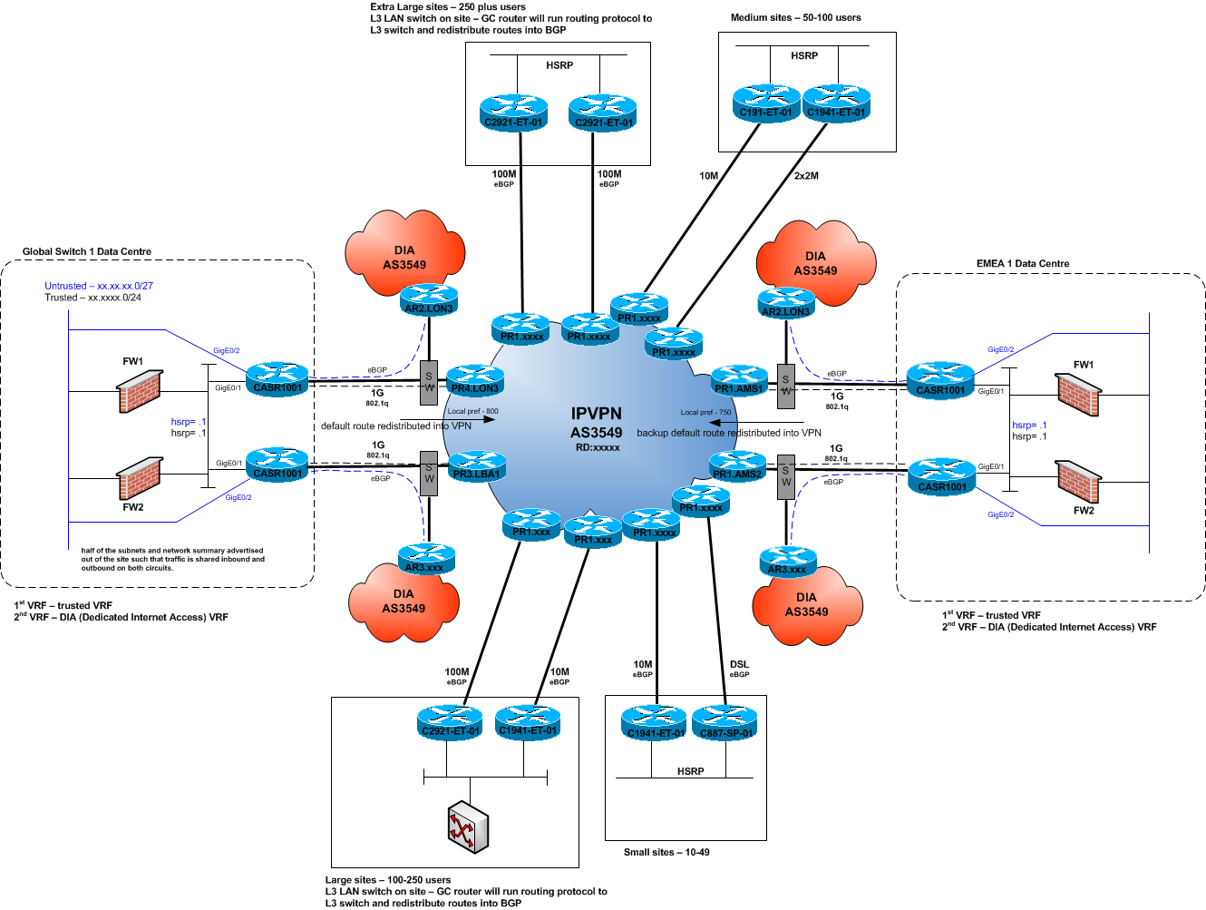
Figure 1: Aegis Media UK and EMEA network
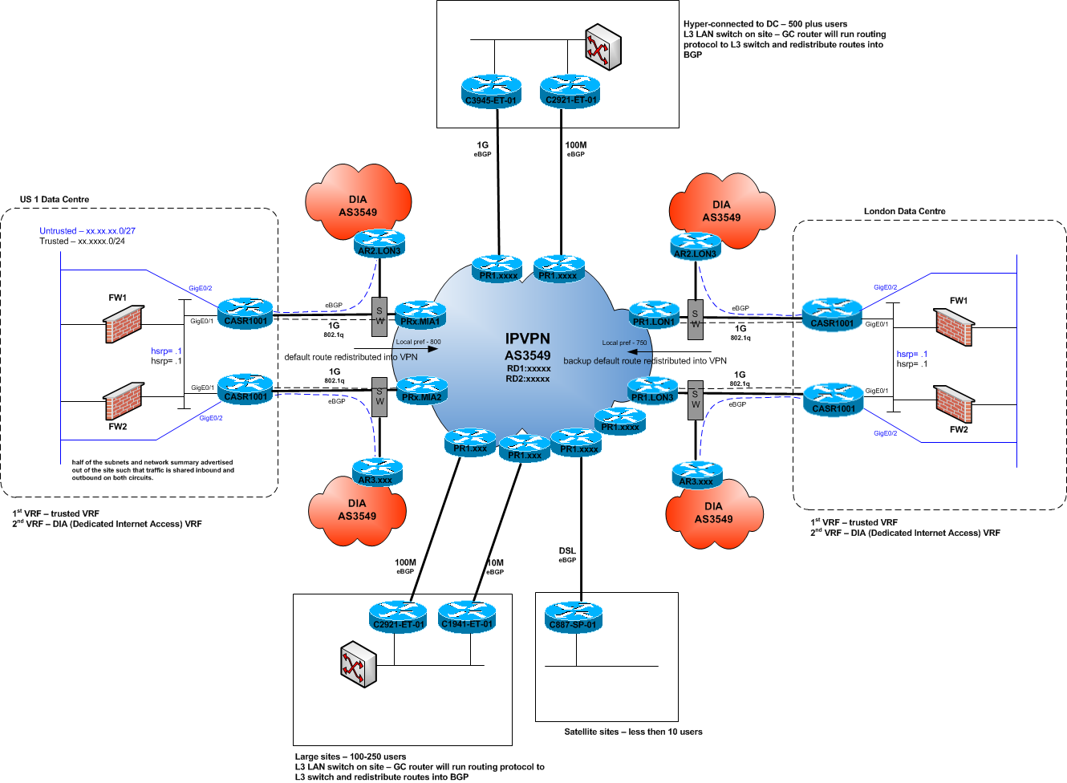
Figure 2: Aegis Media US and Asia network
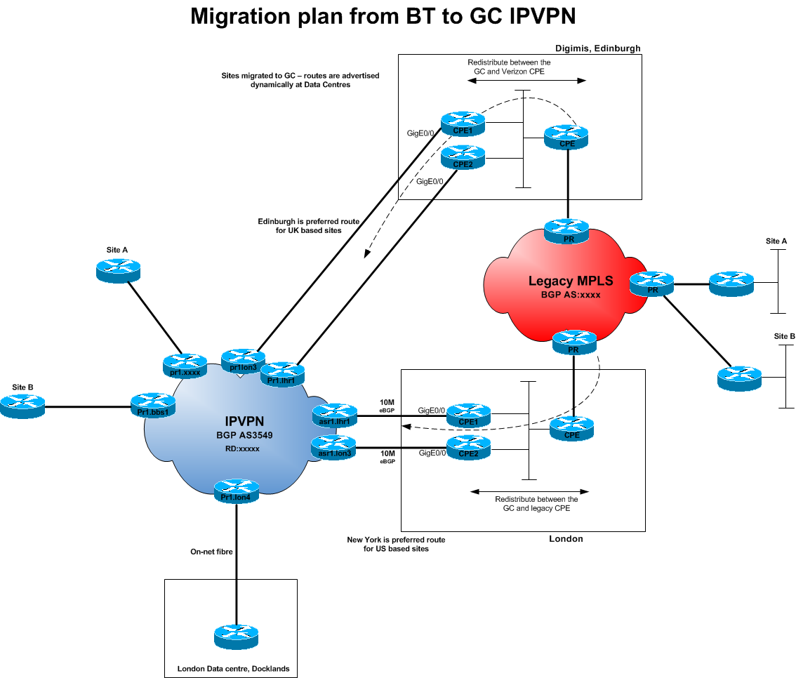
Figure 3: Aegis Media Migration to new network
  - DNS
Microsoft DNS is running on specified Domain Controllers. DNS is set to use Active Directory Integrated zones. Replication is enabled to all domain controllers allowing only secure updates. MX records are hosted for 260 SMTP address for Aegis Media.
Aegis Media use Net names as DNS service provider and MX records are hosted by them for Exchange 2003 solution.
  - Existing Aegis Media Exchange 2003 Environment
Aegis Media currently maintains Exchange servers located in 56 locations. There are four main sites. The two bridgeheads in the US are in different sites, AP and EMEA are all in respective datacentre which are used for the inbound and outbound routing of emails to internet by MessageLabs. There are front end and backend Exchange Server in regional office which connects to their regional bridgehead servers for routing. Regional bridgehead have connectors to route message though three routing servers located in the mail datacentre.
The current messaging system is based on Microsoft Exchange Server 2003 SP2. Aegis Media has also introduced a few Exchange 2010 Servers in one of the sites. Outlook 2007 is their main supported client and few users also have got Outlook 2010. Outlook Web Access is enabled. As well as ActiveSync and RPC over HTTP features are used.
There are 1500 Entourage clients on Mac workstations. There are currently 2500 Blackberry handheld devices deployed in production.
Users are classified as Standard and VIP user’s also regional requirements and available infrastructure determine the mailbox quota and other features.
Public Folders are used but will be discontinued in Exchange 2010 environment. Correct public folders will be migrated to SharePoint.
Aegis Media has multiple regional URL’s for OWA and other remote services provided by Exchange 2003, these services will continue to work until a user is migrated to Exchange 2010. After the migration users will use the new Exchange 2010 URL.

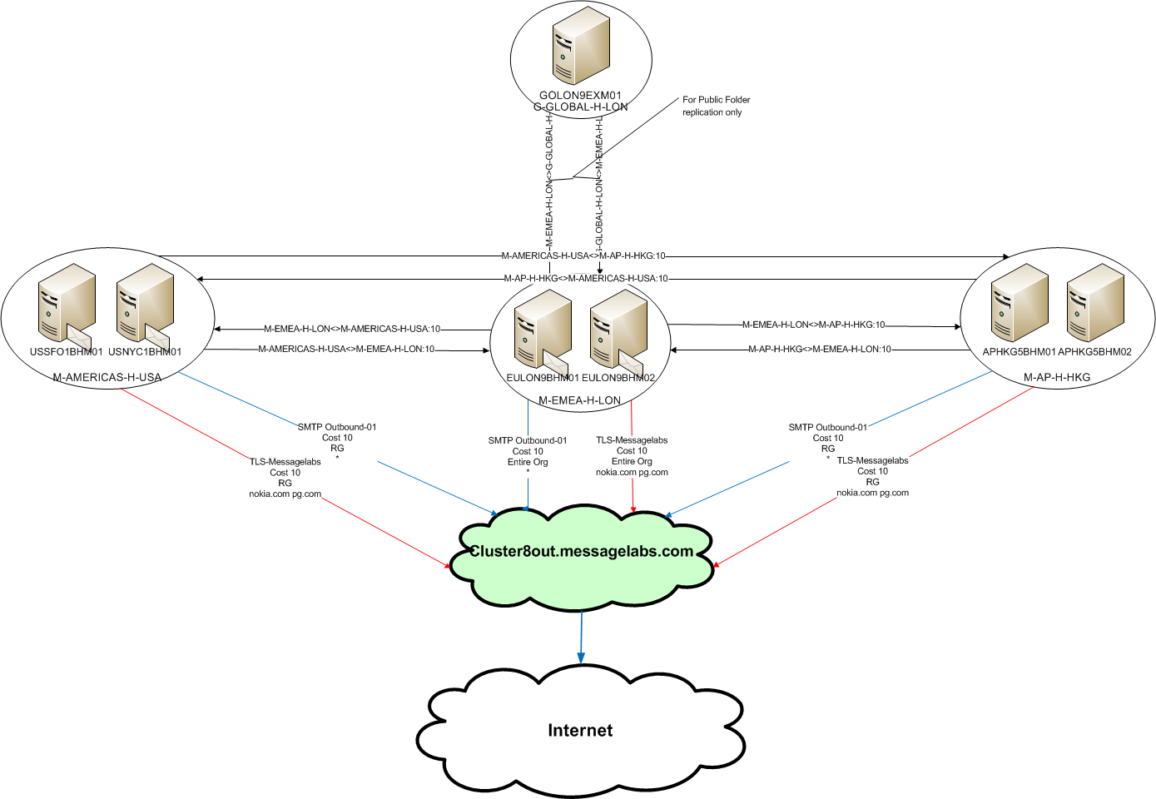
Figure 4: Aegis Media – Global Routing

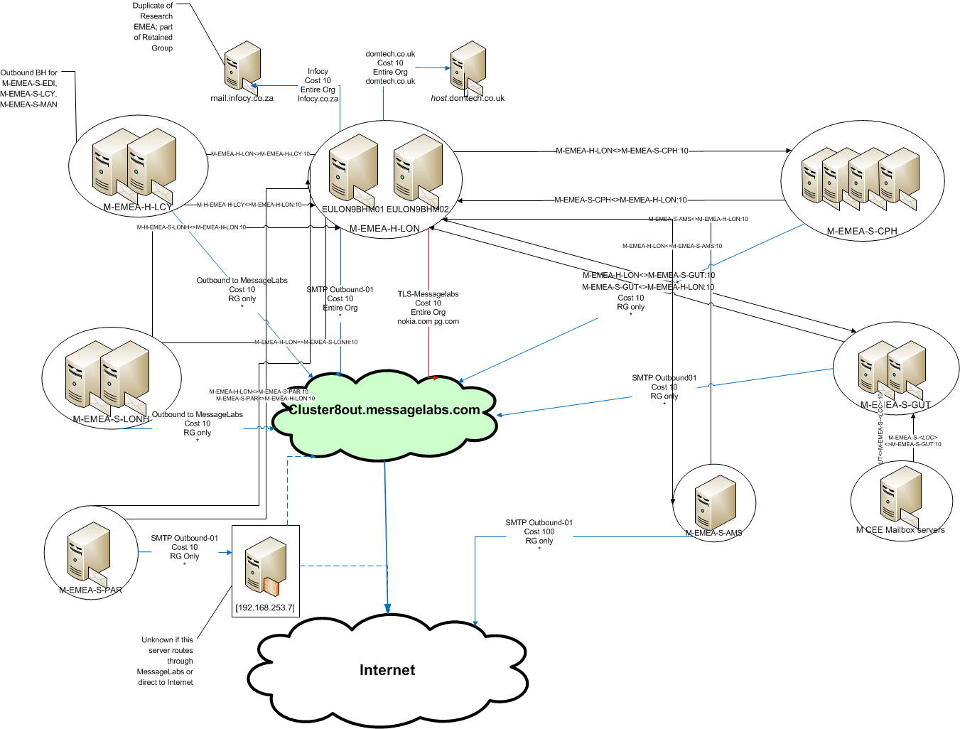
Figure 5: Aegis Media – EMEA Design
    - Exchange Server counts
AD Site | Total Servers
APHKG5-M-HUB | 3
ARBUE1-M | 2
ATVIE1-M | 1
AUSYD1-M | 2
BEBRU1-M | 1
CATOR3-M | 2
CNBEI2-M | 2
CNHKG6-M | 1
CNSHA2-M-HUB | 2
CZPRG2-M | 1
DEGUT1-M-HUB | 7
DKCPH1-M-HUB | 6
EMEA-MEDIA | 2
ESMAD1-M-HUB | 1
FRPAR1-M | 2
GBEDI1-M | 1
GBLONZ-M-HUB | 10
GBMAN2-M | 1
GLOBAL | 4
GRATH2-M | 1
HUBUD2-M | 1
INMUM1-M | 1
ITMIL1-M | 1
JPTYO3-M | 1
KRSEL2-M | 1
MXMEX1-M | 1
MYKUL2-M | 1
NLAMS2-M | 1
PLWAW2-M | 1
PTLIS1-M | 1
SGSIN1-M | 1
SKBTS2-M | 1
THBKK2-M | 1
TRIST1-M | 1
TWTPE1-M | 3
USBOS2-M | 3
USBOS4-M | 2
USCHI1-M | 2
USNYC1-M-HUB | 4
USSF01-M-HUB | 3
USWLT2-M | 3
Grand Total | 86
Table 17: Exchange Server Count
    - Number of users by type and site
Exchange Server | Entity | Users
CACCL1EXM01 | AMERICAS | 35
CATOR3EXM01 | AMERICAS | 450
USBOS2EVM01 | AMERICAS | 425
USBOS2EXM01 | AMERICAS | 14
USBOS4EVM01 | AMERICAS | 332
USCHI1EVM01 | AMERICAS | 238
USNYC1EVM01 | AMERICAS | 606
USNYC1EXM02 | AMERICAS | 6
USNYC1EXM03 | AMERICAS | 353
USSFO1EVM01 | AMERICAS | 355
USWLT2EXM01 | AMERICAS | 67
AUSYD1EXM01 | AP | 562
CNBEI2EVM01 | AP | 363
CNHKG4EXM01 | AP | 181
CNSHA2EVM01 | AP | 674
INDEL1EXM01 | AP | 286
JPTYO3EXM01 | AP | 28
KRSEL2EXM01 | AP | 133
MYKUL2EXM01 | AP | 195
SGSIN1EXM01 | AP | 302
THBKK2EXM02 | AP | 181
TWTPE1EVM01 | AP | 841
ATVIE1EXM01 | EMEA | 197
BEBRU1EXM01 | EMEA | 245
CZPRG2EXM01 | EMEA | 67
DEGUT3EXM04 | EMEA | 489
DEGUT3EXM05 | EMEA | 505
DEGUT3EXM06 | EMEA | 1181
DKCPH1EXM01 | EMEA | 144
DKCPH1EXM02 | EMEA | 528
DKCPH2EXM01 | EMEA | 284
DKCPH2EXM02 | EMEA | 147
ESMAD1EXM01 | EMEA | 641
FRPAR1EVM01 | EMEA | 1738
GBEDI1EXM01 | EMEA | 136
GBLON0EXM02 | EMEA | 187
GBLON6EXM01 | EMEA | 557
GBLONGEXM01 | EMEA | 81
GBLONHEXM01 | EMEA | 304
GBLONZEXM01 | EMEA | 709
GBLONZEXM02 | EMEA | 735
GBLONZEXM03 | EMEA | 667
GBMAN2EXM01 | EMEA | 86
GRATH2EXM01 | EMEA | 70
HUBUD2EXM01 | EMEA | 73
ITMIL4EXM01 | EMEA | 490
NLAMS2EXM01 | EMEA | 435
PLWAW2EXM01 | EMEA | 7
PTLIS1EXM01 | EMEA | 118
SKBTS2EXM01 | EMEA | 62
TRIST1EXM01 | EMEA | 885
ARBUE1EXM02 | LATAM | 77
MXMEX1EXM01 | LATAM | 198
Total Users |  | 18670
Table 18: User count per Mailbox
    - Email Security
Each datacentre has a full complement of servers that provide security service for all inbound and outbound email. They also provide real-time AV protection on the Exchange servers. MessageLabs services are used at each datacentre for inbound and outbound message processing.
MessageLabs Statics for month (from 17th March till 16 April 2012)
- Total Emails Volume: 7515008
- Email Anti-Virus Volume: 4467
- Total number of emails stopped as Spam: 486473
- Total number of emails that triggered a rule: 2893
    - Email Archive
Aegis Media uses Zantaz and KVS as the Archive solutions and there are almost 20TB of total Archive data. Archiving decisions have been mainly country specific hence there is not global solution or policy for the entire environment.
Regional have their own rules for mailbox quota and Archives like in the UK users have 1GB of mailbox quota and any email older than 3 month is archived in Zantaz. Although PST is not allowed as per the corporate policy still few users in specific regions create PSTs.
Aegis Media will use Exchange 2010 Archive in the new Exchange 2010 environment and all the correct Archive data will be migrated to it.
    - Email Mailbox Sizes and Storage
Aegis Media have mailbox size restrictions based on region. UK users have a mailbox of 1GB and few regions also have large mailbox of up to 15GB. A report was created to put the users in classification of 2, 5 and 10 GB range and below is the numbers. These statistics were pulled using Exchange Profile Analyzer which was run on all Exchange 2003 Servers globally and benchmarked with a month’s worth of data.
Region | Small (2GB) | Medium (5GB) | Large (10GB)
G-PLC | 134 | 15 | 24
M-AMERICAS | 2974 | 78 | 28
M-AP | 2623 | 226 | 104
M-EMEA | 9107 | 450 | 232
M-LATAM | 266 | 50 | 10
 | 15104 | 819 | 398
 | 93% | 5% | 2%
Table 19: Users classification
Most Exchange servers have a SAN allocated for data storage. Due to the unique needs of Exchange 2003, a considerable amount of disk is allocated to each mailbox server for performance reasons. This results in a lot of unused disk space in our current configuration.
    - Exchange Operations
Aegis Media has got regional team to manager Exchange 2003 servers located in different regions, only email inbound and outbound routing to internet is managed by an central team in UK. Backup is handled differently based on regions by local teams. Also regional teams decide how and what type of backup to be done. UK takes weekly Full and daily incremental backup with VERITAS.

- Architecture and Design for Microsoft Exchange Server 2010 System Requirements
For the most up to date system requirements, please visit the following link:
http://technet.microsoft.com/en-us/library/aa996719.aspx
  - Supported Coexistence Scenarios
Exchange version | Exchange organization coexistence
Exchange 2000 Server | Not supported
Exchange Server 2003 | Supported
Exchange 2007 | Supported
Mixed Exchange 2007 and Exchange Server 2003 organization | Supported
Figure 6 - Supported Coexistence Scenarios
  - Network and Directory Servers
Component | Requirement
Schema master | By default, the schema master runs on the first Windows Server 2003 or Windows Server 2008 or Windows Server 2008 R2 domain controller installed in a forest. The schema master must be running any of the following:  - Windows Server 2003 Standard Edition with Service Pack 1 (SP1) or later (32-bit or 64-bit)  - Windows Server 2003 Enterprise Edition with SP1 or later (32-bit or 64-bit)  - Windows Server 2008 Standard or Enterprise (32-bit or 64-bit)  - Windows Server 2008 R2 Standard or Enterprise
Global catalog server | In each Active Directory site where you plan to install Exchange 2010, you must have at least one global catalog server running any of the following:  - Windows Server 2003 Standard Edition with SP1 or later (32-bit or 64-bit)  - Windows Server 2003 Enterprise Edition with SP1 or later (32-bit or 64-bit)  - Windows Server 2008 Standard or Enterprise (32-bit or 64-bit)  - Windows Server 2008 R2 Standard or Enterprise
Domain controller | In each Active Directory site where you plan to install Exchange 2010, you must have at l[DC1] one writeable domain controller running any of the following:  - Windows Server 2003 Standard Edition with SP1 or later (32-bit or 64-bit)  - Windows Server 2003 Enterprise Edition with SP1 or later (32-bit or 64-bit)  - Windows Server 2008 Standard or Enterprise (32-bit or 64-bit)  - Windows Server 2008 R2 Standard or Enterprise
Active Directory forest | Active Directory must be at Windows Server 2003 forest functionality mode or higher.
Table 20 - Network and Directory Servers
  - Directory Server Architecture
The use of 64-bit Active Directory domain controllers increases directory service performance. In previous versions of Exchange, we recommended an 8:1 ratio of Exchange processors to global catalog server processors, assuming that the processors are of similar models and speeds. This recommendation still applies in Architecture and Design for Microsoft Exchange Server 2010.
    - Installing Exchange 2010 on Directory Servers
For security and performance reasons, we recommend that you install Exchange 2010 only on member servers and not on Active Directory directory servers. However, you can't run DCPromo on a computer running Exchange 2010. After Exchange 2010 is installed, changing its role from a member server to a directory server, or vice versa, isn't supported.
  - Hardware
Component | Requirement | Notes
Processor | x64 architecture-based computer with Intel processor that supports Intel 64 architecture (formerly known as Intel EM64T)  AMD processor that supports the AMD64 platform  Intel Itanium IA64 processors not supported | It's supported to install the Exchange management tools on a computer that has a 64-bit processor.
Memory | Varies depending on Exchange features that are installed
Paging file size | The page file size minimum and maximum must be set to physical RAM plus 10 MB | The recommended page file size also accounts for the memory that's needed to collect information if the operating system stops unexpectedly. On 64-bit operating systems, memory can be written as a dump file to the paging file. This file must reside on the boot volume of the server.  For more information about the configuration options that are available for memory dump data, see Knowledge Base article 254649.
Disk space | At least 1.2 GB on the drive on which you install Exchange  An additional 500 MB of available disk space for each Unified Messaging (UM) language pack that you plan to install  200 MB of available disk space on the system drive  A hard disk that stores the message queue database on an Edge Transport server or Hub Transport server with at least 500 MB of free space | The minimum space requirements detailed here don't account for disk subsystem requirements for adequate performance.
Drive | DVD-ROM drive, local or network accessible | None.
Screen resolution | 800 x 600 pixels or higher | None.
File format | Disk partitions formatted as NTFS file systems, which applies to the following partitions:  System partition  Partitions that store Exchange binary files  Partitions containing transaction log files  Partitions containing database files  Partitions containing other Exchange files | None.
Table 21: Hardware
  - Operating System
Component | Requirement
Operating system on a computer that has a 64-bit processor | One of the following:  - 64-bit edition of Windows Server 2008 Standard with Service Pack 2 (SP2)  - 64-bit edition of Windows Server 2008 Enterprise with SP2  - 64-bit edition of Windows Server 2008 R2 Standard  - 64-bit edition of Windows Server 2008 R2 Enterprise
Operating system for installing the Exchange management tools on a computer that has a 64-bit processor | One of the following:  - Windows Vista with SP2 for management tools only installation  - 64-bit edition of Windows Server 2008 Standard with SP2  - 64-bit edition of Windows Server 2008 Enterprise with SP2  - 64-bit edition of Windows Server 2008 R2 Standard  - 64-bit edition of Windows Server 2008 R2 Enterprise  - Windows 7
Table 22: Operating System
  - Storage Configuration
Aegis Media has decided to use SAN for Exchange 2010 storage, it is recommended to use dedicated storage for Exchange 2010 mailbox servers. Shared-SAN should not be used as it will be the single point of failure in the solution.
For most up to date Storage recommendations, please visit the below link.
http://technet.microsoft.com/en-in/library/ee832792(en-us).aspx
  - Hardware Virtualization
Microsoft supports Exchange 2010 in production on hardware virtualization software only when all the following conditions are true:
- The hardware virtualization software is running one of the following:
  - Windows Server 2008 with Hyper-V technology
  - Windows Server 2008 R2 with Hyper-V technology
  - Microsoft Hyper-V Server 2008
  - Microsoft Hyper-V Server 2008 R2
  - Any third-party hypervisor that has been validated under the Windows Server Virtualization Validation Program.
- The Exchange guest virtual machine:
  - Is running Microsoft Exchange 2010. This includes Exchange 2010 Hosting Mode, available in Exchange 2010 SP1 or later.
  - Is deployed on Windows Server 2008 with SP2 (or later) or Windows Server 2008 R2 RTM or later.
  - Meets all the requirements set forth previously in this topic.
- With Exchange 2010 SP1 (or later) deployed:
  - All Exchange 2010 server roles, including Unified Messaging, are supported in a virtual machine. Unified Messaging virtual machines have the following special requirements:
    - Four virtual processors are required for the virtual machine. Memory should be sized using standard best practices guidance.
    - Four physical processor cores are available for use at all times by each Unified Messaging role virtual machine. This requirement means that no processor oversubscription can be in use. This requirement affects the ability of the Unified Messaging role virtual machine to utilize physical processor resources.
  - Exchange server virtual machines (including Exchange Mailbox virtual machines that are part of a DAG), may be combined with host-based failover clustering and migration technology, as long as the virtual machines are configured such that they will not save and restore state on disk when moved, or taken offline. All failover activity must result in a cold boot when the virtual machine is activated on the target node. All planned migration must either result in shutdown and cold boot, or an online migration that makes use of a technology like Hyper-V Live Migration. Hypervisor migration of virtual machines is supported by the hypervisor vendor; therefore, you must ensure that your hypervisor vendor has tested and supports migration of Exchange virtual machines. Microsoft supports Hyper-V Live Migration of these virtual machines.
- The storage used by the Exchange guest machine for storage of Exchange data (for example, mailbox databases or Hub transport queues) can be virtual storage of a fixed size (for example, fixed virtual hard disks (VHDs) in a Hyper-V environment), SCSI pass-through storage, or Internet SCSI (iSCSI) storage. Pass-through storage is storage that's configured at the host level and dedicated to one guest machine. All storage used by an Exchange guest machine for storage of Exchange data must be block-level storage because Exchange 2010 doesn't support the use of network attached storage (NAS) volumes. Also, NAS storage that's presented to the guest as block-level storage via the hypervisor isn't supported. The following virtual disk requirements apply for volumes used to store Exchange data:
  - Virtual disks that dynamically expand aren't supported by Exchange.
  - Virtual disks that use differencing or delta mechanisms (such as Hyper-V's differencing VHDs or snapshots) aren't supported.
- Only management software (for example, antivirus software, backup software, or virtual machine management software) can be deployed on the physical root machine. No other server-based applications (for example, Exchange, SQL Server, Active Directory, or SAP) should be installed on the root machine. The root machine should be dedicated to running guest virtual machines.
- Some hypervisors include features for taking snapshots of virtual machines. Virtual machine snapshots capture the state of a virtual machine while it's running. This feature enables you to take multiple snapshots of a virtual machine and then revert the virtual machine to any of the previous states by applying a snapshot to the virtual machine. However, virtual machine snapshots aren't application aware, and using them can have unintended and unexpected consequences for a server application that maintains state data, such as Exchange. As a result, making virtual machine snapshots of an Exchange guest virtual machine isn't supported.
- Many hardware virtualization products allow you to specify the number of virtual processors that should be allocated to each guest virtual machine. The virtual processors located in the guest virtual machine share a fixed number of logical processors in the physical system. Exchange supports a virtual processor-to-logical processor ratio no greater than 2:1. For example, a dual processor system using quad core processors contains a total of 8 logical processors in the host system. On a system with this configuration, don't allocate more than a total of 16 virtual processors to all guest virtual machines combined.
- When calculating the total number of virtual processors required by the root machine, you must also account for both I/O and operating system requirements. In most cases, the equivalent number of virtual processors required in the root operating system for a system hosting Exchange virtual machines is 2. This value should be used as a baseline for the root operating system virtual processor when calculating the overall ratio of physical cores to virtual processors. If performance monitoring of the root operating system indicates you're consuming more processor utilization than the equivalent of 2 processors, you should reduce the count of virtual processors assigned to guest virtual machines accordingly and verify that the overall virtual processor-to-physical core ratio is no greater than 2:1.
- The operating system for an Exchange guest machine must use a disk that has a size equal to at least 15 GB plus the size of the virtual memory that's allocated to the guest machine. This requirement is necessary to account for the operating system and paging file disk requirements. For example, if the guest machine is allocated 16 GB of memory, the minimum disk space needed for the guest operating system disk is 31 GB.
In addition, it's possible that guest virtual machines may be prevented from directly communicating with fibre channel or SCSI host bus adapters (HBAs) installed in the root machine. In this event, you must configure the adapters in the root machine's operating system and present the LUNs to guest virtual machines as either a virtual disk or a pass-through disk.
Root Machine Storage Requirements
Each root machine has minimum disk space requirements that must be met:
- Root machines in some hardware virtualization applications may require storage space for an operating system and its components. For example, when running Windows Server 2008 with Hyper-V, you will need a minimum of 10 GB to meet the Windows Server 2008 R2 System Requirements for the operating system. Additional storage space will also be required to support the operating system's paging file, management software, and crash recovery (dump) files.
- Some hypervisors maintain files on the root machine that are unique to each guest virtual machine. For example, in a Hyper-V environment, a temporary memory storage file (BIN file) is created and maintained for each guest machine. The size of each BIN file is equal to the amount of memory allocated to the guest machine. In addition, other files may also be created and maintained on the host machine for each guest machine.
Exchange Server Storage Requirements
The following are the requirements for storage connected to a virtualized Exchange server:
- Each Exchange guest machine must be allocated sufficient storage space on the root machine for the fixed disk that contains the guest's operating system, any temporary memory storage files in use, and related virtual machine files that are hosted on the host machine. In addition, for each Exchange guest machine, you must also allocate sufficient storage for the message queues on the Hub Transport and Edge Transport servers and sufficient storage for the databases and log files on Mailbox servers.
- Storage used by Exchange should be hosted in disk spindles that are separate from the storage that's hosting the guest virtual machine's operating system.
- Configuring iSCSI storage to use an iSCSI initiator inside an Exchange guest virtual machine is supported. However, there will be reduced performance in this configuration if the network stack inside a virtual machine isn't full-featured (for example, not all virtual network stacks support jumbo frames).
Exchange Server Memory Requirements and Recommendations
Some hypervisors have the ability to oversubscribe or dynamically adjust the amount of memory available to a specific guest machine based on the perceived utilization of memory in the guest machine as compared to the needs of other guest machines managed by the same hypervisor. This technology makes sense for workloads in which memory is needed for brief periods of time and then can be surrendered for other uses. However, it doesn't make sense for workloads that are designed to use memory on an ongoing basis. Exchange, like many server applications with optimizations for performance that involve caching of data in memory, is susceptible to poor system performance and an unacceptable client experience if it doesn't have full control over the memory allocated to the physical or virtual machine on which it is running.
Many of the performance gains in recent versions of Exchange, especially those related to reduction in I/O, are based on highly efficient usage of large amounts of memory. When that memory is no longer available, the expected performance of the system can't be achieved. For this reason, memory oversubscription or dynamic adjustment of virtual machine memory should be disabled for production Exchange servers.
Memory should be sized for guest machines using the same methods as physical deployments.
    - Virtualization Design Decisions
Aegis Media has decided to use VMware to virtualize Hub and CAS, Edge and UM Servers. The VMware hypervisor has been validated under the Windows Server Virtualization Validation Program and therefore it will be a supported scenario.
There is a drive within Aegis to virtualize applications wherever appropriate. The proposed design does not prevent the use of a hypervisor, however none of the functional or non-functional requirements that this design is required to meet are satisfied by the use of a hypervisor and it therefore adds a layer of complexity and compute overhead for which there is little benefit. In addition the use of a hypervisor means that the recovery of the service falls between more support teams which risks increasing recovery times and reducing service uptime.
  - Support for Outlook and Entourage
Exchange 2010 supports the following versions of Microsoft Office Outlook and Microsoft Entourage for Mac:
- Outlook 2010 RTM or Later
- Outlook 2007 RTM or Later
- Outlook 2003 Service Pack 2 or Later
- Entourage 2008 for Mac, Web Services Edition
- Outlook for Mac 2011
Note:
When using Outlook 2003 or earlier to connect against an Exchange 2010 organization, you must make sure a public folder database exist in the organization. This is because Outlook 2003 and earlier uses public folders to retrieve free/busy information and the offline address book (OAB). For more information see: Microsoft KB article: When you use Outlook with an Exchange 2007 mailbox, you cannot connect to Exchange 2007, and you receive an error message
In addition, you should be aware of the following issues and the resolution to each, when using Outlook 2003 to connect to an Exchange 2010 mailbox:
- Outlook connection issues with Exchange 2010 mailboxes because of the RPC encryption requirement
- In Outlook 2003, e-mail messages take a long time to send and receive when you use an Exchange 2010 mailbox
- An error occurs when an Exchange server 2003 user tries to open more than one delegate mailboxes of Exchange Server 2010 in Outlook 2003
- Office Outlook 2003 does not connect to two or more additional mailboxes in a mixed Exchange Server 2007 and Exchange Server 2010 environment
- Users who use Outlook 2003 cannot publish their free/busy data in Exchange Server 2010 or in Exchange Server 2007
- Error message when Outlook synchronizes an offline address book with Exchange Server 2007 and Exchange Server 2010: "0x8004010F"
- An error occurs when you try to synchronize the offline address list on an Exchange Server server while you are using Outlook 2003: "0x8004010F"
- Error message when Outlook 2003 users connect to an Exchange server by using RPC over HTTP: "Server Unavailable"
Aegis Media supported client in Outlook 2007, 2010, Entourage 2008 for Mac (Web Services Edition) and Outlook for Mac 2011. Outlook 2003 will not be used in Aegis Media; any users using Outlook 2003 will be upgraded to a supported version of Aegis Media.
    - Client Access to Archive Mailboxes
The following table lists the client applications that can be used to access archive mailboxes.
Client | Access to archive mailbox
Outlook 2010, Outlook 2007, and Outlook Web App | Yes. Outlook 2010, Outlook 2007 and Outlook Web App users can copy or move items from their primary mailbox to their archive mailbox, and can also use retention policies to move items to the archive.  Note:  Outlook 2010 and Outlook 2007 users can also copy or move items from .pst files to their archive mailbox. Outlook 2007 users require the Office 2007 Cumulative Update for February 2011. Some differences in archive support exist between Outlook 2010 and Outlook 2007. For more information, see Exchange Team Blog article, see Yes Virginia, there is Exchange 2010 archive support in Outlook 2007.
Outlook 2003 and older clients | No.
Microsoft Exchange ActiveSync | No.
Entourage 2008 and Outlook for Mac 2011 | No.
Table 23: Support clients for Personal Archive

- Organization Design
The proposed messaging system design for Aegis Media includes the following components:
- Conceptual Design: Provides an overview of the proposed solution
- Organization Design: Provides detail on the organization configuration settings
- Server Role and Hardware Design: Provides detail on the server role and hardware design
  - Conceptual Design
Aegis Media will deploy a single centralized Exchange 2010 organization to replace the Exchange 2003 messaging system currently deployed throughout the Aegis Media. The Exchange organization will be deployed in the current Aegis Media Active Directory forest global.loc. Aegis Media will deploy Exchange 2010 in the existing Exchange 2003 organization. The stated design goals and requirements have been communicated by Aegis Media and are included in this design. The Architecture and Design for Microsoft Exchange Server 2010 design is intended to be inclusive of the local administrators and the design reflects the goal of role based access control. Exchange servers will be located at the following EMEA sites:
- EMEA Datacentre A
- EMEA Datacentre B
Each of these datacentres needs to be connected by a resilient 1GB link and latency between each datacentre should be less than 250ms.
Exchange management will be centralized.
Two (2) Database Availability Groups with six (6) mailbox servers will be deployed, three (3) in each datacentre. Dedicated mailbox servers will be used to comply with the Aegis silo architecture.
Four (4) co-located Client Access and Hub Transport, two (2) in each datacentre, these servers will be co-located to reduce the overall server count and to comply with Aegis silo architecture.
Each DAG will consist of three (3) mailbox servers. Each DAG will have (2) HA copies of the database in the primary datacentre and one (1) copy in the secondary datacentre. These DAGs will be used to host approximately 23000 mailboxes.
The two sites will function as ingress and egress points for SMTP for external communication. Aegis Media will implement Edge Transport servers in the perimeter network to handle all incoming and outgoing SMTP traffic. The first line of defense for SPAM and content filtering for SMTP will be MessageLabs or Microsoft Forefront Online Protection (FOPE), Once MessageLabs or FOPE process all email, they are delivered to Edge Transport servers and Edge servers will deliver them to the Exchange Hub Transport servers.
Four (4) Edge Transport servers two (2) in each datacentre will be deployed. Edge Transport servers will be deployed to comply with Aegis silo architecture.
Two URLs for all of Aegis Media to use when accessing OWA and the CAS services will be deployed. Users will be redirect to the client access server location they are trying to access (typically their mailbox). An RPC client Access Array will be implemented in each datacentre to prevent single point of failure for RPC client.
Riverbed Stingray hardware load balancers will be deployed for the high availability of CAS and TMG servers. Hardware load balancers (HLB) will also be used for SMTP relay for the applications, HLB will be configured to load balance traffic coming from applications and distribute it on Hub transport servers, as dedicated receive connector will also be created.
Four (4) Unified Messaging servers will be implemented two in each site to provide UM features and high availability of the service. UM servers will be integrated with Aegis Media telephony solutions.
The following diagram provides an overview of the Architecture and Design for Microsoft Exchange Server 2010 design:
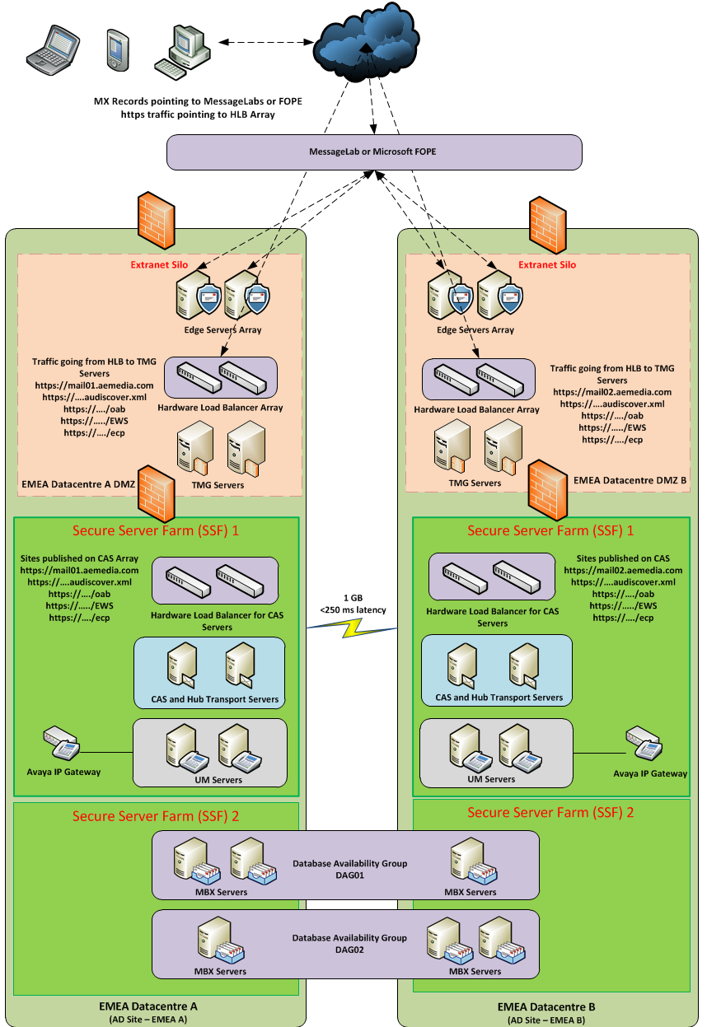
Figure 7: Aegis Media Exchange 2010 Design
    - Design Summary
Design Parameter | Configuration / Specification
Active Directory | Single Forest.
Permission Model | Aegis Media will use shared permission model
Exchange Organization | The name of the Exchange Organization is “Mail”
High Availability | Aegis Media will deploy Database Availability Groups with built-in Replication Technology to provide high availability for approximately 23000 users.
Mailbox Role | EMEA Datacentres:  Aegis Media will deploy 2 DAG consist of 3 member servers each with 2 HA copy database (1 active 1 passive) in the primary datacentre and a 2nd passive copy in secondary datacentre to host approximately 23000 users.
Database Availability Group (DAG) | There will be a total of 2 DAGs in EMEA Datacentres,  - 2 in the EMEA Datacentre A  - 2 in the EMEA Datacentre B
EMEA Datacentre A | Site A-DAG: 3 member server DAG with 80 Databases  Two copies in the EMEA Datacentre A and third in the EMEA Datacentre B.
EMEA Datacentre B | Site B-DAG: 3 member server DAG with 80 Databases  Two copies in the EMEA Datacentre B and third in the EMEA Datacentre A.
Mailbox Storage | Aegis Media will use SAN based storage to support Exchange data
Client Access Role  Hub Transport Role | CAS server role and the Hub Transport role co-located, there will be:  2 CAS/HUB in the EMEA Datacentre A  2 CAS/HUB in the EMEA Datacentre B  This will provide redundancy, performance and load balancing for OWA publishing. 2 CAS Arrays will be deployed, one per datacentre
Edge Transport Role | Aegis Media will deploy 4 Edge transport servers in the DMZ:  2 in EMEA Datacentre A DMZ  2 in EMEA Datacentre B DMZ
Unified Messaging Role | Aegis media will deploy 4 Unified messaging role which will integrate with their Avaya and Cisco IP-PBX in EMEA Datacentres and US datacentres.  2 in EMEA Datacentre A  2 in EMEA Datacentre B
TMG Servers | Aegis Media will deploy 4 TMG servers which will provide reverse proxy services for CAS servers.  2 in EMEA Datacentre A  2 in EMEA Datacentre B
Monitoring | Aegis Media will use their existing Microsoft System Centre Operations Manager (SCOM)2007 R2 infrastructure for monitoring the Exchange 2010 platform
Internet Mail | Internet mail will route through the existing MessageLabs or Microsoft FOPE.
Antivirus | Aegis Media will use TrendMicro ScanMail or Forefront on the Edge and Hub Transport Servers.
AVgateway | Aegis Media will use their existing MessageLabs or Microsoft FOPE to provide inbound and outbound SMTP routing as well as Anti-Virus and Anti-SPAM protection
Clients | Outlook 2007/2010, Outlook Web App (OWA) using IE and Safari, ActiveSync, Entourage 2008 and Office for Mac 2011.
Blackberry | The existing Blackberry servers will be upgraded to support the growing number of mobile information workers within the Aegis Media.
Journaling Server | The Exchange 2010 servers will not be used to provide Journaling for the Organization.
Archiving | Aegis Media will use Exchange 2010 Personal Archiving feature
Design Expansion | The current design can be expanded to handle additional load (additional users or an increase in the user profile) over time by adding more number of servers.
Table 24: Design Summary
    - Datacentre Model
Aegis has a desire to operate an active\active datacentre model where active client connections are load balanced across primary mailbox databases operating in both EDC’s. This is a model that is preferred for all key workloads at Aegis. Operating this model has certain implications for the deployment of Exchange Server.
- To reduce the dependency on the network interconnect between EDC’s Aegis must deploy two DAGs. This has no impact on the hardware required to support the solution but does add a layer of complexity to the solution which increases the risk of service downtime
- Since Aegis will operate network load balanced infrastructure in front of the TMG servers, Aegis will see an increase in traffic across the datacentre interconnect since the load balanced infrastructure can make no determination over the correct location of the mailbox and will therefore direct client connections to the ‘wrong’ TMG servers approximately 50% of the time.
    - Datacentre Consolidation
Aegis Media has Exchange 2003 in 56 locations which will be consolidated in 2 datacentres when Exchange 2010 will be deployed. Aegis Media users are located worldwide there are few locations in Asia Pacific where the latency is higher from the EMEA datacentres. Aegis Media is going through network upgrade and expecting that will reduce the latency. However a contingency design is done to implement Exchange 2010 in Asia Pacific Datacentre if latency is not improved after the network upgrade and users are facing issues. It is recommended that Aegis Media implements contingency design if user experience during pilot is deemed unacceptable.
The test cases provided in Section 12 should be validated by Aegis and then executed from the all relevant Aegis Media locations to validate acceptable user experience and make sure all required features are available and operating as expected. Aegis Media can run these test cases locally where Exchange 2010 servers are located and also from remote locations to understand the user experience. Aegis Media should define acceptable “time” for each test case which will contribute to any decision relating to the localized contingency design implementation.
Aegis Media will utilize ‘Exchange Client Network Bandwidth Calculator’ to calculate the bandwidth and latency requirements for each location. The calculator is available in the below link.
http://technet.microsoft.com/en-us/library/dd638106.aspx
    - Datacentre Locations (Primary / Secondary)
The following table depicts each datacentre and the corresponding backup datacentre:
AD Site Code | Description
EMEA Site A | EMEA Datacentre A Primary site
EMEA Site B | EMEA Datacentre B Secondary site to Datacentre A copy
EMEA Site B | EMEA Datacentre B Primary site
EMEA Site A | EMEA Datacentre A Secondary site to Datacentre B copy
Table 25: Datacentre Locations
    - Client Access Methods
The following client access methods will be supported by the Exchange 2010 messaging system. For additional detail, please reference section Exchange Clients.
Client Access Method | Internal Access | External Access
Outlook RPC (MAPI) | Enabled | Enabled
Outlook HTTPS (Outlook Anywhere) | Enabled | Enabled
Outlook Auto-Discover (Profile Management) | Enabled | Enabled
Outlook Web App (OWA/ECP) | Enabled | Enabled
ActiveSync | Enabled | Enabled
POP | Enabled | Disabled
IMAP | Disabled | Disabled
RIM BlackBerry | Enabled | Enabled
Table 26: Client Access Methods
    - Mail Routing and Transport
All inbound mail will route through the Internet to Aegis Media’s two EMEA datacentres via MessageLabs or Microsoft FOPE to Edge Transport Servers. MX record will be pointing to MessageLabs or Microsoft FOPE. MessageLabs or Microsoft FOPE will route the messages to Edge Transport Servers in the EMEA Datacentre DMZ (Aegis Media External Silo). Edge Transport servers will route the messages to Hub Transport Servers in the Secure Server Farm 1 in the EMEA datacentres. Aegis Media has identified a requirement to scan all inbound SMTP traffic by utilizing MessageLabs or Microsoft FOPE that supports anti-spam, anti-virus, and anti-spyware. Outbound traffic is not processed for content management, only for anti-virus.
Hub Transport server roles located in all the Sites will accept all incoming mail from the Edge Transport servers and process them into Exchange. Outbound e-mail will transfer from the Hub Transports to one of the Aegis Media Edge Transport server. It is recommended to install SMTP Send Connectors on the Edge Transport servers in all Sites and use smart host referrals for MessageLabs or Microsoft FOPE.
All the internal email routing will be handled by Hub Transport servers based on AD sites.
The following diagram depicts the proposed message routing infrastructure:
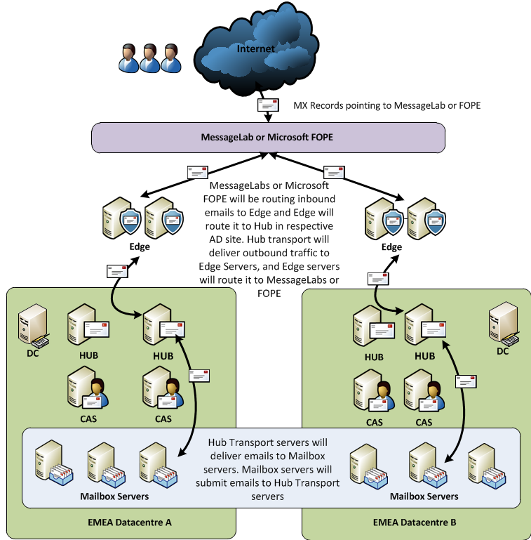
Figure 8: Aegis Media Mail Routing
    - Mail Content Filtering
This design will use TrendMicro ScanMail or Forefront Protection 2010 for Exchange Server running on Edge and Hub Transport roles to provide antimalware services. A combination of transport, real-time, manual and background scanning is available through ScanMail or FPE.
All Exchange Server 2010 Edge and Hub Transport roles will be ScanMail or FPE clients.
The MessageLabs or Microsoft FOPE will provide content filtering, anti-virus protection and spam elimination. Most of the filtering will be accomplished at this level before the email messages are passed on to the Edge Transport servers.
Additional virus scanning will occur when email messages reach the Edge and Hub Transport. TrendMicro ScanMail or Forefront Protection for Exchange will be used for virus scanning on all Exchange servers.
  - Contingency Design
Aegis Media have stated that they would like to implement a single location in EMEA, which will be appropriate for their organization provided all the Aegis locations have sufficient bandwidth and latency (under 320ms) from remote locations to EMEA datacenters.
However during the current environment assessment it was found that latency from Asia pacific locations to EMEA is higher than expected which may mean that the user experience when operating against a mailbox in EMEA is not acceptable. Aegis Media is in the process of upgrading their network. This will encompass all and will include implementation of a Riverbed WAN optimization solution which may reduce the latency and bring it within acceptable levels such that the user experience is not compromised.
Aegis Media requested the inclusion of a contingency Exchange 2010 design which can be implemented in the Asia Pacific and US datacentre if latency cannot be improved or if users in Asia Pacific and US are not getting a good user experience. Since there is no second co-located datacentre in Asia Pacific and US the same recovery targets that exist for the service operating out of the EMEA datacentre cannot be met in Asia Pacific and US.
Asia Pacific and US Exchange 2010 server will be added to the existing Exchange 2010 organization and would be deployed in the current Aegis Media Active Directory forest global.loc. Exchange servers will be located at the Asia Pacific and US datacentres and their secondary datacentre will be EMEA datacentres.
Exchange servers will be located at the following primary and secondary sites:
- US Datacenter (Primary)
- EMEA Datacentre A (Secondary for US)
- Asia Pacific Datacentre (Primary)
- EMEA Datacentre B (Secondary for Asia)
EMEA datacentres needs to be connected by a resilient 1GB link. US to EMEA Datacentre A needs to be connected by a resilient 300MB link and Asia Pacific to EMEA datacentre B need to be connected by a resilient 300MB link and latency between each datacentre should be less than 250ms.
Exchange management will be centralized.
3rd and 4th Database Availability Groups with three (3) mailbox servers for each DAG will be deployed between primary and secondary datacentres and two co-located Client Access and Hub Transport in each datacentre.
DAG will have three (3) HA copies of the database two (2) in the primary datacentre and 3rd in the secondary datacentre.
3rd DAG will consist of three (3) mailbox servers which will be used to host approximately 5266 mailboxes in Asia Pacific.
4th DAG will consist of three (3) mailbox servers which will be used to host approximately 5088 mailboxes in US.
After any potential implementation of the contingency design the four sites will function as ingress and egress points for SMTP for external communication. Aegis Media will implement Edge Transport servers in the perimeter network to handle all incoming and outgoing SMTP traffic. The first line of defense for SPAM and content filtering for SMTP will be MessageLabs or Microsoft Forefront Online Protection (FOPE), Once MessageLabs or FOPE process all email, they are delivered to Edge Transport servers and Edge servers will deliver them to the Exchange Hub Transport servers in the respective site.
Regional URLs will be published for the Asia Pacific and US users. An RPC client Access Array will be implemented in Asia pacific and US datacentre to prevent single point of failure for RPC client.
Riverbed Stingray hardware load balancers will be deployed for the high availability of CAS and TMG servers. Hardware load balancers will also be used for SMTP relay for the applications, HLB will be configured to load balance traffic coming from applications and distribute it on Hub transport servers, as dedicated receive connectors will be created.
Two (2) Unified Messaging servers will be implemented to provide UM features and high availability of the service in each datacentre.
The following diagram provides an overview of the Architecture and Design for Microsoft Exchange Server 2010 after implementation of contingency Datacentres:

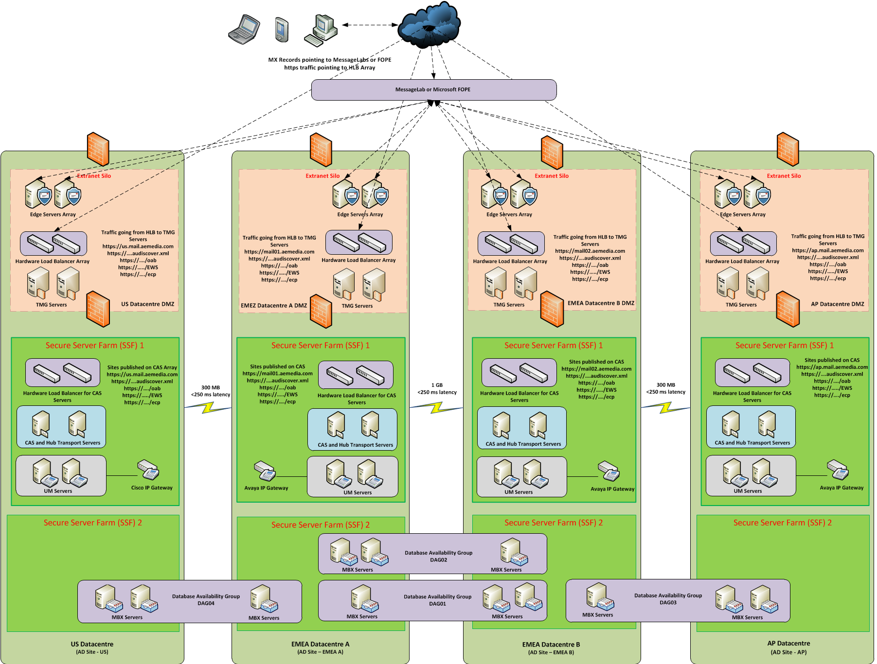
Figure 9: Aegis Media Exchange 2010 Design after contingency implementation

    - Contingency Design Summary
Design Parameter | Configuration / Specification
Active Directory | Single Forest.
Permission Model | Aegis Media will use shared permission model
Exchange Organization | The name of the Exchange Organization is “Mail”
High Availability | Aegis Media will deploy Database Availability Groups with built-in Replication Technology to provide high availability for approximately 5266 users in Asia Pacific and 5088 users in US.
Mailbox Role | Asia Pacific Datacentre  Aegis Media will deploy 1 DAG consist of 3 member servers with 3 HA copy database (1 active 1 passive) in the primary datacentre and 2nd passive copy in the secondary datacentre to host approximately 5266 users.  US Datacentre  Aegis Media will deploy 1 DAG consist of 3 member servers with 3 HA copy database (1 active 1 passive) in the primary datacentre and 2nd passive copy in the secondary datacentre to host approximately 5088 users.
Database Availability Group (DAG) | There will be 1 DAG in Asia pacific and 1 DAG in US,  - 1 in the Asia pacific datacentre  - 1 in the US datacentre
Asia pacific Datacentre | Site C-DAG: 3 member server DAG with 38 Databases
US Datacentre | Site D-DAG: 3 member server DAG with 38 databases
Mailbox Storage | Aegis Media will use SAN based storage to support Exchange data.
Client Access Role  Hub Transport Role | CAS server role and the Hub Transport role co-located, there will be:  2 CAS/HUB in Asia Pacific datacentre  2 CAS/HUB in US Datacenter  This will provide redundancy, performance and load balancing for OWA publishing. CAS Arrays will be deployed in both datacentre
Edge Transport Role | Aegis Media will deploy Edge transport servers in the DMZ:  2 in Asia pacific DMZ  2 in US DMZ
Unified Messaging Role | Aegis media will deploy Unified messaging role which will integrate with their Avaya and Cisco IP-PBX in Asia pacific and US datacentres.  2 in Asia Pacific datacentre  2 in US datacentre
TMG Servers | Aegis Media will deploy 4 TMG servers which will provide reverse proxy services for CAS servers.  2 in Asia pacific Datacentre  2 in US Datacentre
Monitoring | Aegis Media will use their existing Microsoft System Centre Operations Manager (SCOM)2007 R2 infrastructure for monitoring the Exchange 2010 platform
Internet Mail | Internet mail will route through the existing MessageLabs or Microsoft FOPE.
Antivirus | Aegis Media will use TrendMicro ScanMail or Forefront on the Hub Transport Servers.
AVgateway | Aegis Media will use their existing MessageLabs or Microsoft FOPE to provide inbound and outbound SMTP routing as well as Anti-Virus and Anti-SPAM protection
Clients | Outlook 2007/2010, Outlook Web App (OWA) using IE and Safari, ActiveSync, Entourage 2008, and Office for Mac 2011.
Blackberry | The existing Blackberry servers will be upgraded to support the growing number of mobile information workers within the Aegis Media.
Journaling Server | The Exchange 2010 servers will not be used to provide Journaling for the Organization.
Archiving | Aegis Media will use Exchange 2010 Personal Archiving feature
Design Expansion | The current design can be expanded to handle additional load (additional users or an increase in the user profile) over time by adding more number of servers.
Table 27: Contingency Design Summary
Client Access methods for Contingency design will be the same as mentioned in 6.1.5.
Mail content filtering will be the same as mentioned in 6.1.7
    - Contingency Datacentre Locations (Primary / Secondary)
The following table depicts each datacentre and the corresponding backup datacentre:
AD Site Code | Description
Asia Pacific Site | Asia Pacific Datacentre Primary site
EMEA Site B | EMEA Datacentre B Secondary site to Asia pacific copy
US Site | US Datacentre Primary site
EMEA Site A | EMEA Datacentre A Secondary site to US Datacentre copy
Table 28: Datacentre Locations
    - Mail Routing and Transport with Contingency Design
All inbound mail will route through the Internet to Aegis Media’s four datacentres via MessageLabs or Microsoft FOPE to Edge Transport Servers. MX record will be pointing to MessageLabs or Microsoft FOPE. MessageLabs or Microsoft FOPE will route the messages to Edge Transport Servers in the datacentre DMZ’s (Aegis Media External Silo). Edge Transport servers will route the messages to Hub Transport Servers in the Secure Server Farm 1 in the respective datacentre. Aegis Media has identified a requirement to scan all inbound SMTP traffic by utilizing MessageLabs or Microsoft FOPE that supports anti-spam, anti-virus, and anti-spyware. Outbound traffic is not processed for content management, only for anti-virus.
Hub Transport server roles located in all the Sites will accept all incoming mail from the Edge Transport servers and process them into Exchange. Outbound e-mail will transfer from the Hub Transports to one of the Aegis Media Edge Transport server. It is recommended to install SMTP Send Connectors on the Edge Transport servers in all Sites and use smart host referrals for MessageLabs or Microsoft FOPE.
All the internal emails routing will be handled by Hub Transport servers based on AD sites.
The following diagram depicts the proposed message routing infrastructure:
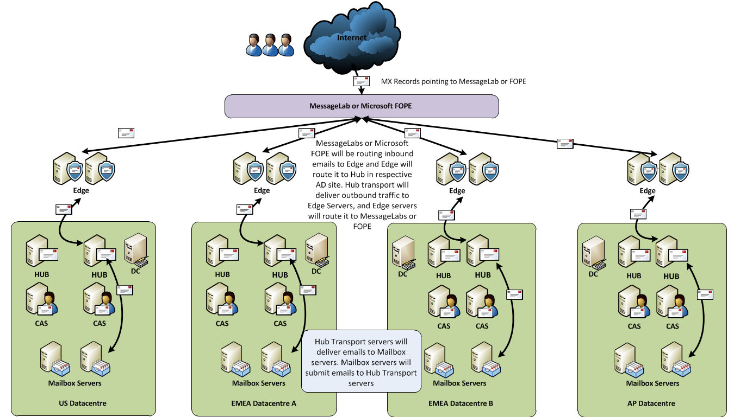
Figure 10: Aegis Media Mail Routing
  - Active Directory Integration
    - Active Directory Forest / Domain Model
Architecture and Design for Microsoft Exchange Server 2010 requires an existing Active Directory infrastructure for all roles except the Edge Transport server. The layout of the Active Directory infrastructure has a direct impact on the planning and design options for Microsoft Exchange.
The following table depicts the Active Directory configuration parameters and the Exchange configured settings:
Active Directory Parameter | Configuration Details
Forest Name | Global.loc
Domain | Media.global.loc
Organization Unit for Exchange Servers | Servers\Exchange Server
Number of GC cores required | 2 per Datacentre
DNS TTL for Exchange Server host records | 5 minutes
Exchange Organization Name | Mail
Active Directory Schema | The global.loc forest schema will be updated for Exchange 2010.
Table 29: Active Directory Configuration
  - Address Lists
An address list is a collection of recipient and other Active Directory objects. Each address list can contain one or more types of objects (for example, users, contacts, groups, public folders, conferencing, and other resources). You can use address lists to organize recipients and resources, making it easier to find the recipients and resources you want. Address lists are updated dynamically. Therefore, when new recipients are added to your organization, they're automatically added to the appropriate address lists.
Address lists reside in Active Directory. Therefore, mobile users who are disconnected from the network are also disconnected from these server-side address lists. However, you can create offline address books (OABs) for users who are disconnected from the network. These OABs can be downloaded to a user's hard disk. Frequently, to conserve resources, OABs are subsets of the information in the actual address lists that reside on your servers
Exchange 2010 can utilize both default and custom address lists. Aegis Media uses custom address lists in Exchange 2003 and will continue to use them in Exchange 2010. The following table lists the Address List configuration:
Address Lists Parameter | Configuration Details
Default Address Lists | - All Contacts This address list contains all mail-enabled contacts in your organization. Mail-enabled contacts are those recipients who have an external e-mail address. If you want mail-enabled contact information to be available to all users in your organization, you must include the contact in the GAL.  - All Groups This address list contains all mail-enabled groups in your organization. Mail-enabled groups are groups of recipients that are created to expedite the mass sending of e-mail messages and other information. When an e-mail message is sent to a mail-enabled group, all members of that list receive a copy of the message.  - All Rooms This address list contains all resources that have been designated as a room in your organization. Rooms are resources in your organization that can be scheduled by sending a meeting request from a client application. The user account that's associated with a room is disabled. For instructions about how to add resource mailboxes to an address list, see Add Resource Mailboxes to an Address List.  - All Users This address list contains all mail-enabled users in your organization. A mail-enabled user represents a user outside your Exchange organization. Each mail-enabled user has an external e-mail address. All messages sent to mail-enabled users are routed to this external e-mail address. A mail-enabled user is similar to a mail contact, except that a mail-enabled user has Active Directory logon credentials and can access resources.  - Default Global Address List This address list contains all mail-enabled users, contacts, groups, or rooms in the organization. During setup, Exchange creates various default address lists. The most familiar address list is the GAL. By default, the GAL contains all recipients in an Exchange organization. In other words, any mailbox-enabled or mail-enabled object in an Active Directory forest that has Exchange installed is listed in the GAL. For ease of use, the GAL is organized by name, not by e-mail address.  - Public Folders This address list contains all public folders in your organization. Access permissions determine who can view and use the folders. Public folders are stored on computers running Exchange.
Custom Address Lists | Aegis Media will create the below Custom Address Lists for the countries and businesses:  G-GLOBAL-PLC-Offline Address List  M-AMERICAS-CA-Offline Address list  M-AMERICAS-US-Offline Address List  M-AP-AUSTRALIA-Offline Address List  M-AP-CHINA-Offline Address List  M-AP-HONG KONG-Offline Address List  M-AP-IND-Offline Address List  M-AP-JAPAN-Offline Address List  M-AP-MALAYSIA-Offline Address List  M-AP-NEW ZEALAND-Offline Address List  M-AP-SINGAPORE-Offline Address List  M-AP-TAIWAN-Offline Address List  M-AP-THAILAND-Offline Address List  M-EMEA-AUSTRIA-Offline Address List  M-EMEA-BELGIUM-Offline Address List  M-EMEA-CZECHREPUBLIC-Offline Address List  M-EMEA-DENMARK-Offline Address List  M-EMEA-ESTONIA-Offline Address List  M-EMEA-FINLAND-Offline Address List  M-EMEA-FRANCE-Offline Address List  M-EMEA-GERMANY-Offline Address List  M-EMEA-GREECE-Offline Address List  M-EMEA-HUNGARY-Offline Address List  M-EMEA-INT-Offline Address List  M-EMEA-ITALY-Offline Address List  M-EMEA-LATVIA-Offline Address List  M-EMEA-LITHUANIA-Offline Address List  M-EMEA-NETHERLANDS-Offline Address List  M-EMEA-NORWAY-Offline Address List  M-EMEA-POLAND-Offline Address List  M-EMEA-PORTUGAL-Offline Address List  M-EMEA-SLOVAKIA-Offline Address List  M-EMEA-SPAIN-Offline Address List  M-EMEA-SWEDEN-Offline Address List  M-EMEA-TURKEY-Offline Address List  M-EMEA-UK-Offline Address List  M-LATAM-AR-Offline Address List  M-LATAM-BR-Offline Address List  M-LATAM-MX-Offline Address List
Hierarchical Address Book | None Defined
Table 30: Address List configuration
  - Email Address Policies
Recipients (which include users, resources, contacts, and groups) are any mail-enabled object in Active Directory to which Microsoft Exchange can deliver or route messages. For a recipient to send or receive e-mail messages, the recipient must have an e-mail address. E-mail address policies generate the primary and secondary e-mail addresses for your recipients so they can receive and send e-mail.
By default, Exchange contains an e-mail address policy for every mail-enabled user. This default policy specifies the recipient's alias as the local part of the e-mail address and uses the default accepted domain. The local part of an e-mail address is the name that appears before the 'at' sign (@). However, you can change how your recipients' e-mail addresses will display. For example, you can specify that your recipients' e-mail addresses display as firstname.lastname@aemedia.com
Furthermore, if you want to specify additional e-mail addresses for all recipients or just a subset, you can modify the default policy or create additional policies.
The following table lists the options for creating email address policies:
Variable | Value
%g | Given name (first name)
%i | Middle initial
%s | Surname (last name)
%d | Display name
%m | Exchange alias
%xs | Uses the first x letters of the surname. For example, if x = 2, the first two letters of the surname are used.
%xg | Uses the first x letters of the given name. For example, if x = 2, the first two letters of the given name are used.
Table 31: Email Address Policies
    - Email Address Policies Design Decision
Aegis Media multiple Recipient policies in the Exchange 2003 environment which are applied to users based on the company or department using “Custom Attribute 14 equals value”. Aegis Media will have multiple Email Address polices in Exchange 2010 as well to meet business requirements.
The following table lists the design parameters for email address policies:
Email Address Parameters | Design Decision
Name | <First Name of SMTP Address. example “AEMEDIA”>
Accepted Domain | aemedia.com
Priority | Based on the sequence of policy creation. It can also be edited as needed. (Example “2”)
Applied | True
Recipient Types | Users of Exchange Mailboxes
Conditions | Custom Attribute 14 equals value
Local Address Format | firstname.lastname@aemedia.com
Table 32: Email Address Policies Design Decision
Please refer to full list of recipient policies in Exchange 2003 environment in Appendix 11.
  - Distribution Groups
This topic provides an overview of the distribution group tasks in the Architecture and Design for Microsoft Exchange Server 2010. Distribution groups are mail-enabled Active Directory directory service group objects that are created to expedite the mass sending of e-mail messages and other information within an Exchange organization.
The following are the types of distribution groups in Exchange 2010: mail-enabled universal distribution groups, mail-enabled universal security groups, and dynamic distribution groups.
Distribution group type | Description
Mail-enabled universal distribution group | A group of recipients that is created to expedite the mass sending of e-mail messages and other information. Mail-enabled universal distribution groups cannot be used to assign permissions.
Mail-enabled universal security group | A group of recipients that is created to grant access permissions to resources in Active Directory. It can also be used to expedite the mass sending of e-mail messages and other information. Unlike a mail-enabled universal distribution group, a mail-enabled universal security group can also be used to assign permissions.
Dynamic distribution group | A group that uses recipient filters and conditions to derive its membership at the time the message is sent. For example, a dynamic distribution group might specify a recipient filter such as "users with external e-mail addresses and contacts with external e-mail addresses," and a condition such as "Recipient is in a company." When someone sends a message to this dynamic distribution group, Exchange queries Active Directory for all recipients that match the filter and condition specified. Then Exchange returns a list of all external recipients that work for the company specified and sends the e-mail message to that list of recipients.
Table 33: Distribution group type
Two types of groups will be used:
- Distribution Groups (both mail enabled distribution group and mail enabled security groups)
- Dynamic Distribution Groups
The following table lists the distribution groups design parameters:
Property | Description / Comments | Parameter Definition
Display Name | Use the text box at the top of the page to view or change the display name for the distribution group. | Defined in the naming standards appendix at the end of this document.
Organizational unit | This field displays the organizational unit (OU) that contains the distribution group. | All distribution groups will be placed into the organizational unit at the following path:  {CustAbbreviation} \ Distribution Groups
Modified | This field displays the last date and time a configuration change was made to the distribution group.
Alias | Use this text box to view or change the alias of the distribution group. The alias cannot exceed 64 characters and must be unique in the forest. | Defined in the naming standards appendix at the end of this document.
Custom Attributes | Click Custom Attributes to open the Custom Attributes dialog box. You can specify up to 15 custom attributes for the distribution group. | Not specified
Name | Use this text box to view or change the name of the group. The name cannot exceed 64 characters. | Defined in the naming standards appendix at the end of this document.
Name (pre-Windows 2000) | Use this text box to type the name of the group that is compatible with earlier versions of Microsoft Windows (prior to the release of Windows 2000 Server). The name of the group that is compatible with earlier versions of Windows cannot exceed 20 characters. It can contain letters, numbers, and the following characters: ! # $ % ^ & - . _ { } | ~. | Defined in the naming standards appendix at the end of this document.
Managed By | Select this check box to specify a user, contact, or group as the manager for this distribution group.  The recipient that is designated as the manager for this distribution group will be visible when users view the properties of this group in Microsoft Outlook.  If the delivery reports option on the Advanced tab is set to Send delivery reports to group manager, the manager will also receive delivery reports for the group. | Distribution Groups may have a manager defined so that the manager
Notes | Use this text box to view or modify administrative notes about the distribution group. These notes are also visible from Outlook. When a user views the properties of the distribution group in Outlook, the notes will be displayed on the General tab. | Not specified
Members | Use this box to add, remove, and/or change the membership of the group
Simple display name | Use this text box to view or modify the simple display name for the distribution group.  In Microsoft Exchange Server 2010, the Display Name field can contain Unicode characters. Third-party applications and older clients may not support Unicode characters. If the system that is displaying the recipient properties does not support Unicode characters, the simple display name can be used.  The simple display name field accepts only ASCII characters. | Defined in the naming standards appendix at the end of this document.
Expansion server | For each message that is sent to a distribution group, Exchange must access the full membership list to route the message to all recipients. This process is known as distribution group expansion.  Use this list to select a Hub Transport server in your Exchange organization that will be responsible for expanding the membership list for this distribution group. Select Any server in the organization to allow the distribution group membership list to be expanded on any server.  Expansion of very large distribution groups is a resource intensive process. If it occurs on a production server, it may impact mail flow. To avoid any production impact, you may want to specify expansion servers for very large distribution groups  Note: If you select a specific server in your organization as the expansion server, the distribution group usage becomes dependent on the availability of the expansion server. If the expansion server is unavailable, any messages that are sent to the distribution group cannot be delivered. If you plan to use specific expansion servers for your distribution groups, to minimize the risk of service interruption, you should consider implementing high availability solutions for these servers. | Not specified
Hide group from Exchange address lists | Select this check box to prevent the distribution group from appearing in Exchange address lists.  Note: After selecting this check box, users in your Exchange organization can still send messages to the distribution group by using its e-mail address. | Not checked
Send out-of-office message to originator | Select this check box to allow Out of Office messages from group members to be sent to the message sender.  If this check box is selected, users who send messages to the distribution group will receive Out of Office replies from any member that has an Out of Office rule turned on.  Clear this check box to prevent Out of Office replies from distribution group members to be sent to the message sender.  By default, this check box is not selected.  Note: To prevent Out of Office replies that do not have any value to the sender, we recommend that you clear this check box for large distribution groups. For example, if a user sends a message to a distribution group that contains all employees in a company, their Inbox may get overwhelmed by the number of Out of Office replies.  As a best practice, select this check box only for small and specific distribution groups where Out of Office replies would be relevant to the message originator. For example, you may want to select this check box for a distribution group that represents a manager's direct reports. | Do not send out-of-office messages to originator
Delivery reports options | You can determine how non-delivery reports (NDRs) are handled for a distribution group. Select one of the following options.  Send delivery reports to group manager Select this option to send an NDR to only the distribution group manager.  Send delivery reports to message originator Select this option to send an NDR to the message sender.  Do not send delivery reports Select this option to prevent the sending of NDRs. | Send Delivery Reports to the message originator
Message Size Restrictions | Select this setting and click Properties to open the Message Size Restrictions dialog box. Use this dialog box to configure the maximum message size in kilobytes (KB) that users are allowed to send to this distribution group.  If a message larger than the specified size is sent to the distribution group, the message will be returned to the sender with a descriptive error message.  In the Message Size Restrictions dialog box, select the Maximum message size (in KB) check box to set the maximum size for messages that can be received by this distribution group. Use the corresponding text box to type the maximum message size allowed (in KB).  The message size must be between 0 and 2,097,151 KB.  Clear the Maximum message size (in KB) check box to remove the size restrictions for receiving messages. | No message size restrictions set at the distribution group level. Message size restrictions applied globally.
Message Delivery Restrictions | Select this setting and click Properties to open the Message Delivery Restrictions dialog box. Use this dialog box to configure which recipients can send messages to this distribution group.  You can accept messages from all or a specified set of recipients, reject messages from a specified set of recipients, and require senders to be authenticated. | Message Delivery Restrictions will be applied for any distribution group over 500 members.
Table 34: Distribution Groups Design
  - Roles Based Access Control
Role Based Access Control (RBAC) is the new permissions model in the Architecture and Design for Microsoft Exchange Server 2010. With RBAC, you don't need to modify and manage access control lists (ACLs), which was done in Exchange Server 2007. ACLs created several challenges in Exchange 2007, such as modifying ACLs without causing unintended consequences, maintaining ACL modifications through upgrades, and troubleshooting problems that occurred due to using ACLs in a nonstandard way.
RBAC enables you to control, at both broad and granular levels, what administrators and end-users can do. RBAC also enables you to more closely align the roles you assign users and administrators to the actual roles they hold within your organization. In Exchange 2007, the server permissions model applied only to the administrators who managed the Exchange 2007 infrastructure. In Exchange 2010, RBAC now controls both the administrative tasks that can be performed and the extent to which users can now administer their own mailbox and distribution groups.
RBAC has two primary ways of assigning permissions to users in your organization, depending on whether the user is an administrator or specialist user, or an end-user: management role groups and management role assignment policies. Each method associates users with the permissions they need to perform their jobs. A third, more advanced method, direct user role assignment, can also be used.
    - Role Groups
Role groups consist of the following components that define what administrators and specialist users can do:
- Management role group The management role group is a special universal security group (USG) that contains mailboxes, users, USGs, and other role groups that are members of the role group. This is where Aegis Media can add and remove members, and it's also what management roles are assigned to. The combination of all the roles on a role group defines everything that users added to a role group can manage in the Exchange organization.
- Management role; A management role is a container for a grouping of management role entries. Roles are used to define the specific tasks that can be performed by the members of a role group that's assigned the role. A management role entry is a cmdlet, script, or special permission that enables each specific task in a role to be performed.
- Management role assignment; A management role assignment links a role and a role group. Assigning a role to a role group grants members of the role group the ability to use the cmdlets and parameters defined in the role. Role assignments can use management scopes to control where the assignment can be used.
- Management role scope; A management role scope is the scope of influence or impact on a role assignment. When a role is assigned with a scope to a role group, the management scope targets specifically what objects that assignment is allowed to manage. The assignment, and its scope, are then given to the members of the role group, and restrict what those members can manage. A scope can consist of servers, organizational units (OUs), or filters on server or recipient objects.
When you add a user to a role group, the user is given all of the roles assigned to the role group. If scopes are applied to any of the role assignments between the role group and the roles, those scopes control what server configuration or recipients the user can manage.
    - RBAC Design Decisions
The Messaging system will be managed by TCS who will provide a 24 x7 Global Service desk. Further details of the service will be available in the subsequent Aegis Media Messaging Services Description document.
The messaging system has to provide access control to support these roles. However, there is no complicated delegation model in place for the overall messaging administration.
Exchange Server 2010 includes a list of management role groups by default. Exchange 2010 also includes a long list of management roles out of the box. Custom management roles, scopes, and groups can also be built by Aegis Media to meet their specific requirements. Some 3rd party products, such as BlackBerry, also come with some recommended RBAC configurations. The following are the built-in role groups that are available out-of-the-box from Exchange 2010:
- Organizational Management
- View-Only Organization Management
- Recipient Management
- UM Management
- Help Desk
- Hygiene Management
- Records Management
- Discovery Management
- Server Management
- Delegated Setup
The current design decision for implementing RBAC is to leverage as much as possible the default groups and configurations.
However, a deep RBAC work session is recommended in Aegis Media’s messaging and AD teams to define the additional roles, if needed, for the future messaging administration and support framework optimization. The tables below could be used and updated after the RBAC session. The additional roles and configurations could be captured and updated in the build and configuration document.
    - Management Role Groups
The following Management Role Groups will be created
Management Role Group Name | Contents
RBAC-GROUP-01 | Recipients
Table 35: Management Role Group Name
    - Management Roles
The following Management Roles will be created:
Management Role | Cmdlet / Script / Special Permission
RBAC-MGMTROLE-01 | To be confirmed as part of implementation and testing
Table 36: Management Roles
    - Management Role Assignment Policies
The following Management Role Assignment Policies will be created:
Management Role Assignment Name | Role / Role Groups Linked
MRG-ASSIGN-01 | To be confirmed as part of implementation and testing
Table 37: Management Role Assignment Policies
    - Management Role Scope
The following Management Role Scopes will be created:
Management Role Scope | Scope
RBAC-SCOPE-01 | To be confirmed as part of implementation and testing
Table 38: Management Role Scope
In addition, Aegis Media can customize recipient filter scopes to facilitate further locking down a particular role group’s capability if such a need arises. For example, when Aegis Media adds a user to the "Help Desk" role group, that user can, among other capabilities, reset the passwords for all users in the organization. But what if this default behavior gives a user too much power according to Aegis Media’s administration model? What if you want to create a departmental/regional help desk administrator who can only reset the passwords for the users in the "Sales" department? To create users with targeted administrative privileges, the first step is to create a custom write scope based on recipient filters, also known as a recipient filter scope. Such recipient filter scopes can be created using Windows PowerShell.
On the other hand, Aegis Media can also restrict the management of important users (e.g. executives). Aegis Media can create a custom write scope based on recipient filters, called an exclusive write scope. Exclusive write scopes isolate the specified users (e.g. an executives group) so only specifically designated administrators or help desk personnel can manage those users. Aegis Media can create exclusive write scopes using Windows PowerShell.
  - Exchange Clients
In order to properly size and design the Architecture and Design for Microsoft Exchange Server 2010 infrastructure the following information must be determined:
- User Profile for all users connecting to the server
- Mix of client types users will be using
    - User Profile and Client Mix
Clients will primarily use Outlook (2007 or 2010) in cached mode to access their Exchange mailbox. Approximately 10% of the mailboxes will be accessed via OWA and 100% users will be connecting via ActiveSync. Approximately 10% of the users will use Entourage 2008 or Outlook for Mac 2011.
Based on information captured from the current messaging system, the following user profile(s) have been defined:
Parameter | Value | Notes
No. of messages sent per day per mailbox | 20 | Based on figures from the legacy platform 16 messages sent per user per day – data collected from Exchange 2003
No. of messages received per day per mailbox | 80 | Based on figures from the legacy platform of 28 messages received per user per day (increased to 80 to fall in line with a Microsoft heavy profile and allow for mail growth) – data collected from Exchange 2003
Average message size | 250KB | Based on figures from the legacy mail platform
User Concurrency | 100% | Default / Recommended
Mailbox Number Growth Percentage | 50% | Exchange 2010 Server hardware planning is done based on 50% or a total of 23,000 mailboxes
Mailbox Size Limits | 3072 mb  5120 mb  1024 mb | Targeted mailbox quota size on new platform.  13000 users with 3072 mb  1000 users with 5120 mb  2000 resource mailboxes with 1024 mb
Personal Archive Mailbox Size | 7168 mb  15360 mb | Exchange 2010 Archive mailboxes planned.  13000 users with 7168 mb  1000 users with 15360 mb
Deleted Item Retention | 14 days | Default
Single Item Recovery | Enabled | Default
Calendar Version Storage | Enabled | Default
IOPS Multiplication Factor | 1.4 | Default and additional 0.4 to accommodate Blackberry overhead.
Megacycles Multiplication Factor | 1.3 | Default and Additional 0.3 to accommodate Blackberry overhead.
Desktop Search Engines Enabled | False | Based on Aegis Media guidance
Percentage of users BES enabled | 20% | Based on Aegis Media guidance
Number of POP/IMAP users | 1% | Primarily used for applications
Number of mailbox moves | 1% | Based on Aegis Media Guidance
Number of user mailboxes per datacentre | 11,500 | Based on Aegis Media Guidance of approximately 1/2 of users in each datacentre from 23,000 total mailboxes
Table 39: User Profile
  - Calendaring and Resources
The improved calendaring feature in Architecture and Design for Microsoft Exchange Server 2010 helps resolve reliability issues, enhance the scheduling process, and encourage more sharing of calendar information. Overall, these improvements make Exchange and Microsoft Outlook calendaring a more reliable, powerful, and efficient tool for time management.
    - Calendaring
Calendaring improvements have been made in the following areas:
Improvement Area | Description
Free/busy information | Up-to-date calendar information and secure free/busy information  Additional free/busy information categories, including Pending and Unavailable  New free/busy information metadata on titles and locations  Free/busy information possible via new Federation service
Scheduling tools | Server processing of meeting updates  Optimal time and resource suggestions
Calendar sharing | Cross-forest sharing of calendars (via either cross-forest tools or Federation service)  Client caching of shared and delegate calendars
Meeting forward notifications | A notification is sent when a meeting request is forwarded  Meeting attendees are added to the calendar when the meeting notification is received
Table 40: Calendaring
    - Resource Management
Resource mailboxes are mailboxes that represent conference rooms or shared equipment. Resource mailboxes can be included as resources in meeting requests, providing a simple and efficient way to utilize resources for an organization.
There are two types of resource mailboxes in Microsoft Exchange Server 2010: room and equipment. Room mailboxes are assigned to a meeting location, such as a conference room, auditorium, or training room. Equipment mailboxes are assigned to a resource that is not location specific, such as a portable computer projector, microphone, or company car.
Resource management improvements have been made in the following areas.
Improvement Area | Description
Booking and search services | Up-to-date resources  Integration with Office Outlook 2007/2010 meeting request process  Ability to delegate management of resource policy to users using Outlook Web Access
Schedule management services | Policies and rules to control who can schedule and when they can schedule  Scheduling workflow supporting manual approval  Usage reporting and statistics
Enterprise-wide resource management services | Ability to create and manage resource schema
Table 41: Resource Mailbox
    - Free/Busy Query Types
The following table lists the different methods used to retrieve free/busy information in various single forest topologies.
Client | Logged on mailbox | Target mailbox | Free/Busy retrieval method
Outlook 2007 / 2010 | Exchange 2010 | Exchange 2010 | The Availability service reads free/busy information from the target mailbox.
Outlook 2007 / 2010 | Exchange 2010 | Exchange 2003 | The Availability service makes HTTP connections to the /public virtual directory of the Exchange 2003 mailbox.
Outlook 2003 | Exchange 2010 | Exchange 2003 | Free/busy information is published in local public folders.
Outlook Web Access 2010 | Exchange 2010 | Exchange 2003 | Outlook Web Access 2007 calls the Availability service API, which makes an HTTP connection to the /public virtual directory of the Exchange 2003 mailbox.
Entourage 2008 | Exchange 2010 | Exchange 2003 | Free/busy information is published in local public folders.
Table 42: Free/Busy Query Types
    - Calendaring and Resources Design Decisions
The following table lists the calendaring design decisions:
Topic / Area | Configuration Decision and comments
Resource Mailboxes | Resource Mailboxes will be defined for all schedulable resources (conference rooms, projectors, and other types).  No custom schema properties will be defined  The system will be sized to include 2,000 resource/shared mailboxes.
Availability Service | The Availability Service will be enabled for all internal Exchange organizations which require free/busy services to be maintained
Federation | Federation with the Microsoft Federation Gateway will not be deployed.
Federated Partners | Federation will not be established with any partners
Table 43: Calendaring and Resources Design Decisions
  - Public Folders
Exchange Server public folders are intended to serve as a repository for information that is shared among many users. You should use public folders when your business requires data replication to multiple servers. Access to public folders is integrated with regular mailbox access through the MAPI protocol.
You must use public folders if your Exchange 2010 organization meets the following criteria:
- You have Outlook 2003 clients in your organization.
- You have Entourage users in your organization.
    - System Folders
There are three main system folders that are of interest: Offline Address Book, Organizational Forms Library, and Schedule+ Free/Busy. These system folders may be housed on Microsoft Exchange 2010 servers but will only be used for clients that use Microsoft Office Outlook 2003 or earlier versions.
    - Public Folder Design Decisions
Topic / Area | Configuration Decision and comments
Public Folders | Public Folders will be enabled in the Exchange 2010 environment for the coexistence. Aegis Media’s supported client is Outlook 2007, 2010 and Entourage 2008.
Public Folder Servers and Replication | Each Microsoft Exchange 2010 SP1 or higher mailbox server role will include a public folder database which contains a replica of the entire public folder hierarchy.
Offline Address Book | A copy of the OAB folder will be maintained on all public folder servers in the organization
Schedule+ Free/Busy | A copy of the Schedule+ Free/Busy folder will be maintained on all public folder servers in the organization
Table 44: Public Folder Design Decisions
  - Archiving and Message Retention
When you plan for the deployment and configuration of transport features, you must clearly identify your organization's business needs and the message-processing practices that best fulfill those needs. To make sure that you have all the information and resources that are required to correctly deploy and configure these features, you should ask the following questions:
- Are there corporate or regulatory mandates to which your organization must comply?
- Should messages be identified for long-term document retention?
- Does your organization transmit confidential messages?
- Does your organization have to journal communications between individuals and groups?
- Should certain types of messages be scheduled or prioritized?
- Do you have to add disclaimers to the body of particular messages?
- Should messages be restricted by attachment size or type?
- Should certain connections be rejected by content or attachment name?
- Does your organization wish to eliminate PSTs?
    - Archiving and Message Retention Design Decisions
Topic Area | Enabled/Disabled | Design Decision
Message Classifications | Enabled | The following classifications will be defined:  - TBD – by Aegis as part of implementation and testing
Transport Rules | Enabled | The following transport rules will be defined  - TBD – by Aegis as part of implementation and testing
Information Rights Management | Enabled | AD RMS is not yet deployed
Journaling | Disabled | No legal requirement for journaling
Messaging Records Management | Disabled | Not required
Multi-Mailbox Search | Enabled | The following compliance officers will have the permissions for multi-mailbox search:  - All members of the Aegis Media Compliance Officer Role Group
Archive Mailbox | Enabled | The Archive Mailbox will be enabled for 14,000 users +50% growth
Archive Mailbox Database | Different Storage | The Archive Mailbox databases will be deployed on same storage
Table 45: Archiving and Message Retention Design Decisions
    - User Archive
In Exchange 2010, User Archive can be used to provide users with an alternate storage location for historical messaging data. Users have seamless access to their archive mailbox using Outlook 2007, Outlook 2010 and Outlook Web App. Using either of these client application, users can view an archive mailbox and move or copy messages between their primary mailbox and the archive. Previous versions of the Outlook client, Entourage 2008, and Office for Mac 2011 will not support the online Exchange User Archive. User archives also provide a consistent view of messaging data to users, and eliminate user overhead required to manage PST files. Eliminating use of PST files significantly reduces the organization's exposure to some of the risks associated with PST files.
Creating and managing archive mailboxes is integrated with mailbox management tasks, allowing for simplified management of archive mailboxes. Archive mailboxes can be created when creating the primary user mailbox, or they can be enabled for existing mailbox users. Archive mailboxes can be disabled and removed. In the current design, a user's archive mailbox resides on the same mailbox database as the user's primary mailbox. When moving the user's primary mailbox from one mailbox database to another, the archive mailbox is moved with the primary mailbox.
In Exchange 2010, archive policies can be applied to a mailbox to automatically move messages from a user's primary mailbox to the archive mailbox after a certain period. Messages continue to be retained in the archive mailbox until they are removed by the user.
    - Default Archive Policy
Exchange Server setup creates a Default Archive Policy. The Default Archive Policy is a retention policy which contains the following retention tags:
Retention tag name | Tag type | Description
Default 2 year move to archive | Default | Applies to items in the entire mailbox that do not have a retention tag applied explicitly or inherited from the folder. Messages are automatically moved to the archive mailbox.
Personal 1 year move to archive | Personal | Messages are automatically moved to the archive mailbox after 365 days.
Personal 5 year move to archive | Personal | Messages are automatically moved to the archive mailbox after 730 days.
Personal never move to archive | Personal | Messages are never moved to the archive mailbox.
Recoverable Items 14 days move to archive | Personal | Messages are moved from the Recoverable Items folder of the user's primary mailbox to the Recoverable Items folder of the archive mailbox. Users attempting to recover deleted items in the archive must use the Recover Deleted Items feature on the archive mailbox.
Table 46: Default Archive Policy
When a mailbox user is enabled for archiving, they are automatically assigned to the Default Archive Policy. After the mailbox assistant processes the mailbox, these tags become available to the user, who can then tag folders or messages to be moved to the archive mailbox. By default, e-mail messages from the entire mailbox are moved after 2 years. Aegis Media will use Personal 1 year move to archive policy.
    - Archive Quotas
Archive mailboxes are designed to allow users to store historical messaging data outside their primary mailbox. One of the reasons users resort to using PST files is low mailbox storage quotas, and the restrictions imposed when different mailbox quotas are exceeded. For example, users can be prevented from sending messages when the mailbox size exceeds the Prohibit send quota, and both sending and receiving of messages can be blocked when the mailbox size exceeds the Prohibit send and receive quota.
To eliminate the need for PST files, it is important to provide an archive mailbox with storage limits that meet user requirements. At the same time, organizations may require some control on storage and growth of archive mailboxes to monitor or control storage costs or better plan for expansion of storage.
Aegis Media will be having 7 GB quota for 13000 users (92.5% user population) and 15GB for 1000 users (7.5% user population).

- Server Role and Hardware Design
Architecture and Design for Microsoft Exchange Server 2010 utilizes a role-based server model. Depending on your organization's requirements, you can deploy the server roles on separate hardware. Also, the roles can be combined on hardware. Microsoft recommends combining the CAS, HUB, and MBX server roles whenever possible to simplify the planning, operations, management and deployment of the Exchange server infrastructure.
Microsoft recommends that Architecture and Design for Microsoft Exchange 2010 server roles be deployed in the following order
- Client Access Server
- Hub Transport Server
- Mailbox Server
- Edge Transport Server
- Unified Messaging Server
The Architecture and Design for Microsoft Exchange Server 2010 Server Role Requirements Calculator should be used when planning the hardware requirements. The calculator is updated regularly with the most current guidance from the Exchange Server product group and can be accessed here: http://msexchangeteam.com/archive/2009/11/09/453117.aspx
Planning for the logical design of the servers should use the Architecture and Design for Microsoft Exchange Server 2010 Deployment Assistant (http://technet.microsoft.com/en-us/exdeploy2010/default.aspx) and the most recent guidance found on TechNet at:
Server Role | Current Role Guidance and Planning Link
Deployment Assistant | http://technet.microsoft.com/en-us/exdeploy2010/default.aspx
Client Access Server | http://technet.microsoft.com/en-us/library/dd298114.aspx
Hub Transport Server | http://technet.microsoft.com/en-us/library/dd351247.aspx
Mailbox Server | http://technet.microsoft.com/en-us/library/dd351040.aspx
Edge Transport Server | http://technet.microsoft.com/en-us/library/dd351247.aspx
Unified Messaging Server | http://technet.microsoft.com/en-us/library/dd298185.aspx
High Availability and Site Resilience | http://technet.microsoft.com/en-us/library/dd638121.aspx
Federation | http://technet.microsoft.com/en-us/library/dd351109.aspx
Performance and Scalability | http://technet.microsoft.com/en-us/library/dd351197.aspx
Table 47: Server Role
Aegis Media will deploy the following roles to meet their Silo Design requirements:
- Client Access Server & Hub Transport Server Combined
- Mailbox Server
- Edge Transport Server
- Unified Messaging Server

  - Aegis Media Silo Architecture
Historically, within Aegis the datacentres have had a “flat” design with security a secondary concern. This model, while functional does not meet modern business flexibility, audit and modern security threat protection requirements. With this in mind, Aegis has adopted a “silo” based design that supports a “plug & play” approach and integrated this with 5 layer security architecture. This level of flexibility and security can be achieved with minimal equipment, however does require more attention to optimizing the configuration to maximize investment and performance. This performance includes speed of data delivery, high grade security in line with industry best practices for high profile business, such as Aegis, and a design that treats data as the primary focus rather than the equipment. This design ethos in turn permits an unprecedented level of control not previously available to the technology and business teams within the company.
Silo is a logical unit that contains specific types of services, applications or data classes that can be accessed by either internal or external users. Silo’s also have specific security configurations per silo type that exclude access between different silo types.
The following is the current list of defined silo types where Exchange 2010 will be implemented:
- Extranet Silo (TMG and Edge Transport Servers)
- Secure Server Farm 1 (Hub, CAS and UM Servers)
- Secure Server Farm 2 (Mailbox Servers)
Secure Server Farm (SSF) is an internal subnet that holds servers and services that have limited access from the Aegis global network with access to servers permitted only in a controlled manner. This access improves security in the event of viral activity, limits management access to the servers to the relevant teams and permits isolation of applications such as finance systems to permitted users or locations at the network layer.
- SSF1 is a secure silo acting as a transit network for servers that are required to support DMZ services or need to be accessed externally, Internal relay for services such as email, remote access and for data replication of DMZ hosted services, including SQL databases in the event of data corruption, unapproved access that causes data loss or other event that might impact like client services. Devices in this farm are hardened and DC’s are read/write. Permitted ports from DMZ’s are ONLY allowed to this internally secured network and NO other location in the Aegis infrastructure. The objective being that servers in the DMZ silo have no access to the data held internally in SSF2.
- SSF2 is for internal Aegis servers and is more freely accessible from the Global Network. This is the default location for all services to be hosted that only need to be accessed internally. This would include email mailbox servers, file and print service.
To comply with Aegis Media Silo design Exchange servers cannot be multirole hence Mailbox and Hub\CAS servers are going to be on separate servers in SSF1 and SFF2.
Also Edge Transport servers will be implemented in the External Silo which will be routing emails to the Hub Transport servers in the SSF1.
Aegis Media will open all the ports between Exchange 2010 servers and there will not be any restrictions impacting server communication.
  - High Availability and Site Resiliency
A highly available system will be deployed based on the following service level agreements and RPO/RTO objectives. These have been agreed upon in the document after meeting with the project stakeholders.
    - RPO and RTO Design Decisions
Item | Recovery Point Objective | Recovery Time Objective | Design Approach | Recovery Method
Single mail item lost | Not defined | Not defined | 14 day deleted item retention | 1.) Self-service for all users.  2.) Admin console to recover for VIPs / special cases.
Single mailbox lost | Not defined | Not defined | 30 day deleted mailbox retention  NOTE: Must be within 30 day retention period | 1.) Recover from deleted mailbox retention.
Single database failure | 5 minutes | 15 minutes | Exchange native feature (DAG) | 1.) Activate a passive database copy in primary EDC.  2.) Activate a passive database copy in secondary EDC.  3.) Recover from backup system.
Multiple database failure on single server | 5 minutes | 15 minutes | Exchange native feature (DAG) | 1.) Activate a passive database copy in primary EDC.  2.) Activate a passive database copy in secondary EDC.  3.) Recover from backup system.
Database lost or corrupted | Restore begun within 30 minutes | Time of last backup | Recover from VSS backup  NOTE: Must be detected within 15 days | 1.) Recover from backup system.
Disk failure | 0 data loss | Less than 4 hours | RAID storage on SAN | 1.) Automatic RAID rebuild of array utilizing spare.  2.) Replace failed disk.
Disk volume failure or corruption | Less than 30 seconds of data loss | Less than 4 hours | Exchange replication checks for corruption | 1.) Activate a passive database copy in primary EDC.  2.) Activate a passive database copy in secondary EDC.  3.) Recover from backup system
Storage unit failure | Less than 15 minutes of data loss | Less than 4 hours | Exchange native feature (DAG) | 1.) Activate replicated database copies.  2.) Build new server to replace failed server.
Server failure | Less than 15 minutes of data loss | Less than 8 hours | Exchange native feature | 1.) Build new server to replace failed server.
Network connectivity lost (WAN) | Less than 15 minutes of data loss | Less than 8 hours | Site resilience could be leveraged for extended WAN outages
Datacentre failure | Less than 15 minutes of data loss | Less than 72 hours | 1.) Site Resiliency – All database replicated to secondary EDC.  2.) Adequate bandwidth to replicate content within 15 minutes /1 log. | Manual activate secondary EDC replicas for all servers.  NOTE: RTO 74 hours is to restore the Exchange Server 2010 services back to normal operation in the primary datacentre which includes Exchange and all of its dependences. This assumes that appropriate resources are allocated to carry out the related activities.
Table 48: RPO and RTO Design Decisions
    - Server Role High Availability Design Decisions
Server Role | Location | Availability Decision
Client Access Server | EMEA Datacentre A  EMEA Datacentre B | Hardware Load Balancing  A maximum of 1 CAS server roles can fail before degradation of service
Hub Transport Server | EMEA Datacentre A  EMEA Datacentre B | Exchange Mail Flow: Automatic  SMTP relay from 3rd party apps: Hardware Load Balancing  A maximum of 1 HUB server roles can fail before degradation of service
Mailbox Server | EMEA Datacentre A  EMEA Datacentre B | Database Availability Group  - 2 database copies in primary DC  - 1 database copy in secondary DC  A maximum of 1 MBX server roles can fail before degradation of service.
Unified Messaging | EMEA Datacentre A  EMEA Datacentre B | Gateway pointing to multiple UM Servers  A maximum of 1 UM server roles can fail before degradation of service
Edge Transport Server | EMEA Datacentre A  EMEA Datacentre B | SMTP Gateway  A maximum of 1 Edge server roles can fail before degradation of service
Hardware Load Balancer | EMEA Datacentre A  EMEA Datacentre B | None  Type of Load Balancer is mentioned to be Riverbed Stingrays.
Table 49: Server Role High Availability Design Decisions
    - Server Role Site Resiliency Design Decisions
Server Role | Location | Availability Decision
Client Access Server | EMEA Datacentre A  EMEA Datacentre B | Hardware Load Balancing
Hub Transport Server | EMEA Datacentre A  EMEA Datacentre B | Exchange Mail Flow: Automatic
Mailbox Server | EMEA Datacentre A  EMEA Datacentre B | Manual Cross site activations
Unified Messaging Server | EMEA Datacentre A  EMEA Datacentre B | IP Gateways pointing to multiple UM servers across sites
Edge Transport Server | EMEA Datacentre A  EMEA Datacentre B | SMTP gateway pointing traffic to Edge servers in both sites
Table 50: Server Role Site Resiliency Design Decisions
    - Log Generation / Replication Requirements
A database availability group that spans two physical locations replicates the data using log shipping. The below percentage of log generation was assumed after discussion with Aegis Media based on their locations and user population in respective the locations. The below numbers are taken from Exchange 2010 storage calculator.
Hour | Percentage of Logs Generated | Log Data Generated / DB
1 | 1.69% | 233 MB
2 | 1.85% | 255 MB
3 | 2.01% | 278 MB
4 | 1.92% | 265 MB
5 | 2.00% | 276 MB
6 | 1.97% | 272 MB
7 | 2.21% | 305 MB
8 | 2.67% | 369 MB
9 | 4.61% | 637 MB
10 | 7.64% | 1055 MB
11 | 9.03% | 1247 MB
12 | 8.31% | 1147 MB
13 | 7.42% | 1025 MB
14 | 6.29% | 869 MB
15 | 6.80% | 939 MB
16 | 6.99% | 965 MB
17 | 7.50% | 1036 MB
18 | 6.46% | 892 MB
19 | 3.80% | 525 MB
20 | 2.07% | 286 MB
21 | 1.68% | 232 MB
22 | 1.75% | 242 MB
23 | 1.70% | 235 MB
24 | 1.63% | 225 MB
Table 51: Log Generation / Replication Requirements
The log generation requirements are used in the Architecture and Design for Microsoft Exchange Server 2010 Mailbox Server Role Requirements Calculator to estimate the bandwidth required on the connections between the datacentres to provide site resiliency.
    - Contingency Server Role High Availability Design Decisions
Server Role | Location | Availability Decision
Client Access Server | Asia pacific Datacentre  US Datacentre | Hardware Load Balancing  A maximum of 1 CAS server roles can fail before degradation of service
Hub Transport Server | Asia pacific Datacentre  US Datacentre | Exchange Mail Flow: Automatic  SMTP relay from 3rd party apps: Hardware Load Balancing  A maximum of 1 HUB server roles can fail before degradation of service
Mailbox Server | Asia pacific Datacentre  US Datacentre  EMEA Datacentres | Database Availability Group  - 2 database copies in primary DC  - 1 database copy in secondary DC  A maximum of 1 MBX server roles can fail before degradation of service.
Unified Messaging | Asia pacific Datacentre  US Datacentre | Gateway pointing to multiple UM Servers  A maximum of 1 UM server roles can fail before degradation of service
Hardware Load Balancer | Asia pacific Datacentre  US Datacentre | None  Type of Load Balancer is mentioned to be Riverbed Stingrays.
Table 52: Contingency Server Role High Availability Design Decisions
    - Contingency Server Role Site Resiliency Design Decisions
Server Role | Primary Location | Secondary Location | Availability Decision
Client Access Server | US Datacentre  Asia Pacific Datacentre | EMEA Datacentre A  EMEA Datacentre B | Hardware Load Balancing
Hub Transport Server | US Datacentre  Asia Pacific Datacentre | EMEA Datacentre A  EMEA Datacentre B | Exchange Mail Flow: Automatic
Mailbox Server | US Datacentre  Asia Pacific Datacentre | EMEA Datacentre A  EMEA Datacentre B | Manual Cross site activations
Unified Messaging Server | US Datacentre  Asia Pacific Datacentre | EMEA Datacentre A  EMEA Datacentre B | IP Gateways pointing to multiple UM servers across sites
Edge Transport Server | US Datacentre  Asia Pacific Datacentre | EMEA Datacentre A  EMEA Datacentre B | SMTP gateway pointing traffic to Edge servers in both sites
Table 53: Contingency Server Role Site Resiliency Design Decisions
  - Client Access Server Logical Design
This section details the Client Access Server logical design and the namespaces associated with the Client Access server roles.
Aegis Media will be publishing the following client services to the internet: ActiveSync, OWA and Outlook Anywhere.
    - Client Access Methods Design Decisions
Client Type | Client Versions | Availability
Outlook Web App | Internet Explorer 7 and later | Internal and external
Exchange Control Panel | Internet Explorer 7 and later | Internal and external
Exchange Web Services | TBD – by Aegis as part of implementation and testing | Internal and external
RPC Client Access Service | Outlook 2007  Outlook 2010  Entourage 2008  Office for Mac 2011 | Internal Only
Outlook Anywhere | Outlook 2007  Outlook 2010  Entourage 2008  Office for Mac 2011 | Internal and external
ActiveSync | N/A | External
Address Book Service | Outlook 2007  Outlook 2010  Entourage 2008  Office for Mac 2011 | Internal Only
Remote PowerShell | PowerShell v2.0 | Internal Only
Offline Address Book | Outlook 2007  Outlook 2010  Entourage 2008  Office for Mac 2011 | Internal and external
AutoDiscover | Outlook 2007  Outlook 2010  Entourage 2008  Office for Mac 2011 | Internal and external
POP3 | Internal Applications | Enabled
IMAP4 | Internal Applications | Disabled
Table 54: Client Access Methods Design Decisions
    - CAS Sites Design Decisions
The following table lists the locations where Client Access Server roles will be installed and published through Forefront TMGs.
AD Site with CAS servers | Configuration/Description | CAS Array Name (MAPI only)
EMEA Datacentre A | Internet facing site | outlook-SiteA.aemedia.com
EMEA Datacentre B | Internet facing site | outlook-siteB.aemedia.com
Table 55: CAS Sites Design Decisions
    - Namespace and Persistence Design Decisions
Aegis Media will use different access methods and URLs for each client type. The following table lists the client types, URLs used, and persistence method that will be used.
Client Type | Internal URL | External URL
Outlook Web App | EMEA Datacentre A  https://mail01.aemedia.com/owa  EMEA Datacentre B  https://mail02.aemedia.com/owa | EMEA Datacentre A  https://mail01.aemedia.com/owa  EMEA Datacentre B  https://mail02.aemedia.com/owa
Exchange Control Panel | EMEA Datacentre A  https://mail01.aemedia.com/ecp  EMEA Datacentre B  https://mail02.aemedia.com/ecp | EMEA Datacentre A  https://mail01.aemedia.com/ecp  EMEA Datacentre B  https://mail02.aemedia.com/ecp
Exchange Web Services | EMEA Datacentre A  https://mail01.aemedia.com/ews/exchange.asmx  EMEA Datacentre B  https://mail02.aemedia.com/ews/exchange.asmx | EMEA Datacentre A  https://mail01.aemedia.com/ews/exchange.asmx  EMEA Datacentre B  https://mail02.aemedia.com/ews/exchange.asmx
RPC Client Access Service | EMEA Site A  https://outlook-siteA.aemedia.com  EMEA Site B  https://outlook-siteB.aemedia.com | N/A – The RPC Client Access Array is configured globally, not internal/external.  All CAS servers in the AD site will be a member of respective AD site CAS array. All mailbox databases in the AD site will have the RPCClientAccessServer attribute configured to the FQDN of the CAS array.
Outlook Anywhere | EMEA Datacentre A  https://mail01.aemedia.com  EMEA Datacentre B  https://mail02.aemedia.com | EMEA Datacentre A  https://mail01.aemedia.com  EMEA Datacentre B  https://mail02.aemedia.com
ActiveSync | EMEA Datacentre A  https://mail01.aemedia.com/Microsoft-Server-ActiveSync  EMEA Datacentre B  https://mail02.aemedia.com/Microsoft-Server-ActiveSync | EMEA Datacentre A  https://mail01.aemedia.com/Microsoft-Server-ActiveSync  EMEA Datacentre B  https://mail02.aemedia.com/Microsoft-Server-ActiveSync
Offline Address Book | EMEA Datacentre A  https://mail01.aemedia.com/oab  EMEA Datacentre B  https://mail02.aemedia.com/oab | EMEA Datacentre A  https://mail01.aemedia.com/oab  EMEA Datacentre B  https://mail02.aemedia.com/oab
AutoDiscover | https://autodiscover.aemedia.com/Autodiscover/Autodiscover.xml  Aegis Media will be configuring numerous Autodiscover URLs for their departments/business who will be using different primary SMTP address. Aegis will provide the details. This is unlikely to be confirmed at this stage exactly which domains as we need to collate this information  Site scopes will be configured to ensure that clients will request AutoDiscover information from a Client Access Server closes to their Active Directory site.
Exchange 2003 | Aegis Media has multiple URL’s configured in Exchange 2003 environment which will be used by users until their account is migrated to Exchange 2010. After migration users will use the above URL’s based on their location. As namespace planned for Exchange 2010 are not in use in Aegis Media existing Exchange 2003 URL’s should not need any update.
Table 56: Namespace and Persistence Design Decisions
    - Namespace and Certification Planning Design Decisions
The following table lists the namespaces required for the certificates that will be used on the Client Access Server roles:
Property | Value | Note
Friendly Name | mail01.aemedia.com | Principle name
Domain Name | mail01.aemedia.com  mail02.aemedia.com  autodiscover.aemedia.com  autodiscover.<SMTP Address>  <Legacy Exchange 2003 URL’s>  <CAS servers FQDN> | The order of the names on the certificate is important – a Subject Alternate Name (SAN) certificate is a requirement here  Aegis Media will be configuring numerous Autodiscover URLs for their departments/business who will be using different primary SMTP address. Aegis will provide the details. This is unlikely to be confirmed at this stage exactly which domains as we need to collate this information
Deployment | Internal: Certificate store on all CAS servers  External: Certificate store on all TMG Servers used for publishing Exchange services | For internal client access into CAS  For external client access to Exchange services
Issuing CA | Internal CA  External: Public CA
Table 57: Namespace and Certification Planning Design Decisions
As a best practice, Aegis Media should minimize the number of certificates they use for the Client Access servers, reverse proxy servers, and transport servers (Hub). We recommend using a single certificate for all of these service endpoints in each datacenter. This approach minimizes the number of certificates that are needed, which reduces both cost and complexity for the solution.
For Outlook Anywhere clients, we recommend that Aegis Media use a single Subject Alternative Name (SAN) certificate for all datacenters, and include multiple host names in the certificate. To enable Outlook Anywhere connectivity after a database, server or datacenter switchover, Aegis must use the same Certificate Principal Name on each certificate, and configure the Outlook Provider Configuration object Active Directory with the same Principal Name in Microsoft-Standard Form (msstd).
For example, if you use a Certificate Principal Name of mail01.aemedia.com, Aegis would configure the attribute as follows:
Set-OutlookProvider EXPR -CertPrincipalName "msstd:mail01.aemedia.com"
    - Contingency CAS Sites Design Decisions
The following table lists the locations where Client Access Server roles will be installed and published through Forefront TMGs.
AD Site with CAS servers | Configuration/Description | CAS Array Name (MAPI only)
Asia pacific Datacentre | Internet facing site | outlook-APSiteA.aemedia.com
US Datacentre | Internet facing site | Outlook-USSiteA.aemedia.com
Table 58: Contingency CAS Sites Design Decisions
    - Contingency Namespace and Persistence Design Decisions
Aegis Media will use different access methods and URLs for each client type. The following table lists the client types, and URLs used that will be used.
Client Type | Internal URL | External URL
Outlook Web App | Asia Pacific Site  https://ap.mail.aemedia.com/owa  US Site  https://us.mail.aemedia.com/owa | Asia Pacific Site  https://ap.mail.aemedia.com/owa  US Site  https://us.mail.aemedia.com/owa
Exchange Control Panel | Asia Pacific Site  https://ap.mail.aemedia.com/ecp  US Site  https://ap.mail.aemedia.com/ecp | Asia Pacific Site  https://ap.mail.aemedia.com/ecp  US Site  https://ap.mail.aemedia.com/ecp
Exchange Web Services | Asia Pacific Site  https://ap.mail.aemedia.com/ews/exchange.asmx  US Site  https://us.mail.aemedia.com/ews/exchange.asmx | Asia Pacific Site  https://ap.mail.aemedia.com/ews/exchange.asmx  US Site  https://us.mail.aemedia.com/ews/exchange.asmx
RPC Client Access Service | Asia Pacific Site  https://outlook-APSiteA.aemedia.com  US Site  https://outlook-USSiteA.aemedia.com | N/A – The RPC Client Access Array is configured globally, not internal/external.  All CAS servers in the AD site will be a member of this array. All mailbox databases in the AD site will have the RPCClientAccessServer attribute configured to the FQDN of the CAS array.
Outlook Anywhere | Asia Pacific  https://ap.mail.aemedia.com  US Site  https://us.mail.aemedia.com | Asia Pacific  https://ap.mail.aemedia.com  US Site  https://us.mail.aemedia.com
ActiveSync | Asia Pacific Site  https://ap.mail.aemedia.com/Microsoft-Server-ActiveSync  US Site  https://us.mail.aemedia.com/Microsoft-Server-ActiveSync | Asia Pacific Site  https://ap.mail.aemedia.com/Microsoft-Server-ActiveSync  US Site  https://us.mail.aemedia.com/Microsoft-Server-ActiveSync
Offline Address Book | Asia Pacific  https://ap.mail.aemedia.com/oab  US Site  https://us.mail.aemedia.com/oab | Asia Pacific  https://ap.mail.aemedia.com/oab  US Site  https://us.mail.aemedia.com/oab
AutoDiscover | Asia Pacific Site  https://ap.mail.aemedia.com/Autodiscover/Autodiscover.xml  US Site  https://us.mail.aemedia.com/Autodiscover/Autodiscover.xml  Aegis Media will be configuring numerous Autodiscover URLs for their departments/business who will be using different primary SMTP address. Aegis will provide the details. This is unlikely to be confirmed at this stage exactly which domains as we need to collate this information  Site scopes will be configured to ensure that clients will request AutoDiscover information from a Client Access Server closes to their Active Directory site.
Exchange 2003 | Aegis Media has multiple URL’s configured in Exchange 2003 environment which will be used by users until their account is migrated to Exchange 2010. After migration users will use the above URL’s based on their location. As namespace planned for Exchange 2010 are not in use in Aegis Media existing Exchange 2003 URL’s should not need any update.
Table 59: Namespace and Persistence Design Decisions
    - Contingency Namespace and Certification Planning Design Decisions
The following table lists the namespaces required for the certificates that will be used on the Client Access Server roles:
Property | Value | Note
Friendly Name | Mail01.aemedia.com | Principle name
Domain Name | Mail01.aemedia.com  Mail02.aemedia.com  sg.mail.aemedia.com  us.mail.aemedia.com  autodiscover.aemedia.com  autodiscover.sg.aemedia.com  autodiscover.<SMTP Address>  <Legacy Exchange 2003 URL’s>  <CAS servers FQDN> | The order of the names on the certificate is important – a Subject Alternate Name (SAN) certificate is a requirement here  Aegis Media will be configuring numerous Autodiscover URLs for their departments/business who will be using different primary SMTP address. Aegis will provide the details. This is unlikely to be confirmed at this stage exactly which domains as we need to collate this information
Deployment | Internal: Certificate store on all CAS servers  External: Certificate store on all TMG Servers used for publishing Exchange services | For internal client access into CAS  For external client access to Exchange services
Issuing CA | Internal CA  External: Public CA
Table 60: Contingency Namespace and Certification Planning Design Decisions
As a best practice, Aegis Media should minimize the number of certificates they use for the Client Access servers, reverse proxy servers, and transport servers (Hub). We recommend using a single certificate for all of these service endpoints in each datacenter. This approach minimizes the number of certificates that are needed, which reduces both cost and complexity for the solution.
For Outlook Anywhere clients, we recommend that Aegis Media use a single Subject Alternative Name (SAN) certificate for all datacenters, and include multiple host names in the certificate. To enable Outlook Anywhere connectivity after a database, server or datacenter switchover, Aegis must use the same Certificate Principal Name on each certificate, and configure the Outlook Provider Configuration object Active Directory with the same Principal Name in Microsoft-Standard Form (msstd).
For example, if you use a Certificate Principal Name of mail01.aemedia.com, Aegis would configure the attribute as follows:
Set-OutlookProvider EXPR -CertPrincipalName "msstd:mail01.aemedia.com"
    - Mobile Device Management
Microsoft Exchange Server 2010 Service Pack 1 (SP1) and Microsoft Exchange ActiveSync offer many different features for both users and administrators. As an administrator, you can create allow lists, block lists, and quarantine lists specifying which mobile devices are allowed to access your Exchange mailboxes. A quarantine list lets you allow only a user's assigned device to connect to the Exchange server.
Aegis Media has defined minimum security level for their mobile devices. With this security baseline, mobile devices that are fulfilling the minimum requirements can be identified. Please see the details below of ActiveSync policies that will be deployed.
    - ActiveSync Policies
Exchange ActiveSync mailbox policies can apply a common set of policy or security settings to a user or group of users. The following table summarizes the settings recommended for Aegis Media values in bold are non-standard.
Policy Setting | Default Value | Aegis Media Value
Allow Bluetooth (E-CAL) | Allow | Allow
Allow Browser (E-CAL) | True | True
Allow Camera (E-CAL) | True | True
Allow Consumer Email (E-CAL) | True | True
Allow Desktop Sync (E-CAL) | True | True
Allow HTML E-mail | True | True
Allow Internet Sharing (E-CAL) | True | True
AllowIrDA (E-CAL) | True | True
Allow non-provisionable devices | True | True
Allow simple password | False | False
Allow POPMAPIEmail | True | True
Allow Remote Desktop (E-CAL) | True | True
Alphanumeric password required | False | False
Allow S/MIME software certificates | True | True
Allow storage card | True | True
Allow text messaging (E-CAL) | True | True
Allow unsigned applications (E-CAL) | True | True
Allow unsigned installation packages (E-CAL) | True | True
Allow Wi-Fi (E-CAL) | True | True
Attachments enabled | True | True
Device encryption enabled | False | False
Maximum calendar age filter | 7 | 15
Password enabled | False | True
Password expiration | Unlimited | Unlimited
Password history | 0 | 0
Policy refresh interval | Unlimited | 72:00:00
Document browsing enabled | True | True
Maximum attachment size | Unlimited | Unlimited
Maximum failed password attempts | 4 | 10
Maximum inactivity time lock | 15 minutes | 15 minutes
Minimum password length | 4 | 4
Maximum e-mail age filter | 3 | 7
Maximum e-mail body truncation size | 3 KB | 3 KB
Minimum device password complex characters | 0 | 0
Maximum HTML e-mail body truncation size | 3 KB | 3 KB
Require Device Encryption | False | False
Require encrypted S/MIME messages | False | False
Require manual synchronization while roaming | False | false
Require storage card encryption | False | False
Unapproved InROM application list (E-CAL) | Null | Null
Password recovery | Disabled | Disabled
UNC file access | Enabled | Enabled
WSS file access | Enabled | Enabled
Table 61 ActiveSync Policies
Note
Setting the policies marked with (E-CAL) to a non-default value requires an Exchange Enterprise Client Access License.
Mobile phones that are compatible with Microsoft Exchange include the following:
- Apple The Apple iPhone, iPod Touch and iPad all support Exchange ActiveSync.
- Nokia Nokia offers Mail for Exchange on their Eseries mobile phones. E-mail, calendar, and contact data can be synchronized over a cellular network or a wireless LAN.
- Sony Ericsson Sony Ericsson offers Exchange ActiveSync support on several of their newer smartphones. They also support Direct Push through a third-party program.
- Palm Palm offers some models of mobile phones that have the Windows Mobile operating system. These devices support Direct Push.
- Motorola Motorola has its own synchronization framework that enables over-the-air synchronization through Exchange ActiveSync on many of its devices.
- Symbian Symbian Limited licenses Exchange ActiveSync for use in the Symbian operating system. This operating system is an open standard operating system for mobile phones.
- Android Many mobile phones with the Android operating system support Exchange ActiveSync. However, these mobile phones may not support all available Exchange ActiveSync mailbox policies.
- All Windows Mobile 6.1 & 6.5, Windows Phone 7, and Windows Phone 7.5
The listed phones do all support basic ActiveSync synchronization with Exchange, please note they do not support all ActiveSync policies! Please visit http://en.wikipedia.org/wiki/Comparison_of_Exchange_ActiveSync_Clients for an overview of what ActiveSync feature each phone supports.
    - Remote Device Wipe
Mobile phones can store sensitive corporate data and provide access to many corporate resources. If a device is lost or stolen, that data can be compromised. Through Microsoft Exchange ActiveSync policies, you can add a password requirement to your mobile phones. This requires users to enter a password to access their mobile phones. We recommend that, in addition to requiring a device password, you configure your mobile phones to automatically prompt for a password after a period of inactivity. The combination of a device password and inactivity locking provides more security for Aegis Media corporate data.
In addition to these features, Microsoft Exchange Server 2010 provides a remote device wipe feature. You can issue a remote device wipe command from the Exchange Management Shell. Users can issue their own remote device wipe commands from the Microsoft Office Outlook Web App user interface.
The remote device wipe feature also includes a confirmation function that writes a time stamp in the sync state data of the user's mailbox. This time stamp is displayed in Outlook Web App and in the user's mobile phone properties dialog box in the Exchange Management Console.
Important:
In addition to resetting the mobile phone to factory default condition, a remote device wipe also deletes any data on any storage card that's inserted in the mobile phone. If you're performing a remote device wipe on a mobile phone in your possession and want to keep the data on the storage card, remove the storage card before you initiate the remote device wipe.
    - OWA Segmentation of Services
Exchange Server 2010 OWA allows for the segmentation of service offerings at the CAS role level. All OWA features can be enabled or disabled at the CAS Server level.
The following table details the Segmentation configuration (Exchange Server 2010 Default configuration);
Feature | Status
Exchange ActiveSync Integration | Enabled (Limited Only)
All Address Lists | Enabled
Calendar | Enabled
Contacts | Enabled
Journal | Enabled
Junk E-mail Filtering | Enabled
Reminders and Notifications | Enabled
Notes | Enabled
Premium Client | Enabled
Search Folders | Enabled
E-mail Signature | Enabled
Spelling Checker | Enabled
Tasks | Enabled
Theme Selection | Enabled
Unified Messaging Integration | Enabled
Change Password | Enabled
Table 62 Segmentation Configuration
    - CAS Publishing
Aegis Media will use TMG to publish CAS Services. TMG will also be used to pre-authenticate the traffic and redirect the traffic to appropriate AD site based on group membership. Use the below document to create appropriate publishing rules.
Publishing Exchange Server 2010 with Forefront Unified Access Gateway 2010 and Forefront Threat Management Gateway 2010
 | Feature | Setting
TMG Configuration | Authentication | Basic
TMG Configuration | Users | All Authenticated Users
TMG Configuration | External URL | Mail01.aemedia.com or mail02.aemedia.com
TMG Configuration | Ports used | 443/tcp (HTTPS)
TMG Configuration | Paths published | /Microsoft-Server-Activesync/*  /ecp/*  /owa/auth/logon.aspx  /owa/auth/logoff.aspx  /owa/logoff.owa  /owa/auth.owa  /owa/languageselection.aspx  /owa/lang.owa*  /owa/14*  /rpc/*  /OAB/*  /ews/*
Exchange Configuration | Port used | 443/tcp (HTTPS)
Exchange Configuration | Authentication | Basic
Table 63 ActiveSync Publishing

 | Feature | Setting
TMG Configuration | Authentication | Basic
TMG Configuration | Users | All Authenticated Users
TMG Configuration | External URL | autodiscover.aemedia.com
TMG Configuration | Ports used | 443/tcp (HTTPS)
TMG Configuration | Paths published | /Autodiscover/*
Exchange Configuration | Port used | 443/tcp (HTTPS)
Exchange Configuration | Authentication | Basic
Table 64 Autodiscover Publishing
    - Contingency CAS Publishing
Aegis Media will use TMG to publish CAS Services. Use the below document to create appropriate publishing rules.
Publishing Exchange Server 2010 with Forefront Unified Access Gateway 2010 and Forefront Threat Management Gateway 2010
 | Feature | Setting
TMG Configuration | Authentication | Basic
TMG Configuration | Users | All Authenticated Users
TMG Configuration | External URL | ap.mail.aemedia.com or us.mail.aemedia.com
TMG Configuration | Ports used | 443/tcp (HTTPS)
TMG Configuration | Paths published | /Microsoft-Server-Activesync/*  /ecp/*  /owa/auth/logon.aspx  /owa/auth/logoff.aspx  /owa/logoff.owa  /owa/auth.owa  /owa/languageselection.aspx  /owa/lang.owa*  /owa/14*  /rpc/*  /OAB/*  /ews/*
Exchange Configuration | Port used | 443/tcp (HTTPS)
Exchange Configuration | Authentication | Basic
Table 65 ActiveSync Publishing
 | Feature | Setting
TMG Configuration | Authentication | Basic
TMG Configuration | Users | All Authenticated Users
TMG Configuration | External URL | ap.mail.aemedia.com or us.mail.aemedia.com
TMG Configuration | Ports used | 443/tcp (HTTPS)
TMG Configuration | Paths published | /Autodiscover/*
Exchange Configuration | Port used | 443/tcp (HTTPS)
Exchange Configuration | Authentication | Basic
Table 66 Autodiscover Publishing
    - Load Balancing Design Decisions
Aegis Media will purchase Riverbed load balancer to distribute load.
The table below lists the ports that will need to be configured for the CAS and HUB services:
Ports | Use
80/tcp | OWA redirect
443/tcp | OWA, ECP, EAS, Autodiscover
110/tcp, 995/tcp | POP3, POP3 SSL
143/tcp, 993/tcp | IMAP4, IMAP4 SSL (for reference - disabled)
25/tcp, 587/tcp | SMTP, Non-MAPI client SMTP
135/tcp, 59600-59601/tcp | RPC Port Mapper, Static RPC port range (for CAS Array) (MAPI/PF, OAB)
Table 67: Load Balancing Ports
Information
Most Exchange 2010 services are built on top of HTTP and use port 443 for Secure Sockets Layer (SSL) access and port 80 for non-SSL access. Outlook Web App, Exchange ActiveSync, Outlook Anywhere, and Exchange Web Services are such services. POP3 and IMAP4 use ports 110 and 143 respectively when not encrypted with SSL and ports 995 and 993 respectively when encrypted with SSL
Other Exchange services, such as the RPC Client Access service and the Exchange Address Book service, are RPC services. When an Outlook client connects directly to the Client Access server using these protocols, instead of using Outlook Anywhere, the endpoint TCP ports for these services are allocated by the RPC endpoint manager. Allocation occurs when the services are started. This requires a large range of destination ports to be configured for load balancing without the ability to specifically target traffic for these services based on port number. You can statically map these services to specific port numbers to simplify load balancing. If the ports for these services are statically mapped, the traffic will be restricted to port 135 and the two specific ports that were selected for these services.
Reference the following article to configure static RPC ports: http://social.technet.microsoft.com/wiki/contents/articles/configure-static-rpc-ports-on-an-exchange-2010-client-access-server.aspx
  - Hub Transport Server Logical Design
The Hub Transport server role is a required role in a Microsoft Exchange Server 2010 organization that provides routing within a single organizational network by using the Active Directory directory service site. Deployed inside the Active Directory forest, computers that have the Hub Transport server role installed handle all mail flow inside the organization, apply transport rules, apply journal rules, and deliver messages to recipients' mailboxes. Messages that are sent to the Internet are relayed by the Hub Transport server to the Edge Transport server role that is deployed in the perimeter network. Messages that are received from the Internet are processed by the Edge Transport server before they are relayed to the Hub Transport server. The Hub Transport server role stores all its configuration information in Active Directory. This information includes transport rules settings, journal rule settings, and connector configurations.
    - Hub Transport Sites and Routing
The Hub Transport server roles will be deployed in 2 AD sites in EMEA. EMEA sites will supports full inbound/outbound routing from the Internet.
AD Site with HUB servers | Configuration/Description
EMEA Datacentre A (Site A) | EMEA Datacentre A Primary inbound/outbound Internet site
EMEA Datacentre B (Site B) | EMEA Datacentre B Primary inbound/outbound Internet site
Table 68: AD Site with HUB servers
    - HUB Transport Configuration Parameters
Topic / Area | Configuration Decision and comments
Message Queue Database Locations | D:\Exchange\QueueLogs\mail.que
Replication of Message Queue Databases | Not Applicable, will use Shadow Redundancy
Transport Dumpster Queue Sizing per Database | 150MB per database (1.5 times the max message size)
Back Pressure | 500mb
Message load | Messages processed by HUB servers are written to disk, and the disk subsystem of these servers needs to be tuned to support the required workload. The message queues are maintained within an ESE database, which means that database and log I/O can be separated.  The workload for the disk subsystem is calculated from the number of messages processed and the average I/O per message.  Total emails per day = No. of emails sent\received per day * No. of mailboxes  - (According to the average user profile 100 emails are sent and received per user per day.)  - Total emails per day = 100 * 11500  - Total emails per day = 1150000  To calculate the peak hourly rate:  - No. of emails per hour = (total emails per day * 80%)/8  - (This assumes that approximately 80% of emails are sent and received during the working day.)  - No. of emails per hour = (1150000 * 80%)/8  - No. of emails per hour = 115000 at peak times  For redundancy 2 HUB servers will be implemented. Calculated load per server is 57500 messages per hour.
Maximum Queue Time | 3 days
Free space / Protocol Logs / Agent Logs / etc… | Minimum of approximately 10gb
Message Tracking Logs | 4.5gb  Note: Based on logs being retained for 30 days and a maximum of 150mb of log data per day
Send Connectors | The default send connector will be retained.  Edge Subscriptions will be configured between Hub and Edge servers which will automatically create send connector. The following send connectors are created by default.  - An implicit Send connector from the Hub Transport servers that are in the same forest to the Edge Transport server.  - A Send connector from the Edge Transport server to the Hub Transport servers in the Active Directory site to which the Edge Transport server is subscribed.  - A Send connector from the Edge Transport server to the Internet  Please refer to 7.5.2 for more details of EdgeSync.  During Edge sync Send Connector creation to Internet will be configured to False and manually Send connectors will be created from EMEA Site A and Site B to Internet. Please see the send connector section.
Receive Connectors | The default receive connectors will be retained.  - Default Servername: Default receive connector to accept SMTP connections from other Exchange Hub Transport servers in the organization  - Client Servername: Default receive connector to accept connections from non-MAPI clients such as POP and IMAP clients  - Edge Subscription process automatically configures permissions and authentication mechanisms. Anonymous sessions and authenticated sessions are granted different permission sets.  A dedicated Receive connector will be created for SMTP relay traffic. Please see section 7.4.8 for details.
External Postmaster | postmaster@aemedia.com
Exchange 2003 Routing Group Connectors | Exchange Server 2010 requires routing group connector(s) to be deployed between the Exchange Server 2003 and Exchange Server 2010 systems. When multiple routing group connectors are deployed minor link state changes need to be suppressed on ALL Exchange 2003 servers.
Table 69: HUB Transport Configuration Parameters
    - Contingency Hub Transport Sites and Routing
The Hub Transport server roles will be deployed in the Asia pacific and US datacentre and will be used for inbound/outbound Internet site.
AD Site with HUB servers | Configuration/Description
Asia pacific Datacentre | Asia Pacific Primary inbound/outbound Internet site
US Datacentre | US Primary inbound/outbound Internet site
Table 70: Contingency AD Site with HUB servers
    - Contingency HUB Transport Configuration Parameters
Topic / Area | Configuration Decision and comments
Message Queue Database Locations | D:\Exchange\QueueLogs\mail.que
Replication of Message Queue Databases | Not Applicable, will use Shadow Redundancy
Transport Dumpster Queue Sizing per database | 150MB per database (1.5 times the max message size)
Back Pressure | 500mb
Storage Sizing | Messages processed by HUB servers are written to disk, and the disk subsystem of these servers needs to be tuned to support the required workload. The message queues are maintained within an ESE database, which means that database and log I/O can be separated.  The workload for the disk subsystem is calculated from the number of messages processed and the average I/O per message.  Total emails per day = No. of emails sent\received per day * No. of mailboxes  - (According to the average user profile 100 emails are sent and received per user per day.)  - Total emails per day = 100 * 5125  - Total emails per day = 512500  To calculate the peak hourly rate:  - No. of emails per hour = (total emails per day * 80%)/8  - (This assumes that approximately 80% of emails are sent and received during the working day.)  - No. of emails per hour = (512500 * 80%)/8  - No. of emails per hour = 51250 at peak times  For redundancy 2 HUB servers will be implemented. Calculated load per server is 25625 messages per hour.
Maximum Queue Time | 3 days
Free space / Protocol Logs / Agent Logs / etc… | Minimum of approximately 10gb
Message Tracking Logs | 4.5gb  Note: Based on logs being retained for 30 days and a maximum of 150mb of log data per day
Send Connectors | The default send connector will be retained.  Edge Subscriptions will be configured between Hub and Edge servers which will automatically create send connector. The following send connectors are created by default.  - An implicit Send connector from the Hub Transport servers that are in the same forest to the Edge Transport server.  - A Send connector from the Edge Transport server to the Hub Transport servers in the Active Directory site to which the Edge Transport server is subscribed.  - A Send connector from the Edge Transport server to the Internet  Please refer to 7.5.2 for more details of EdgeSync.  During Edge sync Send Connector creation to Internet will be configured to False and manually Send connectors will be created from EMEA Site A and Site B to Internet. Please see the send connector section.
Receive Connectors | The default receive connectors will be retained.  - Default Servername: Default receive connector to accept SMTP connections from other Exchange Hub Transport servers in the organization  - Client Servername: Default receive connector to accept connections from non-MAPI clients such as POP and IMAP clients  Edge Subscription process automatically configures permissions and authentication mechanisms. Anonymous sessions and authenticated sessions are granted different permission sets.  A dedicated Receive connector will be created for SMTP relay traffic. Please see section 7.4.8 for details.
External Postmaster | postmaster@aemedia.com
Exchange 2003 Routing Group Connectors | Exchange Server 2010 requires routing group connector(s) to be deployed between the Exchange Server 2003 and Exchange Server 2010 systems. When multiple routing group connectors are deployed minor link state changes need to be suppressed on ALL Exchange 2003 servers.
Table 71: Contingency HUB Transport Configuration Parameters
    - SMTP Relay for Applications
Exchange 2010 automatically load balances all intra-organization message traffic between Edge Transport, Hub Transport, and Mailbox servers using enhanced DNS. However, this functionality doesn't cover the load balancing of messages received from non-Exchange sources such as external mail servers, third-party anti-spam or antivirus solutions, and any internal mail servers outside your Exchange organization, line-of-business (LOB) applications, and POP-based or IMAP-based e-mail clients.
Aegis Media will use Load balancers to Applications mail sources, Aegis Media will load balance incoming SMTP traffic using a unified SMTP namespace (such as smtp.aemedia.com for port 25 and 587) that distributes external e-mail messages across the transport servers within the organization.
As Aegis is planning on placing a load balancing solution in front of your Hub Transport servers for the SMTP relay traffic, Aegis will create a separate Receive connector for that purpose and make sure that only traffic processed by that particular connector is subject to load balancing. This can be achieved by adding an additional IP address to the Hub Transport server and associating this IP address with the new Receive connector. In addition, the Exchange Server authentication option should be disabled on the Receive connector to ensure Exchange traffic doesn’t route over it.
Please see the details of receive connector in section 7.4.9.
    - Accepted Domains
Accepted domains need to be configured in Architecture and Design for Microsoft Exchange Server 2010. Aegis Media will accept mail for the following domains:
SMTP Domain | Type
 | Authoritative
  21twentyone.com
  aaamedia.com.tw
  aca-demy.co.uk
  acteurope.eu.com
  aegisignition.com
  aegis-kinder-jugendhilfe.de
  aegismedia.com.au
  aegisplc.co.uk
  aegisplc.com
  aemedia.asia
  aemedia.com
  aemedia.de
  aemedia.dk
  aemedia.fi
  aemedia.ie
  aemedia-resolutions.com
  aemedia-resolutions.de
  aemedia-resolutions-tr.com
  aemediatrade.com
  aevolve.asia
  aevolve.com.my
  alban.co.uk
  amdeepblue.com
  ammomarketing.com
  amnetgroup.com
  anepiccompany.com
  apollomarketing.com
  apollo-marketing.com.au
  bebrandx.com
  bemarvellous.com
  blue-am.com
  bluestreak.com
  bookmark.nl
  bornlondon.com
  brandscope.co.in
  brandscope.in
  brandxlab.com
  carat.co.th
  carat.co.uk
  carat.com
  carat.com.cn
  carat.com.tr
  carat.dk
  carat.fi
  carat.ie
  carat.it
  carat.no
  carat.se
  carat21.de
  carat-berlin.de
  caratcanada.com
  caratculture.com
  carat-ddorf.de
  caratdeepblue.dk
  carat-direct.de
  caratdisneyteam.com
  carat-expert.de
  caratfresh.com
  carat-hamburg.de
  caratinteractive.com
  carat-jobs.de
  carat-kinder-jugendhilfe.de
  caratmedia.com
  carat-muenchen.de
  carat-na.com
  carat-sponsorship.de
  caratsponsorship.dk
  carat-trade.com
  carat-wiesbaden.de
  checkit.nl
  chewing-com.com
  clownfish.co.uk
  clownfishmarketing.co.uk
  clownfishmarketing.com
  concord.co.uk
  connectfactory.com
  copernicusmarketing.com
  creasy.fr
  creo.biz
  creooslo.no
  cursor-media.com
  de-construct.com
  deconstruct.nl
  de-construct.nl
  deepblue-belgium.com
  deepbluedenmark.dk
  deepbluesa.com
  diffiniti.com
  diffiniti.ie
  digitalmadesimple.tv
  directhome.dk
  directly.dk
  directly.fi
  dist.se
  distcreative.com
  distcreative.dk
  domingopr.se
  doosra.in
  driven-llc.com
  dr-pichutta.de
  eccla.fr
  electric-avenue.com.sg
  elink-ad.com
  e-medianet.com
  extenseo.be
  fcm.co.za
  featherbrooksbank.co.uk
  freestyleinteractive.com
  freshactivation.com
  genesismedia.com
  genesisvizeum.com
  glueisobar.com
  gluelondon.com
  haystac.co.nz
  haystac.com.sg
  healthcaremedia.eu.com
  healthcaremediaeurope.com
  heartland-cn.com
  hme.eu.com
  hms-carat.de
  hms-groupvizeum.de
  hms-wiesbaden.de
  hyperspace.com.sg
  hyperspacedigital.com
  if.net.my
  igk.co.kr
  implicom.com
  ingeniointeractiva.es
  ingeniomedia.es
  insightresearch.dk
  iprospect.be
  iprospect.ca
  iprospect.co.kr
  iprospect.co.nz
  iprospect.co.uk
  iprospect.com
  iprospect.com.au
  iprospect.com.cn
  iprospect.com.hk
  iprospect.com.my
  iprospect.com.sg
  iprospect.com.tr
  iprospect.com.tw
  iprospect.dk
  iprospect.es
  iprospect.fi
  iprospect.in
  iprospect.no
  iprospect.pt
  iprospect.se
  iprospectmanchester.co.uk
  iprospectmanchester.com
  iprospect-wiesbaden.de
  isobar.com
  isobar.dk
  isobar.ie
  isobar.net
  isobar.nl
  isobar.no
  isobaraustralia.com
  isobaraustralia.com.au
  isobarcommunications.com
  isobarcommunications.dk
  jjpartners.se
  jjpexperience.com
  jnjmediacare.com
  jplusmediacare.com
  jumptank.com
  justinternational.com
  justmedia.co.uk
  kobalt.nl
  kobaltmedia.nl
  magictouch.im
  magictouch.net
  marvellous.fr
  marvellous.no
  marvellousmobile.dk
  marvellousmobile.fi
  marvellousmobile.fr
  marvellousmobile.no
  marvellousmobile.se
  mecsa.co.za
  mediabureauet.dk
  medialand.nl
  mediamnt.com
  mediapool.ee
  mediasal.es
  mediekompetens.dk
  mencompany.it
  mindblossom.com
  minigetawaystockholm.com
  molecular.com
  morgagni33.it
  msm-wiesbaden.de
  mvmediagroup.co.uk
  mv-online.co.uk
  mwoffice.de
  netthink.es
  netthinkisobar.es
  onedigital.com.au
  open-outdoor.com
  outdoorvision.com
  planete-interactive.com
  planint.com
  posterscope.co.uk
  posterscope.com
  posterscope.com.cn
  posterscope.de
  posterscope.fi
  posterscope.hu
  ppma.com.cn
  promotions-online.com
  promovator.dk
  promovator.se
  psiad.com
  psiad-cn.com
  publistory.fr
  qamedia.com
  rangeonlinemedia.com
  rapidsa.co.za
  ribersports.com
  rmsarcar.ch
  rmsarcar.com
  safecom.com.au
  smartdata.be
  sourceooh.com
  stb.com.ph
  suddenly.dk
  suddenly.fi
  suddenly.se
  suddenlyoslo.no
  synergybe.co.nz
  taconi.co.uk
  teamsri.com
  teamta.com.au
  teamvelocity.com
  thisispr.se
  tillwembley.se
  tkzo.net
  view.pt
  viewisobar.com
  viewisobar.pt
  vividsport.com
  vizeum.com
  vizeum.com.au
  vizeum.com.cn
  vizeum.dk
  vizeum.fi
  vizeum.ie
  vizeum.nl
  vizeum.no
  vizeum.se
  wearesuperglue.com
  whitesheep.fi
  wwwins.com
  wwwins.com.hk
  xenion.de
  xenionisobar.de
  yourfreshworld.com
  zoomnews.dk
Table 72: Accepted Domains
    - Remote Domains
Remote Domains are used by Exchange to validate mail flow to remote domains is handled appropriately. The following remote domains will be configured as follows:
Name | Domain | Option | Setting
Default | * | Specify out-of-office message types delivered to this remote domain | Allow external out-of-office messages only
Default | * | Allow automatic replies | Unchecked
Default | * | Allow automatic forward | Unchecked
Default | * | Allow delivery reports | Checked
Default | * | Allow non-delivery reports | Checked
Default | * | Display sender’s name on messages | Unchecked
Table 73: Remote Domains
    - Send Connector Configuration
The table below illustrates the Send Connector properties:
Connector Name | Description/Configuration
EdgeSync - Site-A to Internet | Send Connector for internal to send traffic to MessageLabs or FOPE  Name: EdgeSync - Site-A to Internet  Usage: Custom  SMTP: *  Cost: 100  Network Settings: Route through smart hosts 0.0.0.0,0.0.0.0  Source Server: (List of subscribed Edge Transport servers in the site)  AuthMechanism: None  Maximum Message size: 100MB
EdgeSync - Site-B to Internet | Send Connector for internal to send traffic to MessageLabs or FOPE  Name: EdgeSync - Site-B to Internet  Usage: Custom  SMTP: *  Cost: 100  Network Settings: Route through smart hosts 0.0.0.0,0.0.0.0  Source Server: (List of subscribed Edge Transport servers in the site)  AuthMechanism: None  Maximum Message size: 100MB
Table 74: Send Connector
    - Receive Connector Configuration
Connector Name | Description/Configuration
EdgeSync – Internet to Internal | Receive Connector for Internet to accept traffic from MessageLabs or FOPE  Name: EdgeSync – Internet to Internal  Usage: Custom  Bindings: 0.0.0.0:0  Remote IP Ranges: ‘0.0.0.0’,’0.0.0.0’ (IP address of the external SMTP gateway server)
Internal Applications | Receive Connector for internal applications  Name: Internal Applications  Usage: Custom  Bindings: 0.0.0.0:0  Remote IP Ranges: ‘0.0.0.0’,’0.0.0.0’  Server: (each Hub Transport server in the org)  Permission Groups: Anonymous Users  AuthMechanism: None
Table 75: Receive Connector
  - Edge Transport Server Logical Design
In Microsoft Exchange Server 2010, the Edge Transport server role is deployed in the organization's perimeter network. Designed to minimize the attack surface, the Edge Transport server handles all Internet-facing mail flow, which provides SMTP relay and smart host services for the Exchange organization. Additional layers of message protection and security are provided by a series of agents that run on the Edge Transport server and act on messages as they're processed by the message transport components. These agents support the features that provide protection against viruses and spam and apply transport rules to control message flow.
The server that has the Edge Transport server role installed doesn't have access to Active Directory. All configuration and recipient information is stored in Active Directory Lightweight Directory Services (AD LDS). To perform recipient lookup tasks, the Edge Transport server requires data that resides in Active Directory. This data is synchronized to the Edge Transport server using EdgeSync. EdgeSync is a collection of processes that are run on a computer that has the Hub Transport server role installed to establish one-way replication of recipient and configuration information from Active Directory to the AD LDS instance on an Edge Transport server. The Microsoft Exchange EdgeSync service copies only the information that's required for the Edge Transport server to perform anti-spam configuration tasks and the information about the connector configuration that's required to enable end-to-end mail flow. The Microsoft Exchange EdgeSync service performs scheduled updates so that the information in AD LDS remains current.
Aegis Media will deploy Edge servers in the External Silo as they would like all the external traffic to come to external silo and then routed to SSF1 where Hub Transport servers will be placed.
    - Edge Server Topology
Internet SMTP mail delivery and submission for Aegis Media contains 260 SMTP domains.
Receiving Emails will be centralized in the EMEA datacentres, all emails will be received by four Edge servers for load balancing and high availability.
High availability will be achieved by having MessageLabs or Microsoft FOPE pointing emails to Edge Servers with the same priority.
The Edge servers will reside in the perimeter network and will be made a part of the DMZ.local domain. Even when domain joined Edge will query their local AD LDS instance for recipient lookup and message routes etc.
    - EdgeSync
The Edge Subscription process is the procedure that an administrator follows to establish an Edge Subscription for an Edge Transport server. An Edge Transport server is subscribed to an Active Directory service site to associate the Edge Transport server with the Exchange organization. After the Edge Transport server is subscribed, the Microsoft Exchange EdgeSync service periodically replicates recipient and configuration data from Active Directory to the Active Directory Lightweight Directory Services (AD LDS) instance on a computer that has the Edge Transport server role installed.
The Microsoft Exchange EdgeSync service is the data synchronization service that runs on a Hub Transport server. The Microsoft Exchange EdgeSync service that is running on the Hub Transport servers in the Active Directory site to which the Edge Transport server is subscribed periodically performs one-way replication of recipient and configuration data to AD LDS.
The Microsoft Exchange EdgeSync service copies only the information that is required for the Edge Transport server to perform anti-spam configuration tasks, and information about the Send connector configuration that is required to enable mail flow between the Exchange 2010 organization’s Hub Transport servers and the Internet through one or more Edge Transport servers. The Microsoft Exchange EdgeSync service performs scheduled updates so that the information in AD LDS remains current.
When an Edge Transport server is subscribed to an Active Directory site, the following connectors are created by the Microsoft Exchange EdgeSync service:
- An implicit Send connector from the Hub Transport servers that are in the same forest to the Edge Transport server.
- A Send connector from the Edge Transport server to the Hub Transport servers in the Active Directory site to which the Edge Transport server is subscribed.
- A Send connector from the Edge Transport server to the Internet
The Edge Transport server uses non-standard Lightweight Directory Access Protocol (LDAP) ports. By default, these ports are configured when the Edge Transport server role is installed. By default, the following LDAP ports are used to access ADAM:
- LDAP Port 50389/TCP is used locally to bind to the ADAM instance. This port does not have to be open on the perimeter network firewall.
- Secure LDAP Port 50636/TCP is used for directory synchronization from Hub Transport servers to ADAM. This port must be open for successful EdgeSync synchronization.
Domain Name System (DNS) host name resolution must be successful from the Edge Transport server to the Hub Transport servers, and from the Hub Transport servers to the Edge Transport server. This can be done using Hosts files.
In Aegis Media Edge Server in datacentres will subscribe to respective datacentre Hub Transport servers.
    - Edge Configuration
Since the Edge servers will be sending and receiving SMTP traffic to the smart host, a public address should be assigned for each Edge server, this public address could be NATed to the NIC IP address of the server for port 25 only.
Subnet/VLAN | Description | Access Requirements | Servers on DMZ
EMEA Datacentre A DMZ | Perimeter subnet | - Inbound SMTP from MessageLabs or FOPE  - Outbound SMTP to MessageLabs or FOPE  - Inbound SMTP from EMEA Datacentre A internal network from HUB servers  - Outbound SMTP to EMEA Datacentre A internal network to HUB servers  - Inbound (EdgeSync) from EMEA Datacentre A internal network from HUB servers  - Inbound RDP from EMEA Datacentre A internal network from HUB servers | 2 Edge Servers
EMEA Datacentre B DMZ | Perimeter subnet | - Inbound SMTP from MessageLabs or FOPE  - Outbound SMTP to MessageLabs or FOPE  - Inbound SMTP from EMEA Datacentre B internal network from HUB servers  - Outbound SMTP to EMEA Datacentre B internal network to HUB servers  - Inbound (EdgeSync) from EMEA Datacentre B internal network from HUB servers  - Inbound RDP from EMEA Datacentre B internal network from HUB servers | 2 Edge Servers
Table 76: Edge Configuration
    - Contingency Edge Configurations
Since the Edge servers will be sending and receiving SMTP traffic to the smart host, a public address should be assigned for each Edge server, this public address could be NATed to the NIC IP address of the server for port 25 only
Subnet/VLAN | Description | Access Requirements | Servers on DMZ
AP Datacentre DMZ | Perimeter subnet | - Inbound SMTP from MessageLabs or FOPE  - Outbound SMTP to MessageLabs or FOPE  - Inbound SMTP from AP Datacentre internal network from HUB servers  - Outbound SMTP to AP Datacentre internal network to HUB servers  - Inbound (EdgeSync) from AP Datacentre internal network from HUB servers  - Inbound RDP from AP Datacentre internal network from HUB servers | 2 Edge Servers
US Datacentre DMZ | Perimeter subnet | - Inbound SMTP from MessageLabs or FOPE  - Outbound SMTP to MessageLabs or FOPE  - Inbound SMTP from US Datacentre internal network from HUB servers  - Outbound SMTP to US Datacentre internal network to HUB servers  - Inbound (EdgeSync) from US Datacentre internal network from HUB servers  - Inbound RDP from US Datacentre internal network from HUB servers | 2 Edge Servers
Table 77: Edge Configuration
    - MX Records and DNS Settings
The Edge servers will perform the role of mail delivery, antivirus and anti-spam services for Aegis Media environment.
The Edge servers will need to be able to resolve Internet names when they are sending out emails.
The Edge servers in the perimeter network need to be able to resolve the hostnames of the internal hub servers. Aegis Media will use DNS forwarding to internal DNS.
    - Edge Server Firewall Configuration
The Edge transport servers in the DMZ network will require access to the Hub servers in the internal network as well as access to the Internet.
The following diagram shows the details:
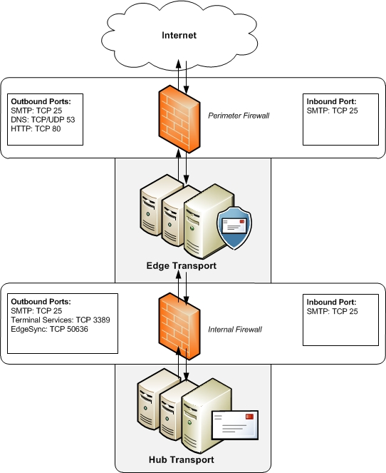
Figure 11: Edge Server Firewall Configuration
  - Mailbox Server Logical Design
The Microsoft Exchange Server 2010 Mailbox server role hosts mailbox databases and provides e-mail storage and advanced scheduling services for Microsoft Office Outlook users. The Mailbox server role can also host a public folder database, which provides a foundation for workflow, document sharing, and other forms of collaboration. It also generates the offline address book (OAB). Mailbox servers provide services that calculate e-mail address policies and address lists for recipients and enforce managed folders.
    - Mailbox Server Logical Configuration Parameters
Topic / Area | Configuration Decision and comments
Database Sizing | Databases will be sized using the Exchange 2010 Mailbox Server Role Requirements Calculator. Detailed sizing information is contained in the physical / storage design section of this document
Backup Methods | VERITAS for Microsoft Exchange 2010.
Public Folders | Public Folders will be used during the migration from Exchange 2003 to Exchange 2010 only for the coexistence period to support Entourage 2008 clients for free/busy information.
Cohosting Server Roles | - Dedicated Mailbox Servers will be deployed to meet Aegis Media Silo Architecture
Database Availability Group Mailbox Servers | The mailbox servers will be deployed as members of a Database Availability Group to enable database replication between the servers.
Offline Address Book Generation | The offline address book will be generated at an interval of 24 hours. It will be configured to be downloaded from the Client Access server role by Outlook clients.
Journal Mailboxes | No journaling mailbox will be deployed since there is no requirement for generating journal reports at Aegis
AutoDatabaseMountDial | This specifies the automatic database mount behavior for a continuous replication environment after a database failover  3 available settings (based on number of logs behind before db automatically mounts):  - Lossless (0)  - GoodAvailability (6)  - BestAvailability (12)  Aegis Media will configure this to GoodAvailability
Exchange Program Files Installation Path | Program files will be installed on the D partition to D:\ExchSrvr
Deleted Item Retention Period | 14 days (As per default)
Deleted Mailbox Retention Period | 30 days (As per default)
BlackBerry Impact on IO | The sizing calculations for BlackBerry uses the numbers provided by Research In Motion here: http://docs.blackberry.com/en/admin/deliverables/8864/BlackBerry_Enterprise_Server_for_Microsoft_Exchange-5.0-US.pdf
Witness Server | Microsoft recommends that a server managed/operated by the Exchange server team is used as the Witness Server (used when there is an even number of nodes in a DAG).  The general design calls for the Witness Server is any Hub Transport server, if the role is NOT on a multi role server including Mailbox server role.  As multi-role servers are deployed a Windows 2008 R2 file server are used as Witness, for details on requirements see7.6.4.  Design Decision  Hub Transport servers <Hostname>\Witness$ will be used as witness “server”
Table 78: Mailbox Server Logical Configuration Parameters
    - Database Availability Group Design Decisions
Aegis Media will deploy 2 Database Availability Groups in the EMEA Datacentre. The Database Availability Groups are:
Topic / Area | Configuration Decision and comments
Database Availability Groups | EMEA Datacentre A  - DAG01: 3 member server DAG with 80 Databases  Two copies in Datacentre A and 3rd copy in Datacentre B.  EMEA Datacentre B  - DAG02: 3 member server DAG with 80 Databases  Two copies in Datacentre B and 3rd copy in Datacentre A
DAG Network Configuration | 2 network interface cards will be installed and configured on each mailbox server:  - NIC1 / Dedicated physical network 1: MAPI network traffic  - NIC2 / Dedicated physical network 1: Replication network traffic  Microsoft recommends at least two dedicated physical networks to ensure that a switch failure does not bring down all access to a database availability group.  Name: DAG1MAPINET  Subnets: (specify subnet)  Network Interfaces: (specify NICs)  Replication Enabled:False  Ignore Network: False  Name: DAG1REPLNET1  Subnets: (specify subnet)  Network Interfaces: (specify NICs)  Replication Enabled:True  Ignore Network: False  Compression: True  Encryption: True
DAG Naming Convention | See Appendix A – Naming Convention
Activation Preference | 1st Preference: Active DB in primary site  2nd Preference: Passive DB in primary site  3rd Preference: Passive DB in the secondary site
Table 79: Database Availability Group Design Decisions
    - Contingency Database Availability Group Design Decisions
Aegis Media will deploy 2 Database Availability Groups in the Asia Pacific and US Datacentre. The Database Availability Group is:
Topic / Area | Configuration Decision and comments
Database Availability Groups | Asia Pacific Datacentre  - DAG03: 3 member server DAG with 38 Databases  Two copies in primary and 3rd copy in secondary datacentre.  US Datacentre  - DAG04: 3 member server DAG with 38 Databases  Two copies in primary and 3rd copy in secondary datacentre
DAG Network Configuration | 2 network interface cards will be installed and configured on each mailbox server:  - NIC1 / Dedicated physical network 1: MAPI network traffic  - NIC2 / Dedicated physical network 1: Replication network traffic  Microsoft recommends at least two dedicated physical networks to ensure that a switch failure does not bring down all access to a database availability group.  Name: DAG1MAPINET  Subnets: (specify subnet)  Network Interfaces: (specify NICs)  Replication Enabled:False  Ignore Network: False  Name: DAG1REPLNET1  Subnets: (specify subnet)  Network Interfaces: (specify NICs)  Replication Enabled:True  Ignore Network: False  Compression: True  Encryption: True
DAG Naming Convention | See Appendix A – Naming Convention
Activation Preference | 1st Preference: Active DB in primary site  2nd Preference: Passive DB in primary site  3rd Preference: Passive DB in the secondary site
Table 80: Contingency Database Availability Group Design Decisions
    - DAG Witness / Quorum Model
A witness server is a server outside of a DAG that's used to achieve and maintain quorum when the DAG has an even number of members. There is no requirement that the version of the Windows Server operating system of the witness server match the operating system used by the DAG members.
Quorum is maintained at the Windows Server cluster level, underneath the DAG. A DAG has quorum when the majority of its members are online and can communicate with the other online members of the DAG.
Quorum refers to the consensus model used by members of a cluster to ensure consistency within the cluster. Exchange uses two of the four cluster quorum models:
- Node Majority (for DAGs with an odd number of members)
- Node and File Share Majority (for DAGs with even number of members)
In this design, the DAG has odd number of cluster nodes. However witness servers is required to achieve a majority if a server fails. The DAG can sustain the loss of 1 voter in the primary sites before compromising the service of healthy nodes caused by loss of Quorum. Alternate witness servers will be configured in the secondary sites which will be used in Site failover scenarios.
There are a number of requirements for the witness server:
- The witness server cannot be a member of a DAG
- The witness server must be in the same Active Directory forest as the DAG
- The witness server must be running Windows Server 2003, Windows Server 2008, or Windows Server 2008 R2
- The specified directory must not be in use by any other DAGs or used for any purpose other than for the witness server
Note: If the witness server you specify isn't an Exchange 2010 server, you must add the Exchange Trusted Subsystem universal security group to the local Administrators group on the Witness Server. These security permissions are necessary to ensure that Exchange can create a directory and share on the Witness Server as needed: Create a Database Availability Group (http://technet.microsoft.com/en-us/library/dd351172.aspx) .
Microsoft’s current recommended practice is that the directory and share is to be hosted on an Exchange server. A Hub Transport server will Witness server.
    - DAG Database Layout Design Decisions
There are several factors to consider when designing the layout of active and passive databases in a Database Availability Group. The following list provides examples of the principles that should be used in an active/passive database layout:
- Provide availability for databases for the maximum number of component failures possible
  - Component failures include disk, lun, server, rack (power/network), power bus, UPS, etc..
    - Determine the cost for adding availability for each component and likelihood of failures (some orgs will plan for single failure of the network, thus 2 devices but may plan for double failures of other components such as drives)
  - Have one copy of a database in each rack (assumes the network switch and power supply as a single point of failure unless mitigated by two network switches and redundant power in each rack and multiple DAG networks)
- Lagged copies are ignored
- LUN awareness, i.e. if DB1 is on LUN01 on server one, then its replica should be on LUN01 on whichever server holds the copy
- When server X goes down, the databases should be spread out over the remaining servers in the other Y racks.
- Balance the Activation Preferences – there should be roughly the same number of 1's, 2's, 3's, and 4's on each server
Using these principles the following database layout design can be achieved:
Figure 12: Database Layout Design
  - Unified Messaging Server
Exchange Server 2010 Unified Messaging (UM) combines voice messaging and email messaging into a single messaging infrastructure. Unified Messaging puts all email and voice messages into one Exchange Server 2010 mailbox that can be accessed from many different devices. After Unified Messaging servers have been deployed on a network, users can access their messages using Outlook Voice Access, from any telephone, from a mobile phone, or from the computer.
In Exchange Server 2010, the Unified Messaging server role combines voice messaging, fax messaging and email messaging in the Exchange store. Unified Messaging integrates Microsoft Exchange with telephony networks. The following figure shows the relationship between an organization’s telephony network components and the UM system.
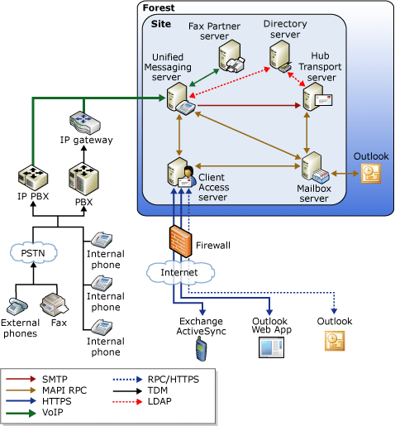
Figure 13 : Unified Messaging Components
In Figure 13, the Unified Messaging solution provides access to telephony systems by using standard Voice over IP (VoIP) protocols. These protocols include Session Initiation Protocol (SIP), Realtime Transport Protocol (RTP), and the T.38 protocol. The IP gateways provide interoperability for legacy Private Branch eXchange (PBX) systems
The UM role was introduced in Exchange Server 2007 and provides Exchange Server 2010 with the ability to act as a voice messaging server. Some of the new features added in Exchange Server 2010 are Speech-to-Text, Message Waiting Indicator, Personal Auto Attendant, Protected Voice Mail, and support for 26 languages.
The Exchange 2010 UM allows Aegis Media users to take advantage of the following capabilities::
- Voicemail
- Personal auto attendants (call answering rules)
- Enhancements to name lookup from caller ID
- Voice mail preview
- Messaging Waiting Indicator
- Missed call and voice mail notifications
- Built-in Unified Messaging administrative roles
The design of the Exchange 2010 UM is based on the following requirements:
- The UM initial deployment will support users in EMEA and USA based on Avaya and Cisco telephony solution.
- The UM design is based on a centralized Exchange deployment
- The design should not have any single point of failure
Exchange UM provides the interaction between voice and the inbox. It acts as a voice mail solution, recording a voice mail and delivering it to an inbox.
Figure 14 provides an overview of the user interaction with the Unified Messaging system.
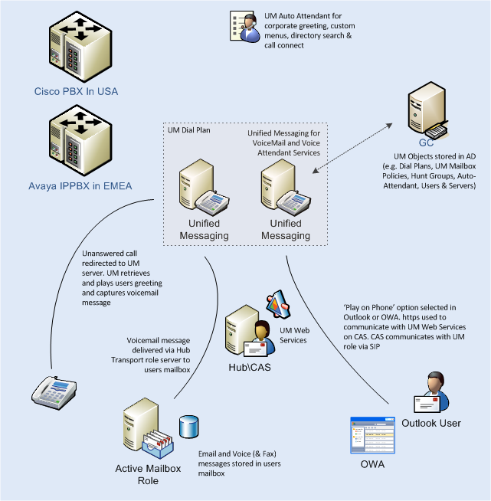
Figure 14 : UM Interaction diagram
    - Cisco Unified Communications Manager Integration
The Exchange Server 2010 Unified Messaging role will be integrated with the Cisco Unified Communications Manager (CUCM) through a Direct SIP connection.
This document does not describe the configuration required on the CUCM environment in depth. It is assumed that the CUCM environment is equipped with sufficient SIP Trunk licenses.
A whitepaper describing the CUCM configuration can be found in the following article:
http://www.microsoft.com/en-us/download/details.aspx?id=13591
    - Avaya
Aegis Media only provide Telephony for UK (London) and Netherlands with Avaya Telephony. The assumption is that Aegis Media only needs to integrate with 8720 IP-PBX in the datacentres, as the 8300’s are Local Survivable Processors.
Aegis Media use Avaya Modular Messaging MAS/MSS for the Voicemails.
Below the description of the VOIP solution in the current environment:
- Data Centre – 2*8720 (CM5.2.1) / 2*G650 Gateways / 1*AES / 1* SES / Modular Messaging 5.1.
- The Cube – 2*G650 / 1*SES
- Parker Street – 1*G450 (LSP)
- Regents Place – 1*G450 (LSP)
- Netherlands – 1*G450 (LSP)
- All voicemail is supplied via Modular messaging at Datacentre.
Aegis Media has also got Avaya CM 5.2.1 / MM 5.1 which integrate with their OCS environment and provide click to call features.
Aegis Media will use Avaya CM 5.2.1 / MM 5.1 to integrate with Exchange 2010 UM servers. Please see the link which provides the configuration details: https://devconnect.avaya.com/public/download/dyn/MSUM_CM_SM61.pdf
    - UM Dial plan
The Dial Plan represents the basic unit of administration in Unified Messaging. It is the telephony extension numbering plan. The UM Dial Plan represents the scope of the voice mail system. Within Unified Messaging, the Dial Plan plus the extension number provides the unique identifier for each Unified Messaging user. This allows greater flexibility in voice mail system consolidation as multiple Dial Plans can work within the same Unified Messaging environment even if extensions are not unique across the different Dial Plans, but the extensions must be unique within the same Dial Plan. Dial plan also controls the numbering scheme and the outbound dialing plan.
A ‘Dial Plan’ is the central component within Exchange UM, and typically has a 1:1 relationship with PBX’s. A dial plan is configured as one of three types:
- Telephone Extension
- SIP URI
- E.164
The dial plan contains all of the configuration settings for the policies, gateways, servers and users. This is where items such as user PIN length, message codec, maximum voice mail length, etc. are configured.
The Unified Messaging Dial Plan object is an Active Directory container that logically represents sets or groupings of PBXs that share common user extension numbering. In practical terms, users' extensions that are hosted on PBXs share a common extension numbering and have the ability to dial one another’s telephone extensions without pre-appending a special number to the extension or dial a full phone number for the other user. Thus, a Dial plan is a logical representation of the telephony Dial Plan that exists for a given organization. An instance of a Dial Plan object must be created in Active Directory for each defined telephony Dial Plan.
The Dial Plan object provides a grouping for users, such that:
- An Extension number, within a telephony/Dial Plan, uniquely identifies a mailbox.
- All users within a Dial Plan are reachable using just Extension number.
- Extensions are unique within a Dial Plan.
- If a Dial Plan spans a Private Voice Network then this network exhibits feature transparency. i.e. Telephony operations, such as initiate transfer, complete transfer, retrieve held call, all work identically for any extension number through any access point.
The Dial Plan, therefore, represents a user community with a set of operational and feature requirements, such as the ability to send messages to each other using an Extension number to address the message, to call the sender of a message, to connect to others using the directory. A shared common user experience is expected throughout the user community, affording a single training/usage pattern.
The rules for a Dial Plan mirror existing rules for legacy Voice Mail systems, so when Exchange Server UM is displacing a legacy Voice Mail system, it is natural that a Dial Plan object should be created for each Voice Mail system replaced.
Aegis Media will gather the details of Dial Plans in the current Avaya and Cisco solution and create 1:1 dial plans in UM Servers. Below is an example of dial plan which Aegis Media will be creating.
Name of Dial Plan | Aegis Media
Digits in Extension | 10
URI Type | Telephone Extension
VoIP Security | Unsecured
Country/Region Code | 44
Pilot Number | 7778002000
Allow callers to transfer to users | Enabled
Allow callers to send voice messages | Enabled
Callers can contact | Anyone in the default Global Address List
Under In Country/Region Rule Groups | Domestic only
Under International Rule Groups | Domestic only
Allow calls to users within the same Dial Plan | Enabled
Allow calls to extensions | disabled
Select In-Country/Region Groups from Dial Plan | Domestic only
Select International Groups from Dial Plan | Domestic only
Table 81 : UM Dial plan
    - UM IP Gateways
A Unified Messaging IP Gateway is a logical object stored in Active Directory that represents an IP PBX that transcodes audio communications.
Table 82 provides the example settings for each of the UM Gateways that will be configured. One UM Gateway will be configured for each of the Cisco Unified Communications Manager servers and Avaya solution.
Item | Setting
Gateway Name | Aegis Media Publisher
IP Address | TBD – by Aegis as part of implementation and testing
Dial Plan | Aegis Media Dial Plan
Allow outgoing calls through this UM Gateway | Enabled
Allow Message Waiting Indicator | Enabled
Table 82 : UM Gateway
    - UM Mailbox policy
UM mailbox policies are required when users are enabled for Unified Messaging. They are useful for applying and standardizing UM configuration settings for UM-enabled users. UM mailbox policies apply a common set of policies or security settings to a collection of UM-enabled mailboxes. You use Unified Messaging mailbox policies to set UM settings for UM-enabled users, such as the following:
- PIN policies
- Dialing restrictions
- Other general UM mailbox policy properties
UM Mailbox policy | Setting
Minimum PIN Length | 6
PIN Lifetime (days) | Disabled (Unlimited)
No. of previous PINs to disallow | 0
Allow common patterns in PIN | disabled
Allow calls to users within the same Dial Plan | Enabled
Allow calls to extensions | Enabled
Select In-Country/Region Groups from Dial Plan | N/A
Select International Groups from Dial Plan | N/A
Table 83 : UM Mailbox policy
    - UM Auto attendant
Unified Messaging enables the creation of one or more UM auto attendants, depending on the needs of the organization. UM auto attendants can be used to create a voice menu system for an organization that lets external and internal callers move through the UM auto attendant menu system to locate and place or transfer calls to company users or departments in an organization.
When anonymous or unauthenticated users call an external business telephone number, or when internal callers call a defined extension number, they are presented with a series of voice prompts that help them place a call to a user or locate a user in the organization and then place a call to that user. The UM auto attendant is a series of voice prompts or audio (.wav) files callers hear instead of a human operator when they call an organization that has Unified Messaging. The UM auto attendant lets callers move through the menu system, place calls, or locate users by using Dial-Tone Multi-Frequency (DTMF) or voice inputs. However, for automatic speech recognition (ASR) or voice inputs to be used ASR must be enabled on the UM auto attendant.
The UM auto attendant:
- Provides corporate or informational greetings.
- Provides custom corporate menus so that a menu option can be linked to another auto attendant to have more than one level.
- Provides a directory search function that enables a caller to search an organization’s directory for a name.
- Enables a caller to connect to the telephone of, or leave a message for, members of the organization.
Aegis Media will create multiple UM Auto Attendants.
    - UM Hunt Groups
Unified Messaging hunt groups are critical to the operation of the Unified Messaging system. The UM hunt group is a logical representation of an existing PBX or IP PBX hunt group. UM hunt groups act as a connection or link between the UM IP gateway and the UM dial plan. Therefore, a single UM hunt group must be associated with at least one UM IP gateway and one UM dial plan.
Unified Messaging hunt groups are used to locate the PBX or IP PBX hunt group from which the incoming call was received. A pilot number defined for a hunt group in the PBX or IP PBX must also be defined within the UM hunt group. The pilot number is used to match the information presented for incoming calls through the Session Initiation Protocol (SIP) signaling message information on the message. The pilot number enables the Unified Messaging server to interpret the call together with the correct dial plan so that the call can be routed correctly. The absence of a hunt group prevents the Unified Messaging server from knowing the origin or location of the incoming call. It is very important to configure the UM hunt groups correctly, because incoming calls that don't correctly match the pilot number defined on the UM hunt group will not be answered, and incoming call routing will fail.
When you create a Unified Messaging hunt group, you are enabling all Unified Messaging servers that are specified within the UM dial plan to communicate with an IP gateway. If you delete the UM hunt group, the associated IP gateway will no longer service calls with the specified pilot number. If the IP gateway is left without remaining UM hunt groups, the IP gateway will be unable to handle incoming calls.
Aegis Media has deployed hunt groups extensively in the current Avaya and Cisco solution. Aegis Media will create UM hunt group for logical representation of an existing PBX or IP PBX hunt group.
    - Network Connections
The UM servers interact with all 3 internal Exchange roles:
- HUB – provision of voice mail delivery
- CAS – interaction with outgoing calls
- MBX – recorded message retrieval, along with mailbox interaction (Outlook Voice Access)
In addition UM will interact with the IP-PBX for all receipt a playback of voice traffic, i.e. Message Waiting Indicator
In the event of failure of any of the individual servers, the process on either UM or the other roles will automatically redirect to the next available server.
There must be adequate bandwidth to support the voice over IP connections between the Cisco Unified Communications Manager system/Avaya solution and the Exchange UM Server. We have not received figures on the usage of the current voicemail system. As a guide, the Ethernet bandwidth is approx. 85 Kb/s per G.711 voice session and 29 Kb/s per G.729 voice session (assumes 30ms). As an example, for 20 simultaneous UM sessions, the Ethernet bandwidth consumption will be approx. 1.7 Mb/s for G.711 and 0.6Mb/s for G.729.
Table 84 provides an overview of the IP ports used for Unified Messaging protocols
Protocol | TCP port | UDP port
SIP (Microsoft Exchange Unified Messaging service) | 5060 (unsecured)  5061 (secured) The service listens on both ports
SIP (UM worker process) | 5065 and 5067 for TCP (unsecured).  5066 and 5068 for mutual TLS (secured)
RTP |  | Ports between 1024 and 65535
Unified Messaging Web service | 443
Table 84 : UM TCP and UDP ports
    - Virtualization of the Unified Messaging Role
The virtualized UM server must be running as the guest operating system under Windows Server 2008 R2 Hyper-V or on third-party virtualization software.
An Exchange 2010 SP1 server that is running the UM server role must be the only Exchange role within a single virtualized server or Hyper-V environment. Other Exchange 2010 server roles, such as Client Access, Edge Transport, Hub Transport, and Mailbox, are not supported in the same virtualized server as the UM server role.
We recommend that the computer that is running the virtualized UM server have at least four CPU cores, and at least 16 GB of memory. For virtualizing UM, the essential requirement is a 1-to-1 mapping of physical cores to virtual cores, and no overbooking. We recommend that the virtualized UM be configured to use at least 2 GB of RAM per core.
In this configuration, a virtualized UM server that experiences a typical mixture of user and caller interactions can handle fewer concurrent calls than a physical UM server that has the same specifications. Under a sustained load, tests show that a virtualized UM server that is configured as described can handle 40 concurrent calls if Voice Mail Preview is active for all UM users, and it can handle 65 concurrent calls if Voice Mail Preview is not in use.
UM does some media (audio) I/O and processing. For the production and consumption of this media, the UM role must be able to keep up with the demands of other endpoints or the user experience will suffer. For example, users may notice audio dropout, either directly for playback or indirectly if speech recognition accuracy is affected.
When you deploy UM servers in both a physical and a virtualized environment, you must consider multiple factors that can affect your Exchange environment:
- The number of mailboxes that are enabled for UM
- The number of incoming calls that are processed
- Whether Voice Mail Preview is enabled for UM-enabled users
- The amount of RAM and the number of processor cores per UM server
In typical UM deployments, the ratio of UM-enabled mailboxes that are served to concurrent calls is at least 100:1. This is because the amount of time that a UM server spends in servicing requests (such as recording messages or using Outlook Voice Access) for any given user usually amounts to a few minutes per day. Therefore, a UM server role, virtualized as described, supports about 4,000 UM-enabled mailboxes if they all have Voice Mail Preview enabled, and about 6,500 mailboxes if Voice Mail Preview is not enabled.
A virtualized UM server role can handle fewer concurrent incoming calls than a physical UM server with the same specifications. Concurrent incoming calls include incoming calls such as call answering or voice mail calls, fax calls, Outlook Voice Access calls, and calls that are answered by UM auto attendants.
A virtualized UM server that is running under Hyper-V can process approximately 40 concurrent incoming calls when Voice Mail Preview is active for all UM-enabled users, and can handle 65 concurrent calls if Voice Mail Preview is not active.
Voice Mail Preview is a UM feature that provides users a text version of their voice messages. The text is generated by automatic speech recognition, and is included with the voice message when it is delivered. Voice Mail Preview is supported in 7 UM language packs (US English, Canadian English, French, Italian, Spanish, Portuguese, and Polish).
If Voice Mail Preview is used, a UM server throttles Voice Mail Previews if the UM server is too busy or is overloaded with incoming calls. Therefore, the percentage of voice messages that include a transcription may be less than 100 percent, depending on the UM configuration and the environment. To be reasonably sure that all average-length voice messages contain voice mail preview text, we recommend that you set the number of concurrent incoming calls to be processed by a virtualized UM server to about 25 instead of 40.
Administrators who must run UM in an environment in which voice mail usage is much heavier than usual should reduce these values. If users receive an average of 10 or more voice messages per day, or use Outlook Voice Access for more than five minutes per day, the ratio of UM-enabled mailboxes that are served to concurrent calls will be nearer to 30:1.
Generally, a UM server role, virtualized as described, should support about 4,000 UM-enabled mailboxes if the mailboxes all have Voice Mail Preview enabled, and about 6,500 mailboxes if Voice Mail Preview is not enabled.
    - UM Storage Design
Voice mails are delivered immediately to the mailbox server, via the Hub Transport server, and as such there is limited need to provision additional storage specifically for the UM server.
However, in the event of a Hub Transport service failure, each UM server will queue 1000 calls locally for delivery before shutting down.
The actual storage required will depend on the codec in use and is shown in Figure 15 below.
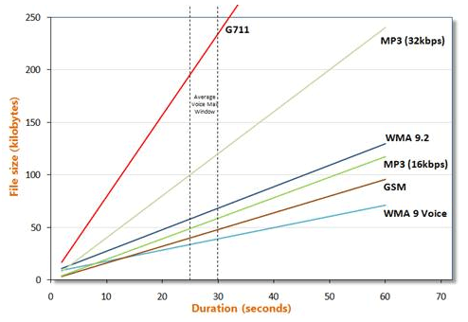
Figure 15 : UM File Size Based on Codec
To ensure UM has enough storage to cope in case of HUB service failure, the following formula is used to determine the local storage requirement:
- 1000 x (Codec size/per second x maximum voice mail duration(seconds)) = storage required
The default voice mail size is set at 20 minutes.

The approximate codec size can be determined from Table 85 below.
Codec | Header size | Per sec
WMA 9 | 7000 | 1100 bytes
GSM |  | 1600 bytes
MP3 (16kbps) |  | 2000 bytes
WMA 9.2 |  | 2300 bytes
MP3 (32kbps) |  | 4000 bytes
G711 (Default) |  | 16,000 bytes
Table 85 : Voice mail size per second
Aegis Media will use WMA Codec.
    - UM Types of users
There are two types of users who access the UM system and consume UM resources: authenticated users and unauthenticated users. When you build a scalable UM environment, you have to consider the effect these users will have and the resources each of these users will consume.
- Authenticated. Authenticated users are UM-enabled and can access their mailbox using Outlook Voice Access. Authenticated users consume UM server resources in several ways, for example, by directly calling in to a subscriber access number, signing in to their mailboxes, accessing their messages, calendar, contacts, or the directory, and using a UM server to play voice messages over a telephone with the Play on Phone feature. They can also indirectly consume resources by transferring a call, sending a voice message, or calling a user's extension number and leaving a voice message.
- Unauthenticated. Users who call in to a UM auto attendant or call in to a subscriber access number but don't sign in to their mailbox are unauthenticated callers. UM resources are used to service their requests every time they call in to a UM auto attendant or use a subscriber access number. Even though they don't sign in to their mailbox, they still consume resources by transferring a call, sending a voice message, transferring to another auto attendant, transferring to another telephone number, or listening to recorded audio prompts.
    - Calculating the UM servers number
The UM users can be classified to two groups, Light users and heavy users. The following table illustrates the characteristics of each group
Activity | Light Users | Heavy Users
Average number of call-answered voice messages per user per day | 4 | 8
Average duration of call-answered voice message, seconds | 25 | 25
Average duration of greeting, seconds | 5 | 5
Average number of fax messages per user per day | 1 | 2
Average duration of fax call, seconds | 60 | 60
Average number of UM logins per user per day | 0.5 | 3
Average duration of UM user session, seconds | 120 | 120
Average usage per user in busy hour (14%), seconds | 33.6 | 100.8
Table 86: UM users can be classification
P.01 probability curve assumes that the user could get busy signal when contacting UM server one time every 100 times he tries
P.05 probability curve assumes that the user could get busy signal when contacting UM server Five times every 100 times he tries
The assumption is in the busy hour 14% of the days calls arrives to UM server
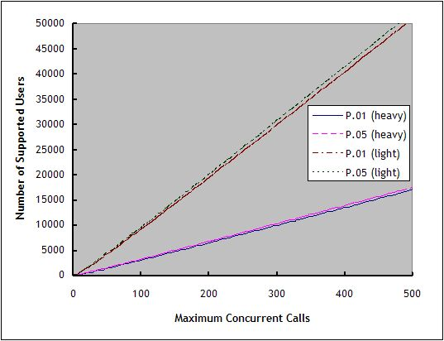
Figure 16: Probability Curve
Design recommendations for Aegis Media based on the graph and the following assumptions:
- The user’s profiles are heavy profile
- One UM server will support 40 concurrent connections
- UM servers will be virtualized
- Voice mail preview will be enabled for all users
One UM server will support approximately 4,000 heavy users with 1% chance of the user getting busy signal when dialing UM pilot number. For fault tolerance multiple server is added, the Exchange UM servers should follow N+1 rule all the time where N is the number of UM servers to support the UM users. Four servers will support 16,000 users with high availability; we can scale out by adding additional server with each 4,000 UM users
    - Load Balancing in Unified Messaging
Unified Messaging deployments can be made more resilient by deploying multiple UM servers to a single dial plan to balance the load of incoming calls. The IP gateways supported by Unified Messaging can be set up to route calls in a round-robin manner to balance the load between multiple UM servers in a dial plan.
Round robin is a method for distributing the workload among multiple servers. However, round robin doesn't by itself enable an IP gateway to detect a server failure. If one of the UM servers fails and if the IP gateway can't detect that a UM server is unavailable, the IP gateway will continue to send incoming calls to the UM server until you detect the failure and remove the server from the dial plan. After you remove the UM server from the dial plan, you should also remove the IP address or FQDN for the UM server from the configuration on the IP gateway.
Unified Messaging doesn't use round-robin DNS or Network Load Balancing to distribute incoming calls. Round-robin DNS can be used on multi-homed computers and can be used to distribute the load for other services, but not for Unified Messaging. NLB is used with other services to distribute client requests and to automatically detect whether a server is unavailable, and then to redistribute other client requests to the remaining server. But it also can't be used with Unified Messaging. The only way to distribute or balance the load between Unified Messaging servers in a dial plan is for the IP gateway to be set up with the IP addresses or FQDNs of the UM servers in the dial plan. The IP gateway will use the list to distribute the load across all the UM servers in the dial plan and can also detect a server failure if the IP/VoIP supports this functionality.
Another way to load balance your UM deployment is to set up PBX hunt groups to connect to multiple IP gateways and then set up the hunt groups to load balance across the IP gateways

- Server Hardware Design Decisions
  - Deployment Design Decisions
Based on the sizing information in the server hardware section of this document, the following server counts have been prepared for each datacentre.
    - Datacentre Design Decisions
Site | Mailbox | CAS &Hub | UM | Edge | Grand Total
EMEA Datacentre A | 3 + 1 (If Contingency Design implemented) | 2 | 2 | 2 | 9 + 1 If Contingency Design implemented
EMEA Datacentre B | 3 +1 If Contingency Design implemented | 2 | 2 | 2 | 9 +1 If Contingency Design implemented
Total | 6 +2 If Contingency Design implemented | 4 | 4 | 4 | 18 + 2 If Contingency Design implemented
Table 87: Datacentre Design Decisions
Aegis Media will use Microsoft Exchange Server 2010 Enterprise edition for the Mailbox Servers and Standard edition for the CAS & Hub, UM and Edge servers.
    - Server Hardware Design Decisions
The current design lists the following server types to be purchased:
- CAS/HUB collocated
- Mailbox Servers
- Edge Servers
- Unified Messaging Server
The following table lists the hardware specifications for the servers to be used in the Architecture and Design for Microsoft Exchange Server 2010 Deployment.
Server Classification | # Cores | Memory  (GB) | DAG / DB configuration | Disk Configuration  Network Configuration
Mailbox server in EMEA Datacentres | 12  Intel Xeon X5690  3.46GHz | 96GB based on calculations recommendation is 4 GB plus 3-30 MB additional memory per mailbox, The total required memory is based on the user profile and database cache size. | Please refer to storage calculations | SAN Storage. See following table for drive/partition layout  81 x 300gb drives local per server  2 x NICs
CAS and Hub | 12  Intel Xeon X5690  3.46GHz | 32GB recommendation is 2 GB per core + added more for ScanMail or Forefront for Exchange. | NA | See following table for drive/partition layout
Edge Transport Server | 12  Intel Xeon X5690  3.46GHz | 16GB recommendation is 1 GB per core + added more for ScanMail or Forefront for Exchange. | NA | See following table for drive/partition layout
Unified Messaging | 12  Intel Xeon X5690  3.46GHz | 24GB recommendation is 2 GB per core | NA
Table 88: Server Hardware Design Decisions
    - Contingency Datacentre Design Decisions
Site | Mailbox | CAS &Hub | UM | Edge | Grand Total
Asia Pacific | 2 | 2 | 2 | 2 | 8
US Datacentre | 2 | 2 | 2 | 2 | 8
Table 89: Contingency Datacentre Design Decisions
Aegis Media will use Microsoft Exchange Server 2010 Enterprise edition for the Mailbox Servers and Standard edition for the CAS & Hub, UM and Edge servers.
    - Contingency Server Hardware Design Decisions
The current design lists the following server types to be purchased:
- CAS/HUB collocated
- Mailbox Servers
- Unified Messaging Server
- Edge Servers
The following table lists the hardware specifications for the servers to be used in the Architecture and Design for Microsoft Exchange Server 2010 Deployment.
Server Classification | # Cores | Memory  (GB) | DAG / DB configuration | Disk Configuration  Network Configuration
Mailbox server | 12  Intel Xeon X5690  3.46GHz | 48GB based on calculations recommendation is 4 GB plus 3-30 MB additional memory per mailbox, The total required memory is based on the user profile and database cache size. | Please refer to storage calculations | SAN Storage. See following table for drive/partition layout  39 x 300gb drives  2 x NICs
CAS and Hub | 12  Intel Xeon X5690  3.46GHz | 32GB recommendation is 2 GB per core + added more for ScanMail or Forefront for | NA | See following table for drive/partition layout
Edge Transport Server | 12  Intel Xeon X5690  3.46GHz | 16GB recommendation is 1 GB per core + added more for ScanMail or Forefront for Exchange. | NA | See following table for drive/partition layout
Unified Messaging | 12  Intel Xeon X5690  3.46GHz | 24GB recommendation is 2 GB per core | NA
Table 90: Contingency Server Hardware Design Decisions
    - Server Drive/Partition Design Decisions
LUN | Drive letter | Usage
1 | C | Operating system, Exchange binaries, and tracking logs
2 | D | mail.que database (Transport database)
3 | E | Tracking logs, Transaction logs (Transport database)
4-x | -- | Additional drives for databases and logs
6 | Z | DVD drive
Table 91: Server Drive/Partition Design Decisions
  - Server Database and Storage Configuration
The server storage design will leverage SAN with the RAID configuration as specified below. Aegis Media will provide the storage calculations to NetApp and they will work together to get the storage needed for the Exchange 2010 solution.
Aegis Media will be deploying the solution for 16000 mailboxes and later will add more storage to cater up to 50% growth. Exchange 2010 Server hardware is planned to take this additional load.

Note:
This is not a recommended approach as if in the future the numbers of users are more than what storage can support from IOPS stand, there will be performance degradation. It will be an overhead for Aegis Media to add storage, databases and users distribution later.
Also as Aegis will not be able to perform Jetstress testing for 23000 users when the solution will be built, it cannot be determined how storage will perform. This presents a significant risk to the performance of the platform.
The Architecture and Design for Microsoft Exchange Server 2010 Server Role Requirements Calculator was used to plan the storage requirements. Exchange 2010 Mailbox Server Role Requirements Calculator
The screenshot are for the calculations done for 16000 users with 50% growth, additional calculations are attached in the end of this section. There are separate calculations done for the contingency Asia Pacific design which will only be used if Asia pacific design will be implemented.
The storage for the mailbox servers will be configured as follows:
    - Input Tab: Environment Configuration
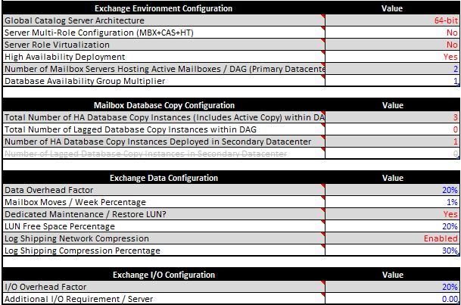
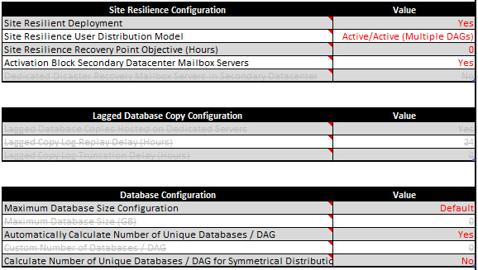
    - Input Tab: Tier 2 Mailbox Configuration
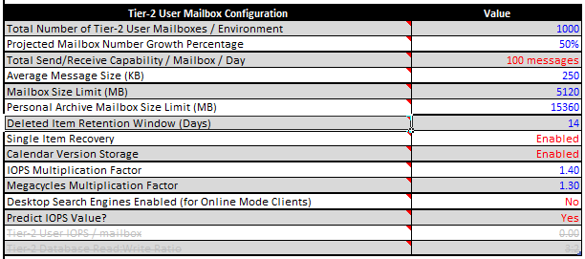
    - Input Tab: Tier 3 Mailbox Configuration
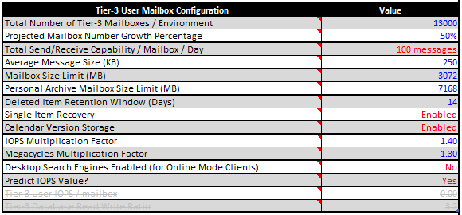
    - Input Tab: Tier 4 Mailbox Configuration
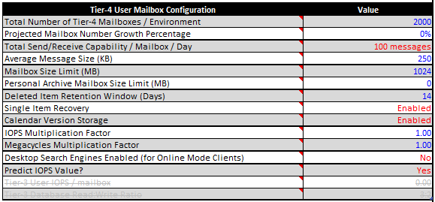
    - Input Tab: Backup Configuration
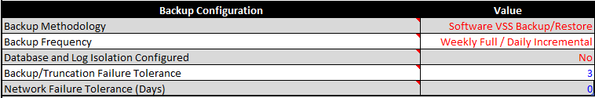
    - Input Factors - Storage Configuration
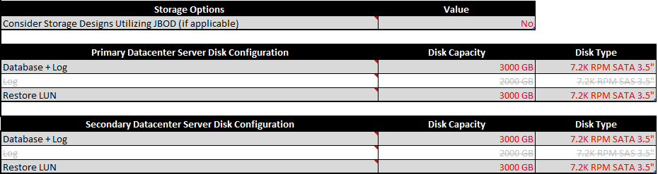
    - Input Factors - Processor Configuration
    - Input Factors - Log Replication Configuration
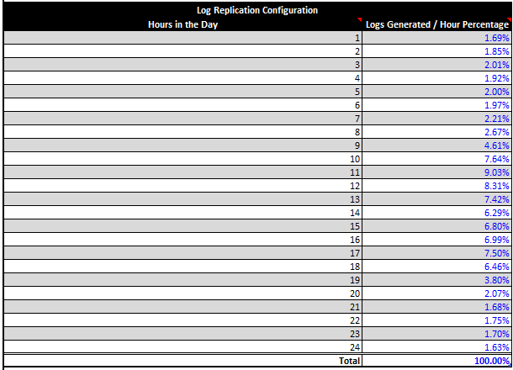
    - Role Requirements Tab: Environment Configuration
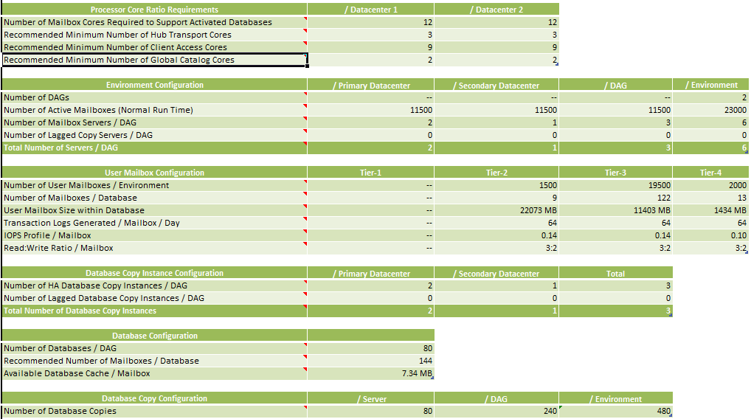
    - Role Requirements Tab: Server Configuration
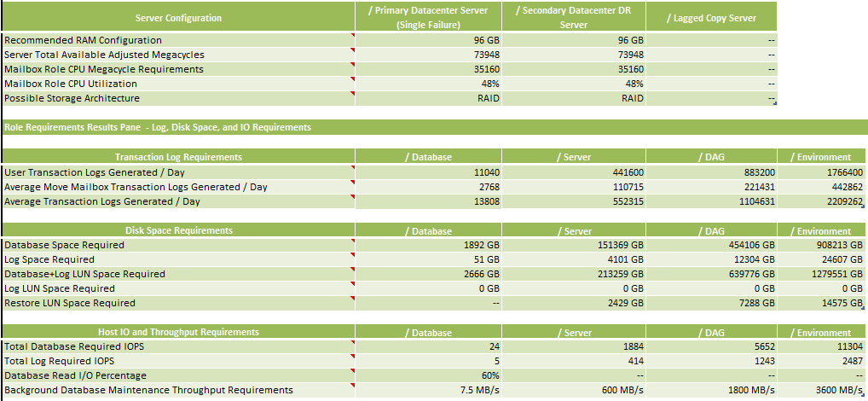
    - Activation Scenarios Results Pane - Active/Active Environments
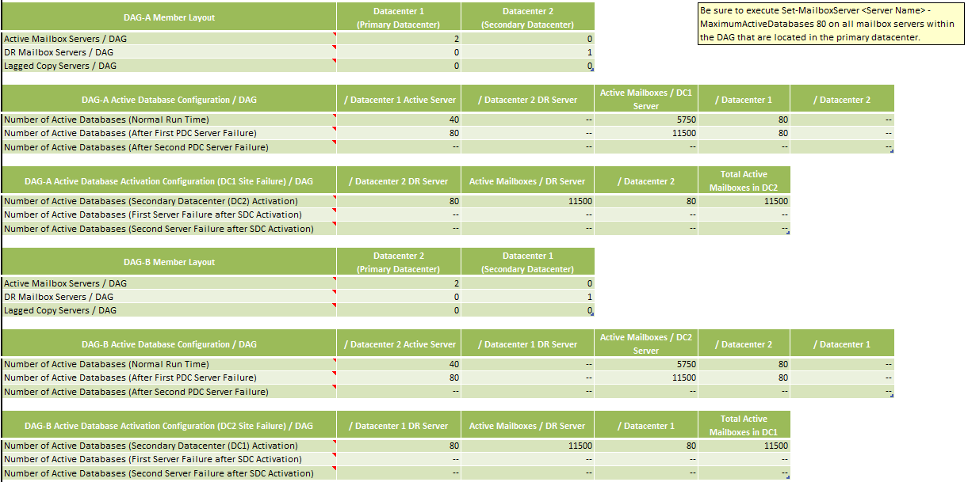
    - DAG Distribution
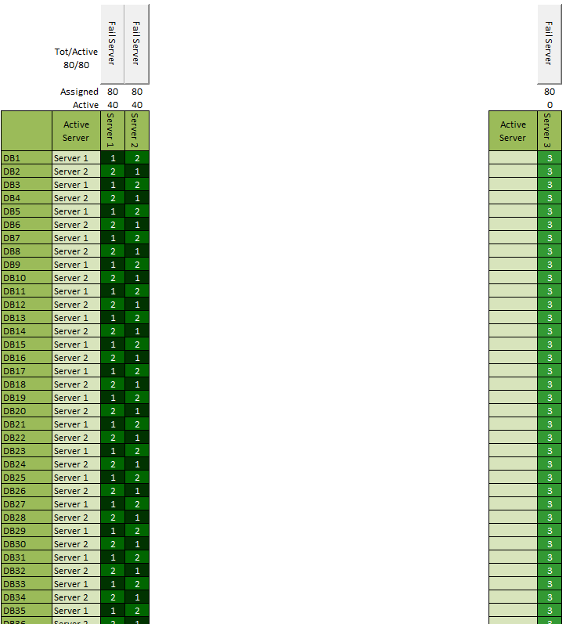
    - LUN Requirements Tab: LUN Design and Configuration
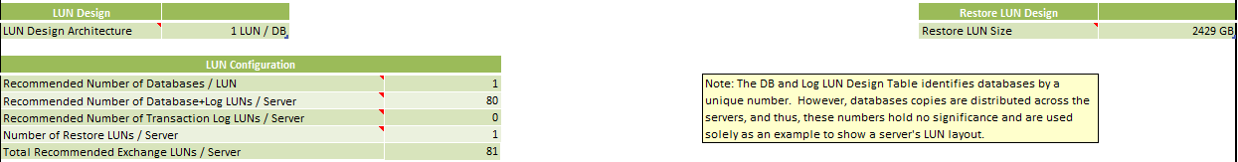
    - LUN Requirements Tab: Database and Log Configuration / Server
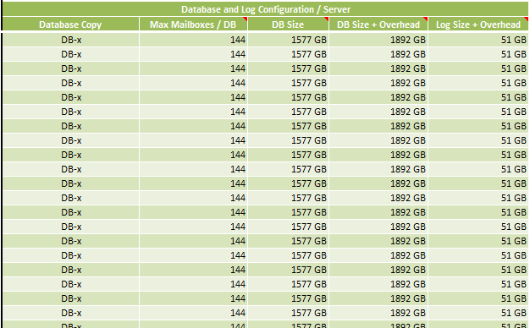
    - LUN Requirements Tab: Database and Log Design / Server
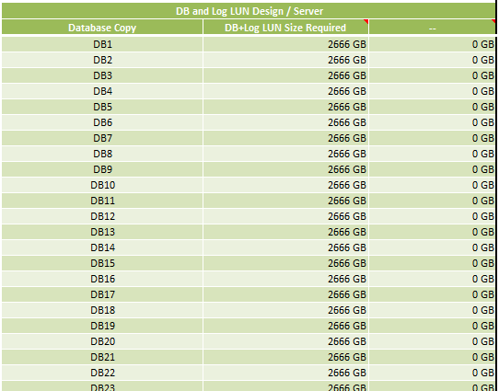
    - Backup Requirements Tab: Backup Configuration
    - Backup Requirements Tab: Backup Frequency Configuration / Server
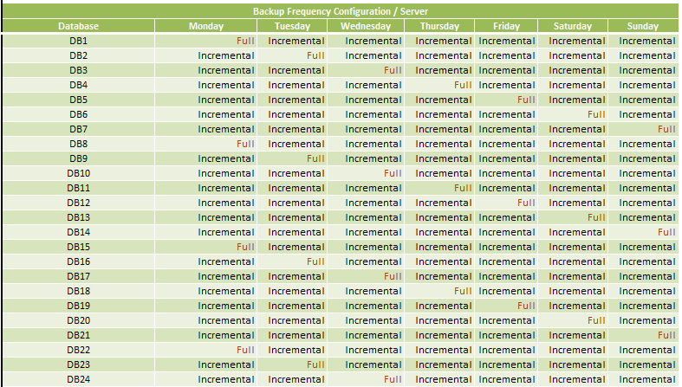
    - Log Replication Requirements Tab: Peak Log & Content Index Replication
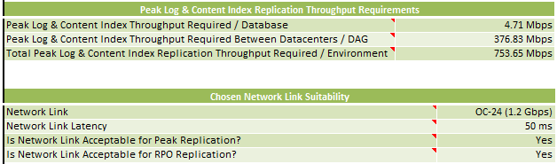
    - Log Replication Requirements Tab: RPO Log & Content Index Throughput Requirements
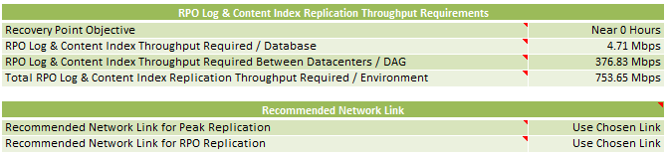
    - Storage Design Tab: Storage Design
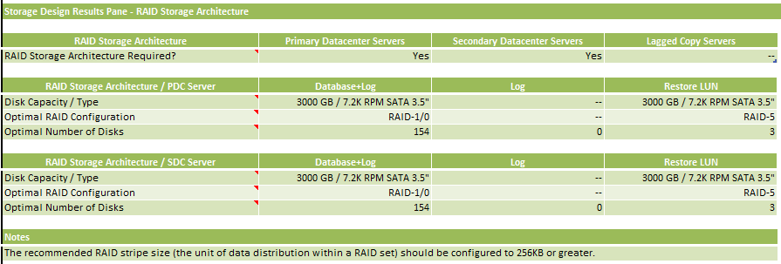
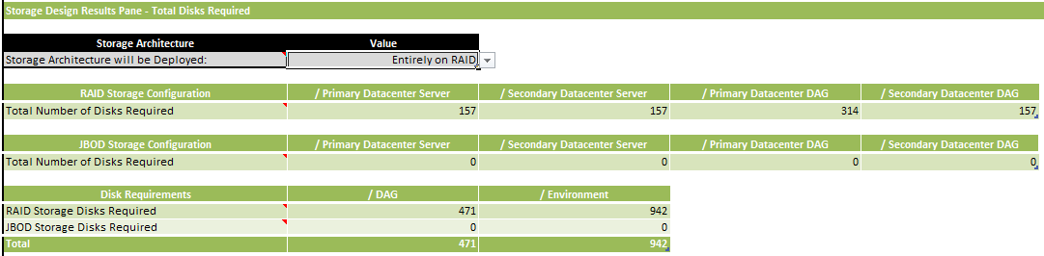
    - Aegis Media Exchange 2010 Storage Calculations
The following embedded file contains the storage calculations for this design:
  - Backup
Aegis Media will be taking backup and maintain last 3 years of data in the tapes. Aegis Media will use VERITAS for the backup. It is important to note that Exchange 2010 no longer supports the ESE streaming APIs for backup and restore of program files or data. Exchange 2010 supports only Volume Shadow Copy Service (VSS) based backups.
    - Backup Schedule
The backup schedule should follow the following guidelines:
- Avoid backing up the active node during business hours since there is a performance penalty hit on the mailbox servers
- Do not backup during the online maintenance windows.
- Consider backing up the passive copy of database, doing backup from the passive copy removes the disk load on the active LUNs.
Aegis Media team decided to use backup plan consisted of:
- Weekly Full Backup.
- Daily incremental Backup.
The following table contains the backup frequency configuration per cluster:
Database | Sunday | Monday | Tuesday | Wednesday | Thursday | Friday | Saturday
DB1 | Full | Incremental | Incremental | Incremental | Incremental | Incremental | Incremental
DB2 | Incremental | Full | Incremental | Incremental | Incremental | Incremental | Incremental
DB3 | Incremental | Incremental | Full | Incremental | Incremental | Incremental | Incremental
DB4 | Incremental | Incremental | Incremental | Full | Incremental | Incremental | Incremental
DB5 | Incremental | Incremental | Incremental | Incremental | Full | Incremental | Incremental
DB6 | Incremental | Incremental | Incremental | Incremental | Incremental | Full | Incremental
DB7 | Incremental | Incremental | Incremental | Incremental | Incremental | Incremental | Full
DB8 | Full | Incremental | Incremental | Incremental | Incremental | Incremental | Incremental
DB9 | Incremental | Full | Incremental | Incremental | Incremental | Incremental | Incremental
Table 92: Backup Frequency
    - Exchange Native Backup Protection
Exchange 2010 includes several new features and core changes that, when deployed and configured correctly, can provide native data protection that eliminates the need to make traditional backups of Exchange data. Using the high availability features built into Exchange 2010 to minimize downtime and data loss in the event of a disaster can also reduce the total cost of ownership of the messaging system. By combining these features with other built-in features, such as Legal Hold, organizations can reduce or eliminate their dependency on traditional point-in-time backups and reduce the associated costs.
In addition to determining whether Exchange 2010 enables to move away from traditional point-in-time backups, Microsoft also recommends that the cost of the current backup infrastructure should be evaluated. The cost of end-user downtime and data loss also should be considered when attempting to recover from a disaster using the existing backup infrastructure. Also, including hardware, installation, and license costs, as well as the management cost associated with recovering data and maintaining the backups. Depending on the requirements of the organization, it is quite likely that a pure Exchange 2010 environment with at least three mailbox database copies will provide lower total cost of ownership than one with backups.
Backups are typically used for the following scenarios, and there are Exchange 2010 features to meet each of these needs in an efficient and cost effective manner.
- Disaster recovery: In the event of a hardware or software failure, multiple database copies in a database availability group (DAG) enable high availability with fast failover with no data loss. This eliminates the end-user downtime and resulting lost productivity that's a significant cost of recovering from a past point-in-time backup to disk or tape. DAGs can be extended to multiple sites and can provide resilience against datacentre failures.
- Recovery of accidentally deleted items: Historically, in a situation where a user deleted items that later needed to be recovered, it involved finding the backup media on which the data that needed to be recovered was stored, and then somehow obtaining the desired items and providing them to the user. With the new Recoverable Items Folder in Exchange 2010 and the Hold Policy that can be applied to it, it's possible to retain all deleted and modified data for a specified period of time, so recovery of these items is easier and faster. This reduces the burden on Exchange administrators and the IT help desk by enabling end users to recover accidentally deleted items themselves, thereby reducing the complexity and administrative costs associated with single item recovery.
- Long-term data storage: Sometimes, backups also serve an archival purpose, and typically tape is used to preserve point-in-time snapshots of data for extended periods of time as governed by compliance requirements. The new archiving, multiple-mailbox search, and message retention features in Exchange 2010 provide a mechanism to efficiently preserve data in an end-user accessible manner for extended periods of time. This eliminates expensive restores from tape, and increases end-user productivity by enabling rich clients such as Microsoft Outlook and Outlook Web App access to older data.
- Point-in-time database snapshot: If a past point-in-time copy of mailbox data is a requirement for the organization, Exchange provides the ability to create a lagged copy in a DAG environment. This can be useful in the rare event that there's a logical corruption that replicates across the databases in the DAG, resulting in a need to return to a previous point in time. It may also be useful if an administrator accidentally deletes mailboxes or user data. Recovery from a lagged copy can be faster than restoring from a backup because lagged copies don't require a time-consuming copy process from the backup server to the Exchange server. This can significantly lower total cost of ownership by reducing end-user downtime.
Aegis Media will deploy and use a backup solution for Exchange 2010 since it is a legal requirement to do so. Aegis Media will store 3 years of backup on taps.

- Transition and Coexistence
Any organization that is upgrading from Exchange 2003 will experience a period of coexistence. In a coexistence scenario, any combinations of the following versions of Microsoft Exchange are deployed in a single Exchange organization: Exchange Server 2003, and Exchange 2010. These multiple versions of Exchange are able to communicate with each other and share data resources, recipient information, and configuration information. Parts of the organization still use Exchange 2003 functionality and other parts have completed the upgrade to Exchange 2010.
The following items should be considered before the upgrade:
- Active Directory and Domains: When upgrading from Exchange Server 2003 to Exchange Server 2010, specific Exchange permissions should be granted in each domain in where Exchange 2003 DomainPrep has been run. To do this, the setup /PrepareLegacyExchangePermissions command must be executed. Granting these permissions is part of preparing Active Directory domains for installing Exchange Server 2010.
- Management interfaces: In Exchange 2010, managing Exchange 2010 servers and mailboxes could be done by using either the Exchange Management Console (EMC) or the Exchange Management Shell. EMC could also be used to view some attributes on Exchange 2003 servers.
- Routing groups: A large organization that has many routing groups must plan their routing topology to maintain mail flow during the coexistence period. When planning for a period of coexistence between Exchange 2003 and Exchange 2010, it will be required to understand the differences in how each version determines its routing topology.
- Native Mode: Exchange 2010 can be deployed only in an Exchange 2003 organization that operates in native mode.
When upgrading to Exchange 2010, the first servers should be the servers in the internet accessible Active Directory sites first, and then followed by upgrading the internal Active Directory sites. This is because Client Access server to Front End redirection (or Proxying to Back End) is only supported from the newer CAS versions (Exchange 2010) to older versions (Exchange 2003) and not the other way around.
Generally, it is recommended to upgrade a single Active Directory site at a time to Exchange 2010.
Here is a high-level overview of the upgrade steps that you follow to upgrade from Exchange 2003 to Exchange 2010.
First, you upgrade all Internet-facing Active Directory sites by doing the following:
- Upgrade existing Exchange 2003 servers to Exchange 2003 Service Pack 2 (SP2).
- Deploy Exchange 2010 servers in this order:
- Client Access
- Hub Transport
- Unified Messaging
- Mailbox
- Configure the Exchange 2003 front-end server and the Exchange 2010 Client Access server.
- Configure the Exchange 2010 Hub Transport server and the Unified Messaging servers.
- Move mailboxes from Exchange 2003 to Exchange 2010
Then, upgrade all internal Active Directory sites in the same manner.
  - Administration Differences
Exchange Server 2003 uses Administrative Groups to organize Exchange objects for the purposes of delegating permission to manage those objects. Exchange 2010 does not use Administrative Groups as a logical management unit for administrative delegation. However, to support coexistence between Exchange Server 2003 and Exchange 2010, all Exchange 2010 servers are automatically put in a single Administrative Group when Exchange 2010 is installed. This Administrative Group is recognized in the Exchange System Manager of earlier versions of Exchange as Exchange Administrative Group (FYDIBOHF23SPDLT).
Exchange 2010 servers shouldn’t be moved out of Exchange Administrative Group (FYDIBOHF23SPDLT) and should not be renamed by using a low-level directory editor. Exchange 2010
  - Client Access Server Coexistence
The Client Access server role provides the functionality that was provided by a front-end server in Exchange 2003 and more. All client connectivity (including Outlook MAPI connectivity) now goes through the Client Access server role. There are no longer any clients directly connecting to the mailbox server role. The Client Access server role can coexist with Exchange Server 2003 servers. The following list describes the Exchange 2010 dependencies and requirements for coexistence with Exchange Server 2003:
- Whether a user sees the Outlook Web Access client of Exchange Server 2003 or Exchange 2010 depends on the location of the user's mailbox. If the user's mailbox is located on an Exchange Server 2003 back-end server and the Client Access server is running Exchange 2010, the user will be forwarded to Exchange 2003 server and will see the Exchange Server 2003 version of Outlook Web Access.
- The version of Exchange ActiveSync that clients use also depends on the server version that is hosting the user's mailbox. The user's mailbox must be located on a server that is running Exchange Server 2003 Service Pack 2 or Exchange 2010 to have Direct Push enabled for Exchange ActiveSync.
  - Hub Transport Server Coexistence
The Hub Transport server role is designed to handle all mail flow for the Exchange organization. It is also responsible for handling Transport Rules, Journaling policies and message delivery. This server is deployed in the Active Directory forest and is required for Exchange 2010 mailboxes to send and receive messages. Messages that are sent to the Internet are relayed by the Hub Transport server to the Edge Transport server or a third-party smart host.

Exchange 2010 Hub Transport server could be added to an existing Exchange organization after deploying Exchange 2010 CAS servers. When introducing Exchange 2010 Hub servers in Exchange 2003 environment, all Exchange 2010 Hub servers are placed in a single separate routing group. To enable mail flow between the Exchange 2010 deployment and the existing Exchange 2003 organization, a Routing Group connector must be created. This Routing Group connector is created during the setup of the first Exchange 2010 Hub Transport server.
The following routing groups will be created:
- M-EMEA-H-LON and Exchange 2010 Routing Group
- M-AMERICAS-H-USA and Exchange 2010 Routing Group
- M-AP-H-HKG and Exchange 2010 Routing Group
The main routing group that connects all the other routing groups together is M-EMEA-H-LON, thus Exchange 2003 servers should be in this Routing group until all other routing groups are decommissioned to guarantee the mail flow between Exchange 2003 servers and Exchange 2010 servers.
  - Mailbox Server Coexistence
The Mailbox server role can coexist with Exchange Server 2003 mailbox servers. For Exchange 2010 and Exchange Server 2003 mailbox servers to coexist, sending mail among the mailboxes must be configured. Exchange 2010 uses the Hub Transport server to send mail. An Exchange 2010 Hub Transport server must be deployed in each Active Directory site that contains an Exchange 2010 Mailbox server. Client Access server also is needed in each Active Directory site where there is a Mailbox server.
When moving a mailbox from Exchange Server 2003 to Exchange 2010 and the mailbox is part of an e-mail address policy, the e-mail addresses for that mailbox is automatically updated based on the configuration of the e-mail address policy. If the mailbox had a primary SMTP address that differs from the e-mail address that is enforced by the e-mail address policy, that SMTP address becomes a secondary SMTP address and the e-mail address generated by the e-mail address policy becomes the primary SMTP address.
  - Client Access Upgrade Process
This section explains in detailed the process required to upgrade Exchange 2003 in Aegis Media to Exchange 2010.
    - Prepare Legacy Permissions
When upgrading from Exchange Server 2003 to Exchange Server 2010, specific Exchange permissions should be granted first global.loc domain where Exchange 2003 DomainPrep is configured before.
The following command should be used as a part of preparing Active Directory:
setup /PrepareLegacyExchangePermissions
    - Upgrade From Exchange 2003 Client Access
Aegis Media has multiple URL’s configured in Exchange 2003 environment to provide users OWA and other remote services. Exchange 2010 planned namespace URL’s are not if use in the existing environment hence users will be able to continue to use the URL’s they use today to access OWA until their mailbox is moved to Exchange 2010. The following diagram shows the co-existence between Exchange 2010 Client Access and Exchange 2003 servers, <Legacy> refers to the existing Exchange 2003 URL’s in use:
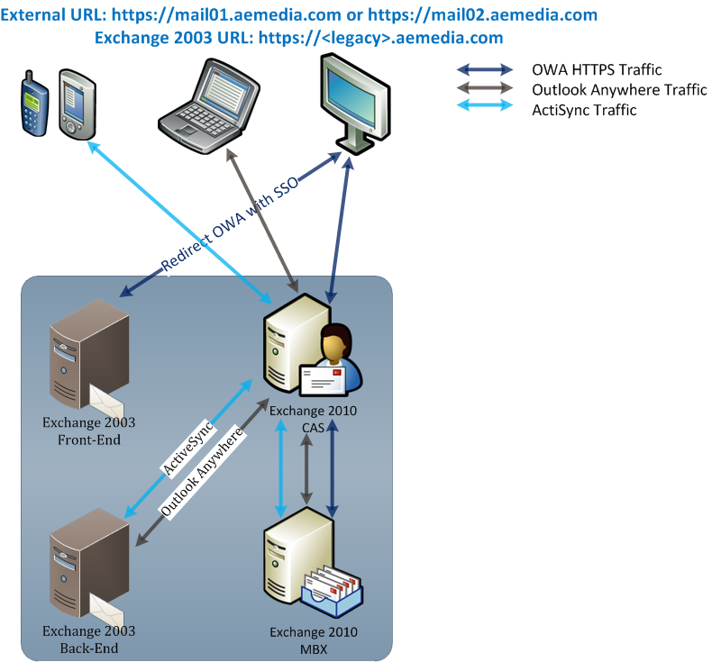
Figure 17: CAS Co-existence
In the above diagram, the behavior will change based on where the mailbox of the users located as follows:
Exchange 2010 : if the mailbox is placed on Exchange 2010 mailbox server the following behavior will be applied for each type of users:
- OWA users: will use the URL https://mail01.aemedia.com or https://mail02.aemedia.com which is translated to the CAS IP, CAS will contact Exchange 2010 mailbox server to get the user’s mailbox.
- Outlook Anywhere: users will use the same URL https://mail02.aemedia.com or https://mail02.aemedia.com which points to the CAS server; CAS will contact the mailbox server.
- ActiveSync: the same URL will be configured on ActiveSync devices https://mail01.aemedia.com or https://mail02.aemedia.com, CAS will get the users’ data from the mailbox server and synchronize with the devices.
- If contingency design is implemented users will connect to their regional URLs for all the CAS services on https://us.mail.aemedia.com or https://ap.mail.aemedia.com which points to their regional CAS servers; CAS servers will connect to user’s mailbox.
Exchange 2003: if the user’s mailbox is placed on Exchange 2003 Back-End, Users can continue to use their existing Exchange 2003 URL until their mailbox is moved to Exchange 2010. The following will be applied based on type of access if user mailbox is still on Exchange 2003 and they try to use Exchange 2010 URL’s:
- OWA users: will can use the external URL https://mail01.aemedia.com or https://mail02.aemedia.com to contact Exchange CAS 2010 which will identify that the user’s mailbox is located on Exchange 2003 server, and redirect the user to Exchange 2003 Front-End URL Error! Hyperlink reference not valid., the session will be configured with Single Sign On so the user will not be requested to enter the password again.
- Outlook Anywhere (RPC/HTTPs): will be configured to use https://mail01.aemedia.com or https://mail02.aemedia.com, CAS will contact Exchange 2003 Back-End directly for the user’s mailbox.
- ActiveSync users: will synchronize their mailboxes using the same URL https://mail01.aemedia.com or https://mail02.aemedia.com, CAS will get there mailboxes from Exchange 2003 Back-End server.
- If contingency design is implemented users will connect to their regional URLs for all the CAS services on https://us.mail.aemedia.com or https://ap.mail.aemedia.com which points to their regional CAS servers; Exchange 2010 will treat the request as mentioned in the above points based on type of service request.
    - Understanding Legacy Host Names
An important part of the upgrade process is configuring a legacy host name and associating that host name with Exchange 2003 Front-End Server. This is a necessary step if there will be a significant number of mailboxes that can't all be moved from Exchange 2003 to Exchange 2010 during the downtime scheduled for the upgrade and if the organization supports Outlook Web Access for Internet users.
Aegis Media is using multiple URL’s in the Exchange 2003 environment is does not conflict with the Exchange 2010 namespace hence no change will be needed.
The legacy host name are configured and published to the Internet and associated with the virtual directories of the various services on Exchange 2003, such as Microsoft Exchange ActiveSync, Microsoft Outlook Web Access.
Users will experience a seamless transition. Exchange 2010 will redirect OWA users from the Exchange 2010 Client Access server to the Exchange 2003 front-end server if they use the new Exchange 2010 URL’s. Users will have to learn a new URL to access Outlook Web Access (called Outlook Web App in Exchange 2010) and reconfigure their Exchange ActiveSync devices if they do not support redirection. Outlook Anywhere users can also continue to access their mailboxes without interruption as Aegis Media users have Outlook 2007/2010 and an upgrade will be needed for Entourage 2008 with Web services edition.
    - Certificate Planning for Upgrade
To support coexistence of Exchange 2003 and Exchange 2010, a new certificate should be obtained. A certificate that supports Subject Alternative Names should be obtained. However, a wildcard certificate is also supported.
The details of required certificate is explained in the section 7.3.4
    - RPC Client Access
In Microsoft Exchange Server 2010, the Client Access server role includes a task that wasn't included in previous Exchange Server versions. That new task handles the processing from MAPI clients such as Microsoft Office Outlook. In previous Exchange versions, Outlook clients connecting to an Exchange server from inside an organization's firewall would connect directly to the Exchange 2007 Mailbox server or Exchange 2003 Back-End Server. In Exchange 2010, that processing has been moved to the Exchange 2010 Client Access server.
The change in Exchange 2010 to move all processing to the Client Access server was implemented to provide all data access through a single, common path of the Client Access server. This change improves consistency for applying business logic to clients, and provides a better client experience when failover occurs. This change also allows a higher number of concurrent connections per server and a higher number of mailboxes per server.
In addition to moving processing of incoming Outlook connections to the Client Access server, in Exchange 2010, directory access is also handled by the Client Access server.
    - Outlook Client Configuration
When upgrading to Exchange 2010, clients running Outlook 2007 or later versions will automatically be compatible with the change to RPC Client Access, since they support RPC encryption by default. However Outlook 2003 doesn’t use RPC encryption and RPC Client Access requires it by default. If RPC encryption hasn’t been turned off, users will need to configure Outlook 2003 for RPC encryption manually or by using Group Policy to force Outlook 2003 to use RPC encryption.
Symptoms of this problem include the following error messages:
- Cannot start Microsoft Office Outlook. Unable to open the Office window. The set of folders could not be opened.
- Unable to open the default e-mail folders. The information store could not be opened.
If Outlook is configured to use Cached Exchange Mode, Office won't display an error, but will start in disconnected mode.
Aegis Media is using Outlook 2007 or 2010 as the supported clients and will upgrade Entourage 2008 with Web services edition.
    - Client Access Upgrade Process Summary
The following steps show a high level overview about the upgrade process considering client access only (Mail Transport and Mailbox move steps are considered in separate sections):
- Installing Exchange 2010 within the organization on new hardware
- Configuring Exchange 2010 Client Access
- Obtaining a digital certificate with the names that will be used during the coexistence period and installing it on the Exchange 2010 Client Access server
- Moving mailboxes from Exchange 2003 to Exchange 2010
- Decommissioning Exchange 2003 infrastructure
  - Upgrade From Exchange 2003 Transport
The following diagram shows the mail from between Exchange 2003 and Exchange 2010 and the steps of upgrading Exchange 2003 mail flow:
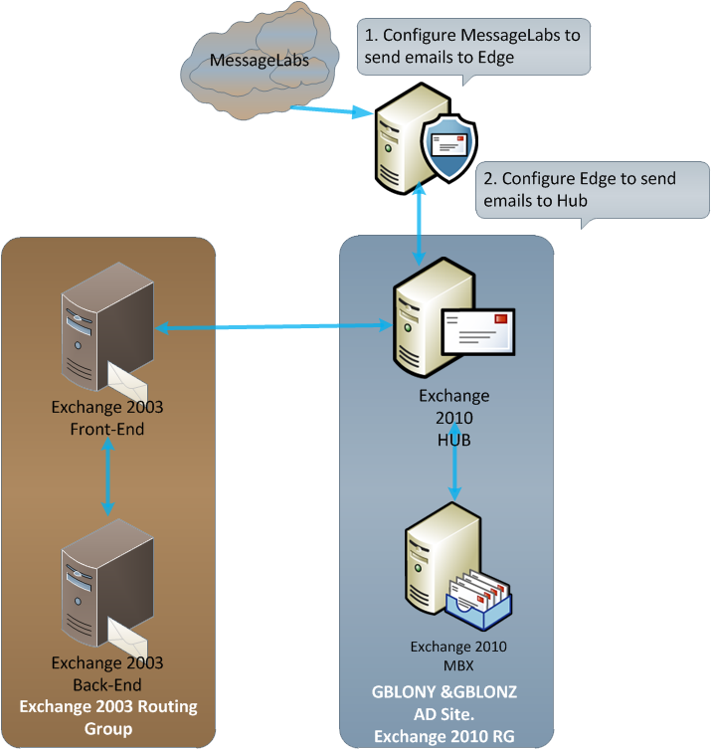
Figure 18: Transport Co-existence
This section discusses the process of upgrading Exchange 2003 to Exchange 2010 from mail flow point of view.
    - Routing Group Topology
Exchange 2003 use routing groups to define an Exchange-specific routing topology. Typically, routing groups are used to specify a set of well-connected Exchange servers. Servers in the same routing group can communicate with each other without the use of connectors. Ideally, the routing groups defined based on IP subnets and closely mirror the Active Directory site configuration.
When more than one routing group is defined in an Exchange 2003 organization, routing group connectors should be created manually to enable mail flow between Exchange 2003 servers in different routing groups. The routing group connector must specify a source server and a target server as the connector endpoints. The bridgehead servers relay e-mail to other routing groups on behalf of other servers in their routing group and receive e-mail from other routing groups for delivery to other servers in their routing group.
In Exchange 2010 there is no need define an Exchange-specific routing configuration. Exchange 2010 uses the existing Active Directory site topology to define its routing topology. However, Exchange-specific configuration changes could be configured to Active Directory sites and IP site link costs to control mail flow. E-mail routed to Exchange servers located in different sites must be relayed by Hub Transport servers. Hub Transport servers send e-mail to Hub Transport servers in remote sites by using the intra-organization Send connector. The intra-organization Send connector is an implicit connector computed by using Active Directory site and IP site link information.
    - Routing Group Connectors
To support coexistence between these two routing topologies, all Exchange 2010 servers are automatically added to a single routing group when Exchange 2010 is installed. The Exchange 2010 routing group is recognized in Exchange System Manager in Exchange 2003 as Exchange Routing Group (DWBGZMFD01QNBJR) within Exchange Administrative Group (FYDIBOHF23SPDLT).
During the installation of the first Exchange 2010 Hub Transport server in an existing Exchange organization, an Exchange 2003 bridgehead server should be specified to establish the first routing group connector. Generally it’s recommend to select a bridgehead server located in a hub routing group or in a routing group that has many mailboxes. The routing group connector links the routing group where the Exchange 2003 server resides and the Exchange 2010 routing group. The Exchange 2010 routing group includes all Exchange 2010 servers, regardless of the Active Directory site in which they reside.
Exchange 2010 servers should not be moved out of Exchange Routing Group (DWBGZMFD01QNBJR), and should not be renamed by using a low-level directory editor. Neither action is supported. Exchange 2010 must use this routing group for communication with Exchange 2003.
The following routing groups will be created:
- M-EMEA-H-LON and Exchange 2010 Routing Group
- M-AMERICAS-H-USA and Exchange 2010 Routing Group
- M-AP-H-HKG and Exchange 2010 Routing Group
    - Link State Updates
When connecting the Exchange 2010 routing group to the Exchange 2003 organization, the behavior of link state routing should be considered.
Exchange 2003 servers maintain a link state routing table that's updated through communication with the routing group master. Each connector that has been created between Exchange 2003 routing groups is considered a link. Exchange 2003 servers determine how a message is routed inside the organization by using the cost assigned to these links. If a particular routing group is inaccessible by using the lowest cost route, the link state table is updated by the routing group master to show the state of that link as down. This data is communicated to every routing group in the Exchange organization. When the data is received, the link state table is updated, and another route is calculated.
Link state routing isn't used by Exchange 2010 Hub Transport servers. Exchange 2010 can't propagate link state updates, and it doesn't recalculate routes. Hub Transport servers always try to communicate directly with other Hub Transport servers. When a connection to a site is unavailable, Exchange 2010 uses the IP site link costs associated with Active Directory sites to determine the closest site at which to queue the message. This behavior is known as queue at point of failure. The message queue generated at the point of failure is put in a retry state.
If multiple paths exist between the Exchange 2010 routing group and any Exchange 2003 routing group, minor link state updates must be suppressed to make sure that message looping doesn't occur when a route is recalculated. Generally, it’s recommend that minor link state updates be suppressed for each server in the Exchange 2003 organization. When link state updates are suppressed, Exchange 2003 servers also queue at point of failure, instead of recalculating the route.
Aegis Media existing environment contains many routing groups; the following steps should be completed to Suppress Link State Update on all Exchange 2003 in the organization:
- Open Registry Editor.
- Locate HKEY_LOCAL_MACHINE\System\CurrentControlSet\Services\RESvc\Parameters.
- Right-click Parameters and select New | DWORD value. Name the new DWORD value SuppressStateChanges.
- Double-click SuppressStateChanges.
- In the Value data field, enter 1.
- Close Registry Editor, and then restart the SMTP service, the Microsoft Exchange Routing Engine service, and the Microsoft Exchange MTA Stacks services for the change to take effect.
    - Message Tracking
The message tracking schema in Exchange 2010 is significantly different from the message tracking schema in Exchange 2003. The events logged by Exchange 2010 message tracking don't correspond directly to the message tracking events logged by Exchange 2003. Messages sent and received by Exchange 2010 can only be tracked by Exchange 2010 servers. There is no Microsoft Windows Management Instrumentation (WMI) support in Exchange 2010. Therefore, an Exchange 2003 server can't query for message tracking logs on an Exchange 2010 server. If a message tracking query in Exchange 2010 indicates that the message was transferred to an Exchange 2003 server, the Exchange 2003 message tracking tool should be used to continue to search for the message.
Exchange 2010 message tracking tool should be used to track messages inside routed inside Exchange 2010 servers. However once moved to Exchange 2003, the message tracking tool of Exchange 2003 should be used.
  - Upgrade From Exchange 2003 Mailbox
The Microsoft Exchange Server 2010 Mailbox server role can coexist with Exchange Server 2003. When upgrading from an Exchange 2003 organization to Exchange 2010, the first server role to be upgraded is the Client Access server role.
After implementing and configuring Client Access, then mail flow should be configured by implementing Exchange 2010 HUB and Edge servers. Then, after Mailbox servers have been deployed, mailboxes from Exchange 2003 should be moved to Exchange 2010.
Moving mailboxes to Exchange 2010 could be done by one of the following options:
- Move request cmdlet.
- Exchange Management Console.
    - Move Mailboxes
Typically in the upgrade scenario moving mailboxes will be done from Exchange 2003 mailbox databases (Source) to Exchange 2010 mailbox databases (Target).
There are some important guidelines to be considered when moving mailboxes from Exchange 2003 to Exchange 2010:
- Mailboxes could not be moved from Exchange 2003 Service Pack 1 (SP1) or earlier.
- Perform the move from a server running Exchange 2010 by using the move request cmdlets in the Exchange Management Shell or Exchange Management Console.
- Exchange System Manager or Active Directory Users and Computers could not be used to move mailboxes from Exchange 2003 to Exchange 2010.
- The move process is performed offline, and end-users won't be able to access their mailboxes during the move.
Aegis Media IT team with TCS will schedule and plan moving mailboxes for users, a clear communication plan should be sent to all users notifying them about the time, duration and the effect of moving mailboxes from Exchange 2003 to Exchange 2010.
  - Decommission Exchange 2003 Servers
The last step in the Exchange Server 2010 upgrade is to remove Exchange 2003 servers from the organization.
To remove servers from a co-existence scenario with Exchange 2010 and Exchange 2003, additional steps should be performed so that all features and functionality will continue to work as expected. Also, full System state backups from both the AD DC’s and from the Exchange 2003 servers which will be decommissioned should be performed before any action takes place.
When removing the last Exchange 2003 server from an Exchange organization that is running Exchange 2010, the following steps should be performed:
- Inbound mail should be routed to an Exchange 2010 server.
- All applications should be configured to send Emails through Exchange 2010 Hub servers.
- Any outbound SMTP connectors on the Exchange 2003 server should be replaced with Exchange 2010 send connectors.
- If being used, public folders should be migrated to SharePoint.
- All Mailboxes should be moved to Exchange 2010
- Public folder hierarchy should be removed from Exchange 2003.
- Remove Public Folder and Mailbox Stores from Exchange 2003 server.
- Offline Address Book (OAB) generation process should be moved to an Exchange 2010 server.
- The routing group connector between the Exchange 2010 routing group and the Exchange 2003 should be removed.
- Any Mailbox Manager recipient policies on the Exchange 2003 should be removed.
- The Recipient Update Service should be deleted.
- Appendix A – Naming Standards
  - User Objects
    - Required Attributes
The following attributes of user objects have naming standards defined:
Attribute | Description | Naming Standard
sAMAccountName | User logon name (pre-Windows 2000) | firstname.lastname
userPrincipalName | User logon name | firstname.lastname@global.loc
displayName | Display Name | Lastname, Firstname (Description)  Note: Description uses the standard abbreviations
cn or name | Full Name | Lastname, Firstname (Description)  Note: Description uses the standard abbreviations
givenName | First Name | Firstname
sn | Surname | Lastname
phoneNumber | Office Telephone Number | +a-bbb-ccc-dddd  a = Country code  b = Area code  c = Exchange  d = Number
Table 93: Required Attributes
Current attributes that do not have a defined naming standard:
- Title
- Division
- Company
- Address
- Reporting Unit / Cost Center
- Employee ID
- Telephone – Mobile
- Telephone – Business
Some of the above items may not be applicable for all user objects, for example resource mailboxes may not have a corresponding phone number. In this case the attribute should be left blank.
    - Conflict Resolution
When user objects are in conflict (same sAMAccountName or displayname exists), the following rules will be used to resolve the conflict:
- Use additional characters from the first name
Example 1: Evelyn Nieves and Evelyn Nieves (no middle name)
Full name | sAMAccountName
Evelyn Nieves | enieves
Evelyn Nieves | evnieves
Table 94: Object Conflict Resolution
- Use the middle initial
Example: Robert J Thomas and Robert M Thomas
Full name | sAMAccountName
Robert J Thomas | rthomas
Robert M Thomas | rmthomas
Table 95: User Object Conflict Resolution
- Add a numerical suffix to the user object
Example: Hu Chang, Hu Chang, and Hu Chang
Full name | sAMAccountName
Hu Chang | hchang
Hu Chang | huchang
Hu Chang | huchang1
Table 96: User Object Conflict Resolution
  - Groups
The following attributes of group objects have naming standards defined
Attribute | Description | Naming Standard
sAMAccountName | User logon name (pre-Windows 2000) | GroupName
displayName | Display Name | Business Unit / Location {space} Description
cn | Full Name | Business Unit / Location {space} Description
Group Scope | Universal | Exchange 2007 uses only universal groups for distribution group objects.
Table 97: Attributes of Groups
  - Servers
Servers are named using the following standard
Server Name | 2 Characters | 4 Characters | 3 Characters | 2 characters
 | Country - Location of the server | Site Name | Role of the server  CAS and Hub = CAS  Mailbox = MBX  Unified Messaging = UMX  Edge = EDG | Unique numerical suffix
GBLONZCAS01 | GB | LONZ | CAS | 01
USNYC1MBX01 | US | NYC1 | MBX | 01
SGSIN1MBX01 | SG | SIN1 | MBX | 01
Table 98: Server Naming Standards
  - Database Availability Groups
DAG Name | 3 Characters | 2 characters (numeric)
DAG01 | DAG | 01
DAG02 | DAG | 02
DAG03 | DAG | 03
Table 99: DAG Naming Standards
  - Exchange Databases – Mailbox
Exchange Databases are named using the following standard:
5 Characters | 3 Characters | Naming Standard
dag01 | db1 | dag01-db1
dag01 | db2 | dag01-db2
dag02 | db3 | dag02-db3
dag02 | db4 | dag02-db4
Table 100: Exchange Databases Names
- Appendix B - Aegis Media Recipient policies in Exchange 2003
- Appendix C – Client Test Cases
Use the below test from the all Aegis Media locations to validate good user experience and make sure all the features are working.
 | Clients Tests | Pass | Fail | Skip | Blocked | Owner | Est. Time | Dependency | Date
 | MAPI based clients (Outlook 2007)
1 | Send and receive mail on your local server. Verify multiple mailboxes can be opened by the client |  |  |  |  | open | 5
2 | Send and receive mail on between two servers |  |  |  |  | open | 1
3 | Send and receive mail between users than are on different stores (in a multiple store scenario) |  |  |  |  | open | 5
4 | Reply to mail |  |  |  |  | open | 1
5 | Forward mail |  |  |  |  | open | 1
6 | Send mail to a Exchange 2003 mail enabled group |  |  |  |  | open | 1
7 | Send mail to a query based distribution group |  |  |  |  | open | 1
8 | Send mail to a user at a completely invalid SMTP domain |  |  |  |  | open | 1
9 | Send mail to users with Delivery Receipts and/or Read Receipts requested |  |  |  |  | open | 1
10 | Send mail with an attachment |  |  |  |  | open | 1
11 | Get properties of user (Outlook and ADU&C) |  |  |  |  | open | 1
12 | Add user to your Outlook Address Book; send mail to them |  |  |  |  | open | 1
13 | Create a rule (i.e. move messages from a certain user to a specific folder) |  |  |  |  | open | 5
14 | Copy/Move a message to a Archive folder |  |  |  |  | open | 5
15 | Verify free busy information |  |  |  |  | open | 2
16 | Download OAB and check user's properties |  |  |  |  | open | 10
17 | Send message on behalf of another user |  |  |  |  | open | 5
18 | Send high/low priority messages |  |  |  |  | open | 1
19 | Enable OOF notification |  |  |  |  | open | 1
20 | Send mail to "Internet" |  |  |  |  | open | 2
21 | Repeat Steps using each approved client OS (Windows 7, Windows XP) |  |  |  |  | open | 60
 | MAPI based clients (Outlook 2010)
22 | Enable Outlook 20010 Cached Mode |  |  |  |  | open | 5
23 | Verify Cached Mode can access OAB. This includes access while OL is connected to network and disconnected from network. |  |  |  |  | open | 30
24 | Use Search folders while in Cached Mode. |  |  |  |  | open | 15
25 | Send and receive mail on your local server. Verify multiple mailboxes can be opened by the client |  |  |  |  | open | 5
26 | Send and receive mail on between two servers |  |  |  |  | open | 1
27 | Send and receive mail between users than are on different stores (in a multiple store scenario) |  |  |  |  | open | 5
28 | Reply to mail |  |  |  |  | open | 1
29 | Forward mail |  |  |  |  | open | 1
30 | Send mail to a distribution group |  |  |  |  | open | 1
 | Send mail to a query based distribution group
31 | Send mail to a user at a completely invalid SMTP domain |  |  |  |  | open | 1
32 | Send mail to users with Delivery Receipts and/or Read Receipts requested |  |  |  |  | open | 1
33 | Send mail with an attachment |  |  |  |  | open | 1
34 | Get properties of user |  |  |  |  | open | 1
35 | Add user to your PAB |  |  |  |  | open | 1
36 | Create a rule (i.e. move messages from a certain user to a specific folder) |  |  |  |  | open | 5
37 | Copy/Move a message to a Archive folder |  |  |  |  | open | 5
38 | Verify free busy information |  |  |  |  | open | 2
39 | Download OAB and check user's properties |  |  |  |  | open | 10
40 | Send message on behalf of another user |  |  |  |  | open | 5
41 | Send high/low priority messages |  |  |  |  | open | 1
42 | Enable OOF notification |  |  |  |  | open | 1
43 | Send mail to PAB and 1-Off recipients to SMTP recipients. Configure the recipient’s attributes to override SMTP Connector setting such as Rich Text and other settings. |  |  |  |  | open | 2
44 | Configure Junk Email. Send message from a known spammmer (by defining who are spammers in junk email) and verify message is placed in junk email folder. |  |  |  |  | open | 10
45 | Configure Exchange to allow outlook anywhere. Setup OL2010 to Outlook anywhere. Verify that you can connect with Outlook anywhere. |  |  |  |  | open | 60
46 | Client pass using Windows 7 as OS |  |  |  |  | open | 60
47 | Repeat test pass to test all features working with outlook anywhere. |  |  |  |  | open | 60
 | Calendaring
48 | Send a meeting request |  |  |  |  | open | 1
49 | Accept, Decline and Tenative a meeting request. Verify it shows up correctly on both the sender and receivers calendars |  |  |  |  | open | 5
50 | Forward a meeting request |  |  |  |  | open | 1
51 | Send a meeting request with an attachment |  |  |  |  | open | 1
52 | Send a meeting request to a distribution list |  |  |  |  | open | 1
53 | Modify first meeting, send update, and accept |  |  |  |  | open | 2
54 | Cancel first meeting, send update, and remove from calendar |  |  |  |  | open | 2
55 | Create Weekly recurring meeting, invite and accept |  |  |  |  | open | 2
56 | Open recurring meeting and view availability of attendees |  |  |  |  | open | 5
57 | Move one instance or recurring meeting, delete another, send update, and accept |  |  |  |  | open | 5
58 | Attendee deletes one instance or recurring meeting, sends notification |  |  |  |  | open | 2
59 | Create single meeting and check free/busy information of user and Meeting resource |  |  |  |  | open | 5
60 | Use Scheduling Assistant to find rooms and suggested time of users. |  |  |  |  | open | 5
61 | Use delegate access to create and invite meeting request on behalf of manager |  |  |  |  | open | 5
62 | Create single meeting and invite user with delegate, delegate accepts for manager |  |  |  |  | open | 5
63 | Test Calendaring functionality with Outlook 2010 |  |  |  |  | open | 60
 | Outlook Web Access
60 | Open IE and logon to Exchange server |  |  |  |  | open | 1
61 | Send and read email |  |  |  |  | open | 1
62 | Read mail using preview pane |  |  |  |  | open | 1
63 | From IE or Safari, compose/send mail and format body of message |  |  |  |  | open | 1
64 | Send a meeting request from Outlook; accept it from web client |  |  |  |  | open | 1
65 | Delete email messages (right click or X icon; can multiple select with IE) |  |  |  |  | open | 1
66 | Send email with an attachment |  |  |  |  | open | 1
67 | Change views in inbox |  |  |  |  | open | 1
68 | Create new folders in your inbox |  |  |  |  | open | 1
69 | Go to Calendar |  |  |  |  | open | 1
70 | Read appointments on calendar |  |  |  |  | open | 1
71 | Create an appointment on the calendar |  |  |  |  | open | 1
72 | Switch calendar view to weekly/monthly view |  |  |  |  | open | 1
73 | Create a post in a public folder |  |  |  |  | open | 1
74 | Send a meeting request |  |  |  |  | open | 1
75 | Create a recurring appointment (daily, weekly, monthly, etc) |  |  |  |  | open | 1
76 | Create a contact |  |  |  |  | open | 1
77 | Find an object within the GAL and view its properties |  |  |  |  | open | 5
78 | Send Multimedia Message (IE6, Change Options from Standard to Multimedia Forms) |  |  |  |  | open | 1
79 | Read a Multimedia message |  |  |  |  | open | 1
80 | Reply and Forward a Multimedia message |  |  |  |  | open | 1
81 | Switch from Shortcut to Folder view |  |  |  |  | open | 1
82 | Use Spell Checker |  |  |  |  | open | 1
83 | Install the S/MIME client. Send and receive S/MIME mail if possible |  |  |  |  | open | 15
84 | Configure Rules. Verify rules also appear in Outlook |  |  |  |  | open | 1
85 | Configure Junk Email. Send message from a known spammmer (by defining who are spammers in junk email) and verify message is placed in junk email folder. |  |  |  |  | open | 1
86 | Using IE on Windows 7, verify that when logoff occurs you cannot gain access into mailbox by clicking back in IE. |  |  |  |  | open | 1
87 | Enable Forms based Authentication. Verify user receives logon page. |  |  |  |  | open | 1
88 | With FBA enabled, ensure time outs occur. |  |  |  |  | open | 1
89 | With FBA enabled, log into Premium Client |  |  |  |  | open | 1
90 | With FBA enabled, log into Basic Client |  |  |  |  | open | 1
91 | With FBA enabled, log into Premium Client |  |  |  |  | open | 1
 | Mobility
92 | Enable support for ActiveSync |  |  |  |  | open | 1
93 | Send email to a user with small attachments (doc, xls, jpg)  View Attachment on Windows phone  Reply to Sender |  |  |  |  | open | 1
94 | Accept a meeting request, Propose new meeting time, and decline a meeting request. |  |  |  |  | open | 1
95 | Perform a lookup in the Global Address List |  |  |  |  | open | 1
96 | Use a Windows Mobile to check the calendar |  |  |  |  | open | 1
97 | Use a Windows Mobile device to access via ActiveSync |  |  |  |  | open | 1
Table 101: Client Test Cases
- Appendix D - Exchange Server Resources
  - Exchange Server
The Microsoft Exchange Team Blog ‘You had me at EHLO...’
http://msexchangeteam.com/
Microsoft Exchange
http://www.microsoft.com/exchange/2010/en/us/default.aspx
Exchange Server 2010 on TechNet
http://technet.microsoft.com/en-us/library/bb124558(EXCHG.140).aspx
  - Exchange Server Tools
Exchange Remote Connectivity Analyzer
https://www.testexchangeconnectivity.com/
Exchange Server Jetstress 2010 Beta
http://www.microsoft.com/downloads/details.aspx?displaylang=en&FamilyID=13267027-8120-48ed-931b-29eb0aa52aa6
Exchange Load Generator 2010 Beta
http://www.microsoft.com/downloads/details.aspx?displaylang=en&FamilyID=1aaa3f65-bab0-42e6-861b-a25adf258ef3
ExFolders
http://msexchangeteam.com/files/12/attachments/entry453398.aspx
  - Forefront Protection for Exchange Server 2010
Forefront Security for Exchange Server
http://www.microsoft.com/forefront/serversecurity/exchange/en/us/default.aspx
Forefront Security for Exchange Server TechCenter
http://technet.microsoft.com/en-gb/forefront/serversecurity/bb734822.aspx
Microsoft Forefront Server Security Blog
http://blogs.technet.com/fss/
  - Systems Center Operations Manager
System Centre Operations Manager TechCenter
http://technet.microsoft.com/en-us/opsmgr/default.aspx
Exchange Server 2010 Management Pack for SCOM 2007
http://www.microsoft.com/downloads/details.aspx?FamilyID=7150bfed-64a4-42a4-97a2-07048cca5d23&displaylang=en
  - Powershell
Windows Powershell Blog
http://blogs.msdn.com/powershell/
Scripting with Windows Powershell
http://technet.microsoft.com/en-us/scriptcenter/dd742419.aspx
  - Forefront Unified Access Gateway 2010 and Forefront Threat Management Gateway 2010
Publishing Exchange Server 2010 with Forefront Unified Access Gateway 2010 and Forefront Threat Management Gateway 2010

